Start - React

React concepts

We had jQuery before which is very imperative using DOM manipulation, leading to messy & slow development, making it very hard to scale.

React is created by Facebook.

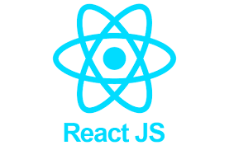

React can be used everywhere i.e Mobile devices & VR apps

Combining Lego blocks -> a Website

**React Architecture**

React renders DOM element using Virtual DOM with

a Tree architecture

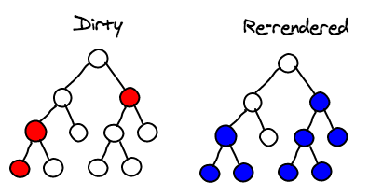

In the past, Parent do NOT know about Children

React: Changes in children also ack other children

Virtual DOM

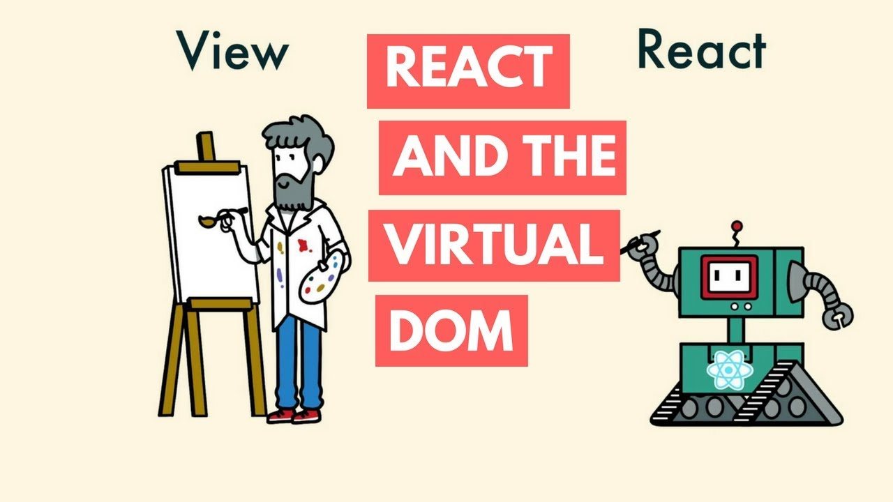

In the past, we = painter, use DOM to make changes by

Triggering callback function to update DOM after each action

[Procedural]

React DOM = JS object ->

current state of the website ->

React makes DOM manipulation for you

[Declarative]

Eco-System

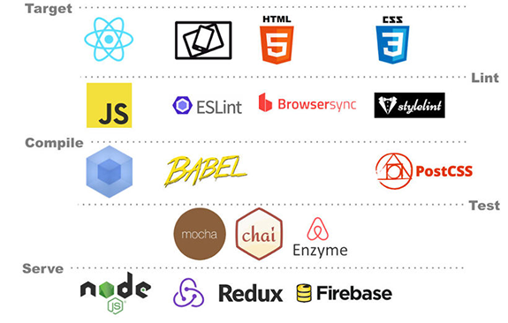

**React.Component is a private class (like a car)**

**Inheriting a blueprint from a parent class (blueprint)**

**constructor() {**

**super()**

**}**

**to inherit all React constructed attributes (gears inside a car)**

**(e.g. this.state) & React.methods (private)**

class <> extends React.Component {

constructors() {

super();

this.state = {

date: new Date()

};

}

}

render() {

return (

<div>

<h1>Hello, world!</h1>

<h2>It is {this.state.date.toLocaleTimeString()}.</h2>

</div>

);

}

ReactDOM.render(

<Clock />,

document.getElementById('root')

);

Virtual DOM

Every JS DOM has a virutal DOM

Virtual DOM = An object identical to JS object

vDOM = representation of JS DOM obj

vDOM obj has same power + properties + methods as DOM obj

vDOM = blueprint (plan)

vDOM cannot directly manipulate DOM obj

React holds 2 vDOMs:

1. Updated state vDOM

2. Previous state vDOM

e.g. Accessing previous state variables

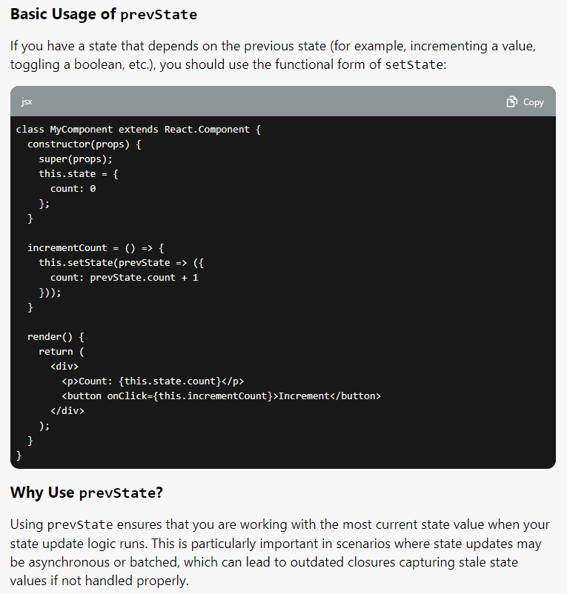

Then, calculate the difference => update real DOM

**Reconciliation Flow**

i. Entire vDOM gets updated

ii. vDOM gets compared to what it looked like, before updating it

React figures out which obj have changed

iii. Changed obj, and the changed obj only, get updated on real DOM

iv. Changes on real DOM cause screen to change

==== **Components**

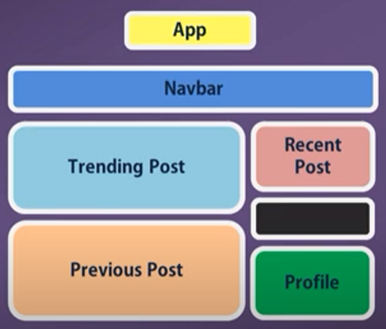

Each color = individual component

Reuseable + Encapsulation + cross-browser compatibility

==== **Babel**

Browser interprets code as text, thus no need to compile JS code

==== **Current Time - useEffect**

imrc = import React, { Component } from 'react';

class Timer extends Component {

state = {

date: new Date(),

};

callMe() {

setInterval{ () => {

this.setState({ date: new Date() } );

}, 1000);

}

render() {

return (

<div className="app">

<h1>Current Time: </h1>

<h2>{this.state.date.toLocaleTimeString()}</h2>

{ this.callMe() }

</div>

);

}

}

export default Timer;

React Strict Mode

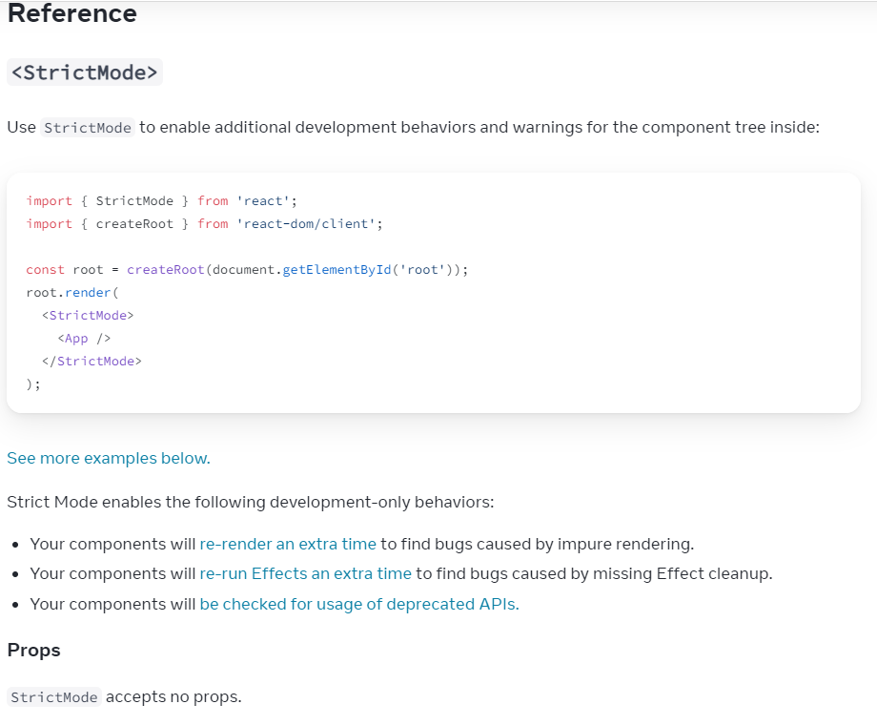

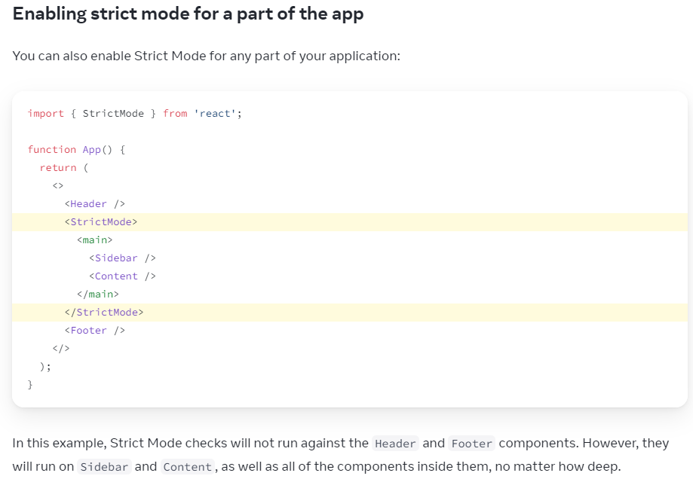

**Fixing bugs found by double rendering in development**

React assumes that every component you write is a pure function.



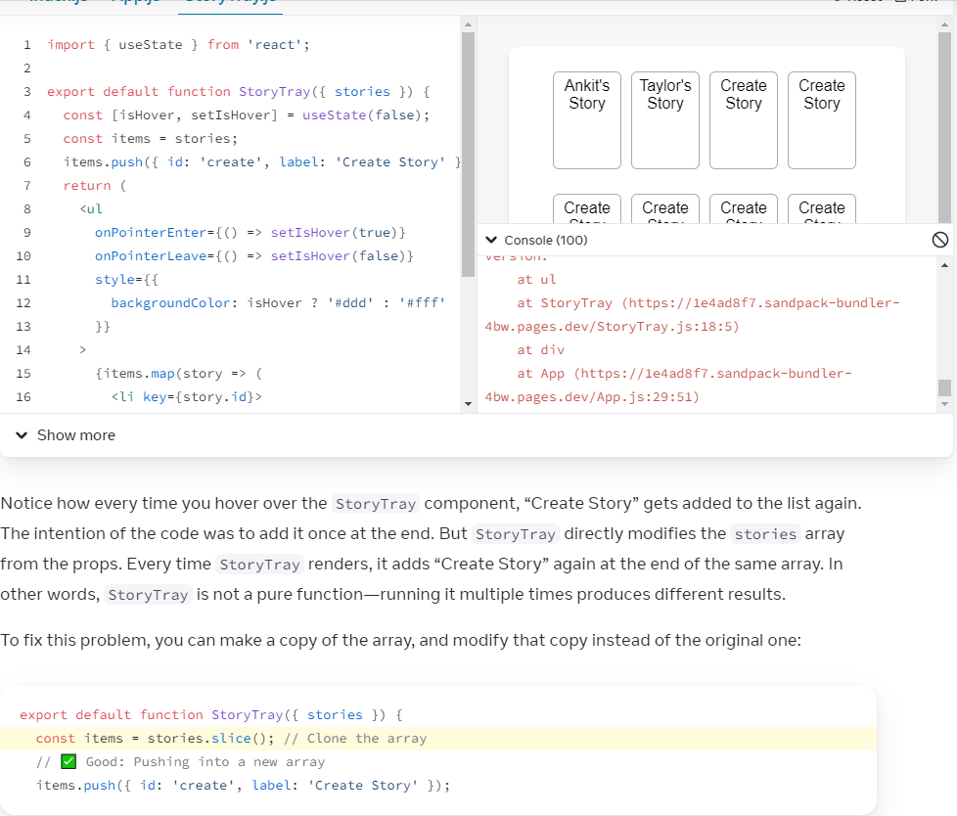

Reading React Docs

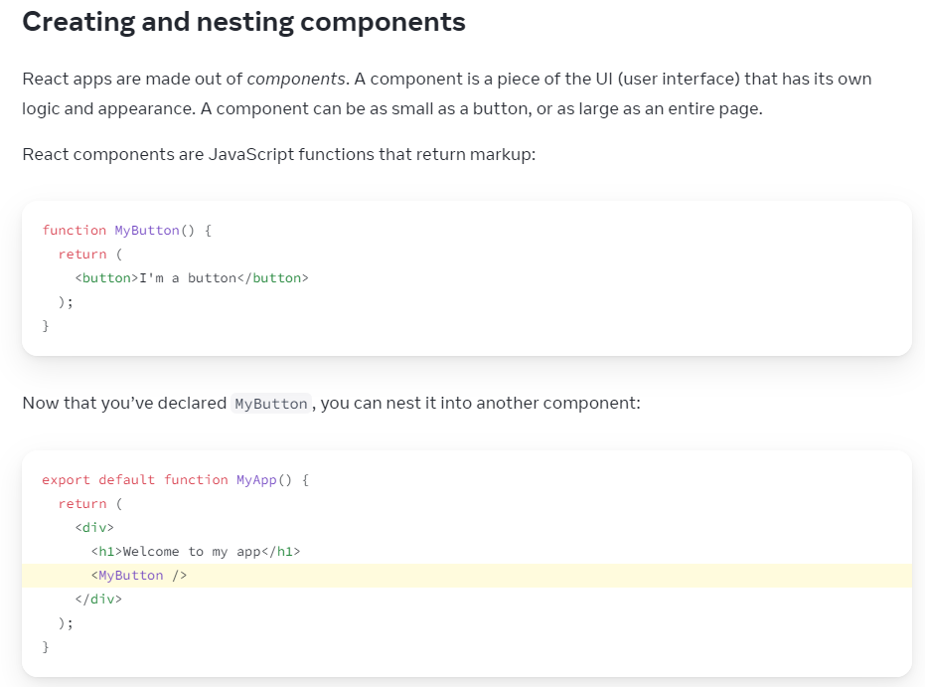

React Components must always start with Capital letter

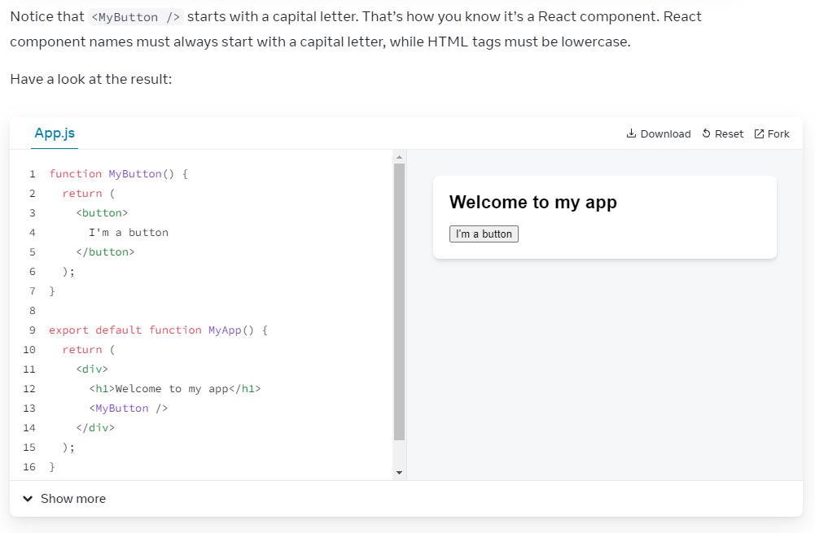

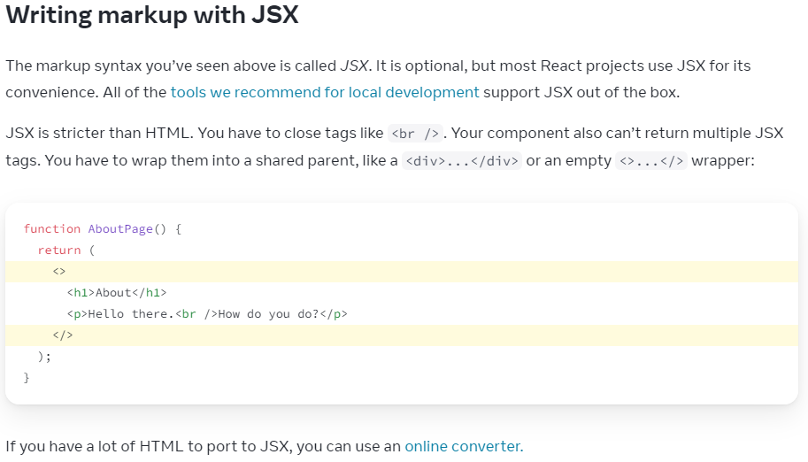

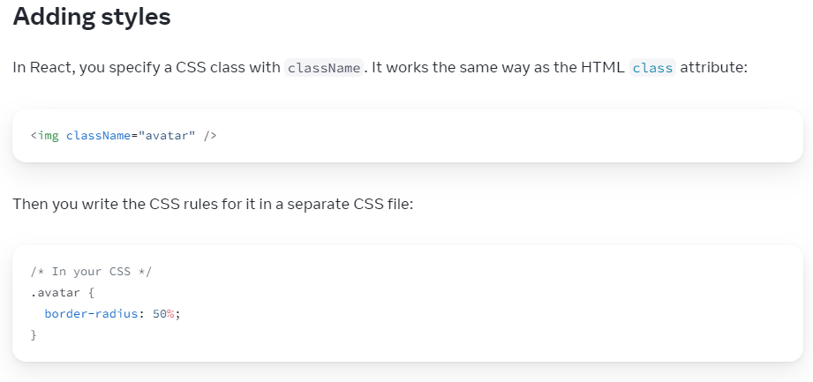

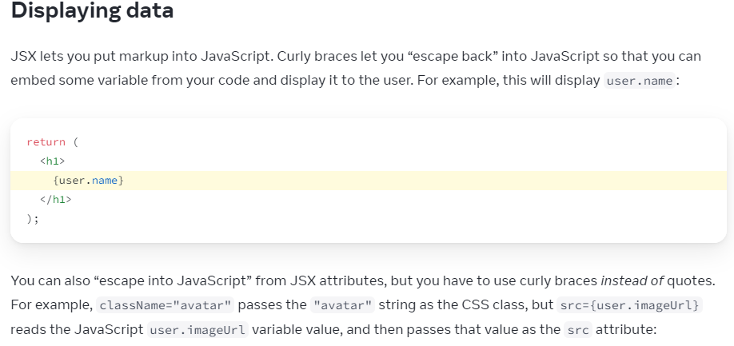

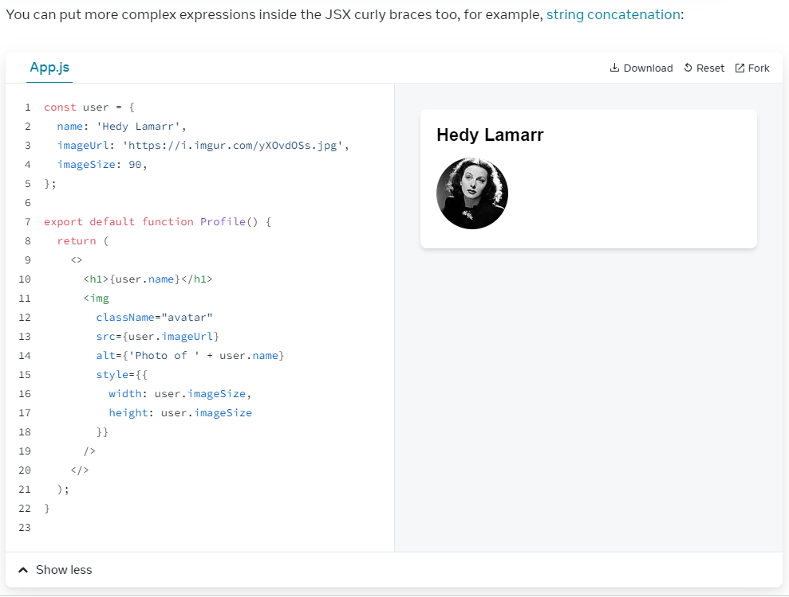

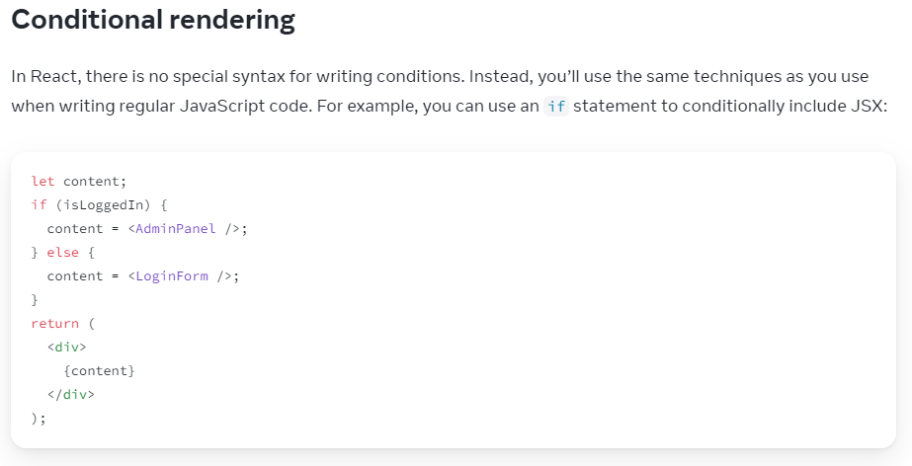

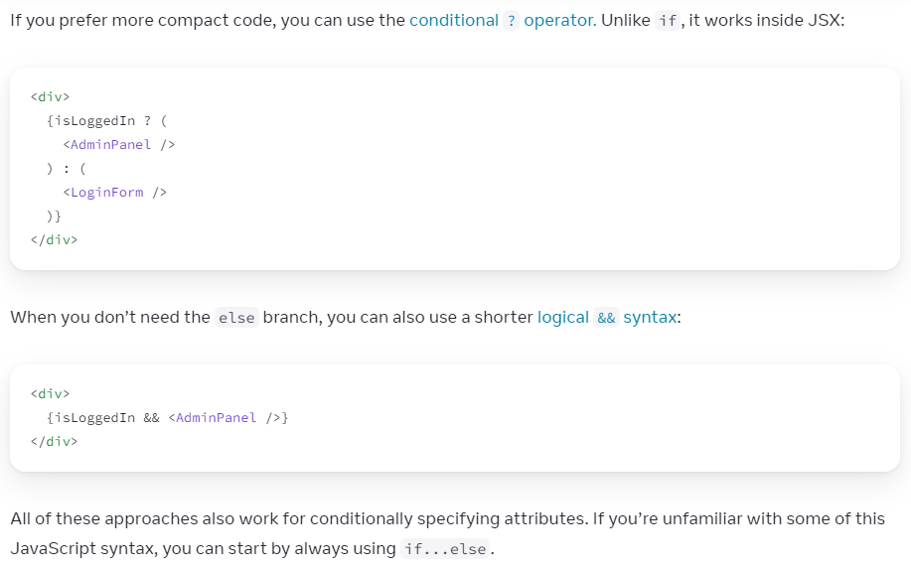

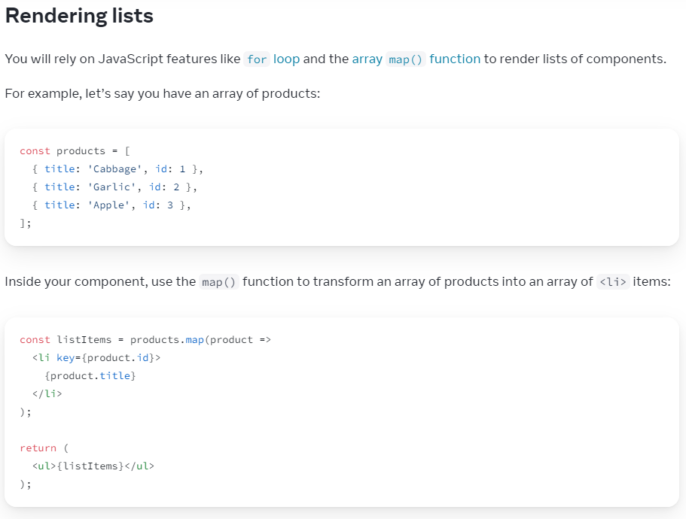

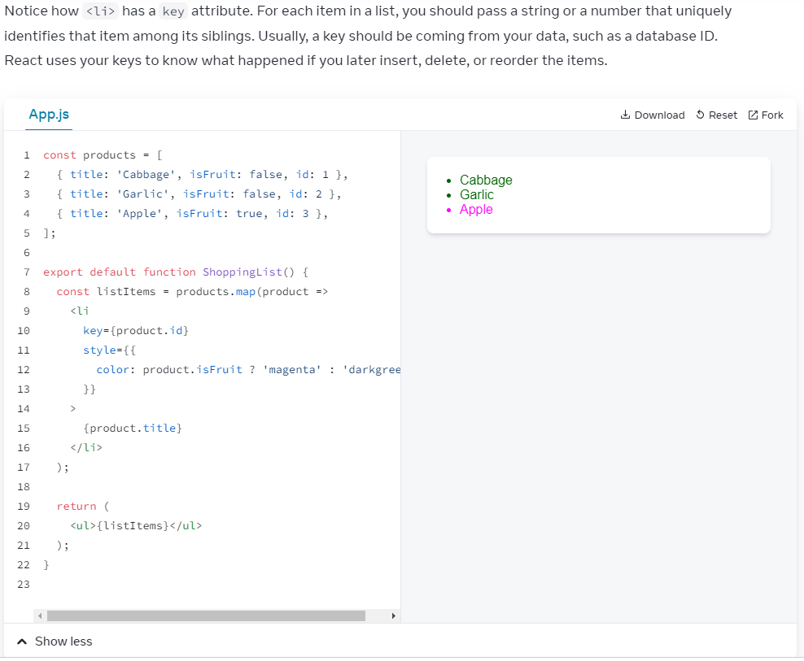

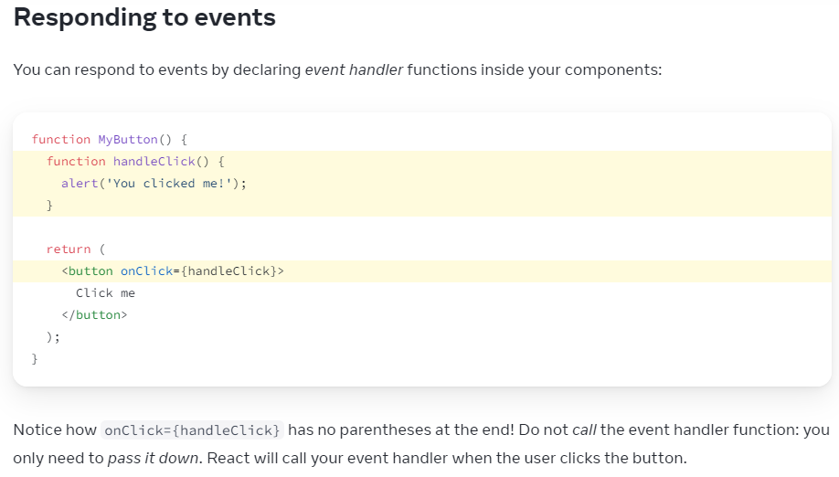

Functional vs Class components

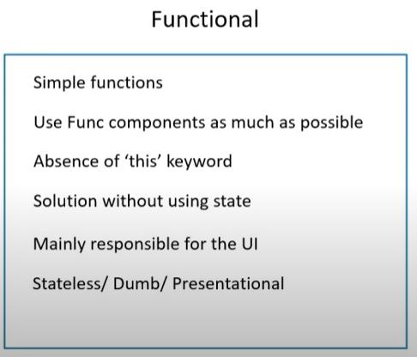

Functional = Stateless

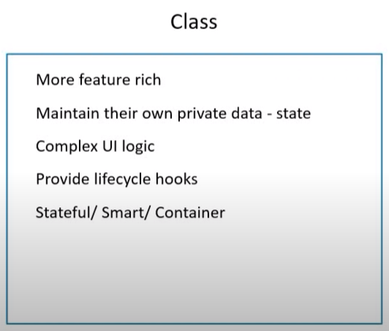

Class = Stateful

React JSX templating

Markup with JSX

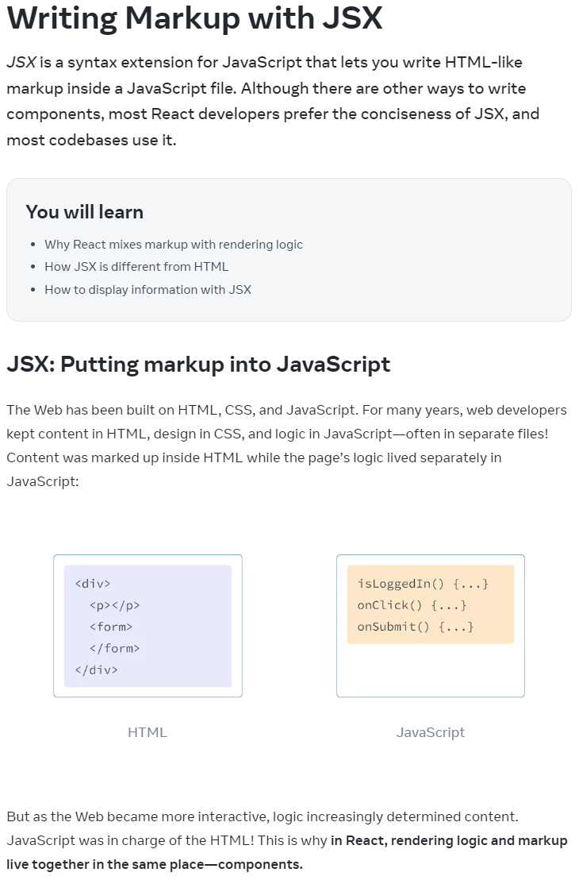

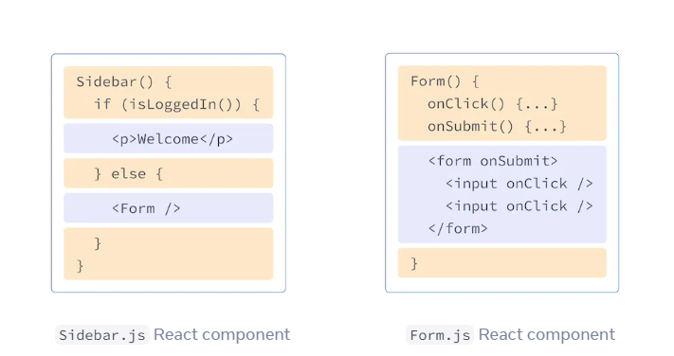

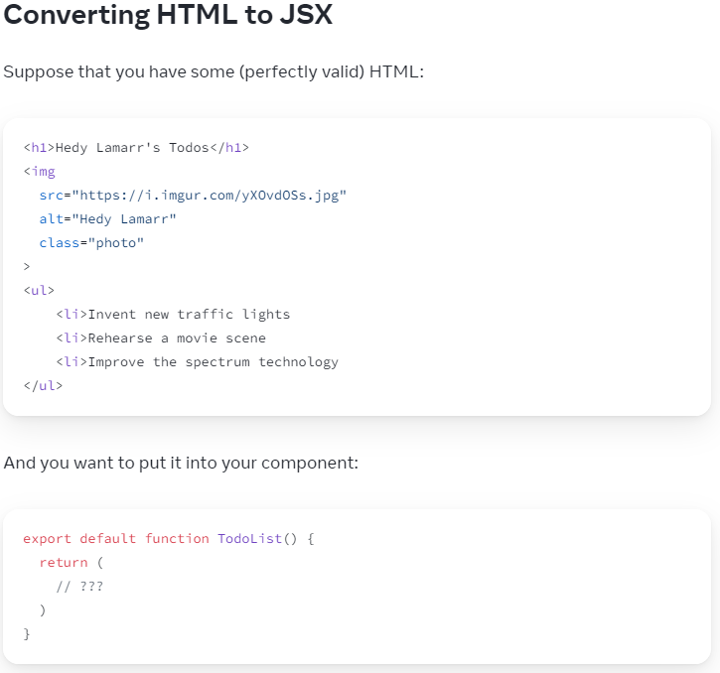

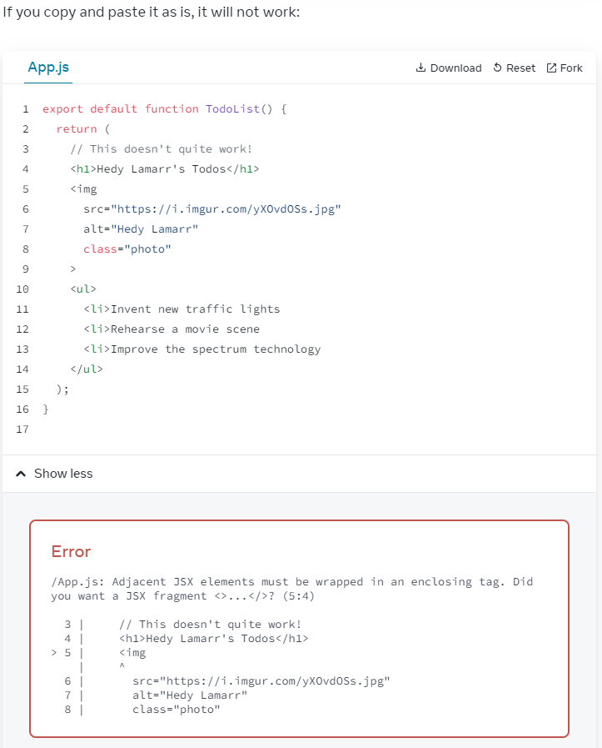

My solution:

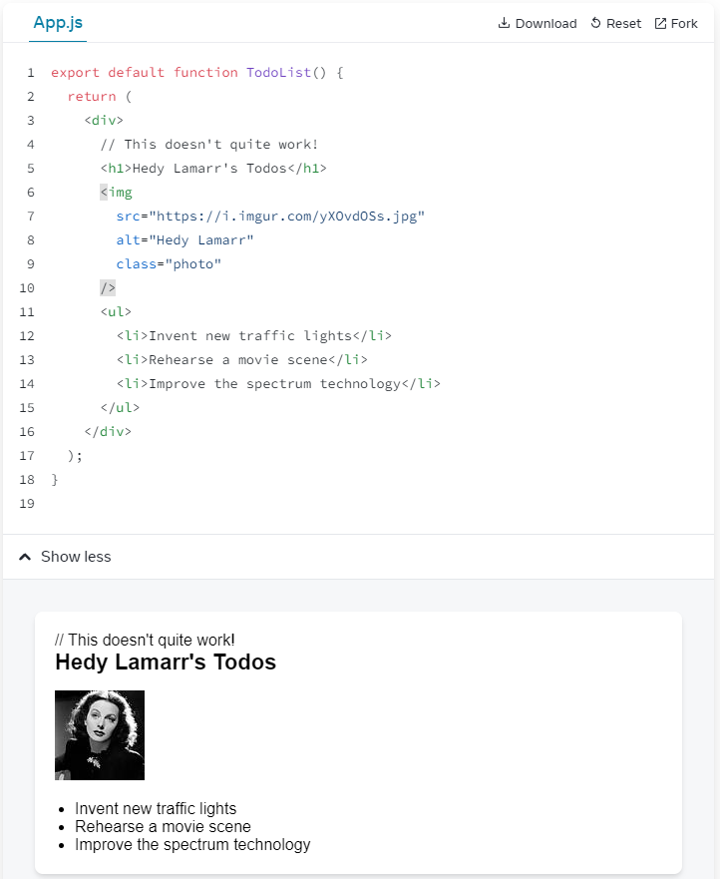

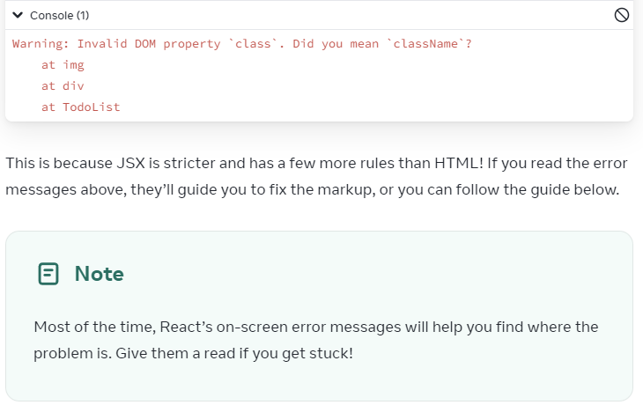

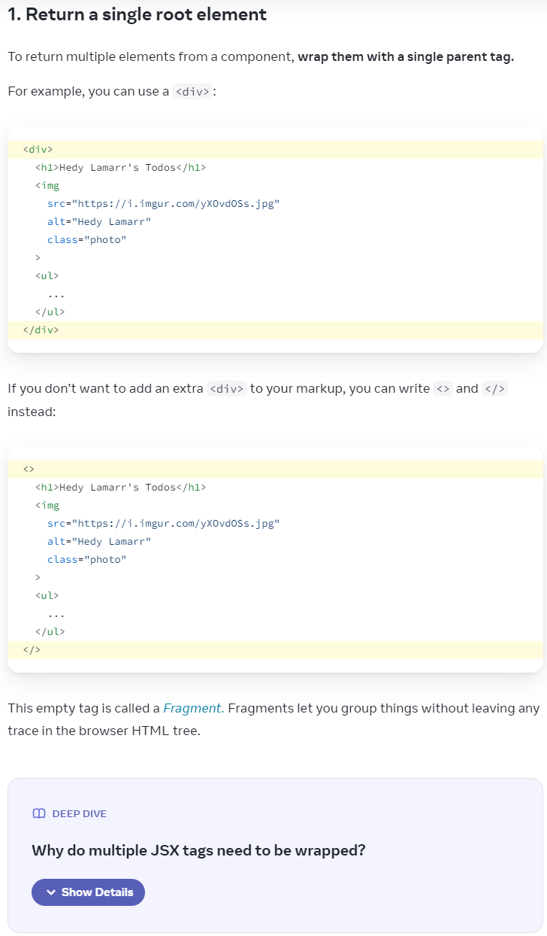

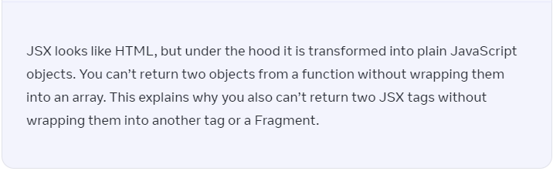

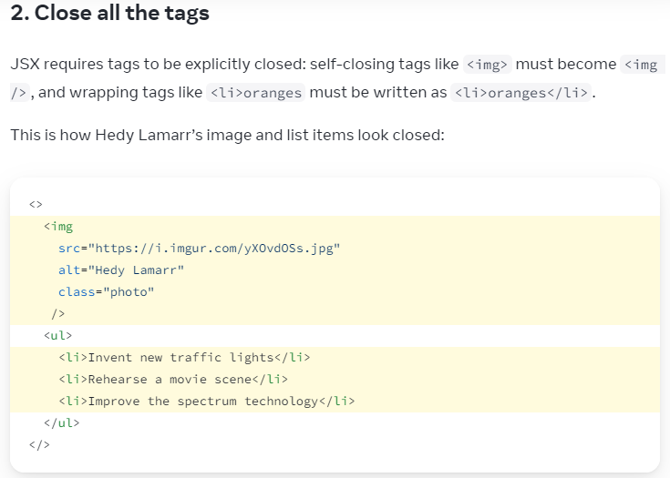

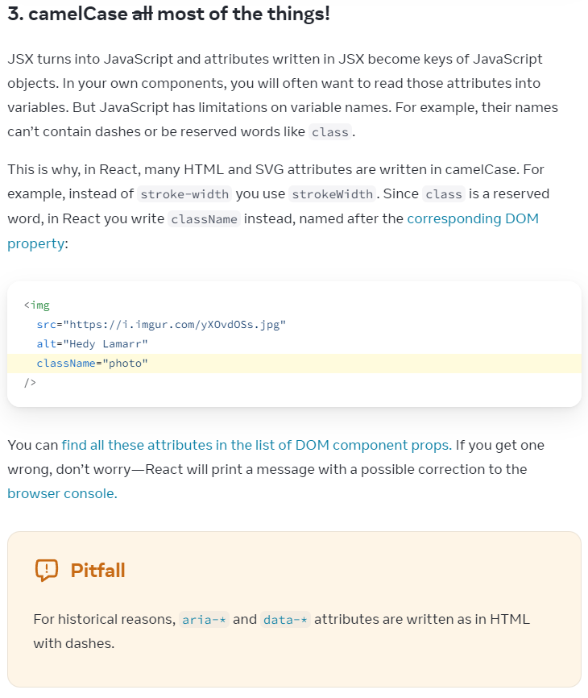

JavaScript in JSX with Curly Braces { }

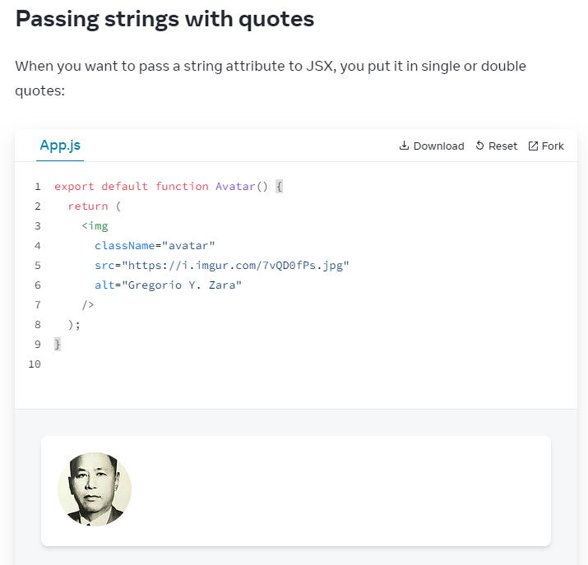

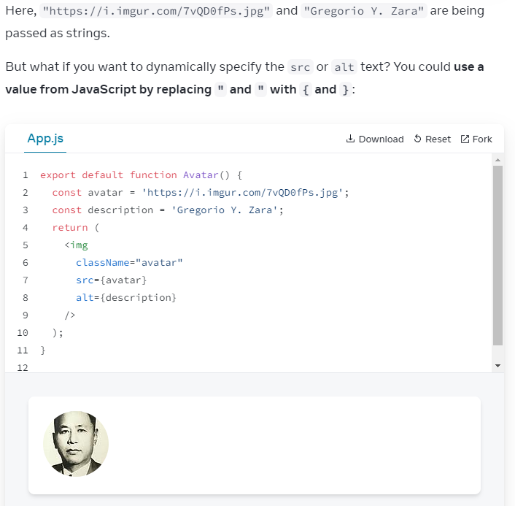

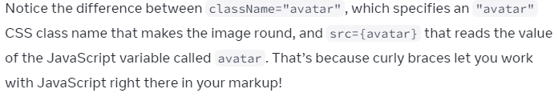

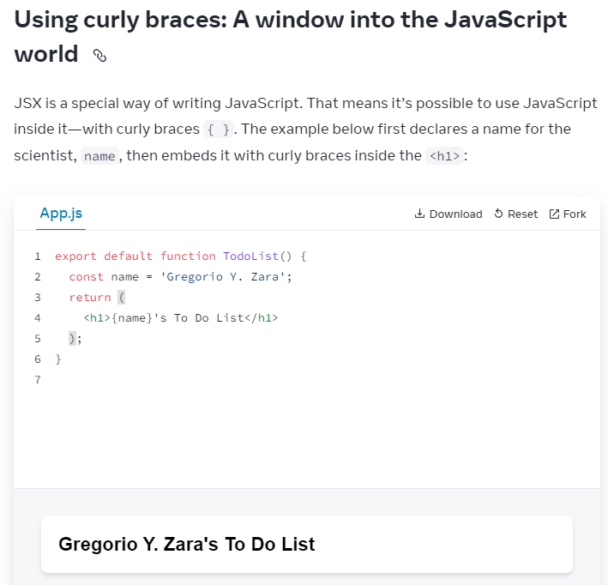

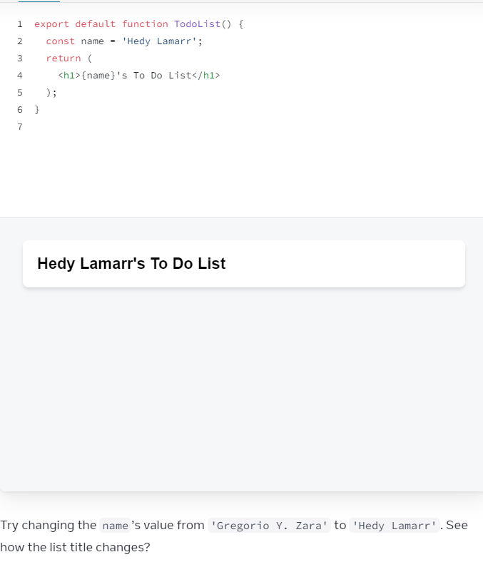

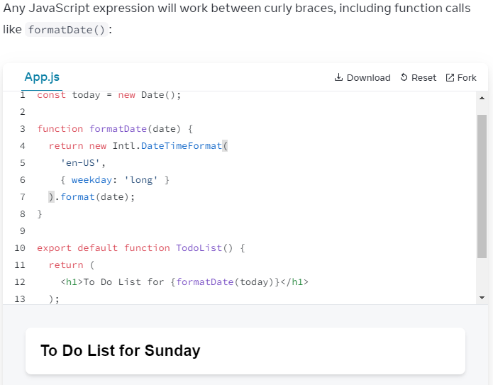

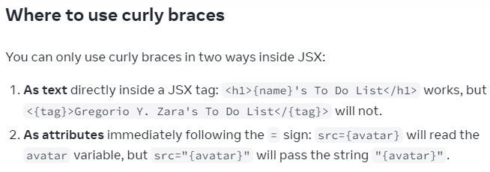

variable src={ }

string src="{ }"

Double curlies {{ }}

To pass a JS object in JSX:

person = {{ name: "Hedy Lamarr", inventions: 5 }}

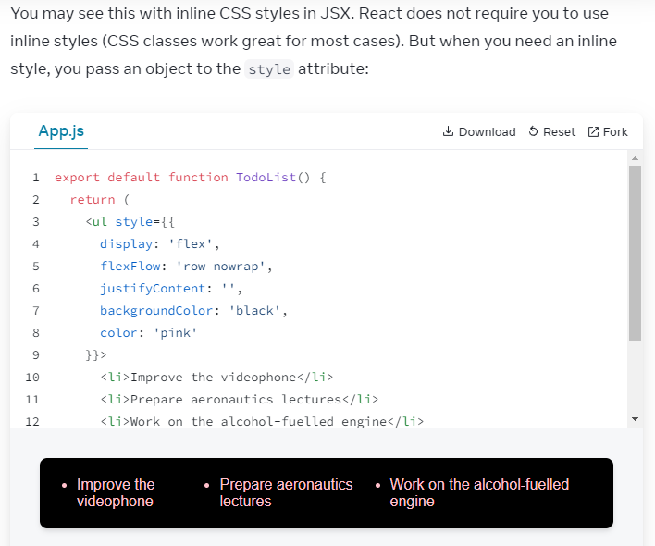

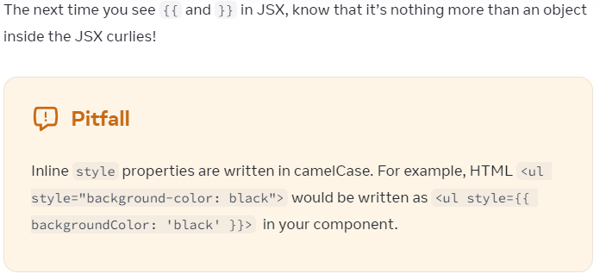

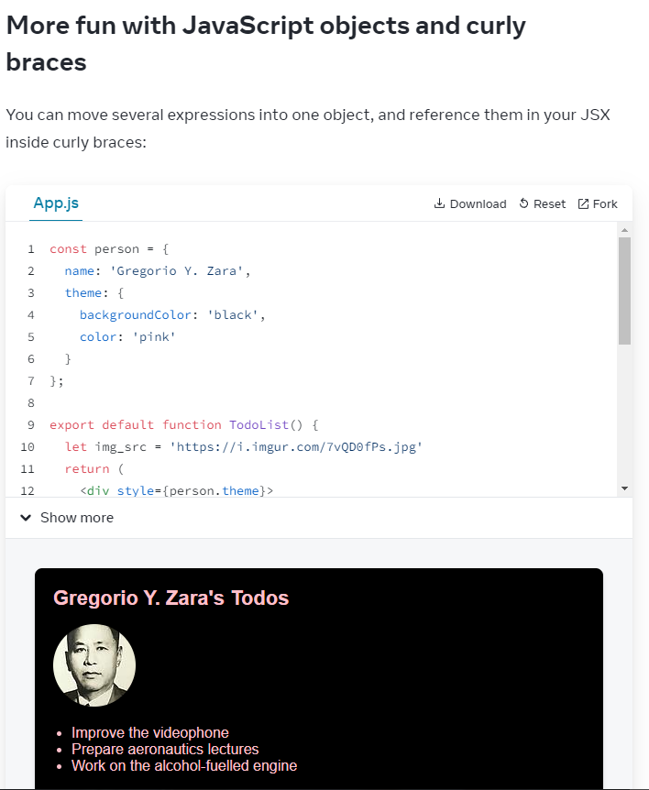

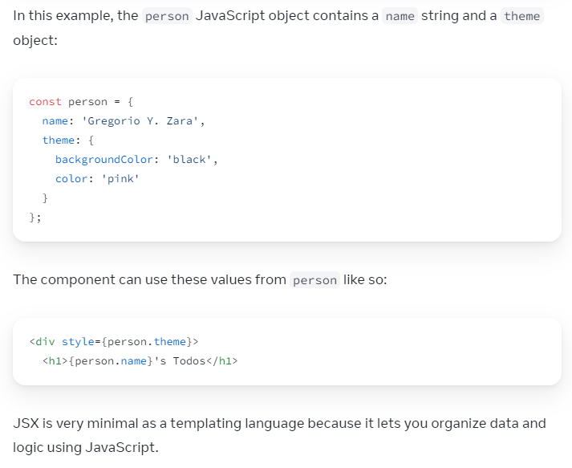

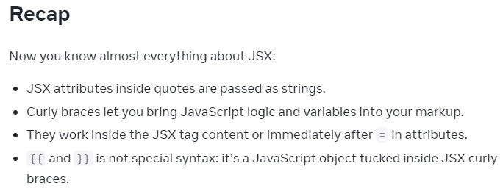

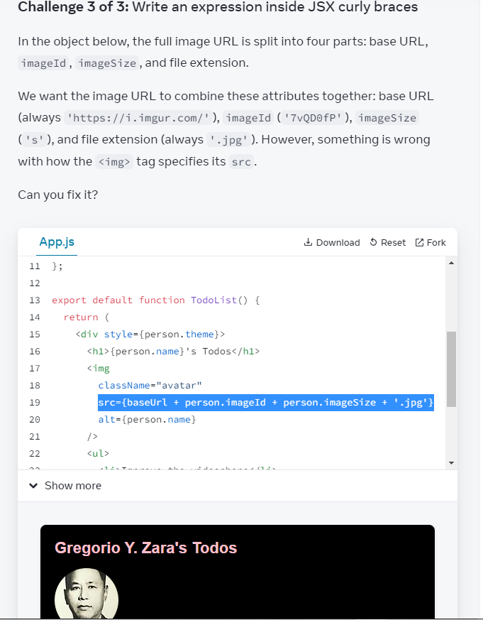

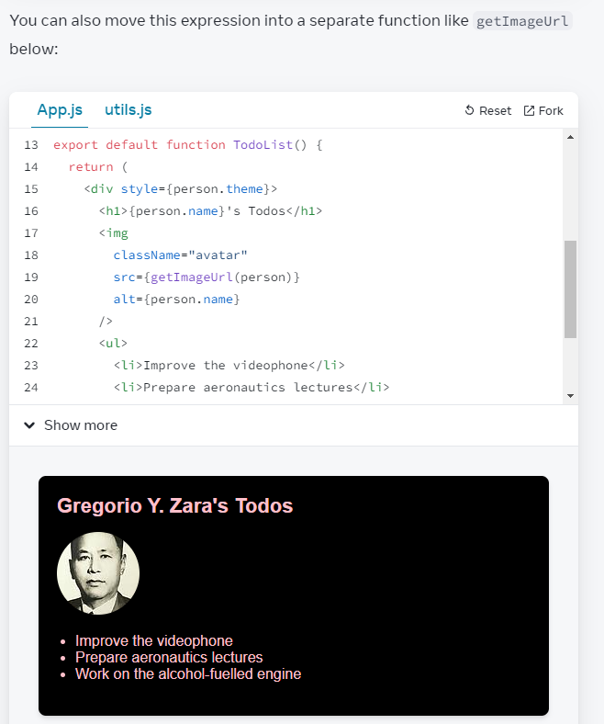

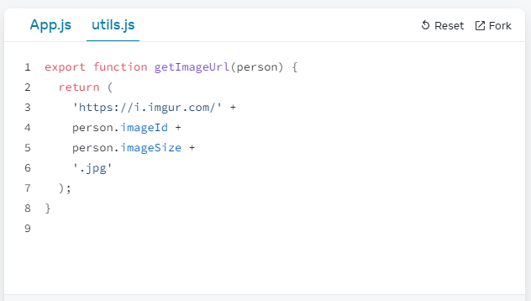

Passing props to Component

React components use 'props' to communicate with each other

props (objects, arrays, func) ~ html attributes

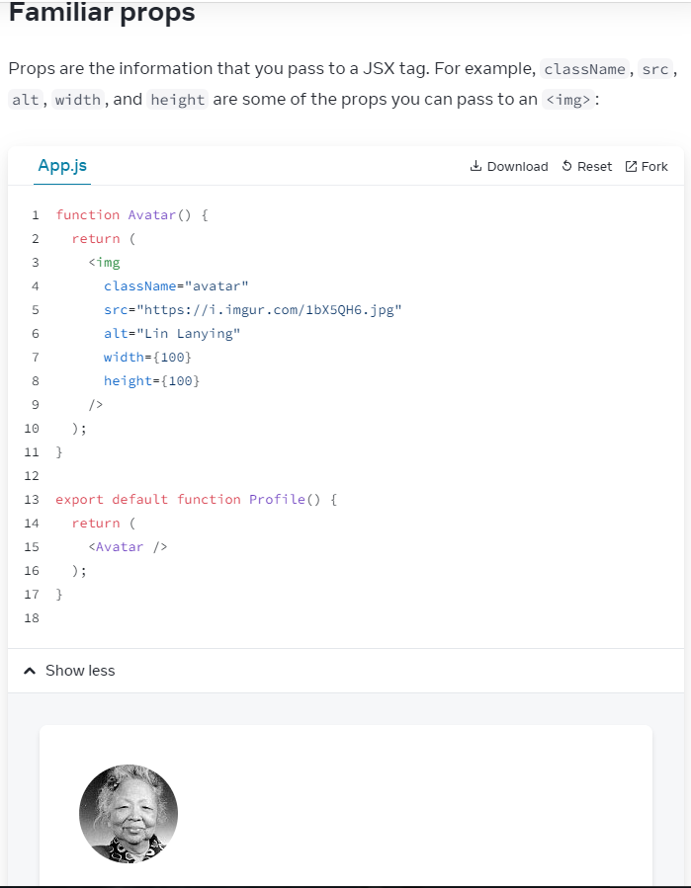

<img

className=""

src=""

alt=""

width={value}

height={value}

/>

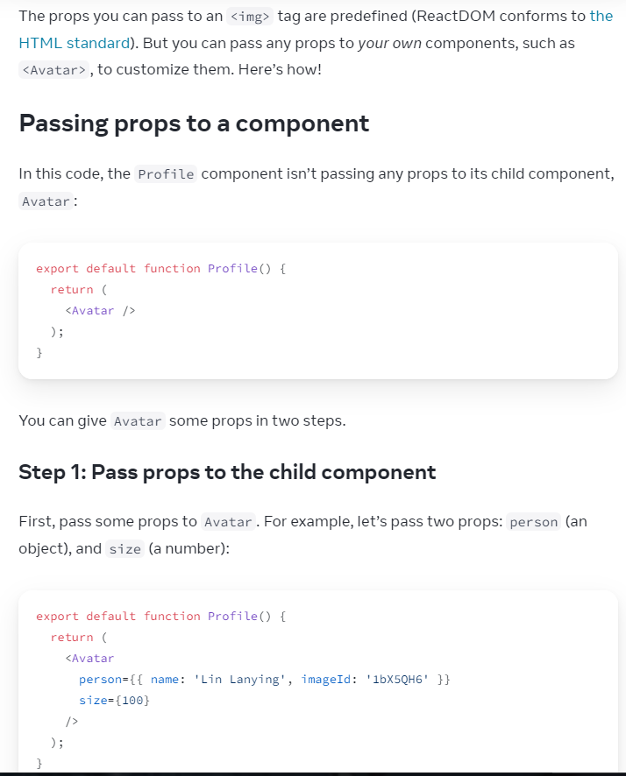

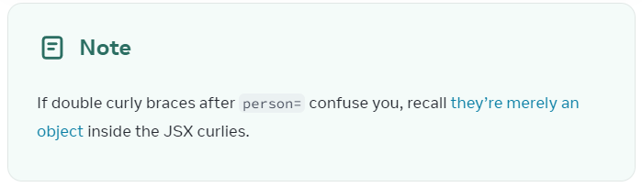

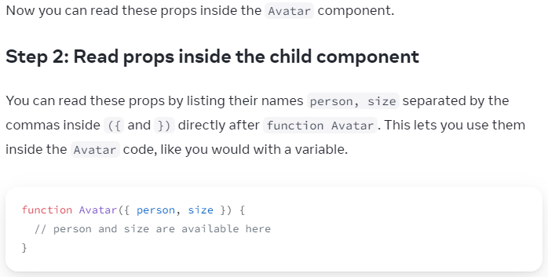

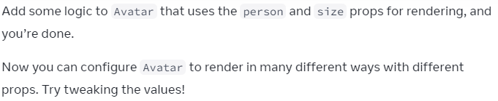

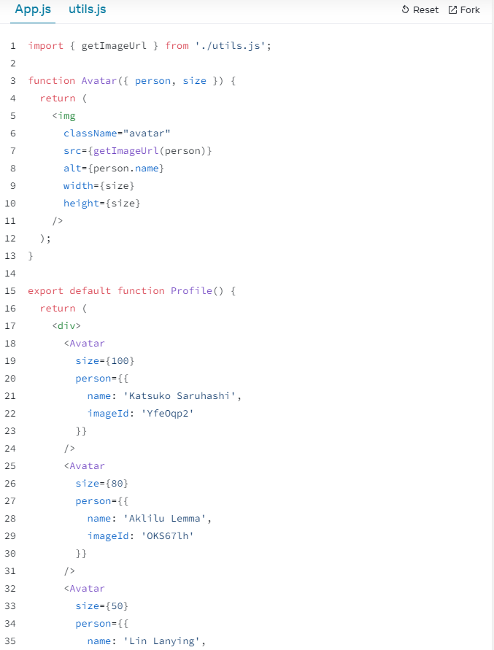

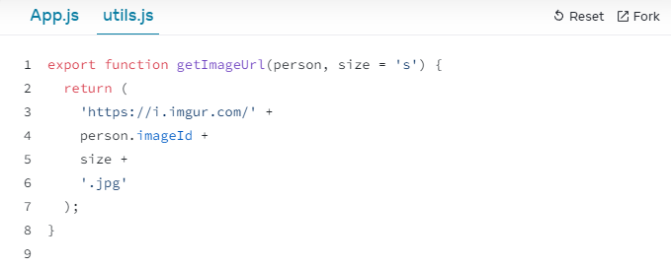

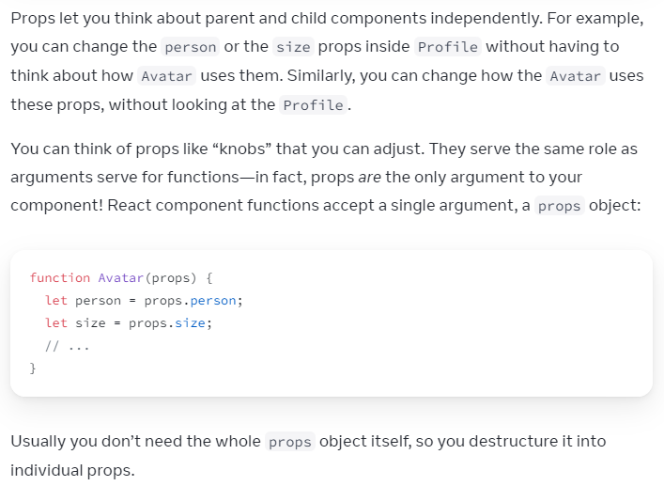

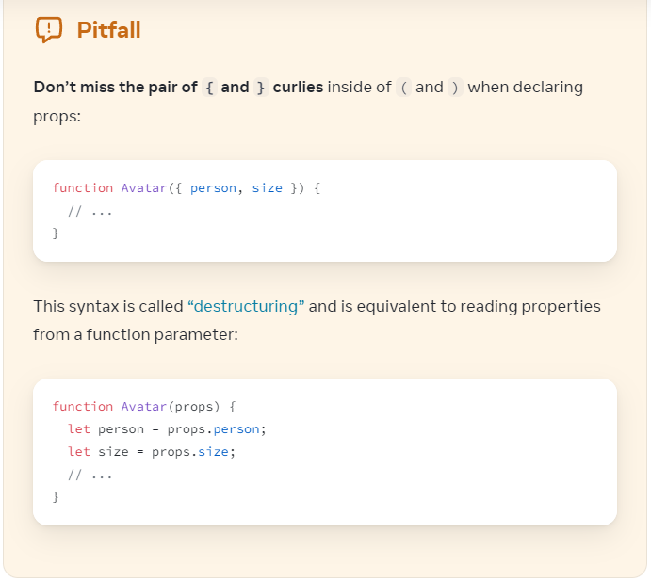

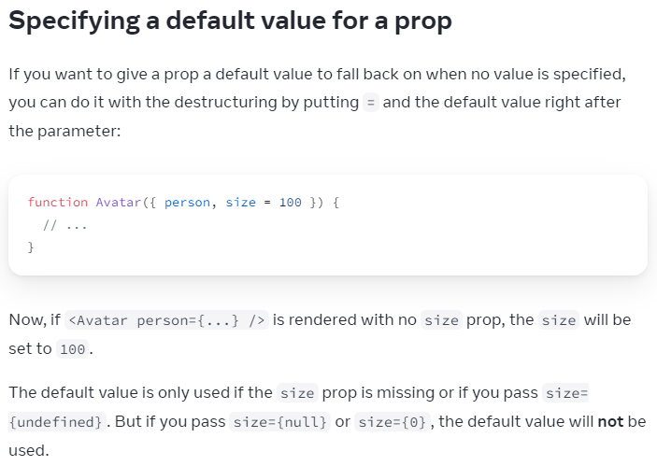

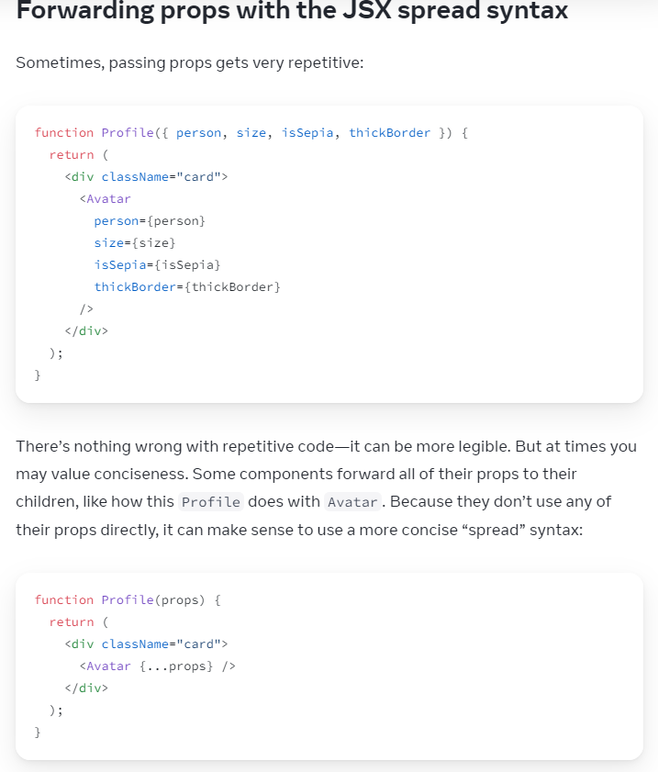

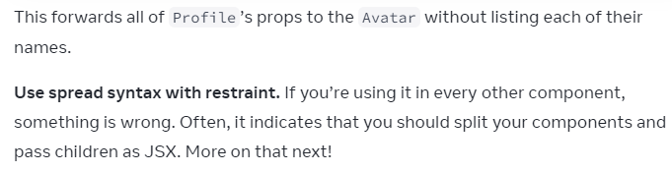

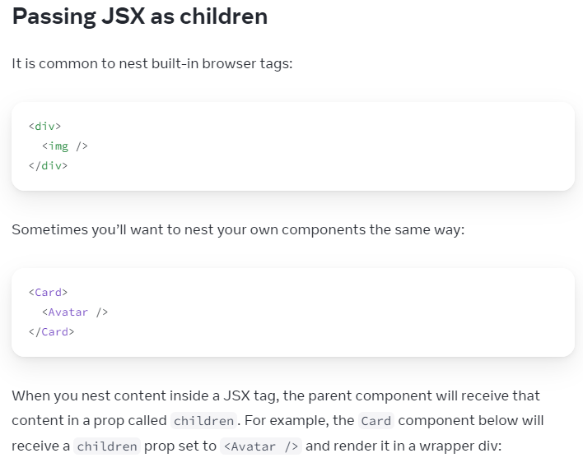

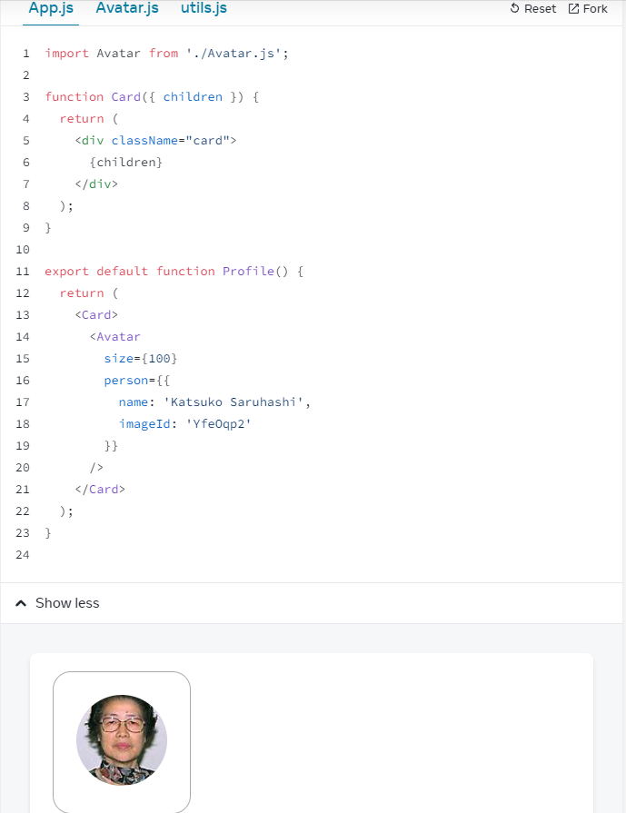

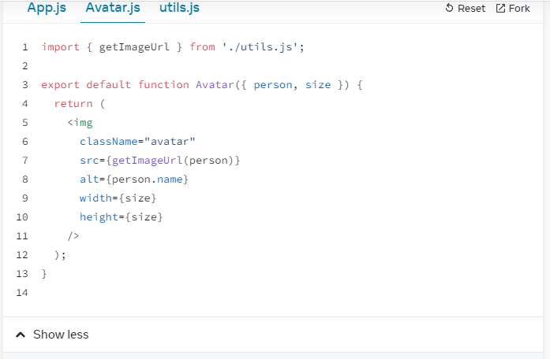

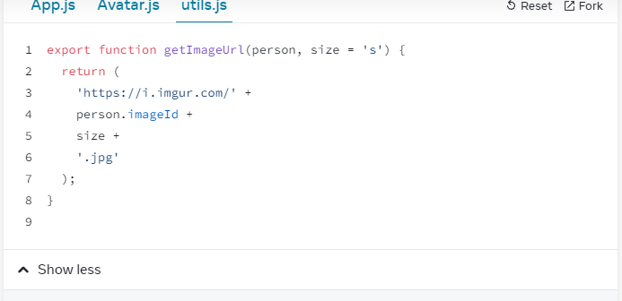

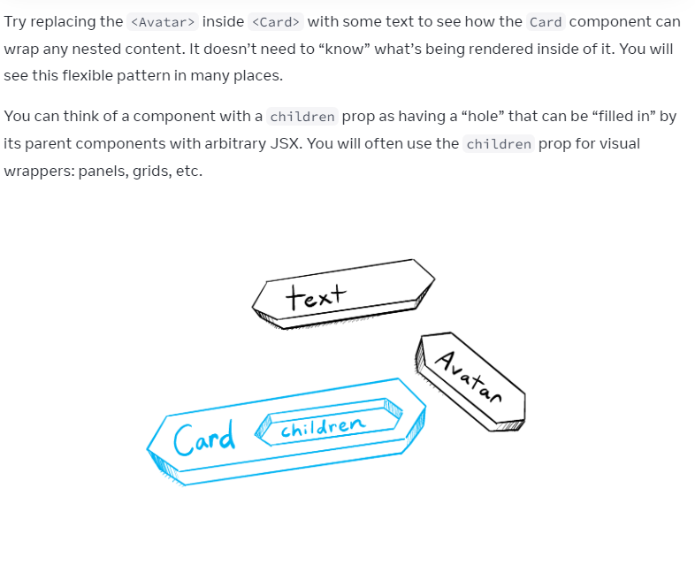

Tried replacing function Card( { props }) {

return (

<div className="card">

{props}

</div>

);

}

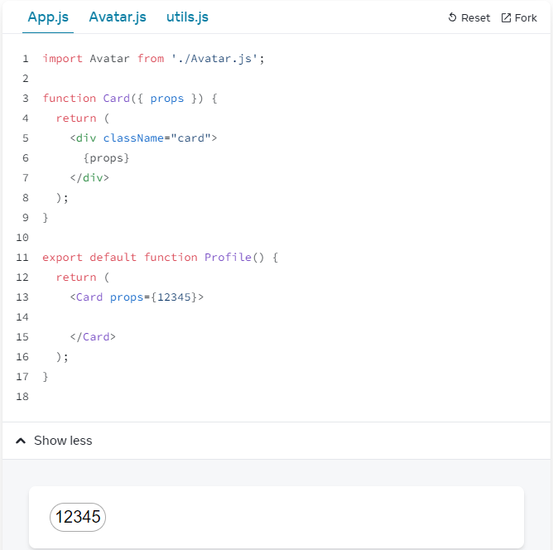

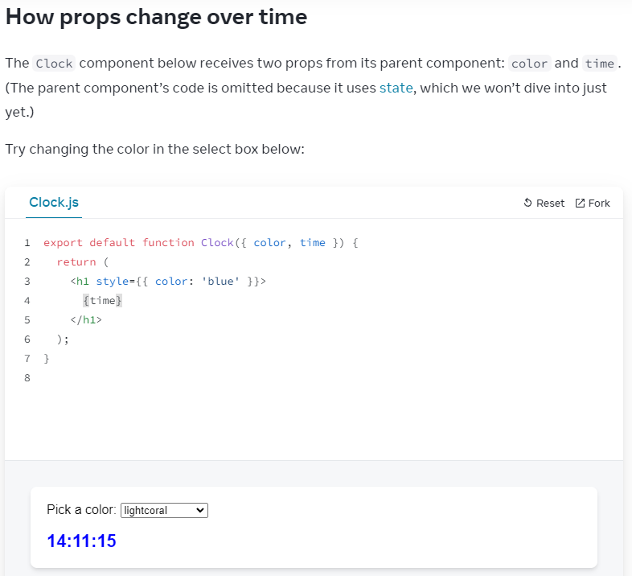

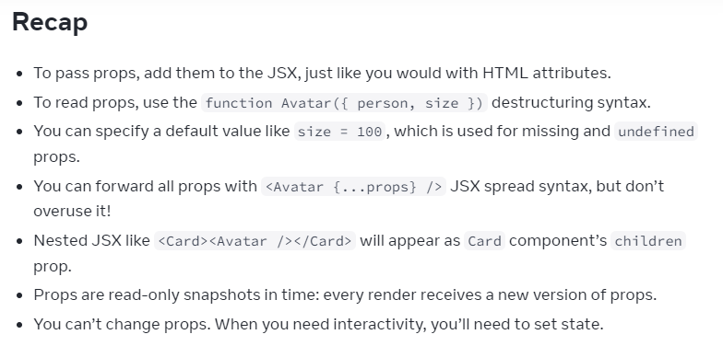

=====Challenge1

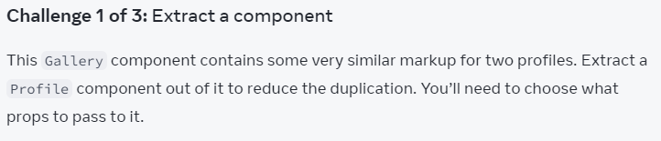

App.js

import { getImageUrl } from './utils.js';

export default function Gallery() {

return (

<div>

<h1>Notable Scientists</h1>

<section className="profile">

<h2>Maria Skłodowska-Curie</h2>

<img

className="avatar"

src={getImageUrl('szV5sdG')}

alt="Maria Skłodowska-Curie"

width={70}

height={70}

/>

<ul>

<li>

<b>Profession: </b>

physicist and chemist

</li>

<li>

<b>Awards: 4 </b>

(Nobel Prize in Physics, Nobel Prize in Chemistry, Davy Medal, Matteucci Medal)

</li>

<li>

<b>Discovered: </b>

polonium (element)

</li>

</ul>

</section>

<section className="profile">

<h2>Katsuko Saruhashi</h2>

<img

className="avatar"

src={getImageUrl('YfeOqp2')}

alt="Katsuko Saruhashi"

width={70}

height={70}

/>

<ul>

<li>

<b>Profession: </b>

geochemist

</li>

<li>

<b>Awards: 2 </b>

(Miyake Prize for geochemistry, Tanaka Prize)

</li>

<li>

<b>Discovered: </b>

a method for measuring carbon dioxide in seawater

</li>

</ul>

</section>

</div>

);

}

Solution

App.js

import { getImageUrl } from './utils.js';

function Profile({

name,

imageId,

profession,

awards,

discovery,

size = 70

}) {

return (

<section className="profile">

<h2>{name}</h2>

<img

className="avatar"

src={getImageUrl(imageId)}

alt={name}

width={size}

height={size}

/>

<ul>

<li>

<b>Profession: </b>

{profession}

</li>

<li>

<b>Awards: {awards.length} </b>

({awards.join(', ')})

</li>

<li>

<b>Discovered: </b>

{discovery}

</li>

</ul>

</section>

);

}

export default function Gallery() {

return (

<div>

<h1>Notable Scientists</h1>

<Profile

name='Maria Sklodowska-Curie'

imageId='szV5sdG'

prefession='physicist and chemist'

awards={[

'Nobel Prize in Physics',

'Nobel Prize in Chemistry',

'Davy Medal',

'Matteucci Medal'

]}

discovery='polonium (chemical element)'

/>

<Profile

name='Katsuko Saruhashi'

imageId='YfeOqp2'

profession='geochemist'

awards={[

'Miyake Prize for geochemistry',

'Tanaka Prize'

]}

discovery='a method for measuring carbon dioxide in seawater'

/>

</div>

);

}

=====Challenge2

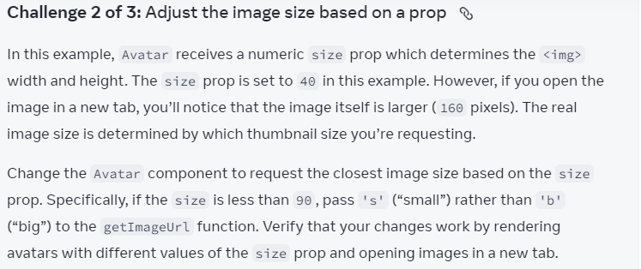

Question:

App.js

import { getImageUrl } from './utils.js';

function Avatar({ person, size }) {

return (

<img

className="avatar"

src={getImageUrl(person, 'b')}

alt={person.name}

width={size}

height={size}

/>

);

}

export default function Profile() {

return (

<Avatar

size={40}

person={{

name: 'Gregorio Y. Zara',

imageId: '7vQD0fP'

}}

/>

);

}

Solution:

App.js

import { getImageUrl } from './utils.js';

function Avatar({ person, size }) {

let thumbnailSize = 's';

if (thumbnailSize > 90) {

thumbnailSize = 'b';

}

return (

<img

className="avatar"

src={getImageUrl(person, thumbnailSize)}

alt={person.name}

width={size}

height={size}

/>

);

}

export default function Profile() {

return (

<div>

<Avatar

size={40}

person={{

name: 'Gregorio Y. Zara',

imageId: '7vQD0fP'

}}

/>

<Avatar

size={120}

person={{

name: 'Gregorio Y. Zara',

imageId: '7vQD0fP'

}}

/>

</div>

);

}

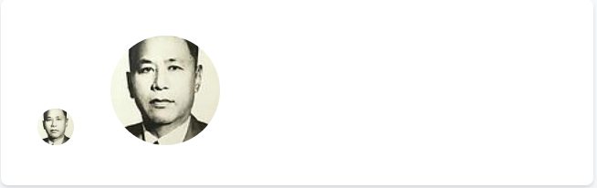

=====Challenge3

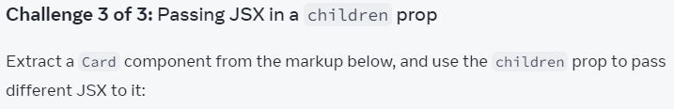

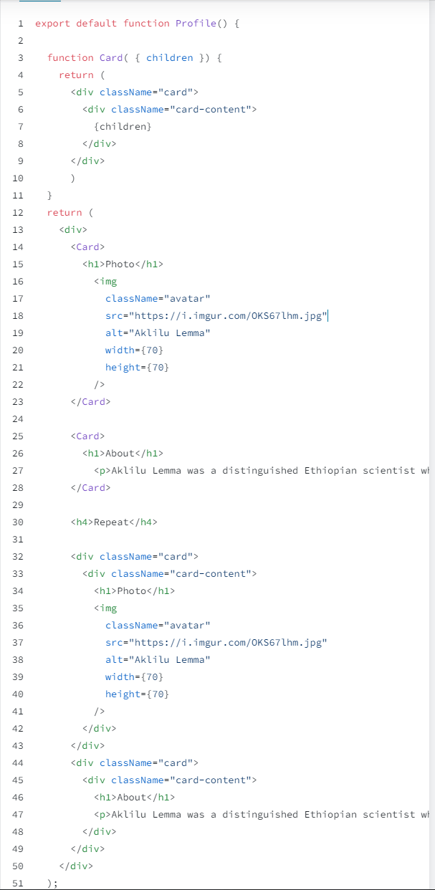

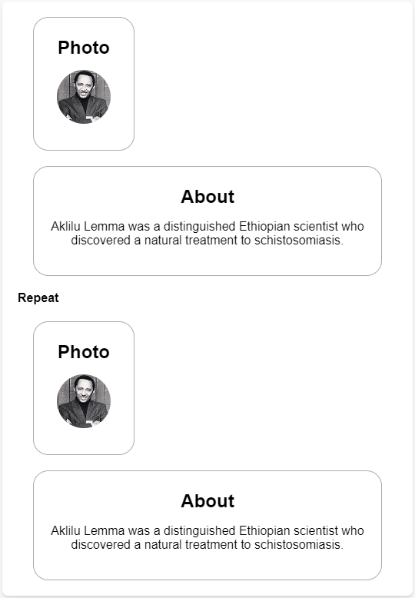

Question

App.js

export default function Profile() {

return (

<div>

<div className="card">

<div className="card-content">

<h1>Photo</h1>

<img

className="avatar"

src="https://i.imgur.com/OKS67lhm.jpg"

alt="Aklilu Lemma"

width={70}

height={70}

/>

</div>

</div>

<div className="card">

<div className="card-content">

<h1>About</h1>

<p>Aklilu Lemma was a distinguished Ethiopian scientist who discovered a natural treatment to schistosomiasis.</p>

</div>

</div>

</div>

);

}

Solution

App.js

function Card({

children

}) {

return(

<div className="card">

<div className="card-content">

{children}

</div>

</div>

);

}

export default function Profile() {

return (

<div>

<Card>

<h1>Photo</h1>

<img

className="avatar"

src="https://i.imgur.com/OKS67lhm.jpg"

alt="Aklilu Lemma"

width={70}

height={70}

/>

</Card>

<Card>

<h1>About</h1>

<p>Aklilu Lemma was a distinguished Ethiopian scientist who discovered a natural treatment to schistosomiasis.</p>

</Card>

</div>

);

}

Conditional Rendering

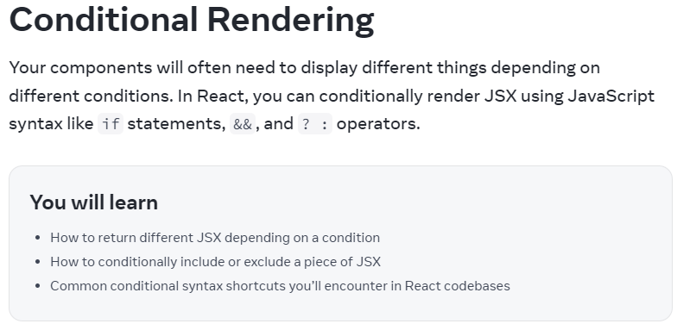

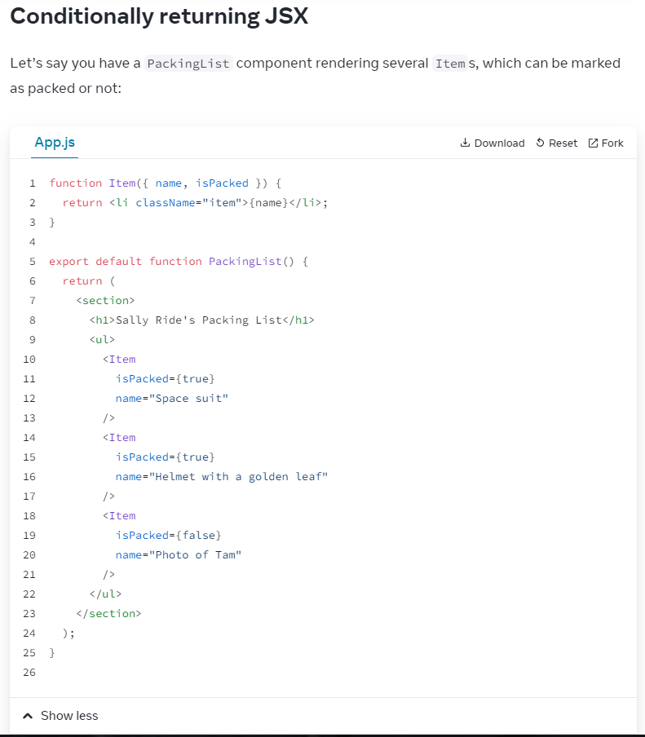

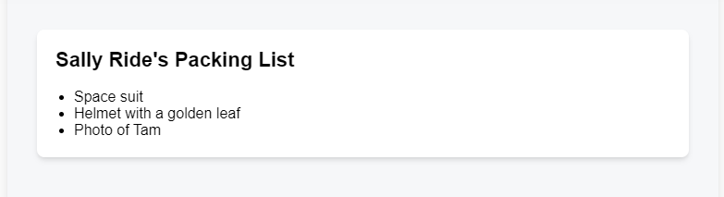

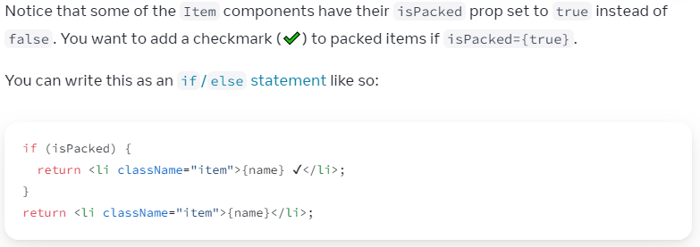



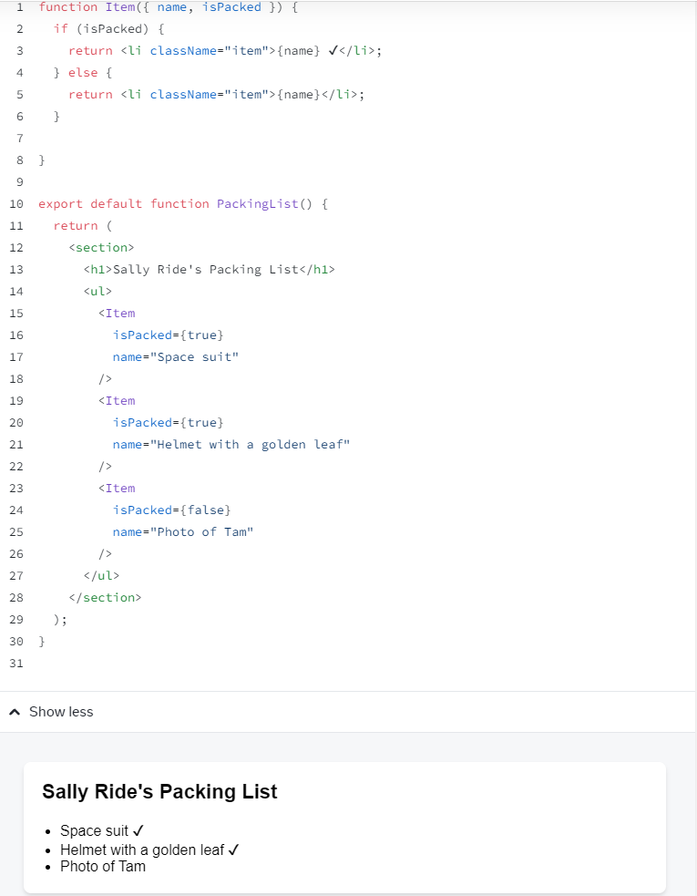

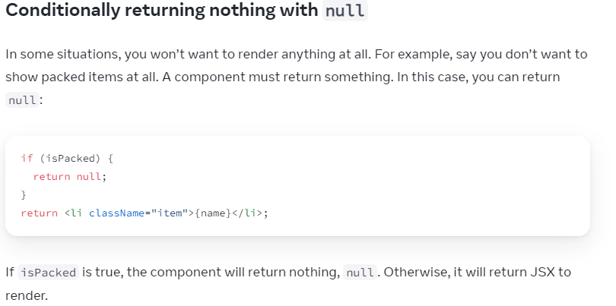

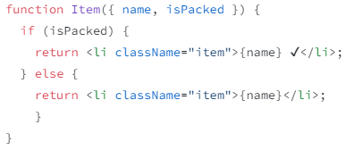

----Using Ternary Operator

<tag className="">

{ condition ? (

true_arg

) : (

false_arg

)}

</tag>

OR

<tag className="">

{ condition ? (

<tag>

{ props + 'string' }

</tag>

) : (

<tag>

{ props + 'string' }

</tag>

)}

</tag>

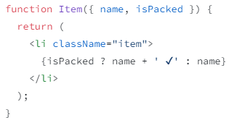

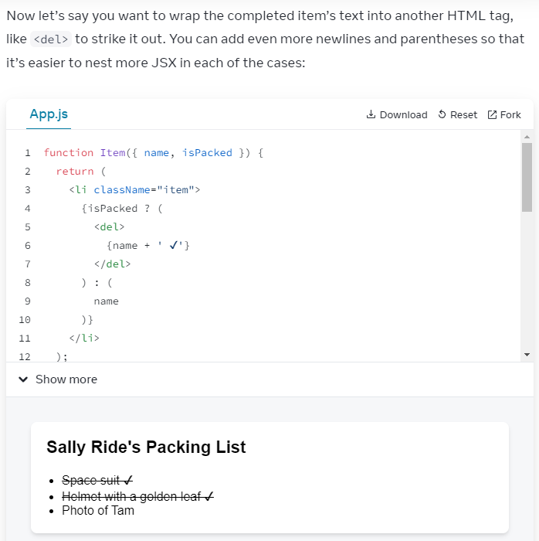

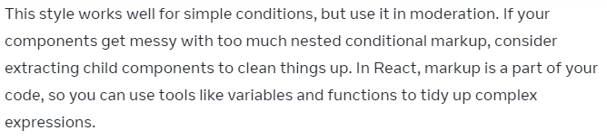

if (condition) {

render()

}

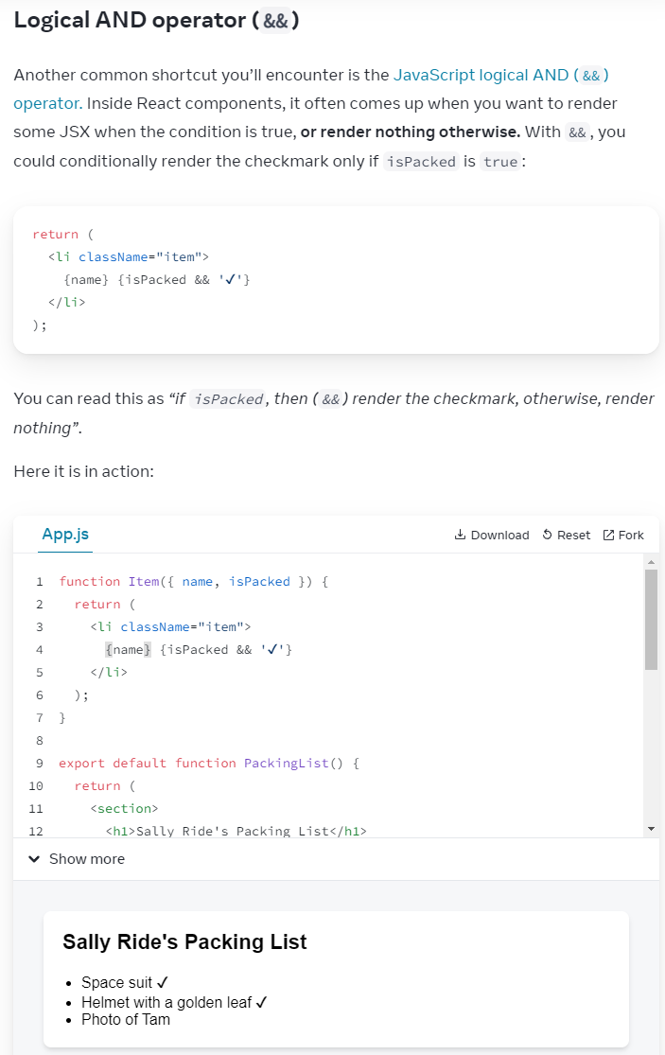

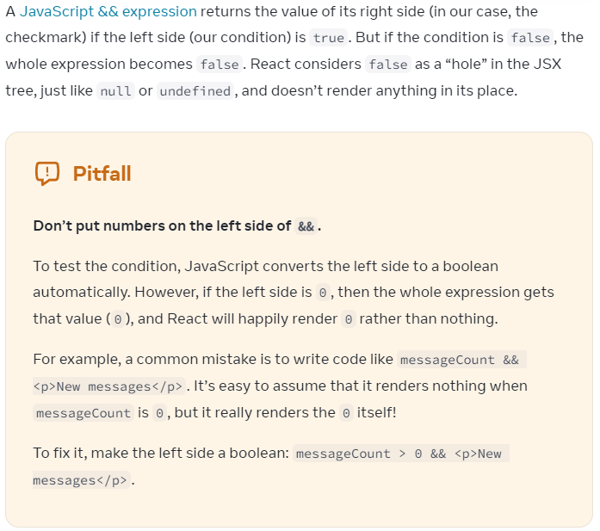

Conditionally assigning JSX to a variable

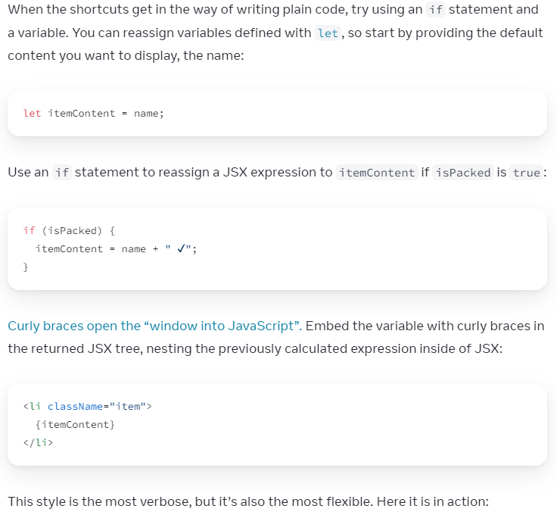

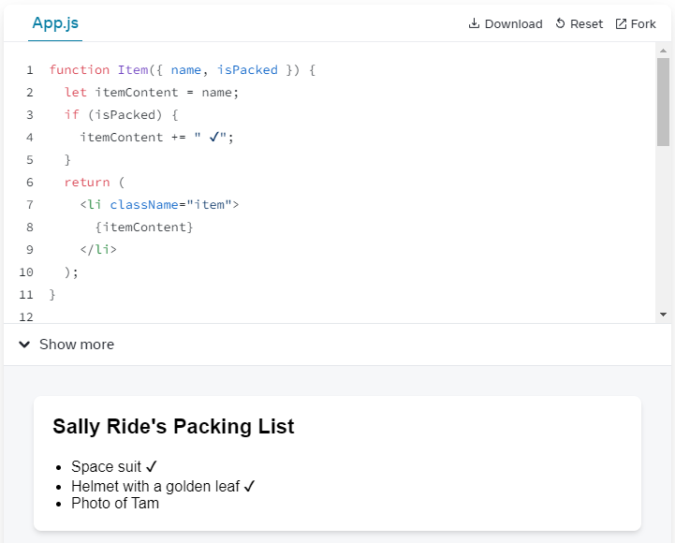

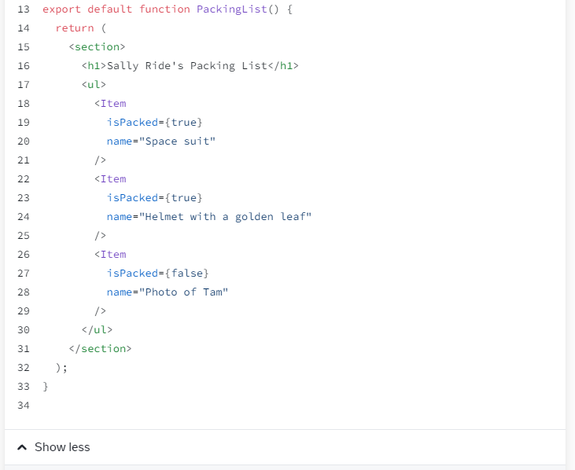

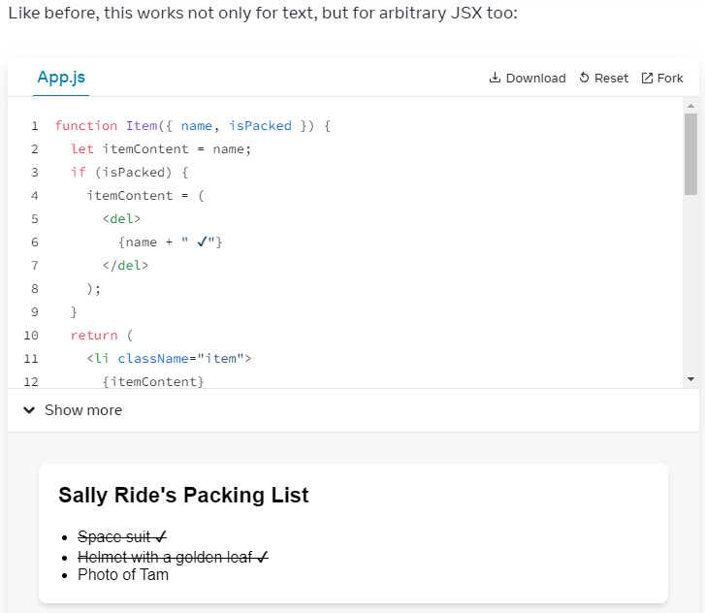

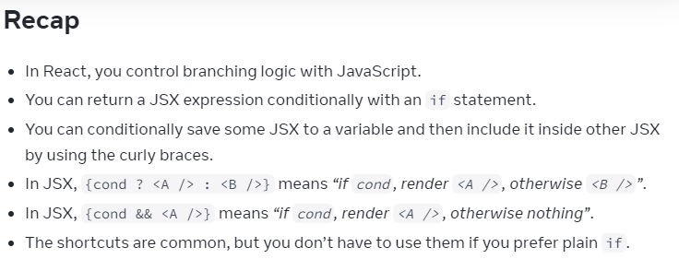

**Challenge1 of 3**

Question:

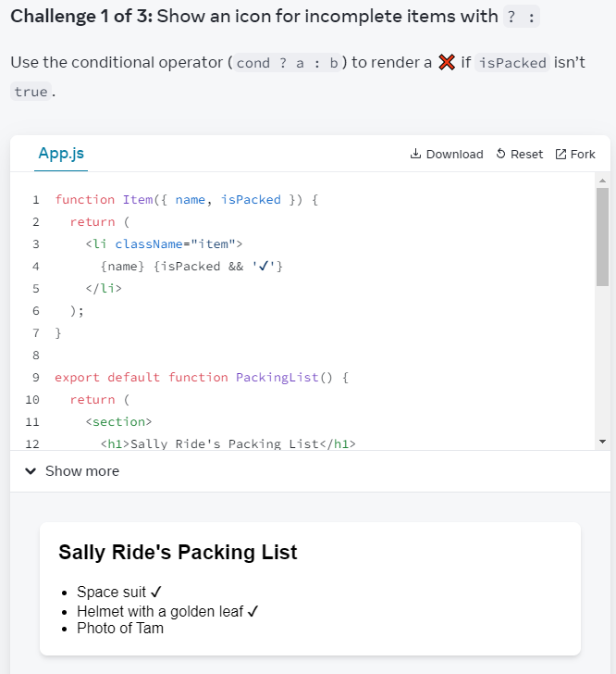

My solution1:

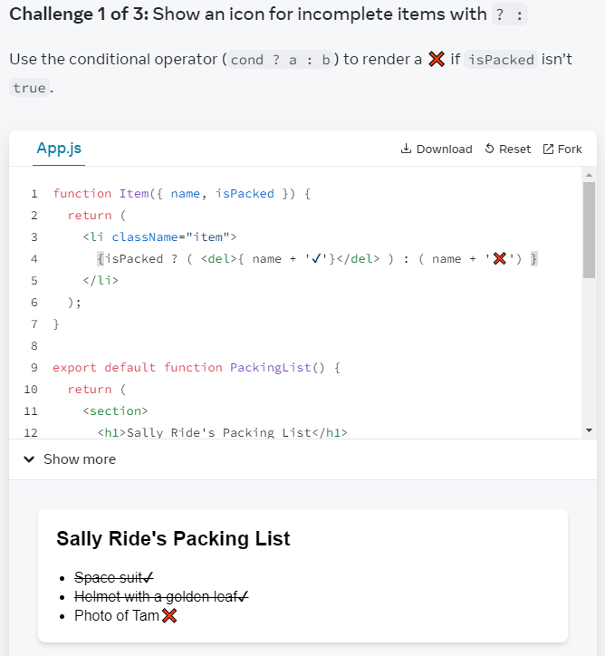

My solution2:

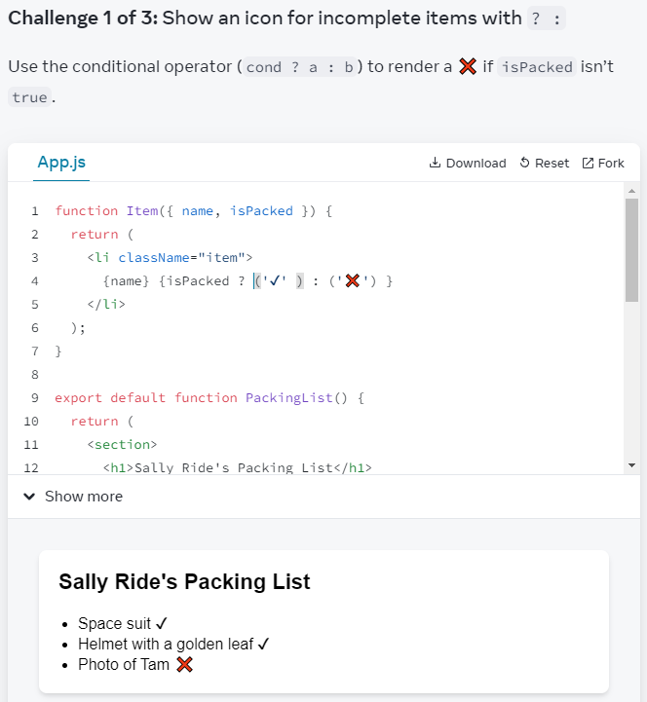

Challenge2 of 3 Question:

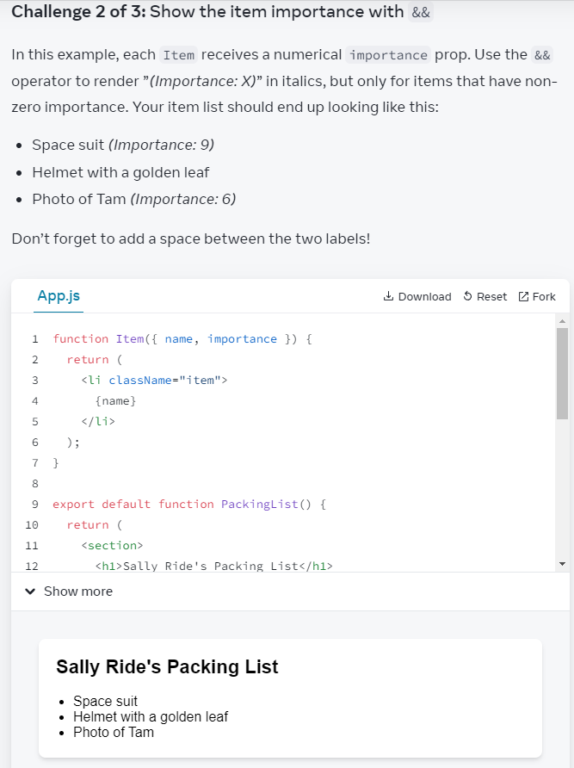

My solution:

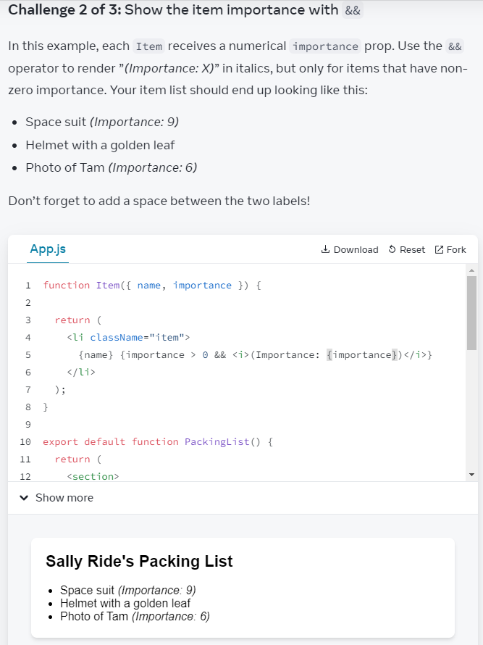

Challenge3 of 3

Question:

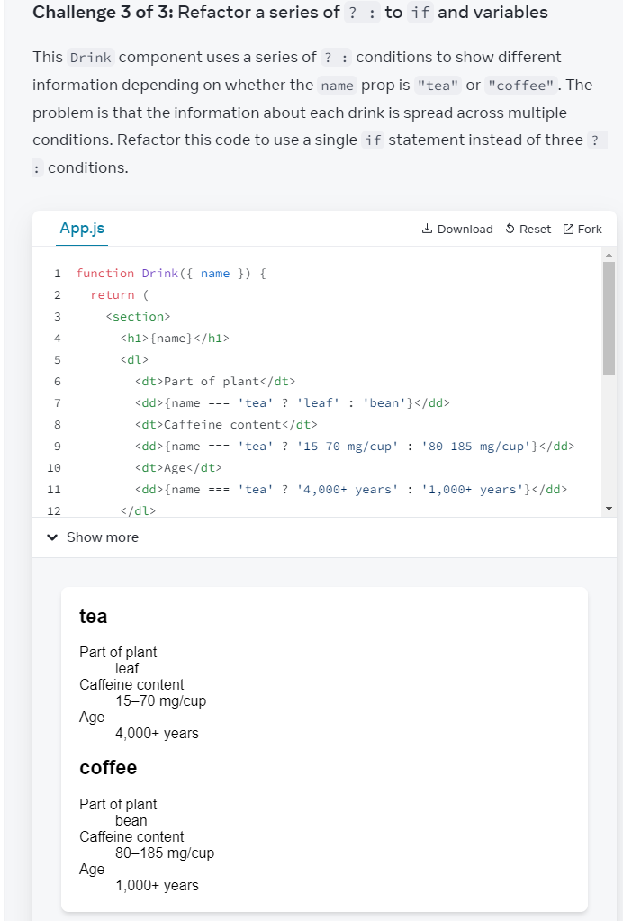

My solution:

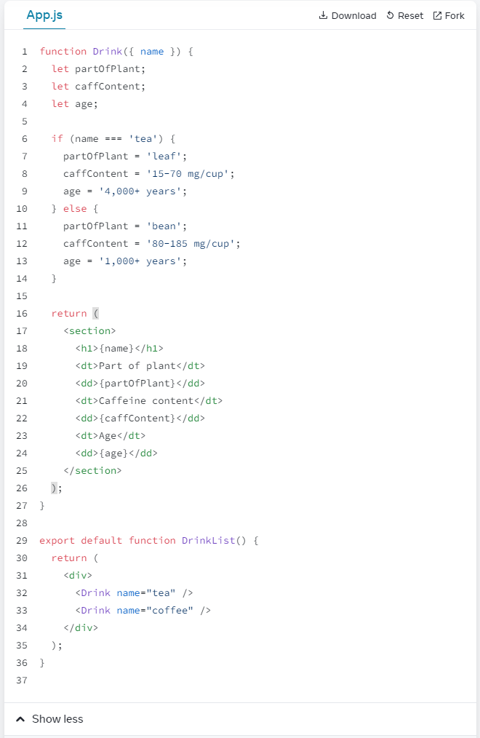

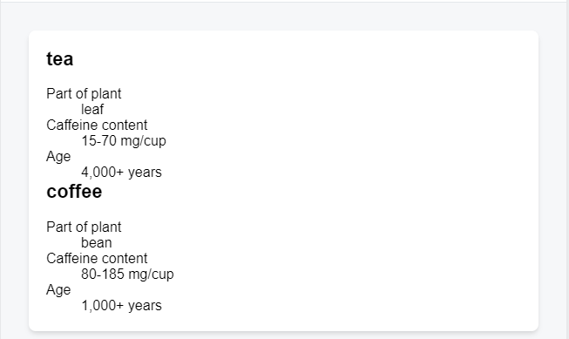

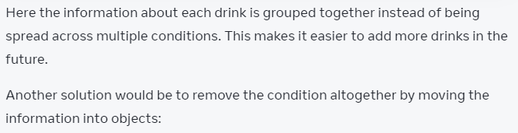

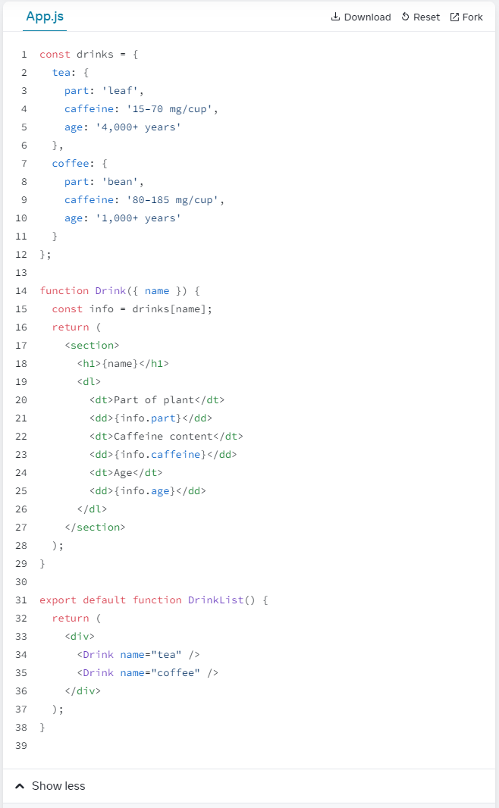

Try + Drinks

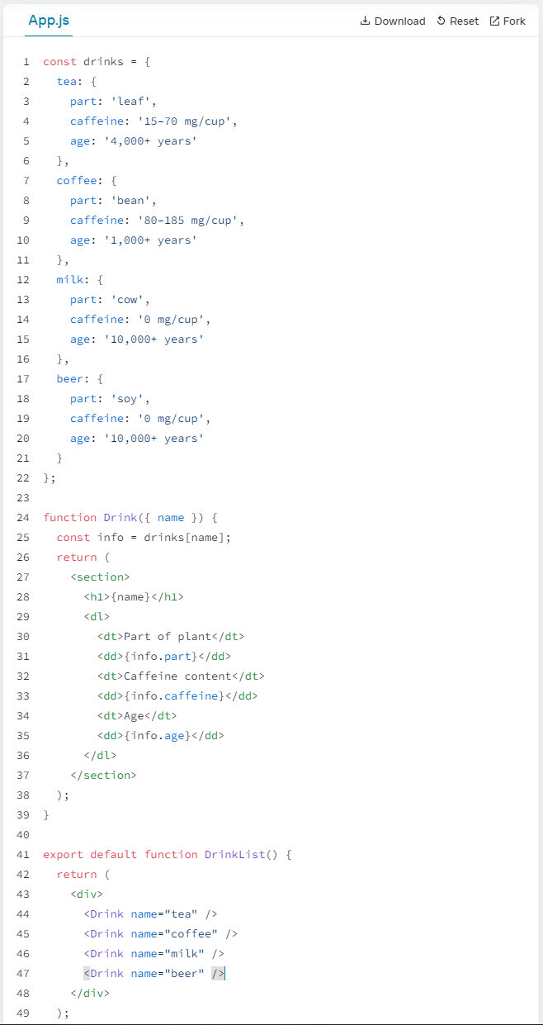

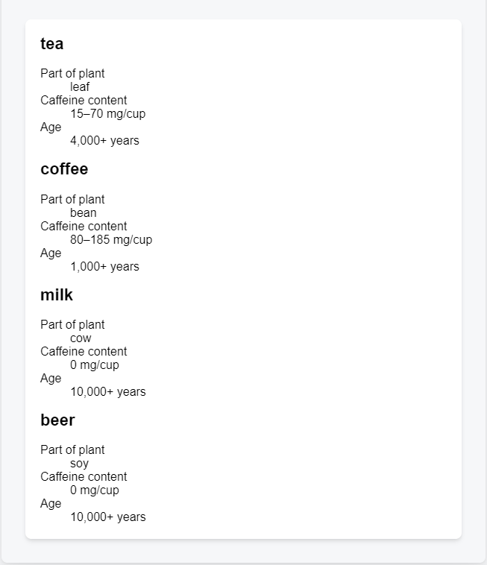

Rendering Lists

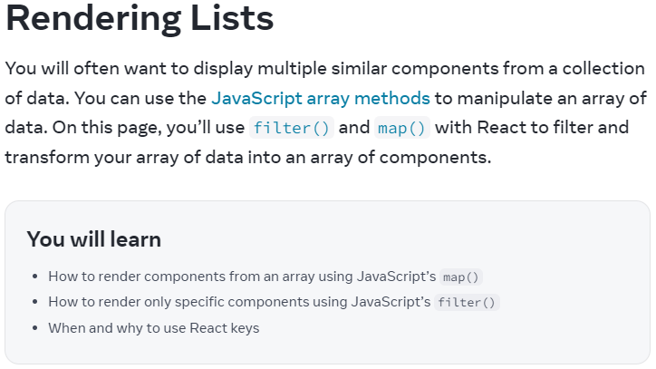

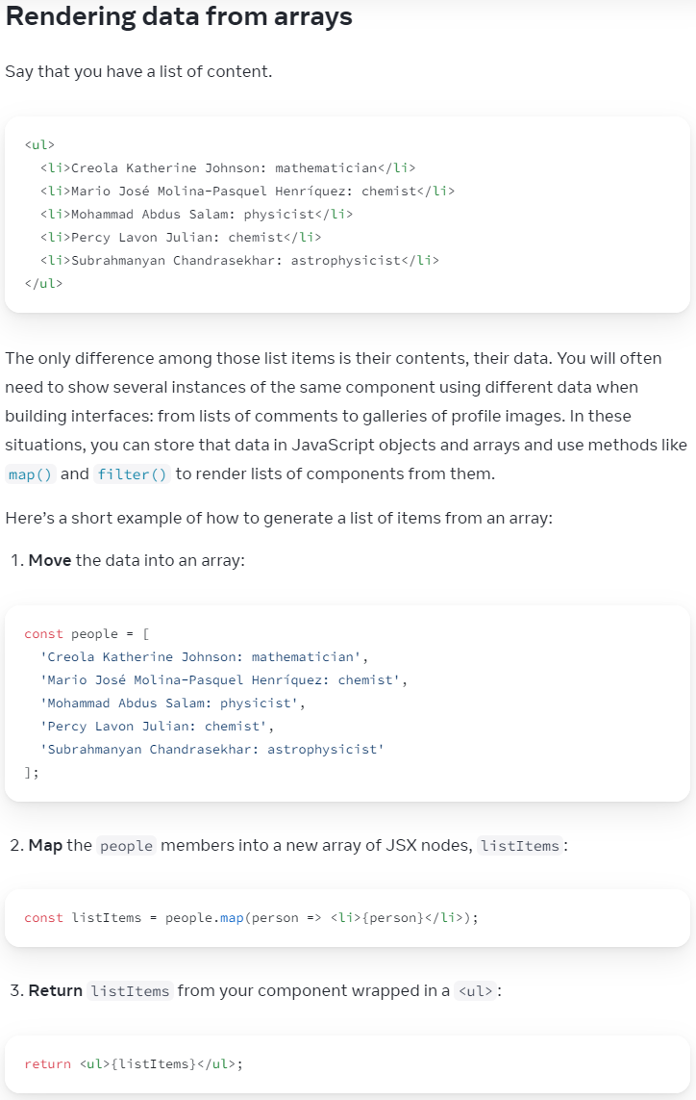

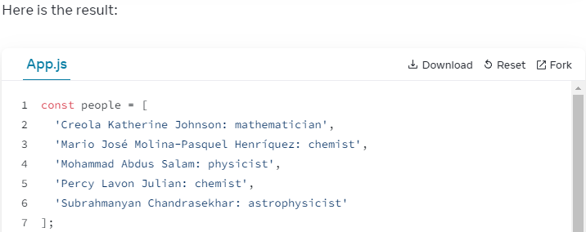

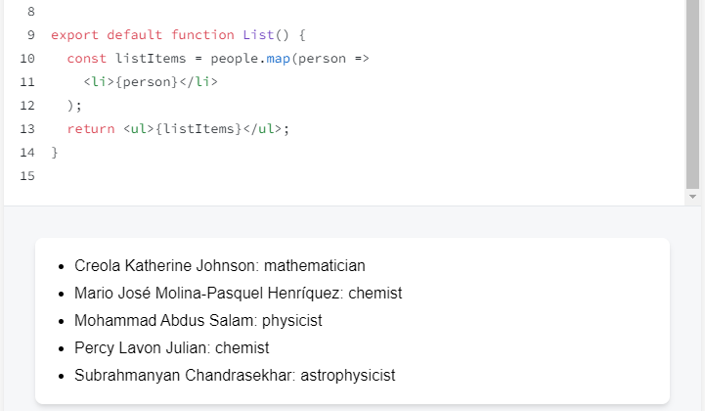

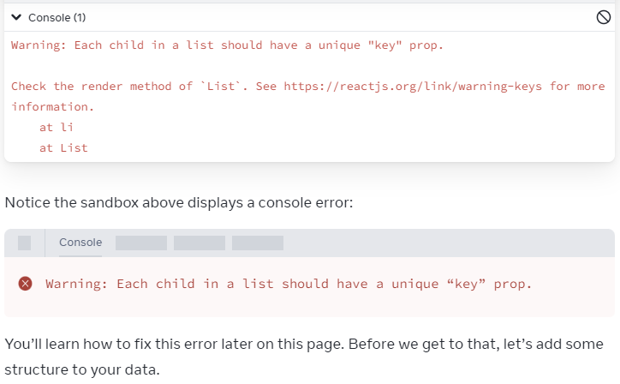

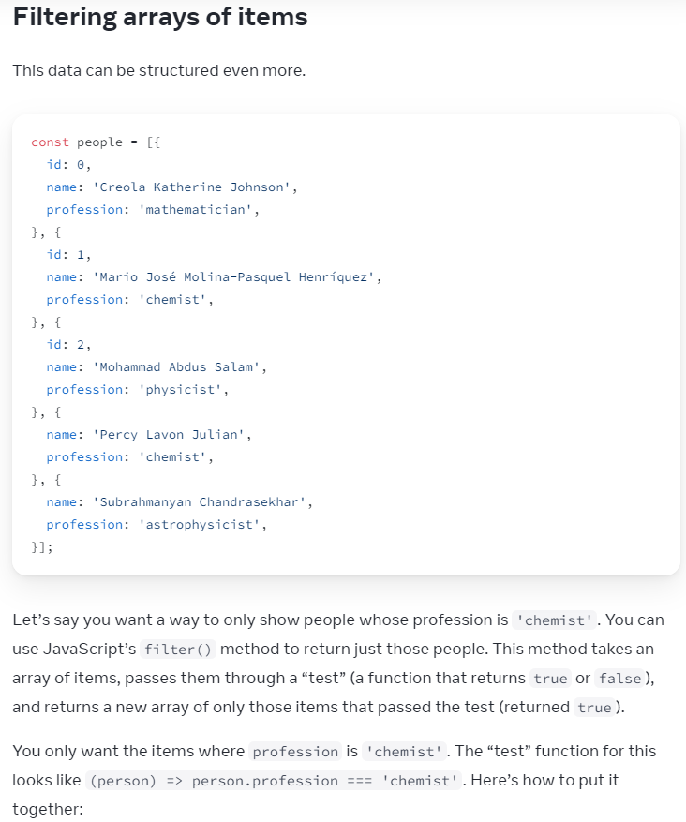

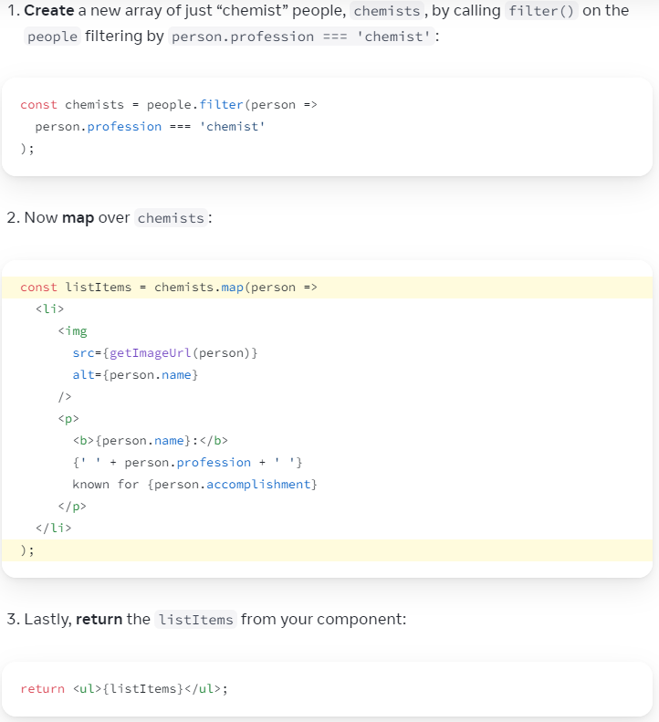

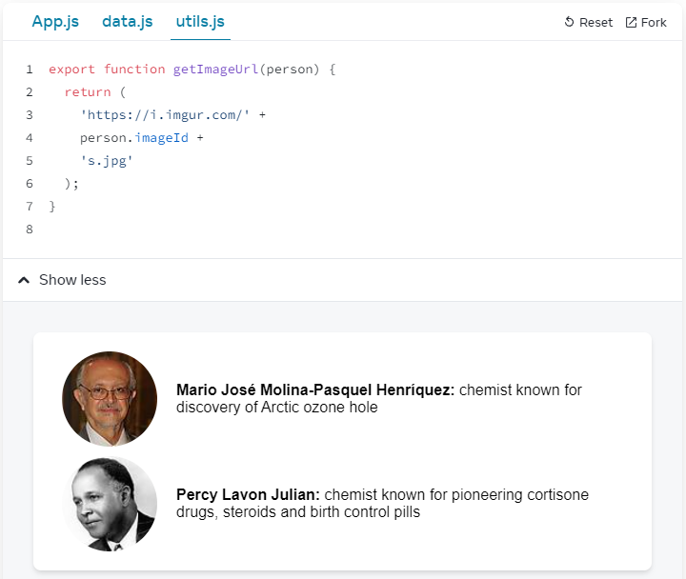

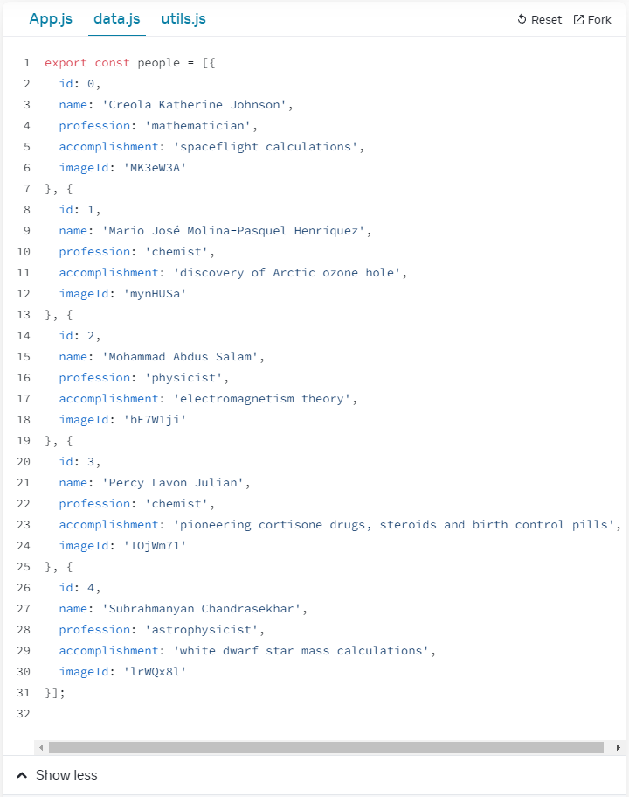

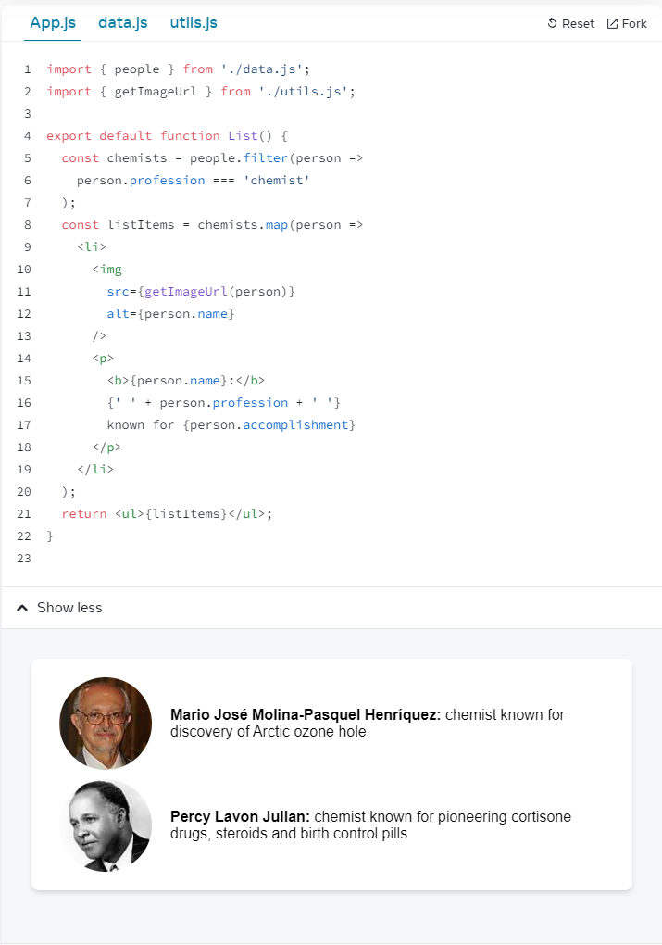

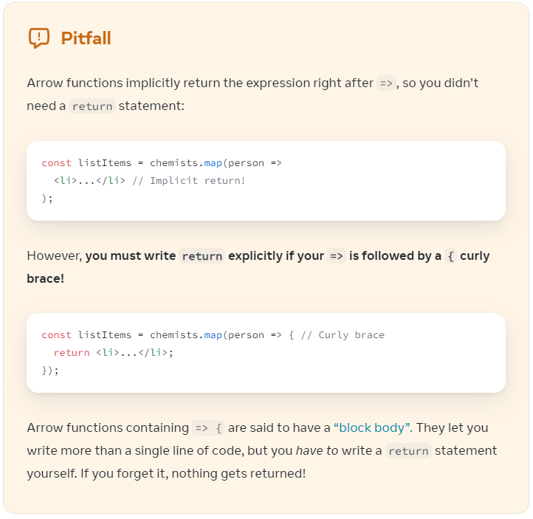

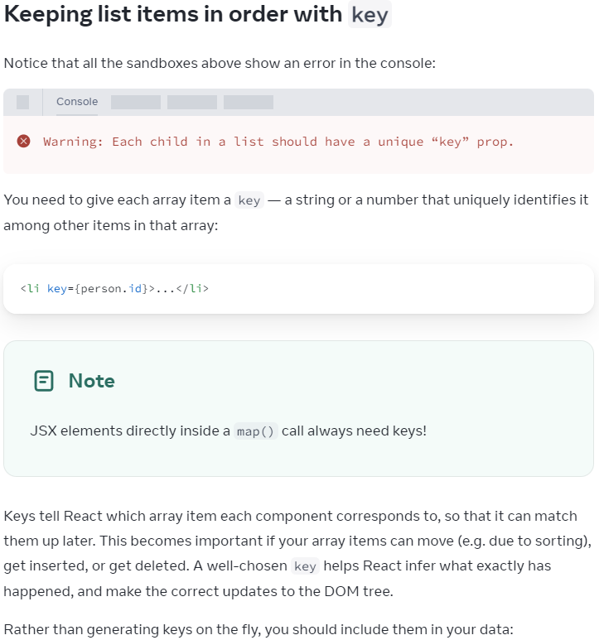

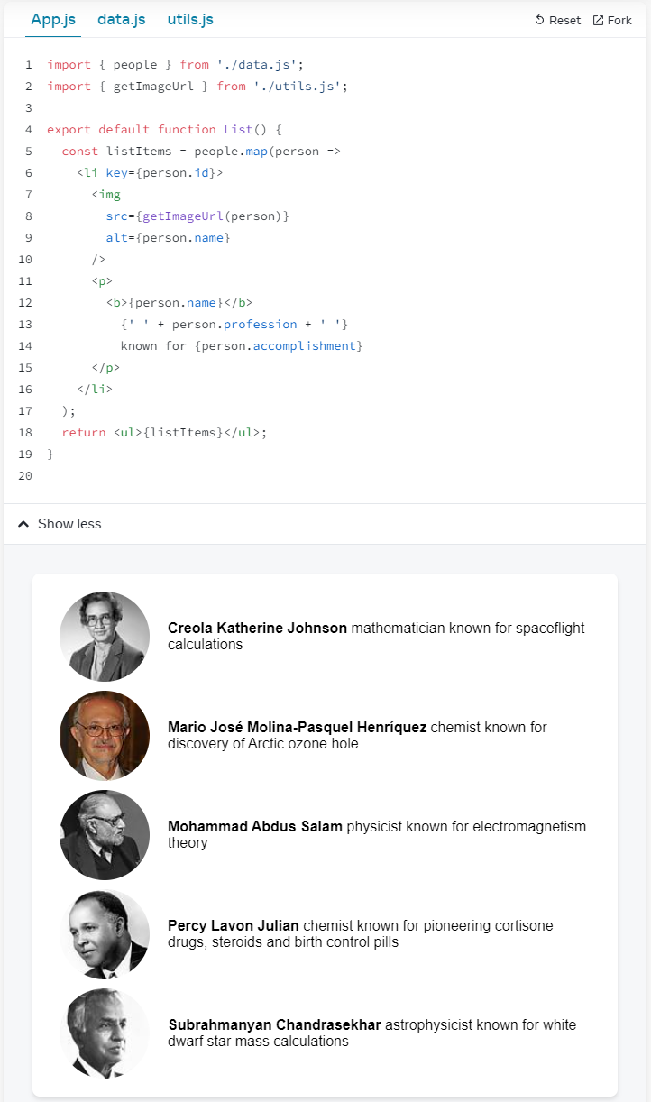

Customized

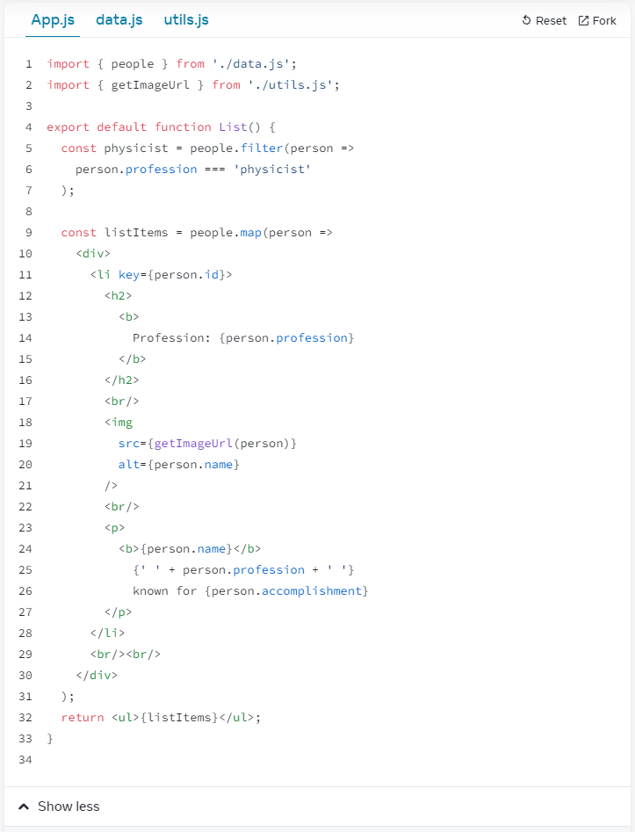

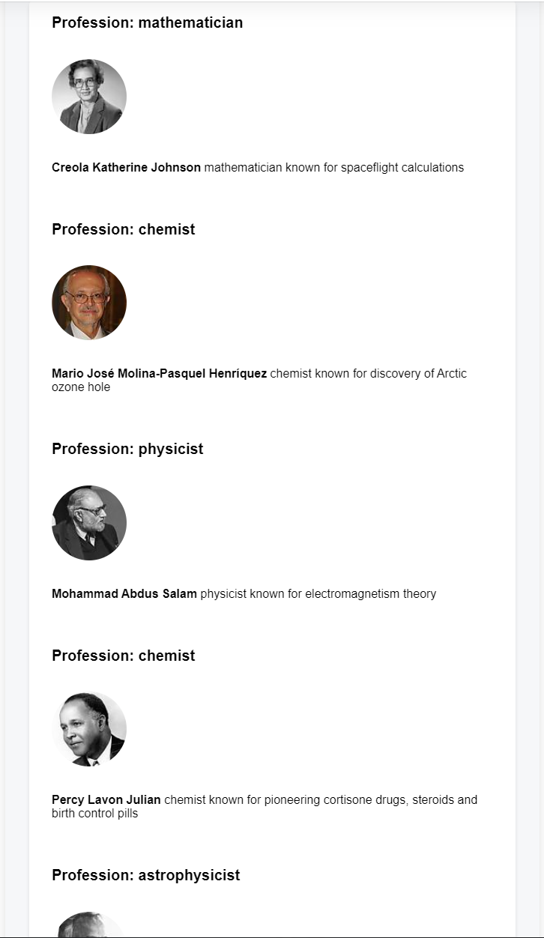

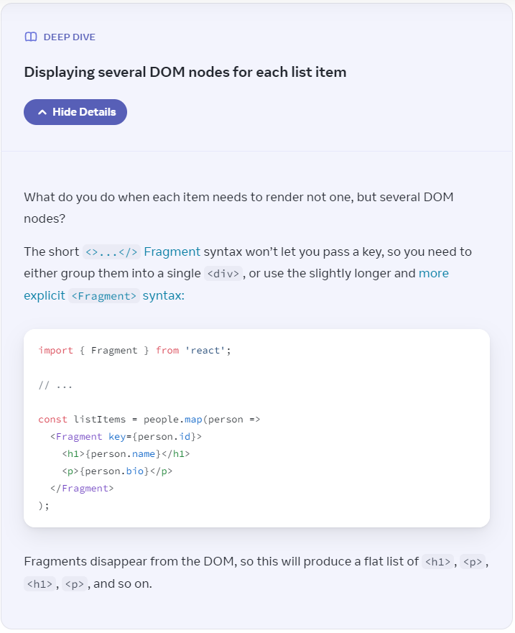

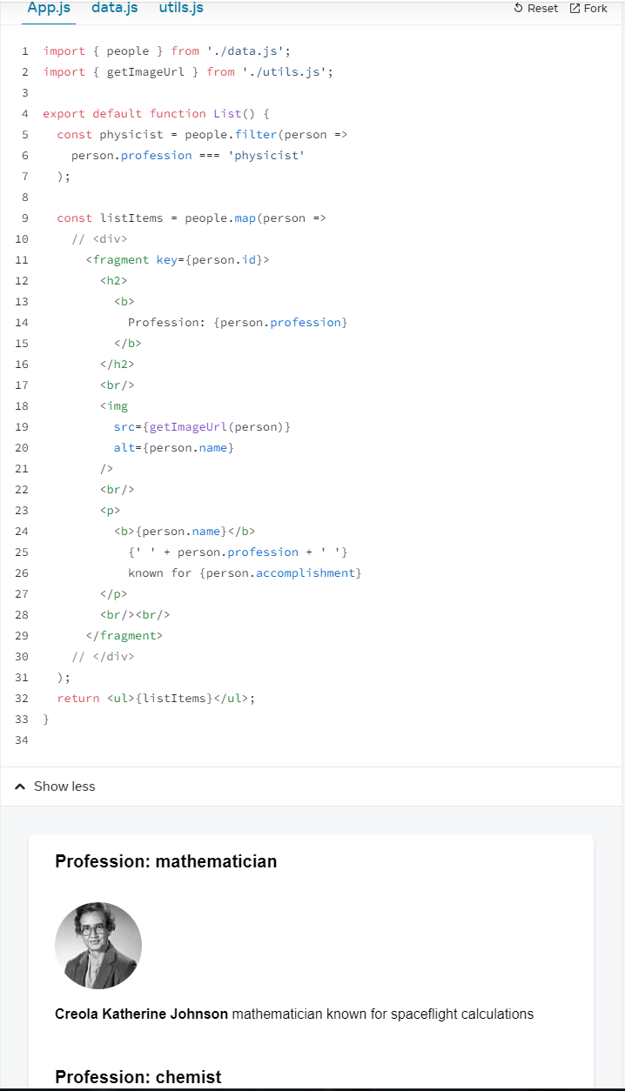

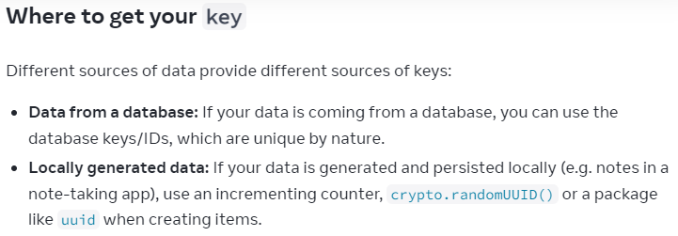

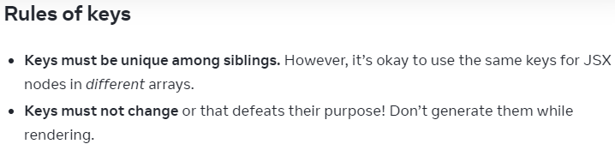

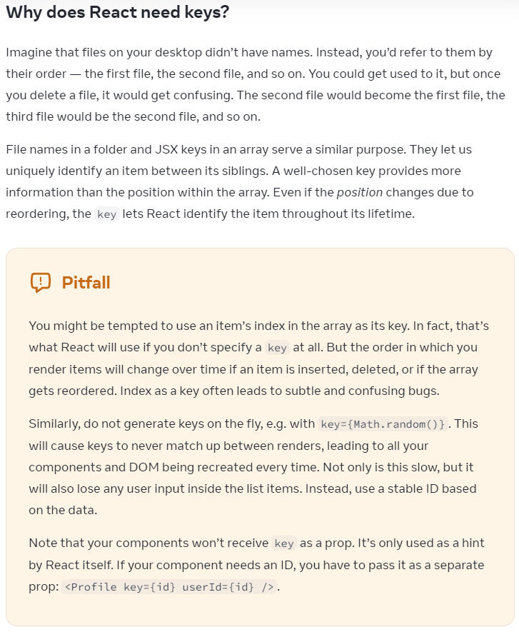

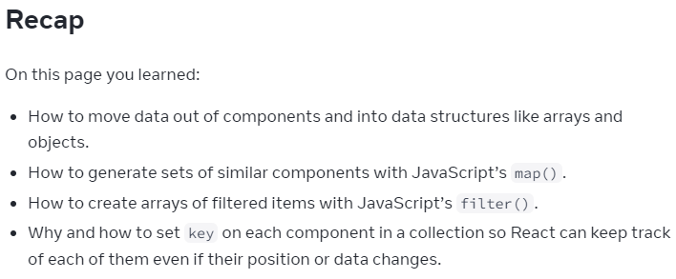

Challenge 1 of 4

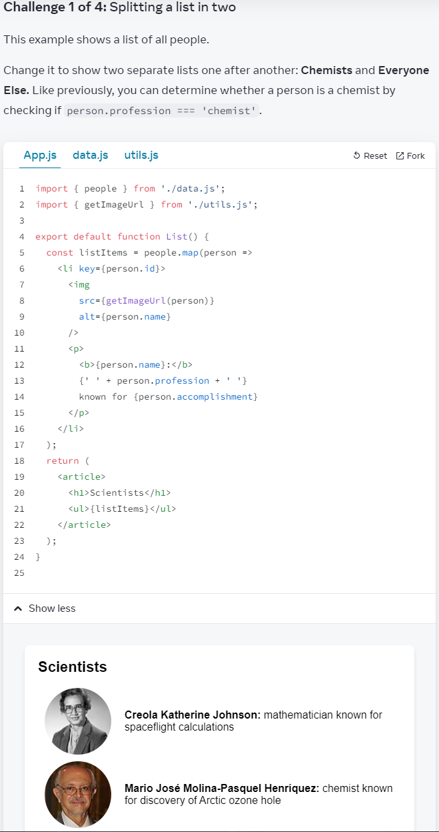

My solution:

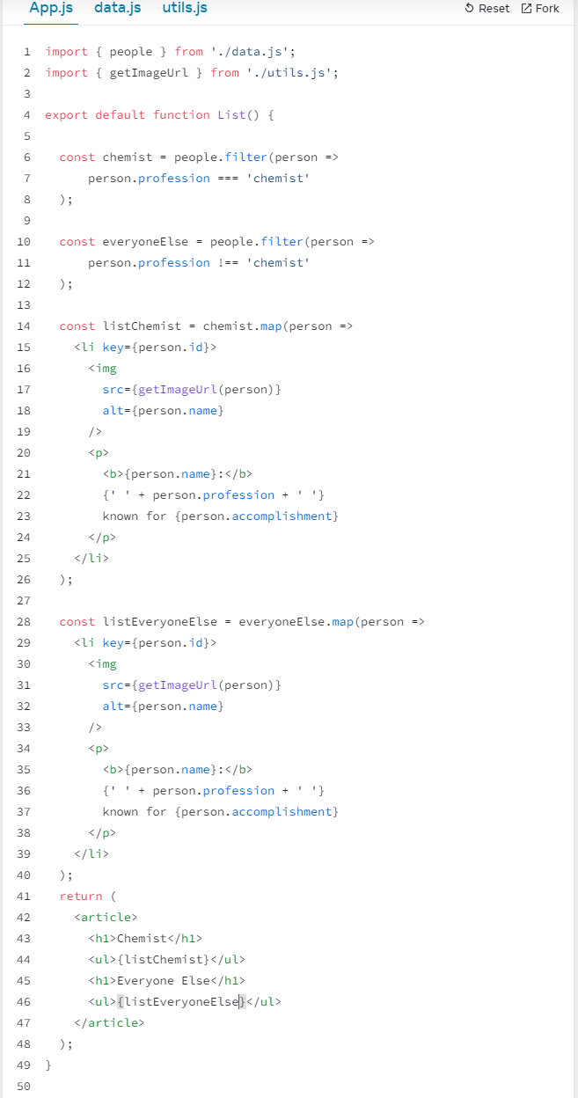

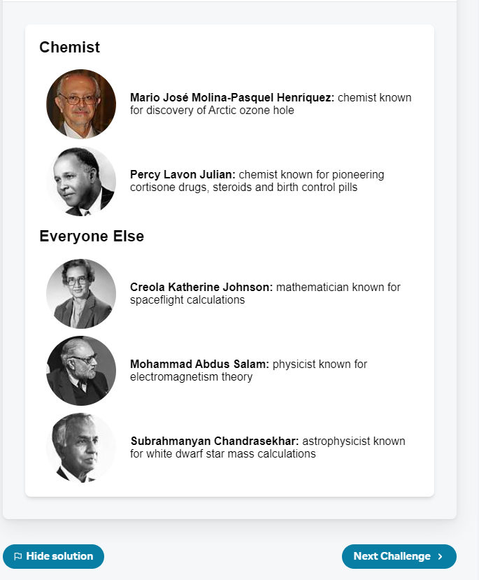

A simplified version:

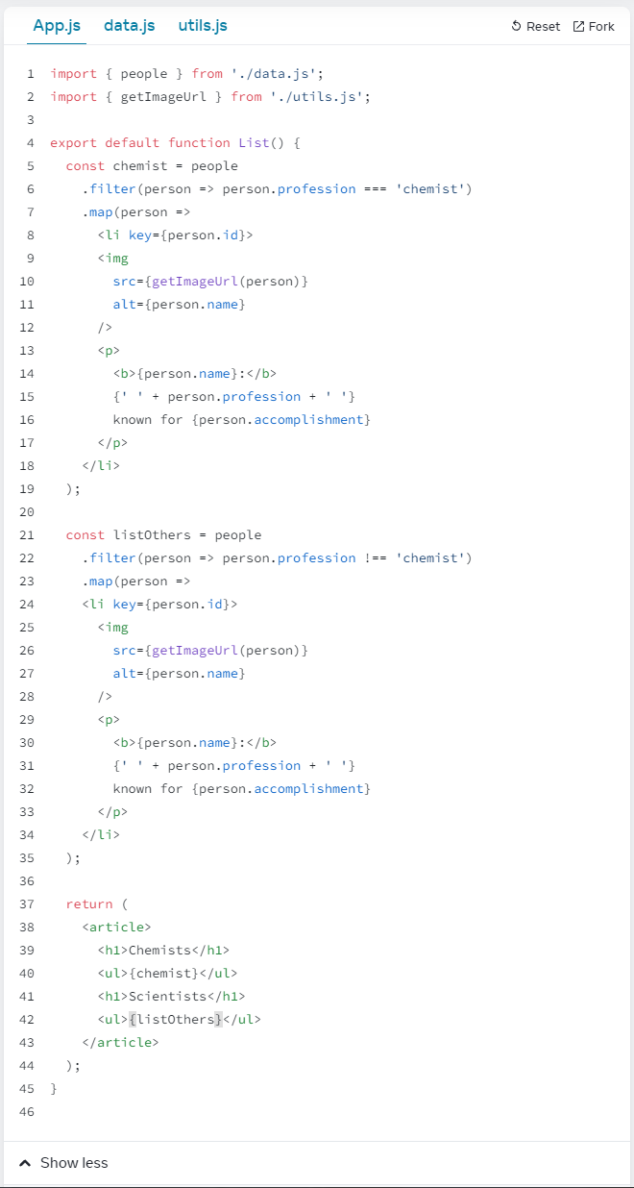



Challenge 2 of 4

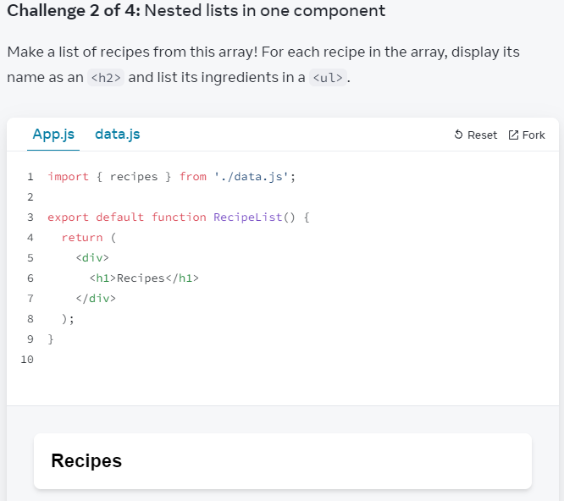

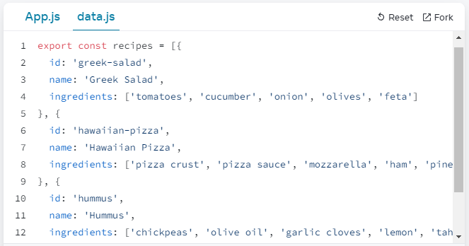

My solution:

Part1 - List recipe name

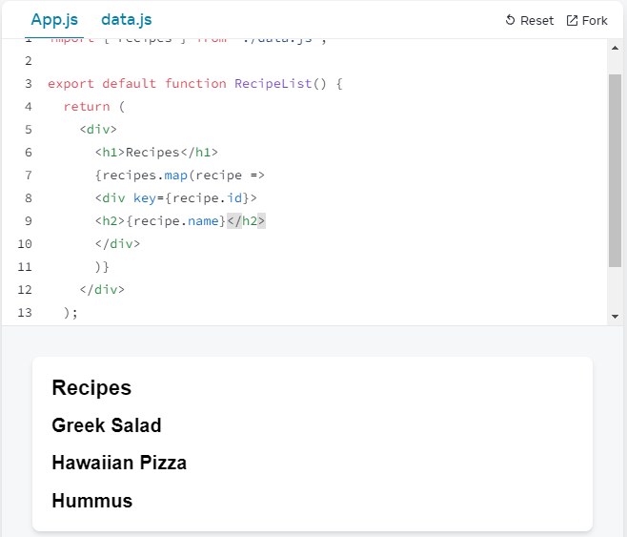

Part2 - All

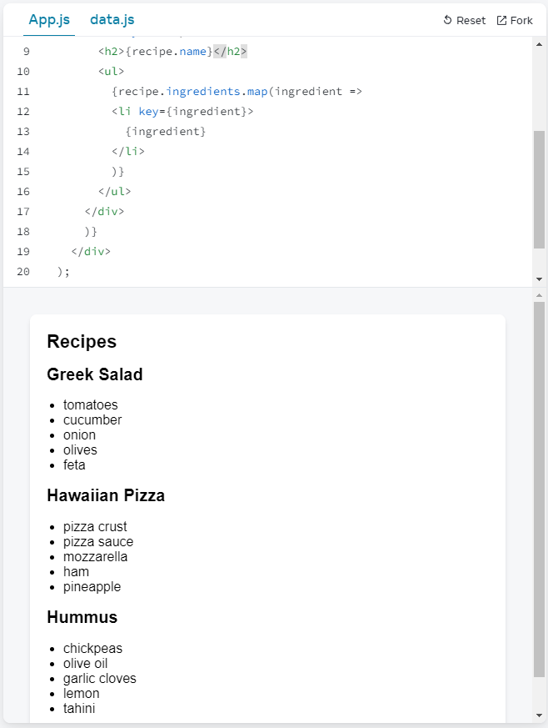

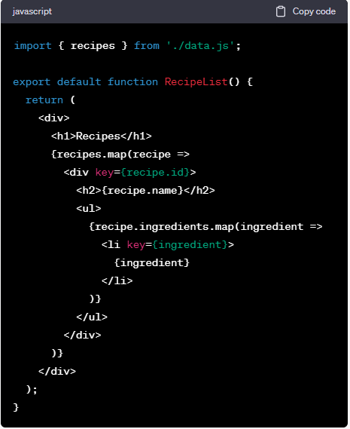

=====Challenge 3 of 4

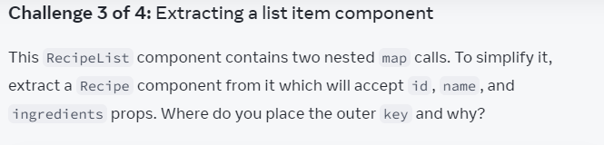

Question:

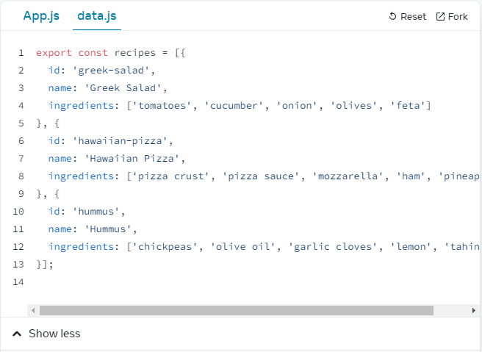

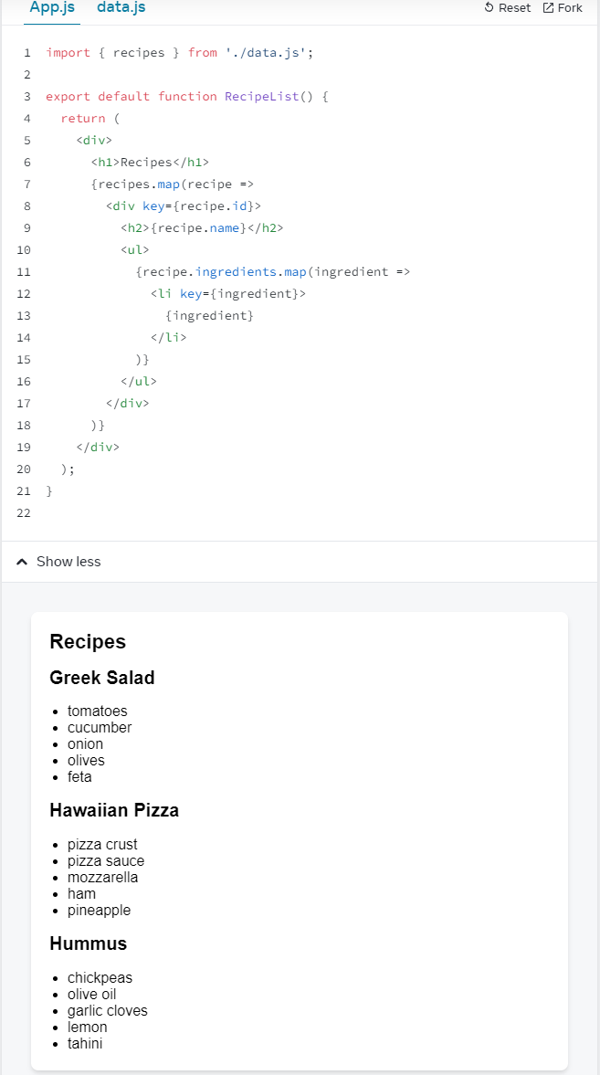

My solution:

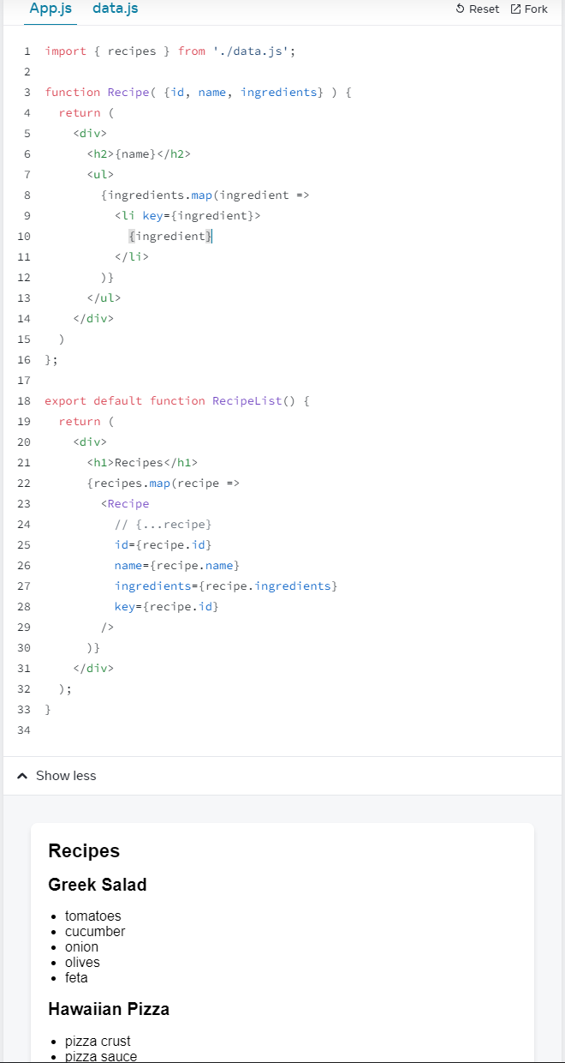

=====Challenge 4 of 4

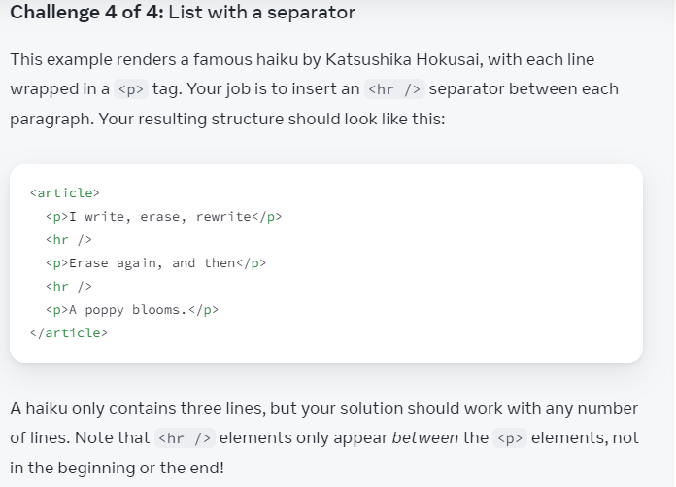

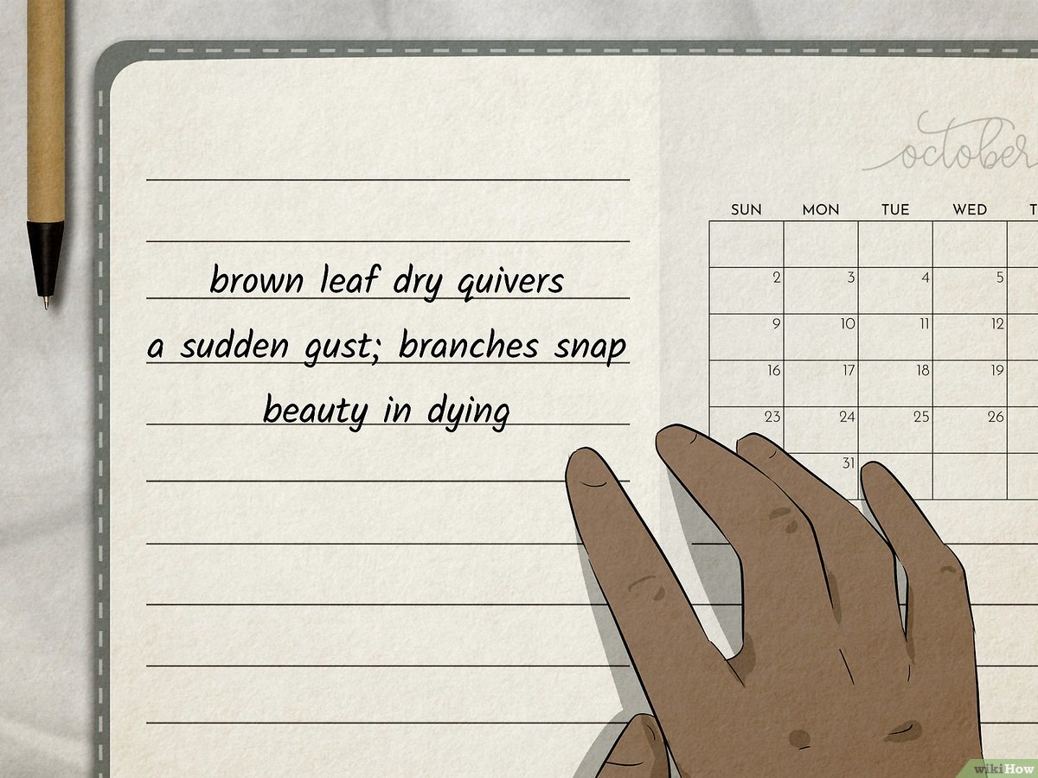

Question:

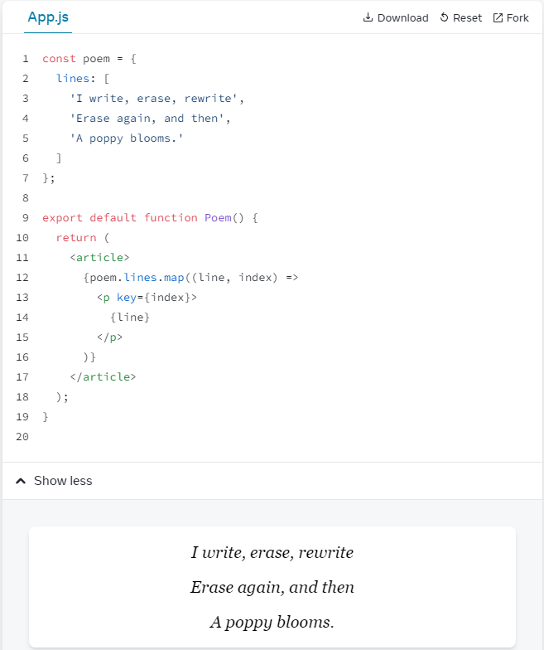

My solution?

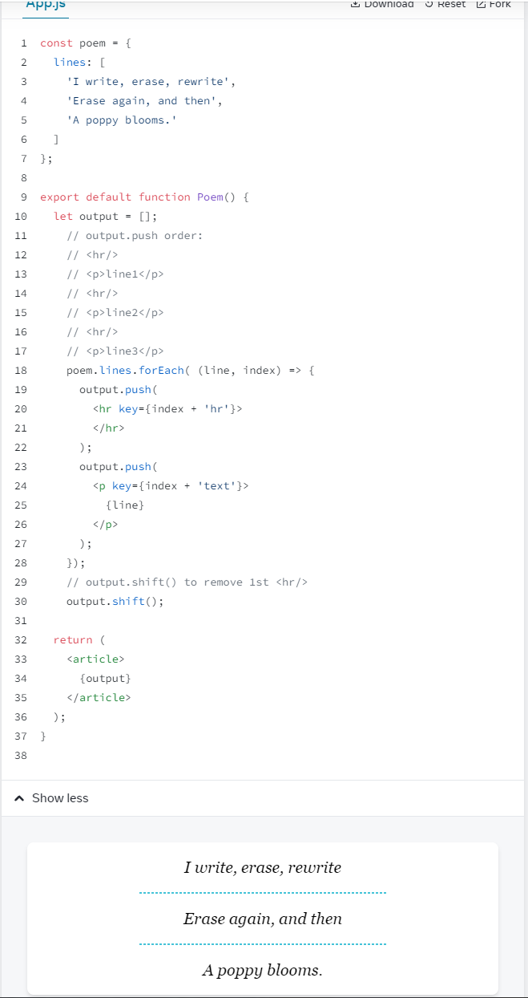

Keeping Components Pure

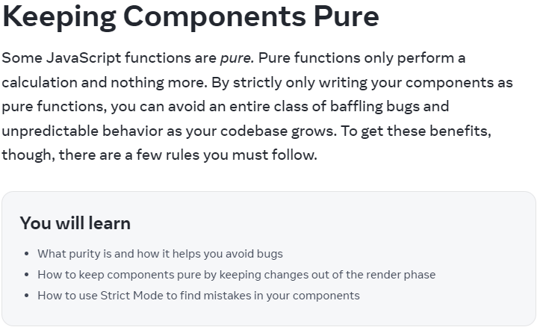

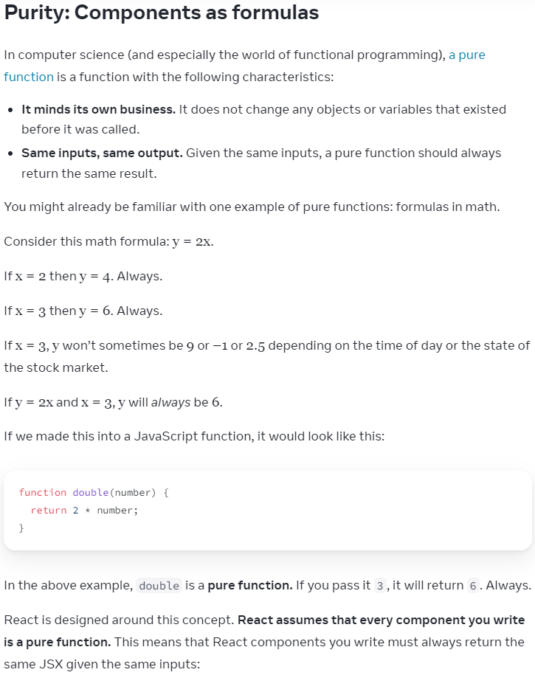

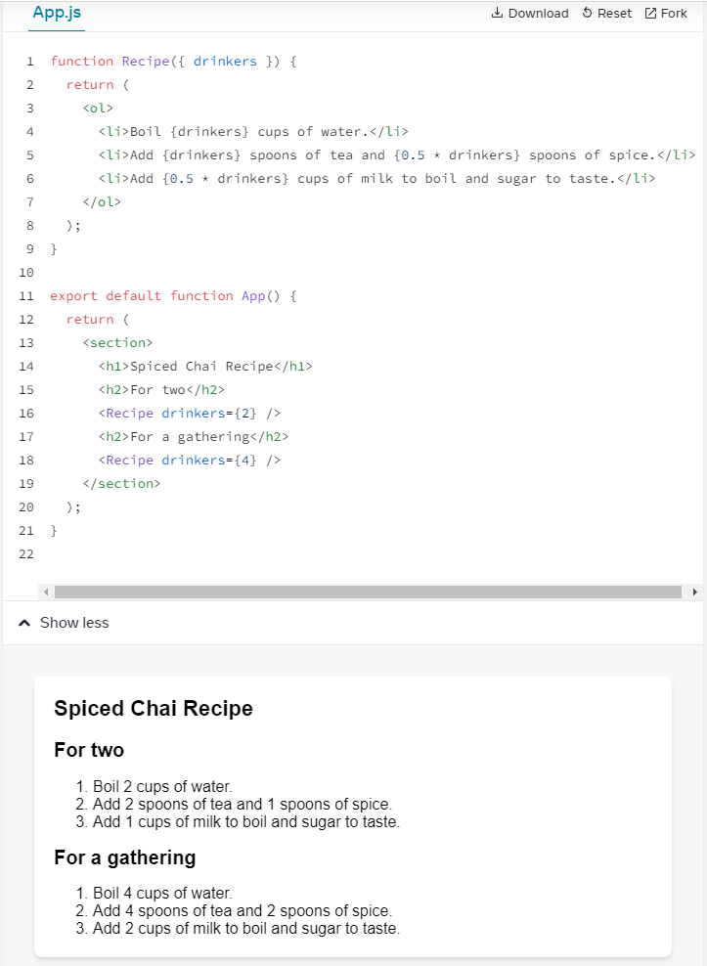

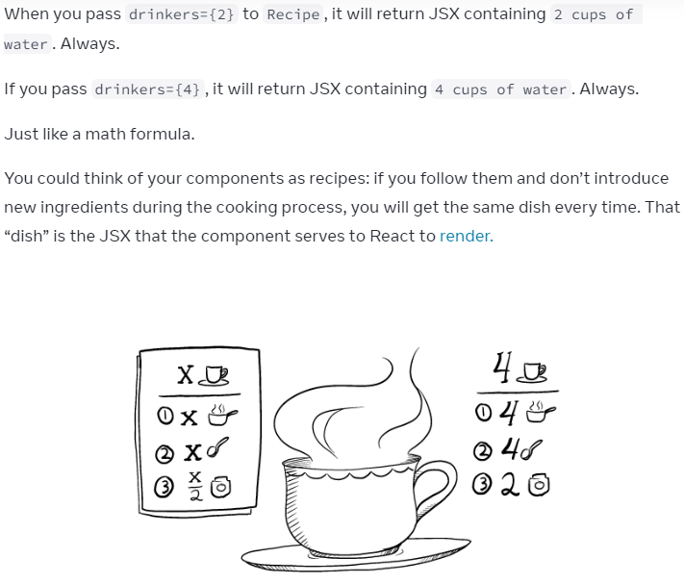

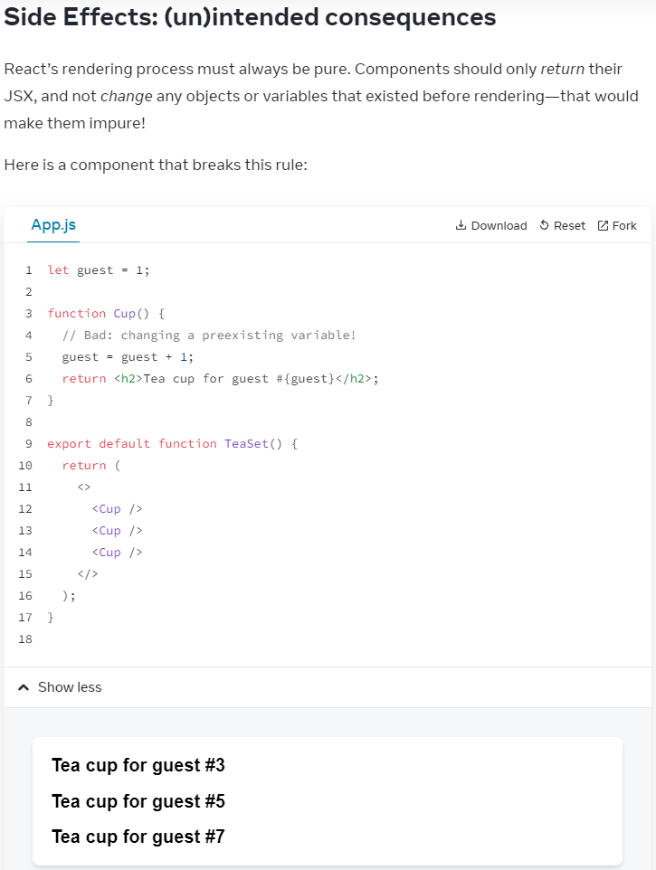

Everytime <Cup /> is called:

guest = guest + 1;

is hoisted to global

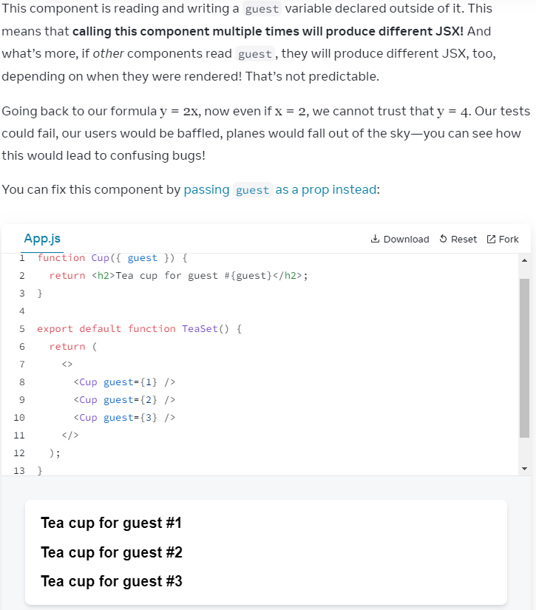

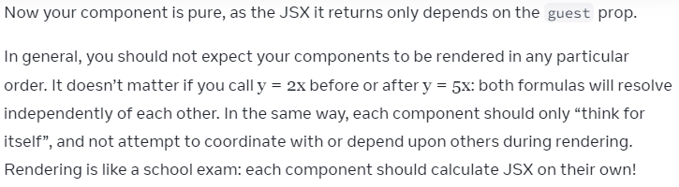

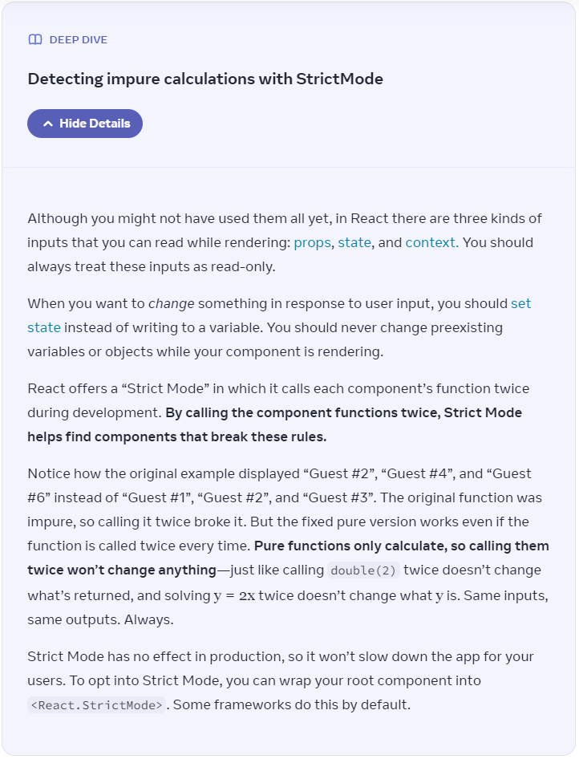

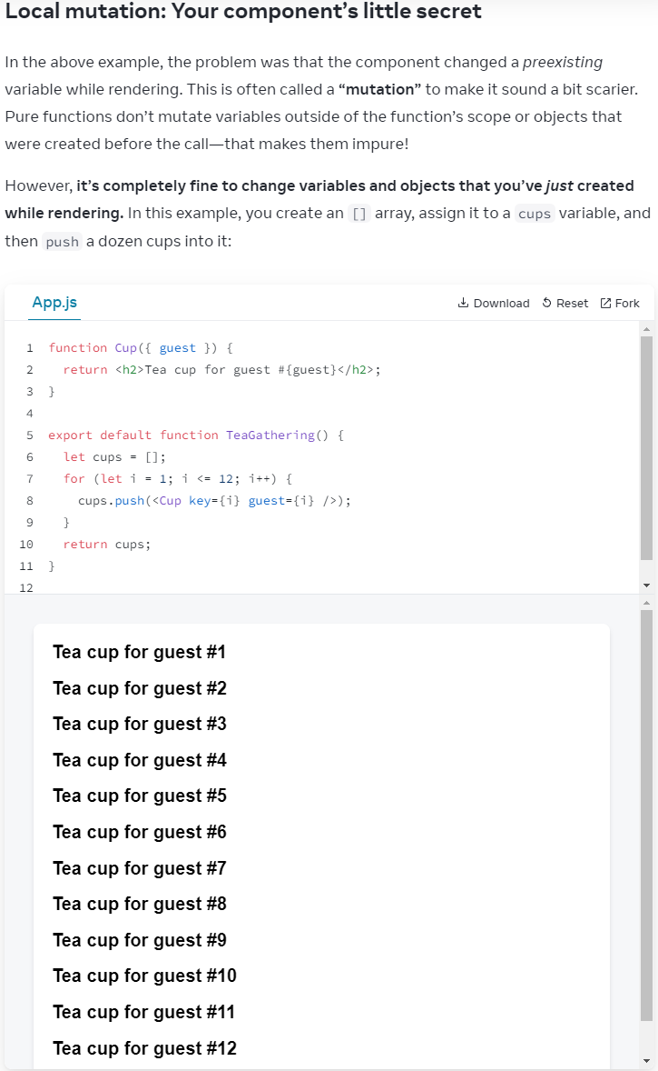

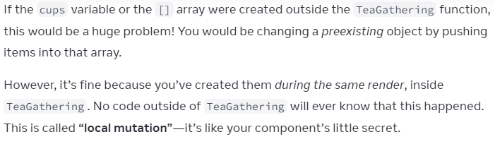

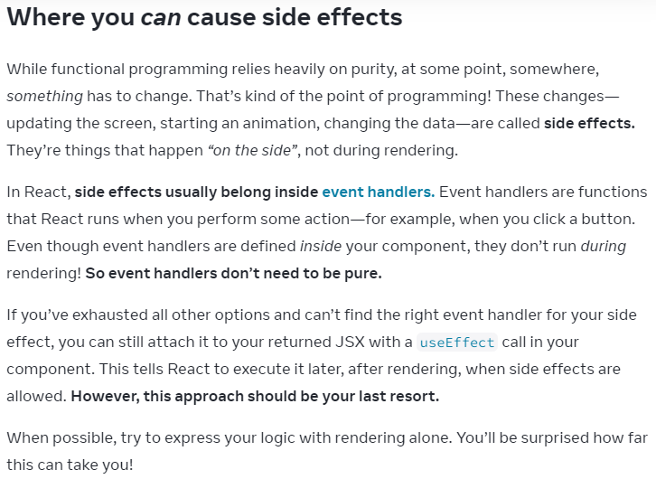

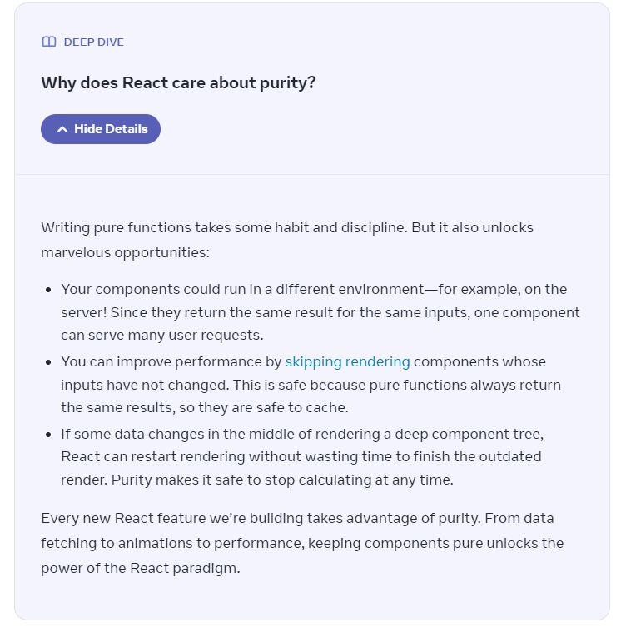

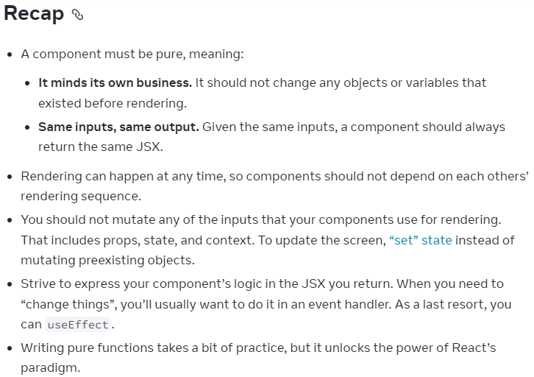

=====Challenge 1 of 3

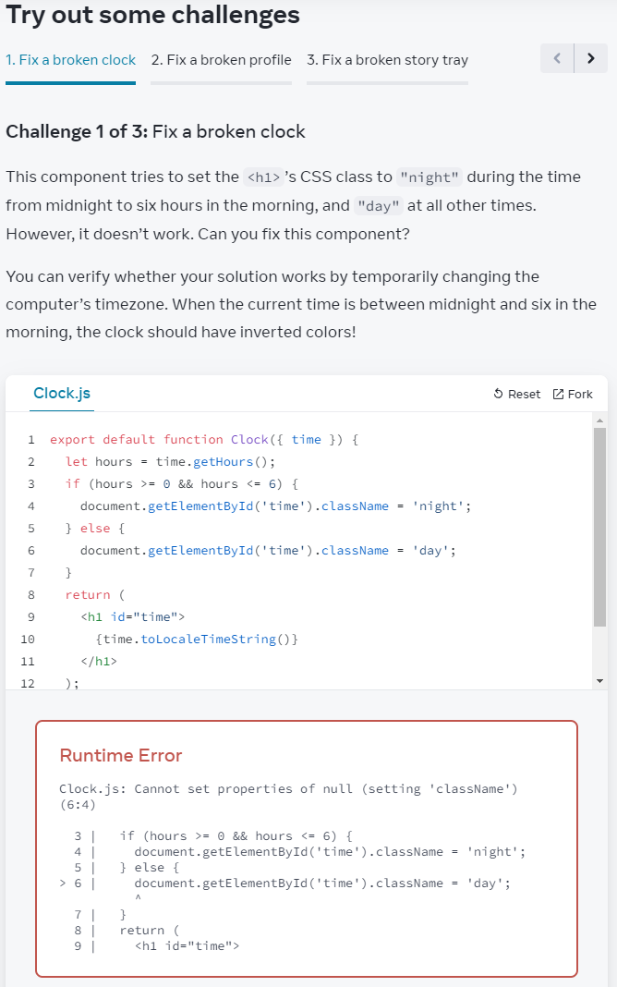

Ans:

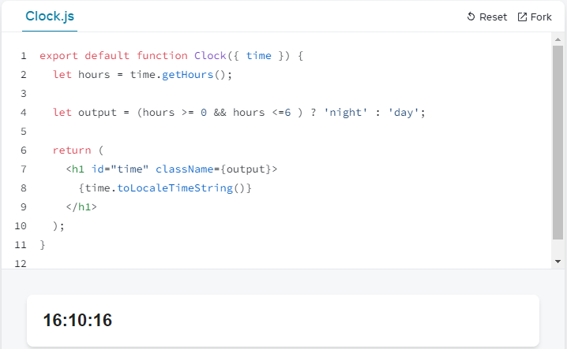

ChatGPT:

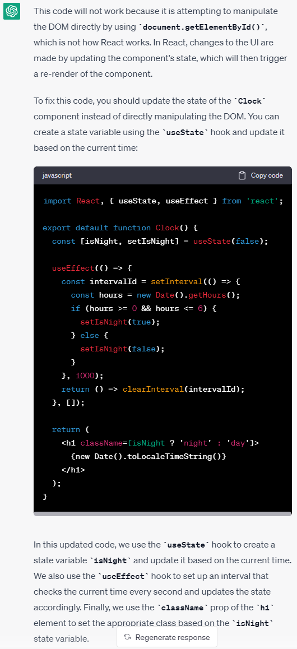

=====Challenge 2 of 3

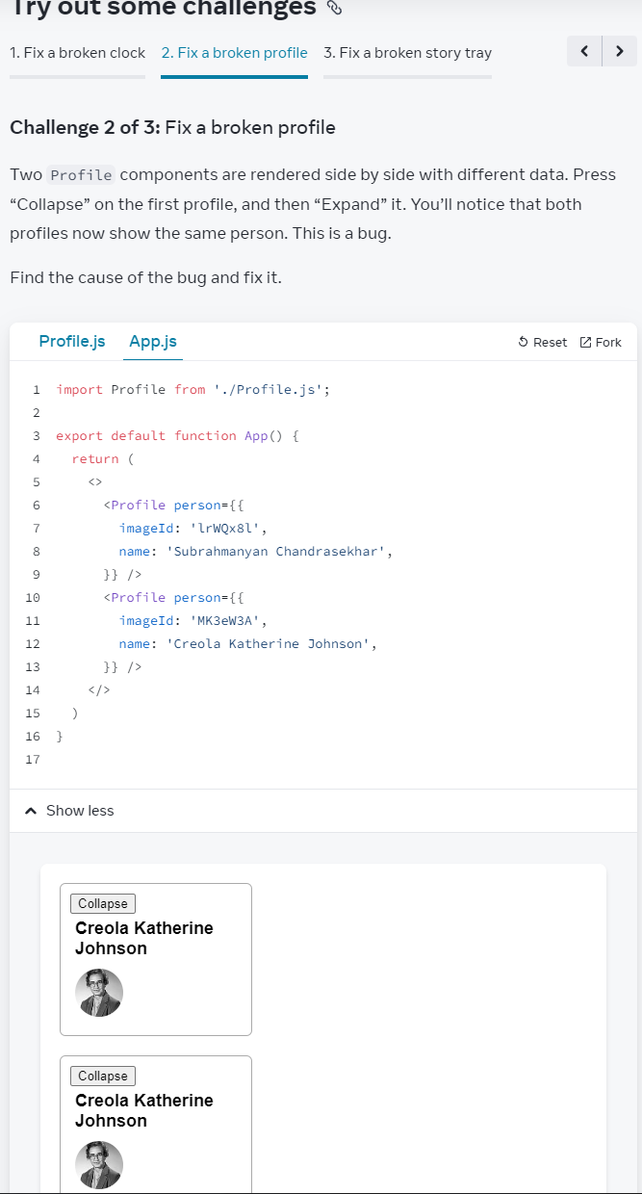

Question:

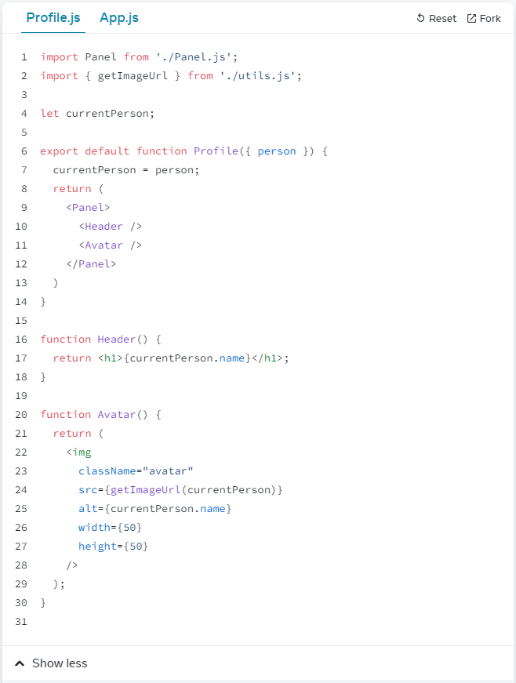

Answer:

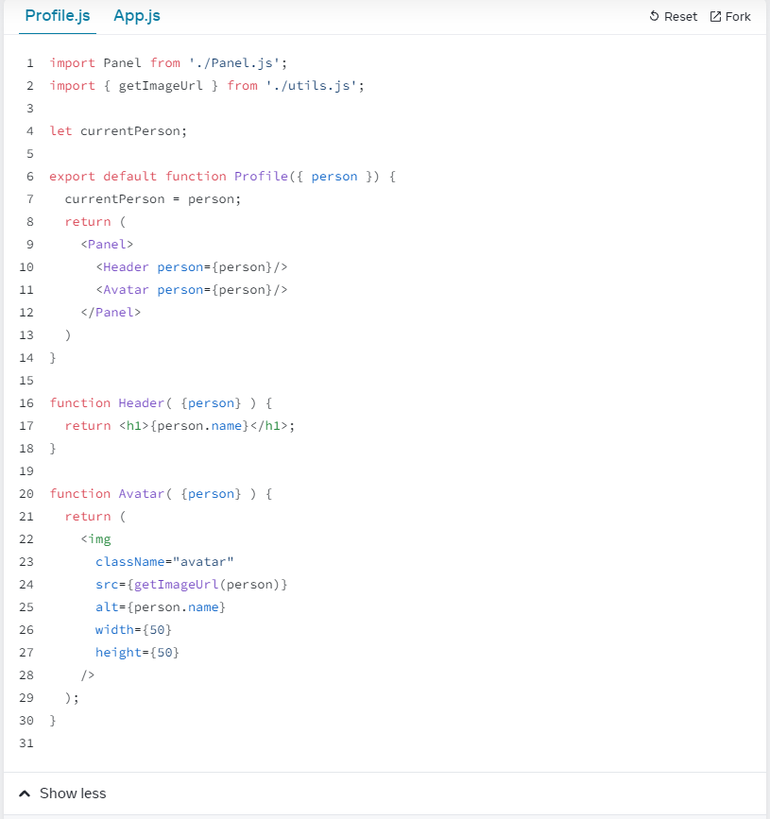

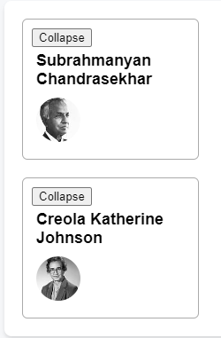

Need person data from App.js when building components

function Header( {person} ) {

return <h1>{person.name}</h1>;

}

function Avatar( {person} ) {

return (

<img

className="avatar"

src={getImageUrl(person)}

alt={person.name}

width={50}

height={50}

/>

);

}

=====Challenge 3 of 3

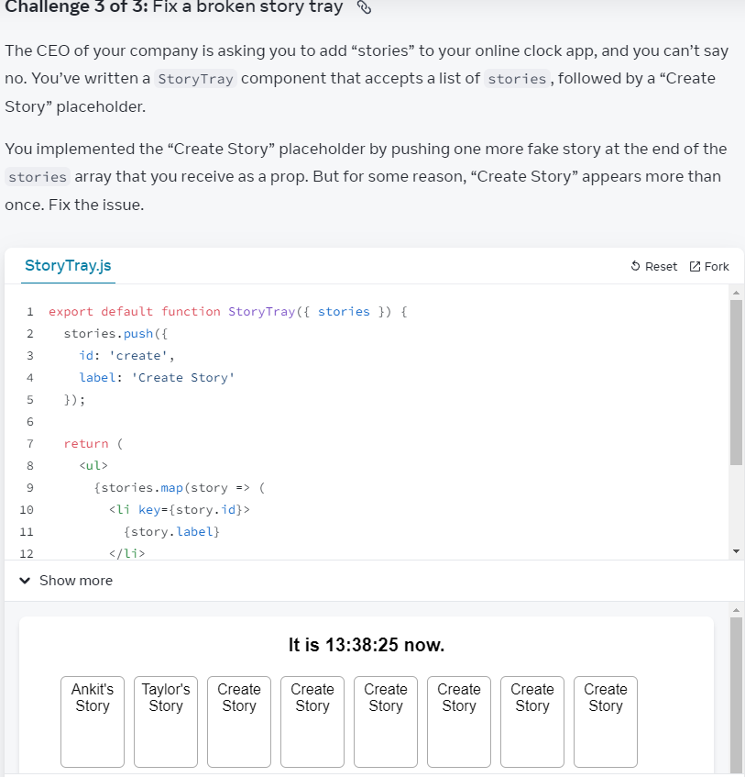

StoryTray() is NOT a pure function:

-> stories.push({

id: 'create',

label: 'Create Story'

});

A pure function should always 'Same input -> Same output';

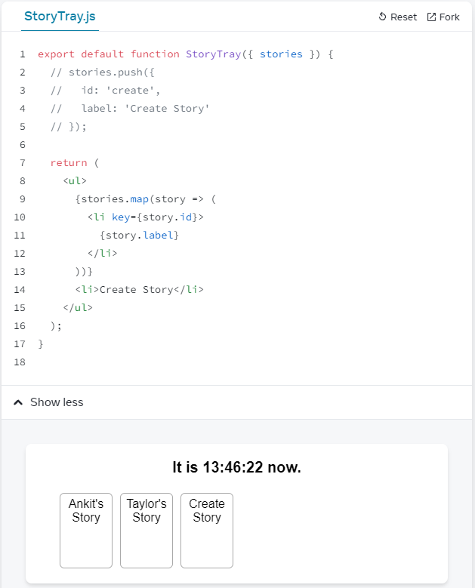

Adding Interactivity - Responding to Events

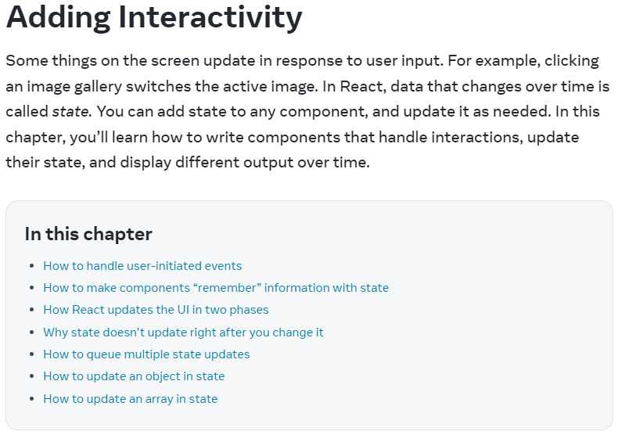

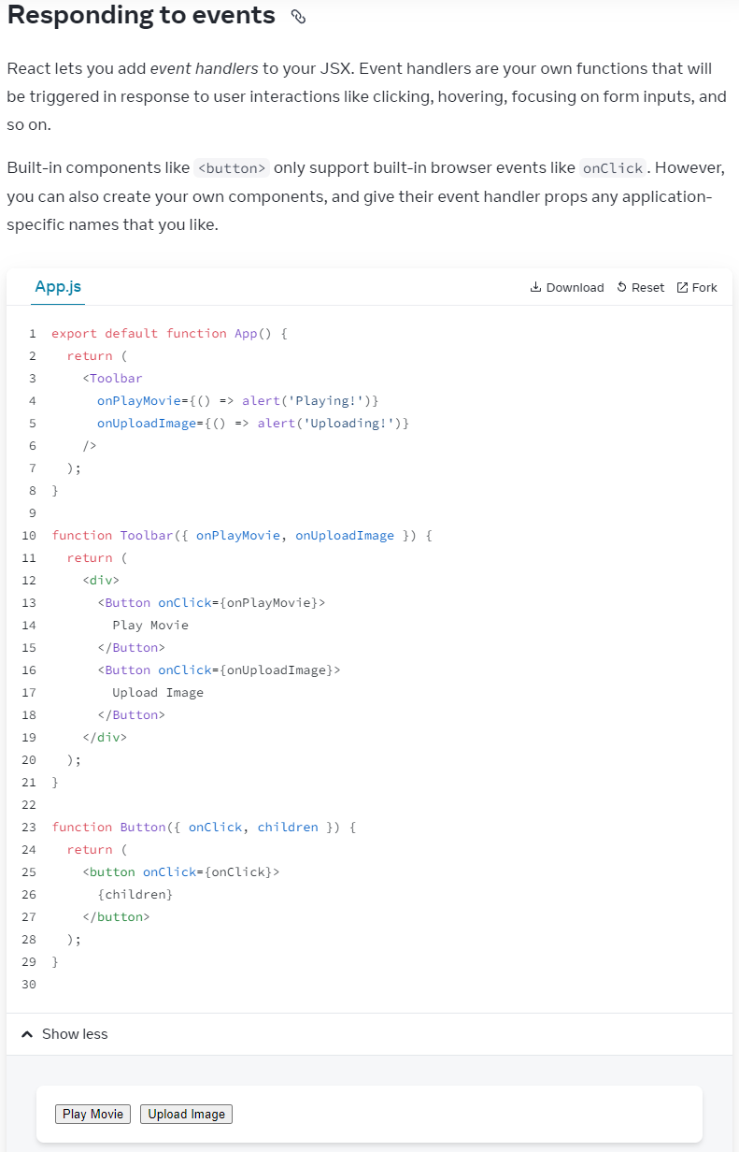

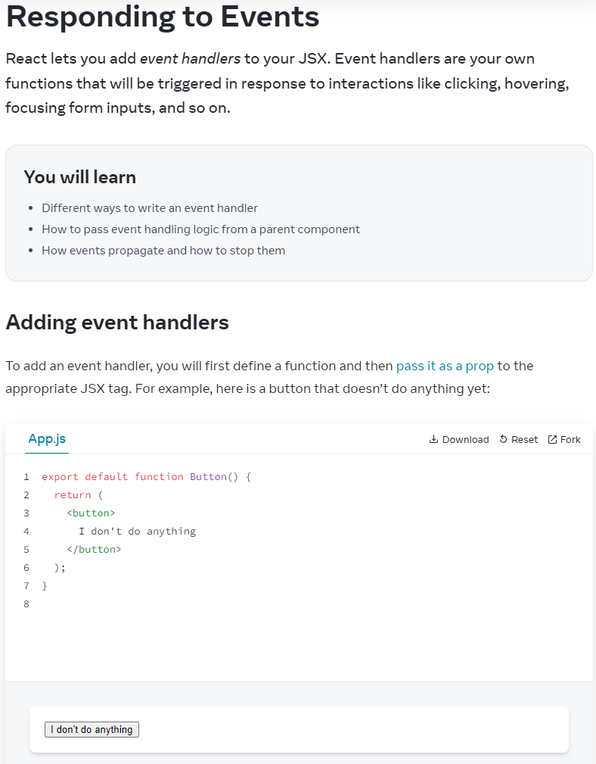

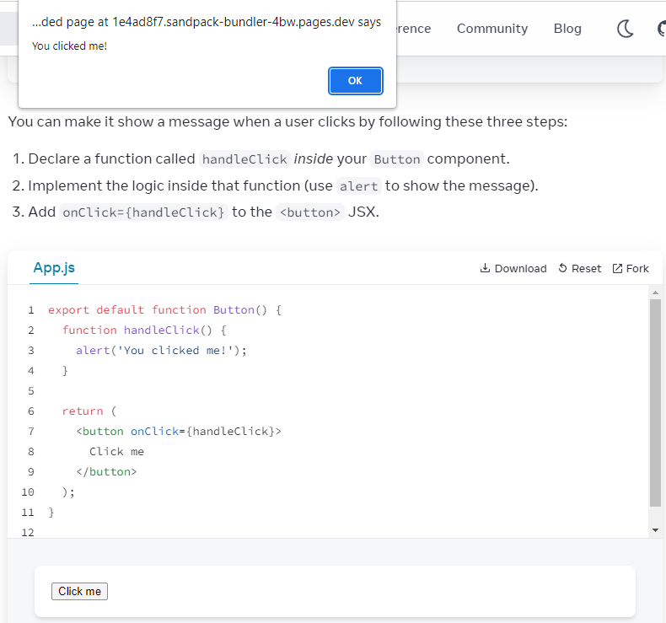

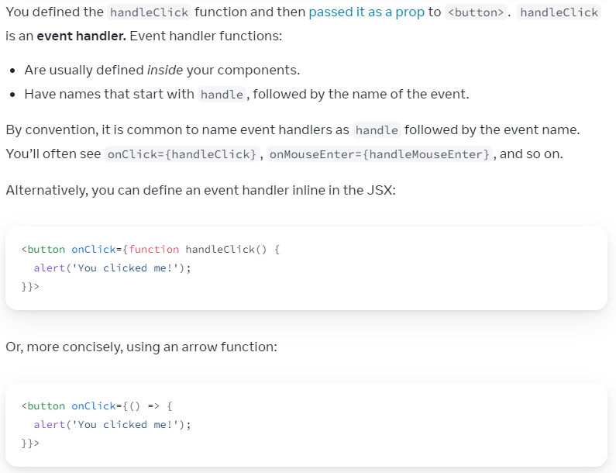

Practice:

export default function Button() {

return (

<div>

<button onClick={ () => {

alert('in place arrow function1')

}

}>

I handle clicks

</button>

<br/>

<button onClick={ () => {

alert('in place arrow function2')

}

}>

again

</button>

</div>

);

function handleClick() {

alert('Handling clicks');

}

function handleClick2() {

alert('Clicking again');

}

}

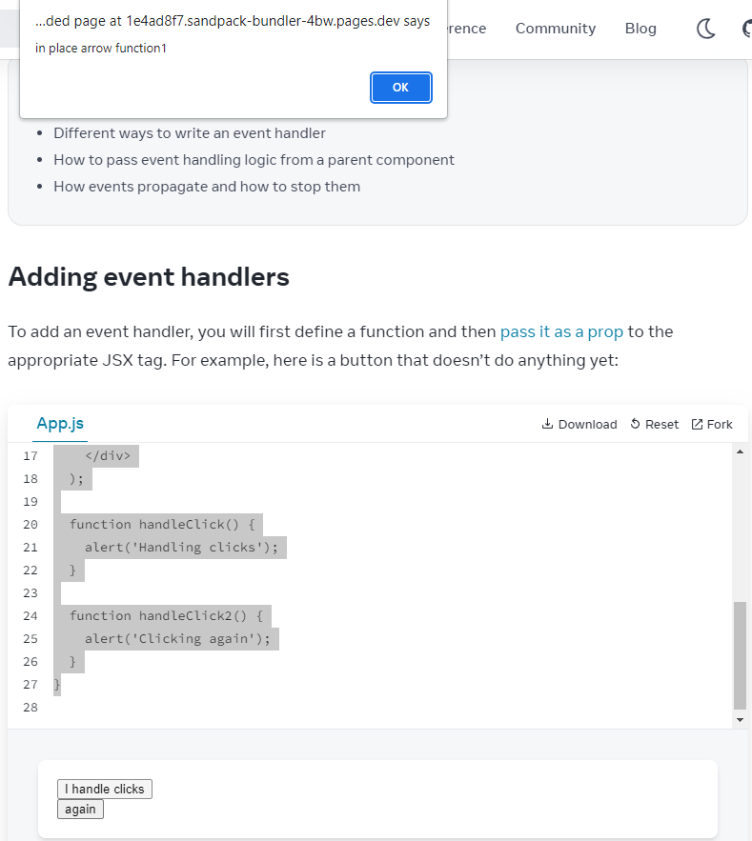

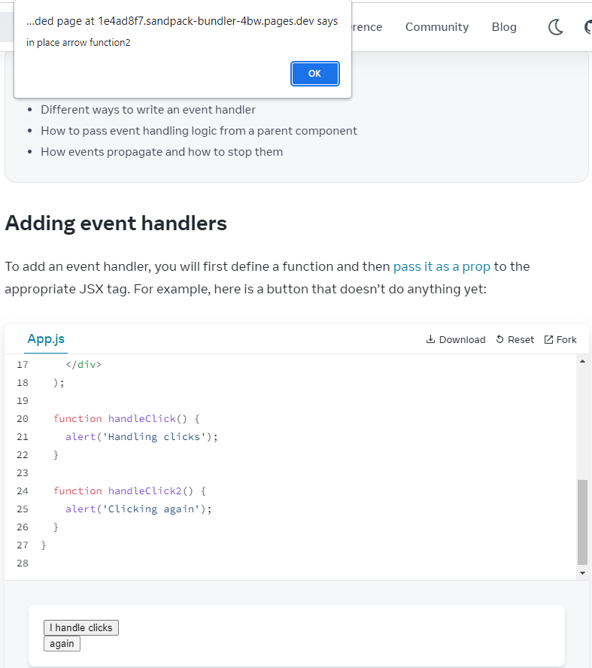



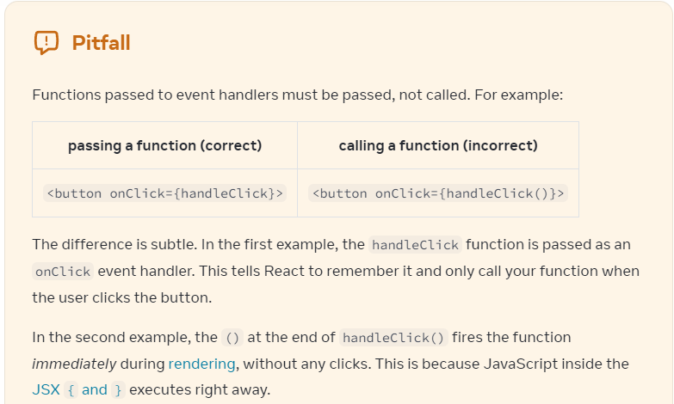

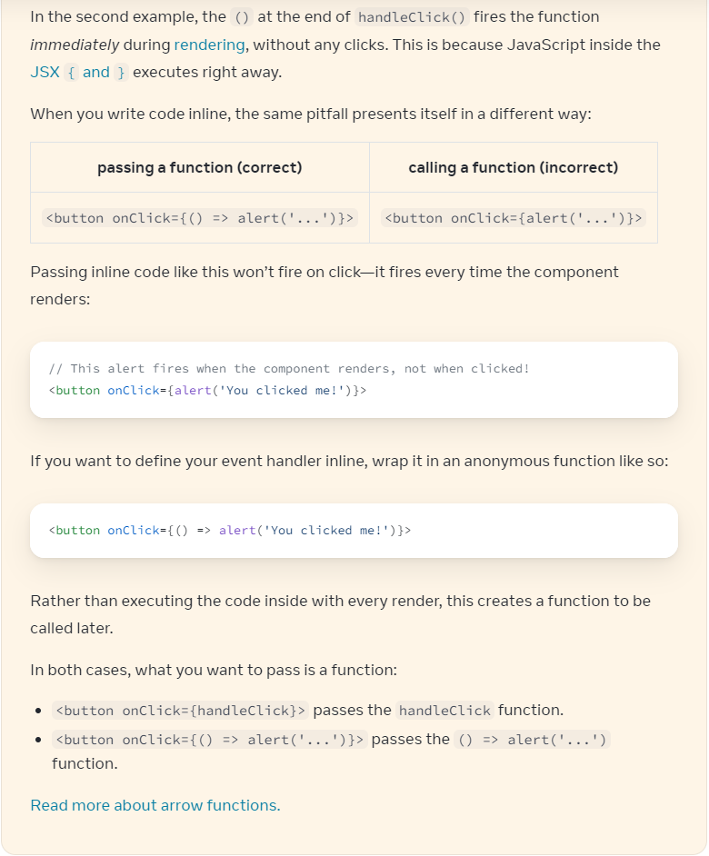

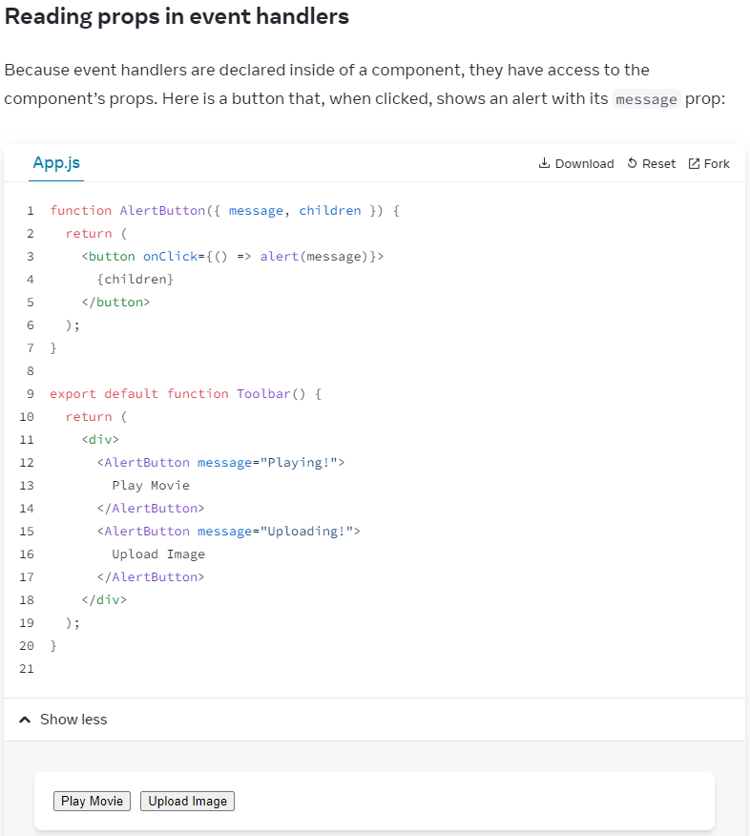

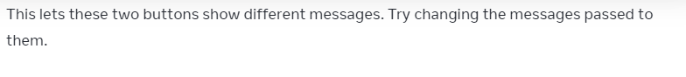

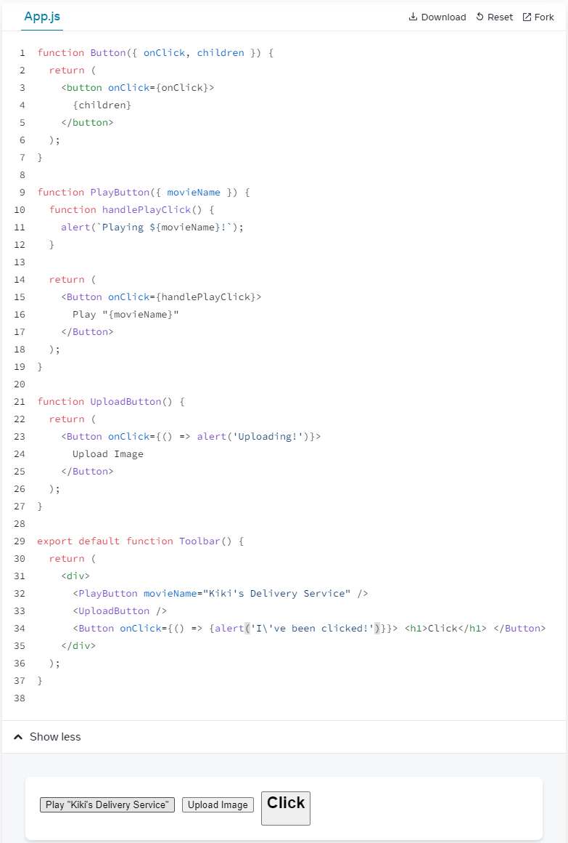

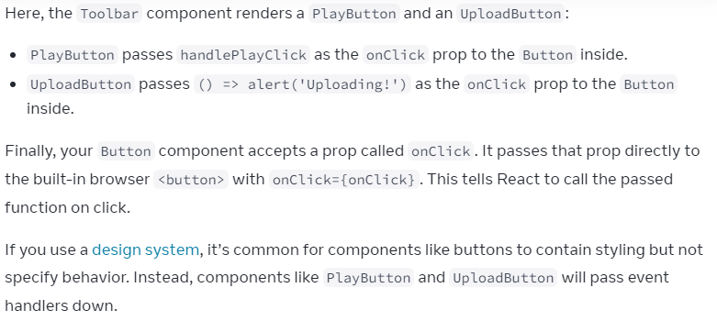

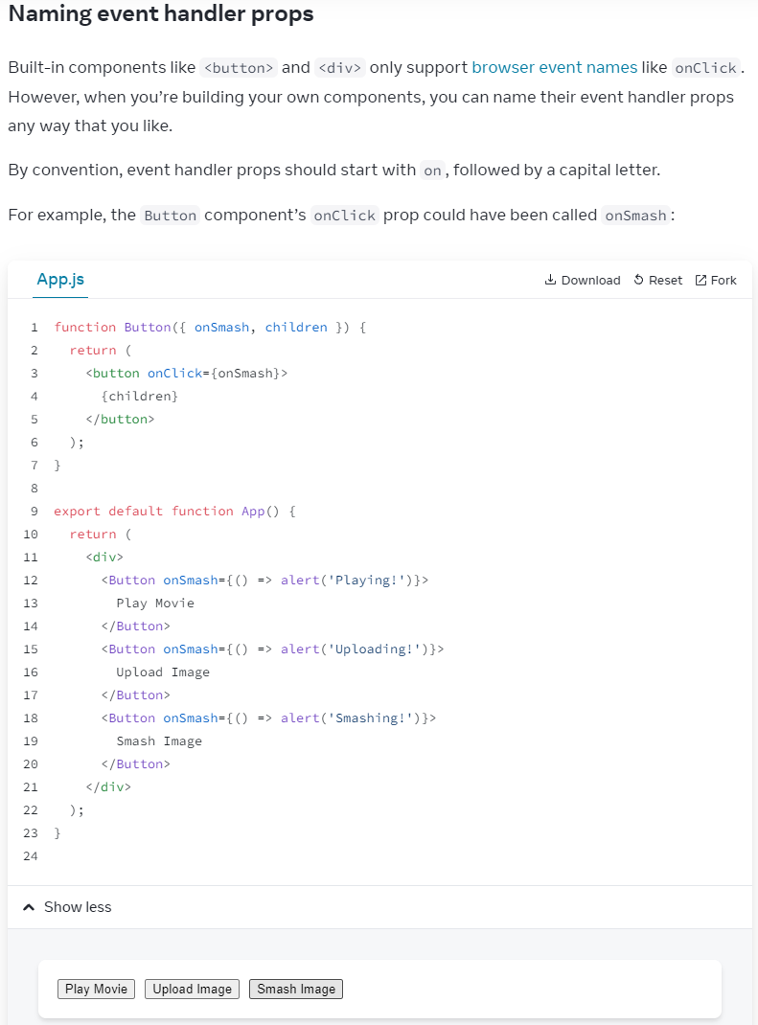

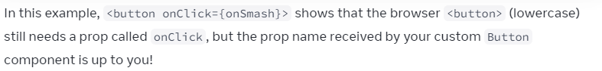

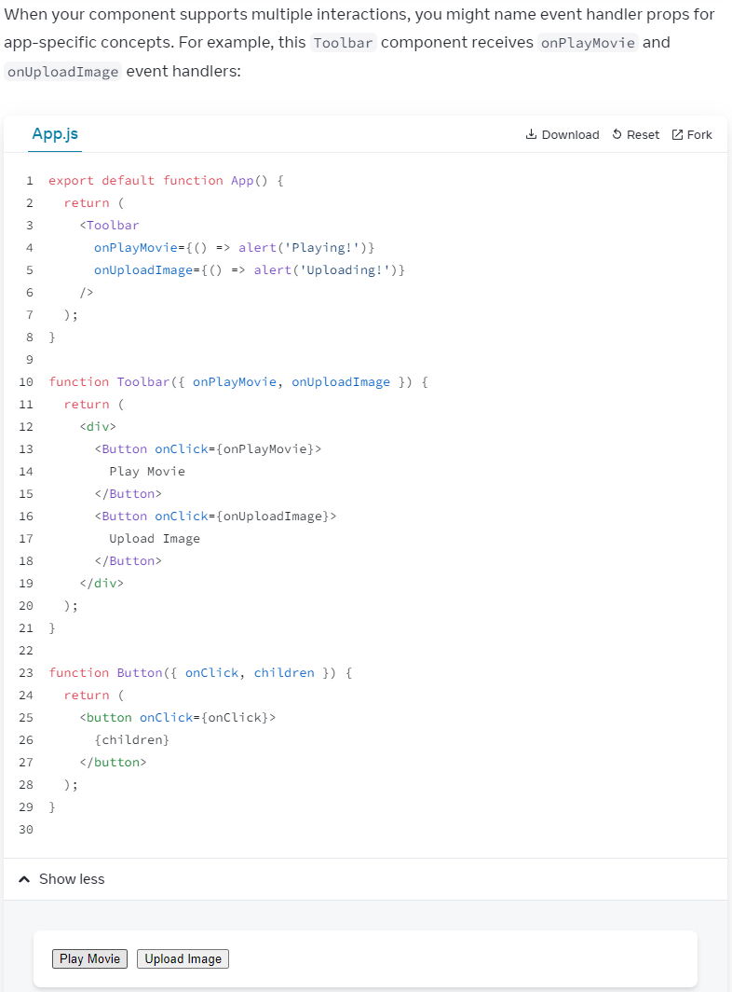

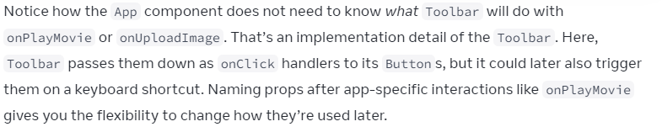

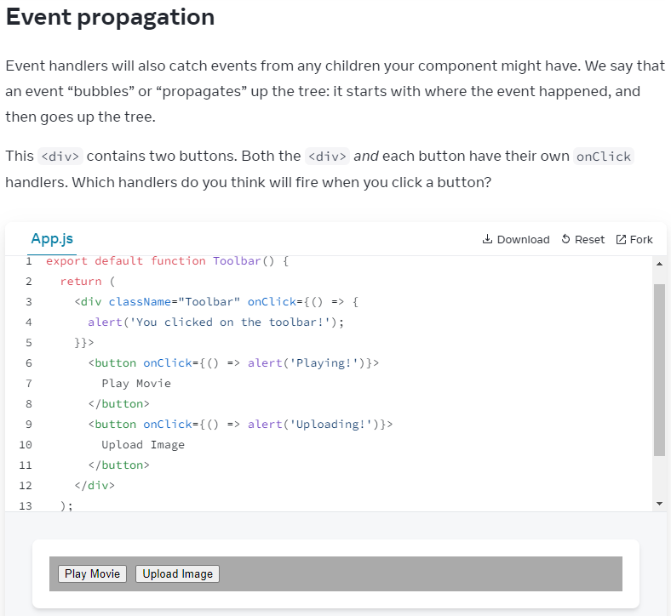

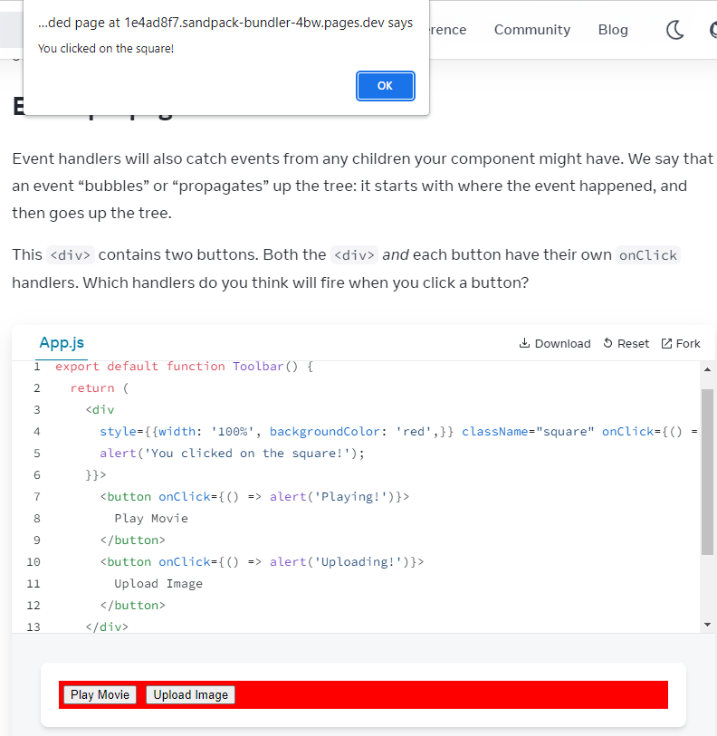

Click 'Play Movie' -> 'Playing' -> 'You clicked on the square!'

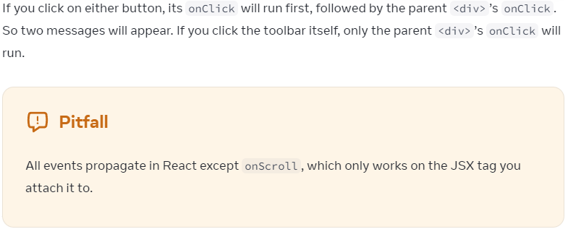

**Stop propagation from child to parent**

Click 'Play Movie' -> 'Playing';

function Button({ onClick, children }) {

return (

<button onClick={e => {

e.stopPropagation();

onClick();

}}>

{children}

</button>

);

}

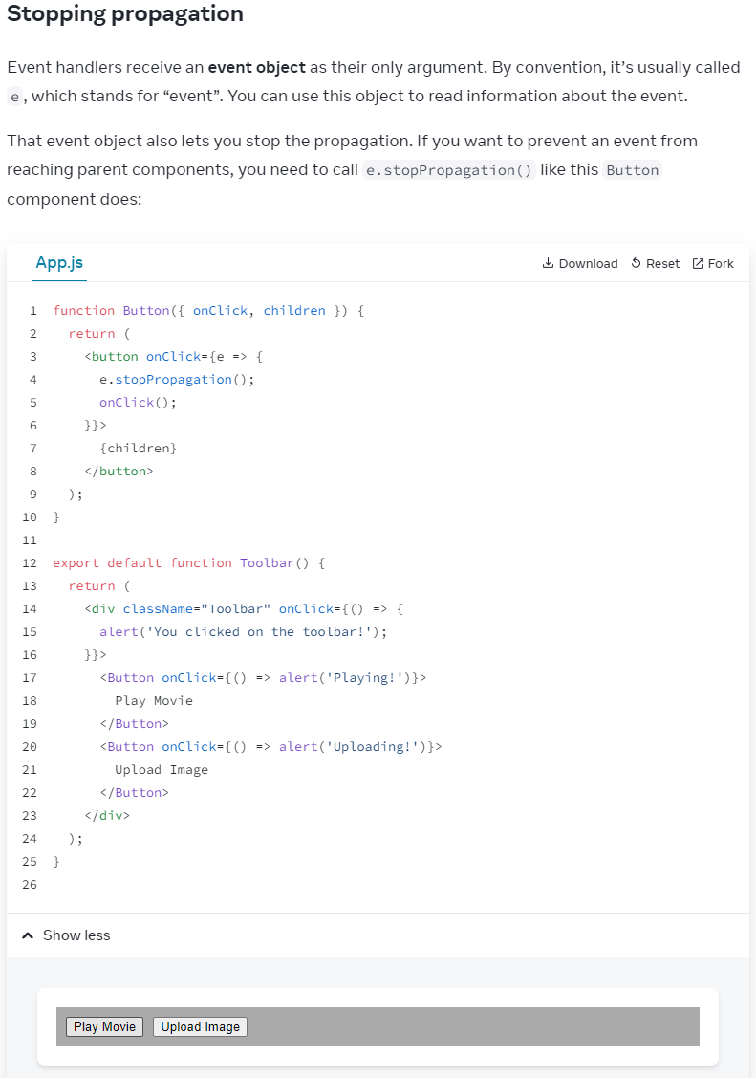

When a <Button /> is clicked:

1. React calls 'onClick' handler passed to <button>

2. That handler, in 'Button', does:

-Calls e.stopPropagation() , prevent bubbling further

-Calls 'onClick' func, a prop passed from 'Toolbar' component

3. That func, defined in 'Toolbar' component, displays the button's own alert

4. As propagation was stopped, parent <div className="Toolbar">'s onClick handler does NOT run

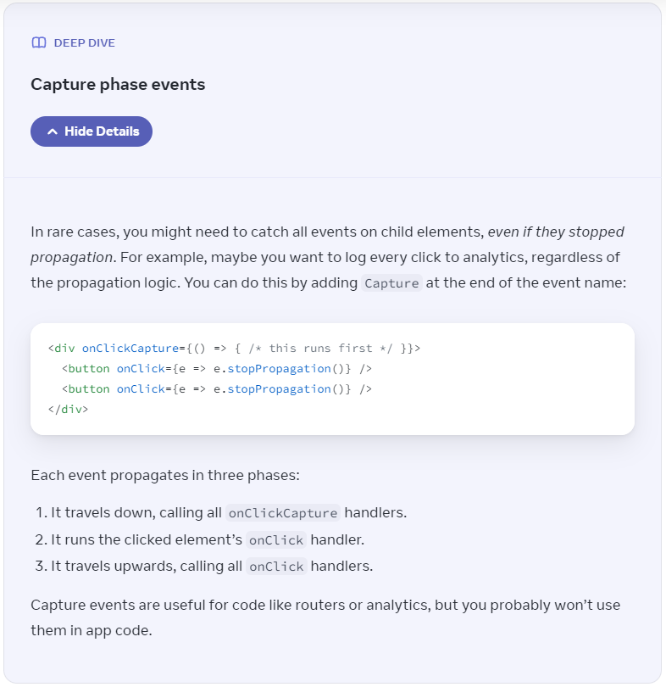

Syntax:

function Button( { onChange, children }) {

return (

<button onClick={e => {

e.stopPropagation();

onChange();

}}>

{children}

</button>

);

}

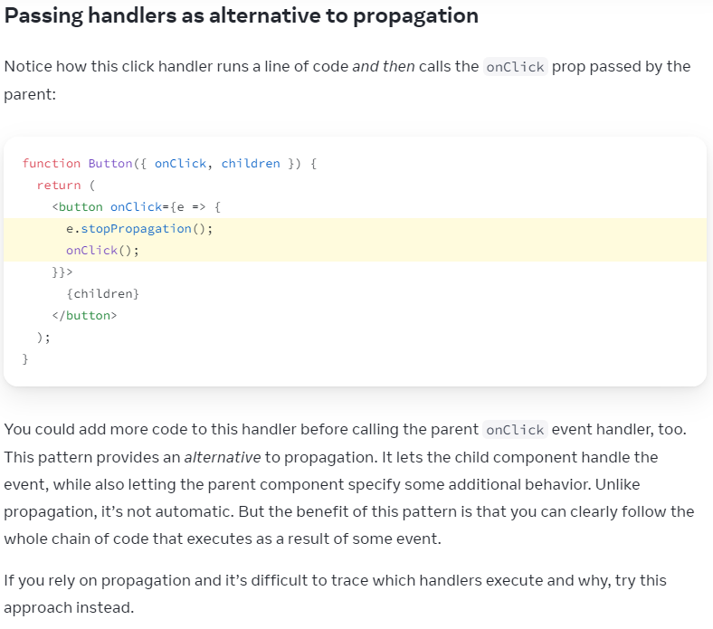

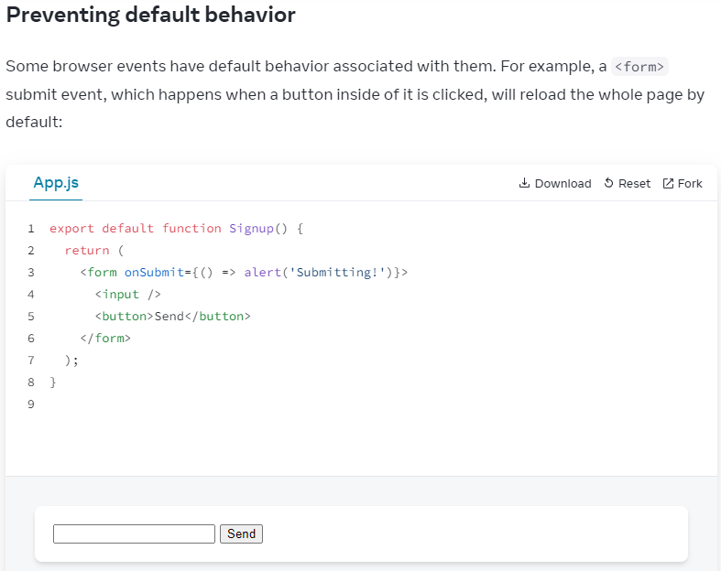

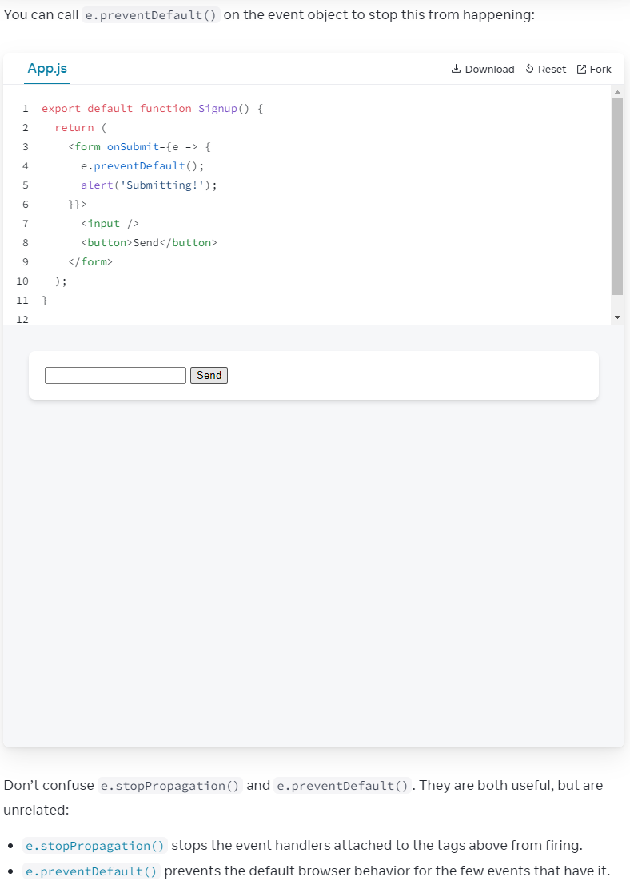

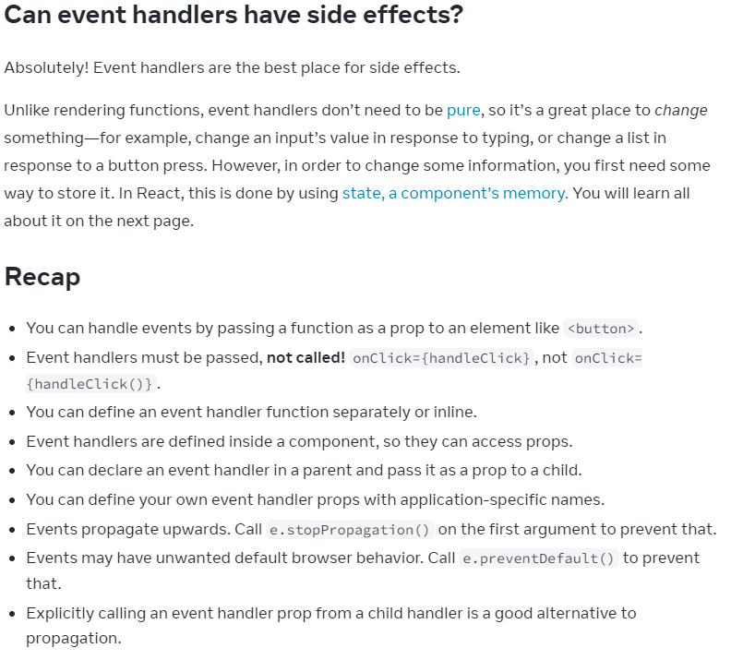

=====Challenge 1 of 2

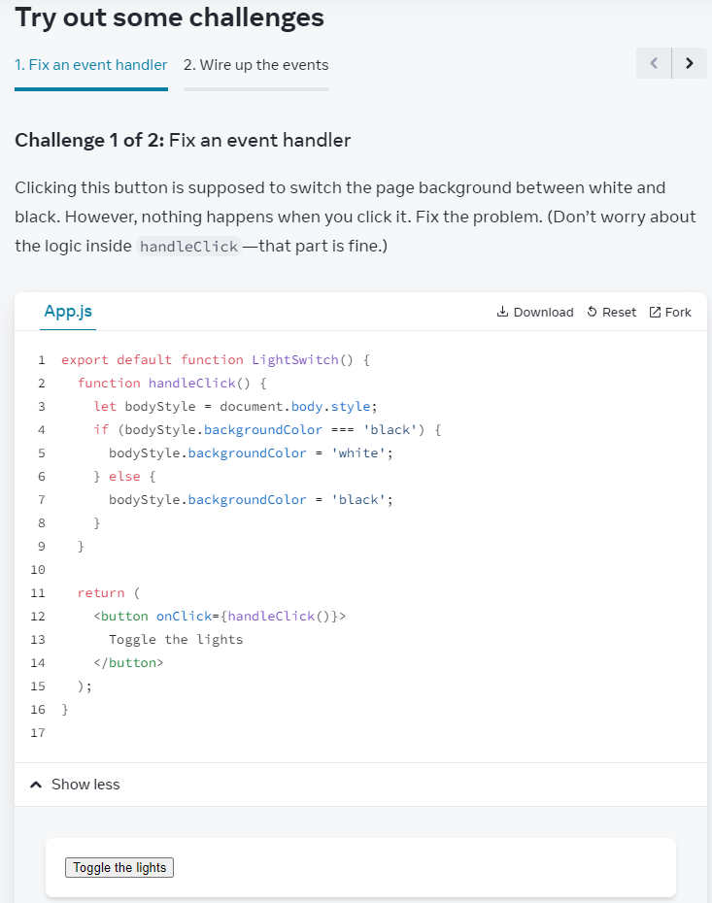

Solution:

// <button onClick={pass to a func}>

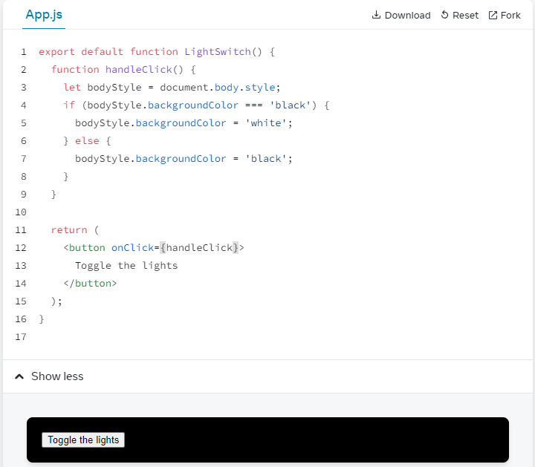

=====Challenge 2 of 2

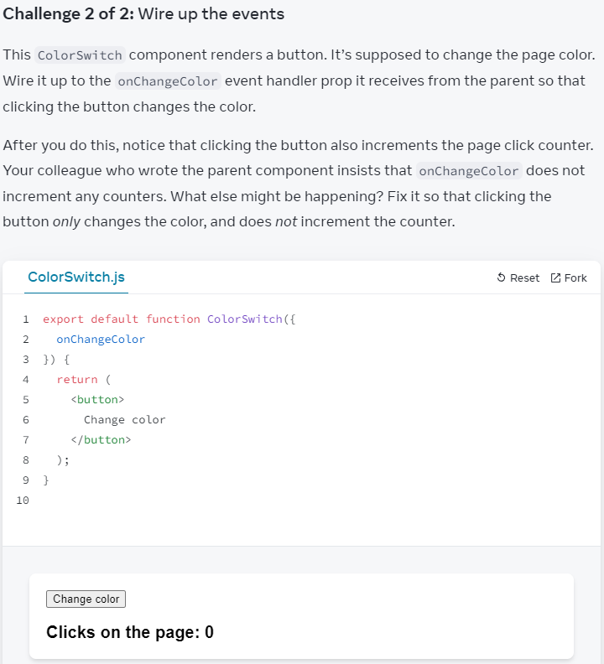

Solution:

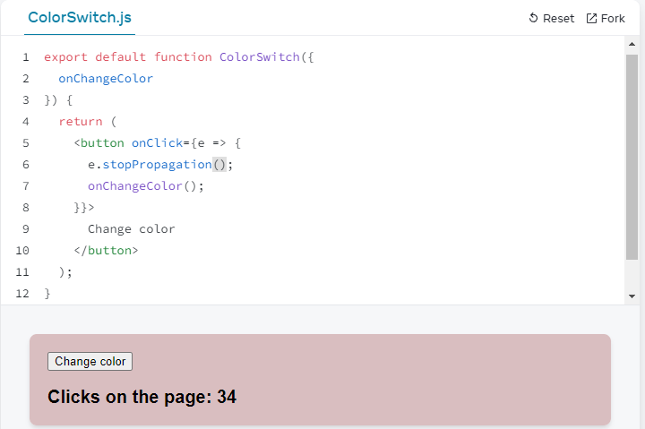

State: A Component's Memory

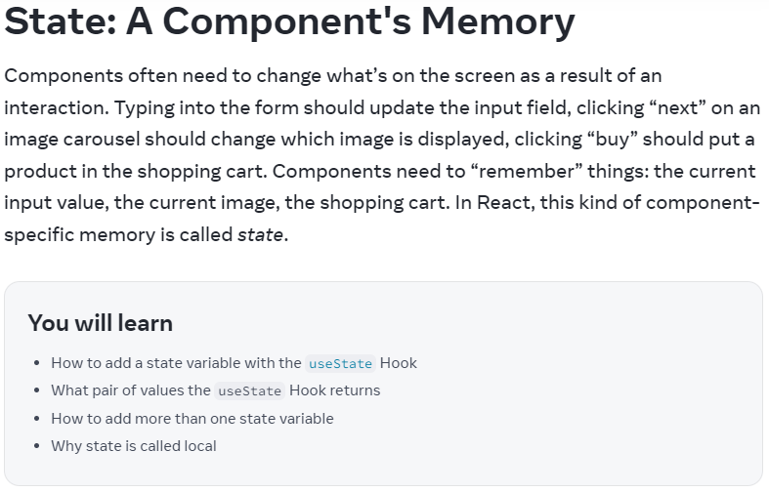

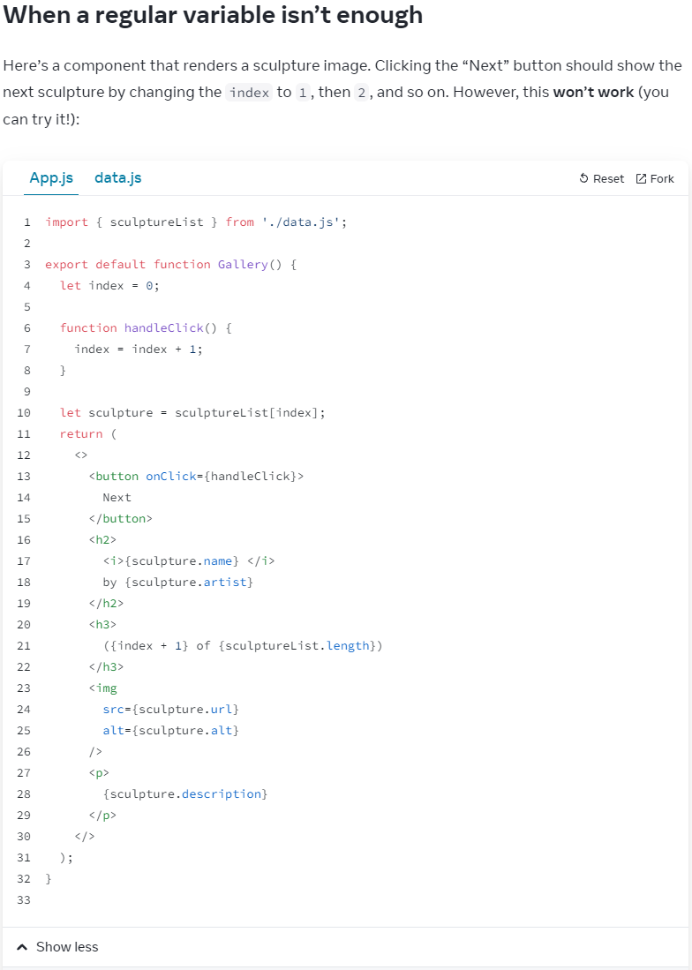

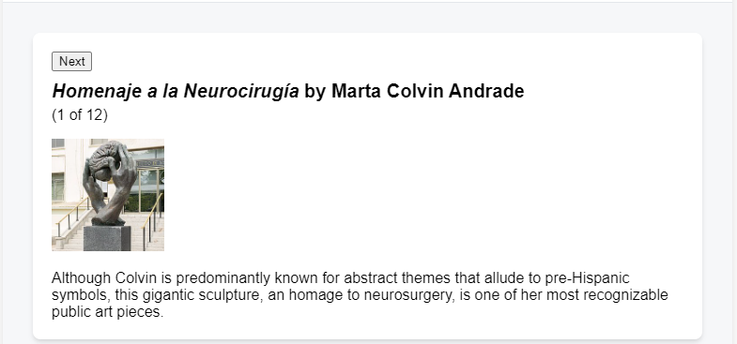

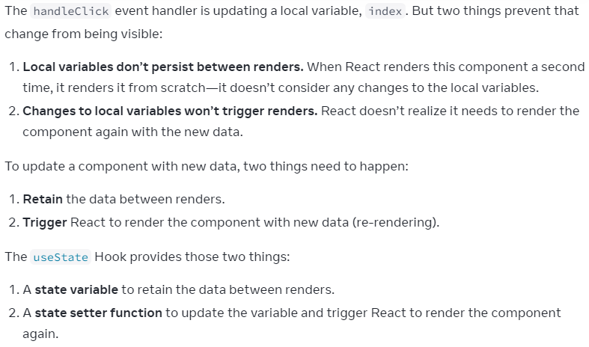

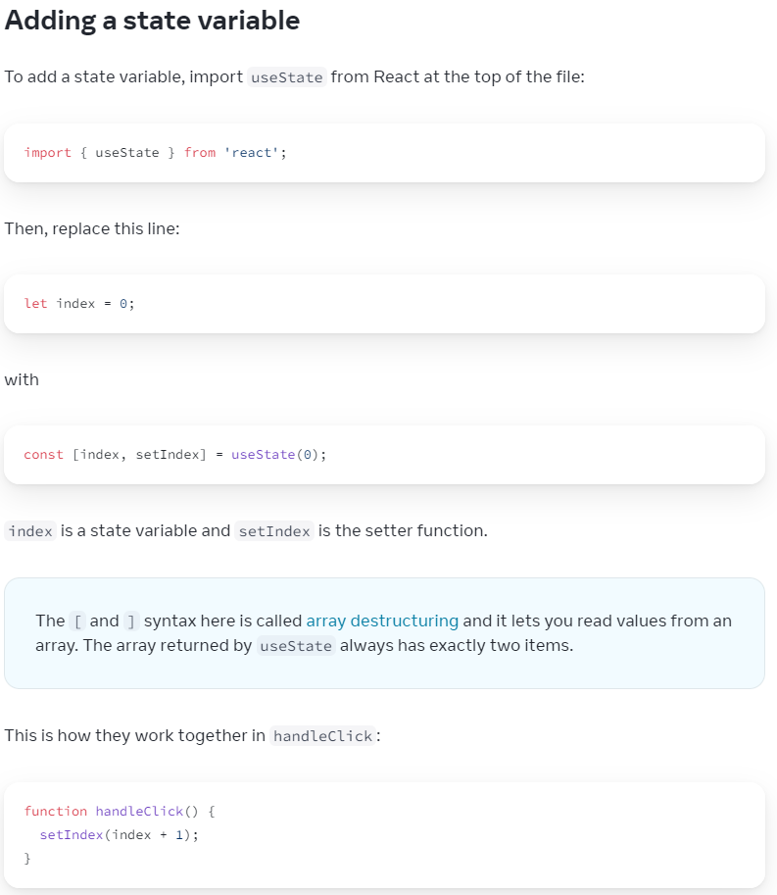

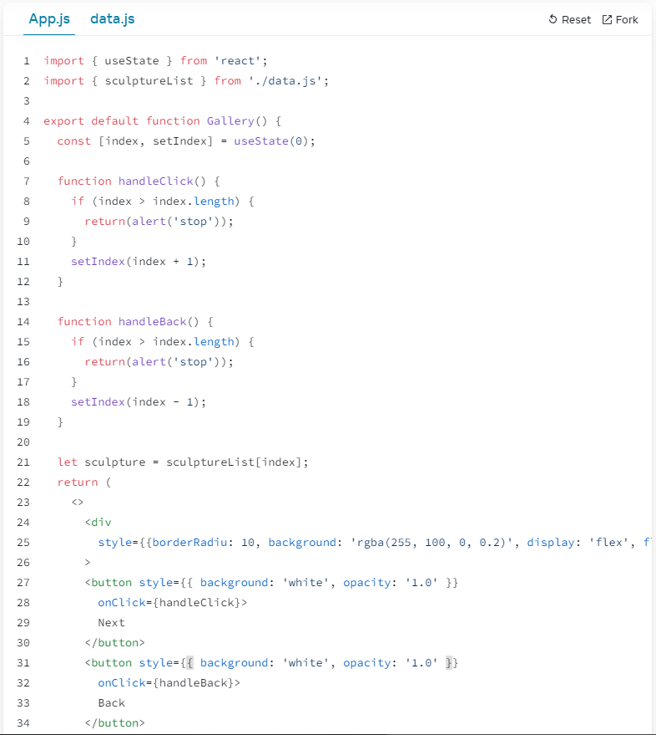

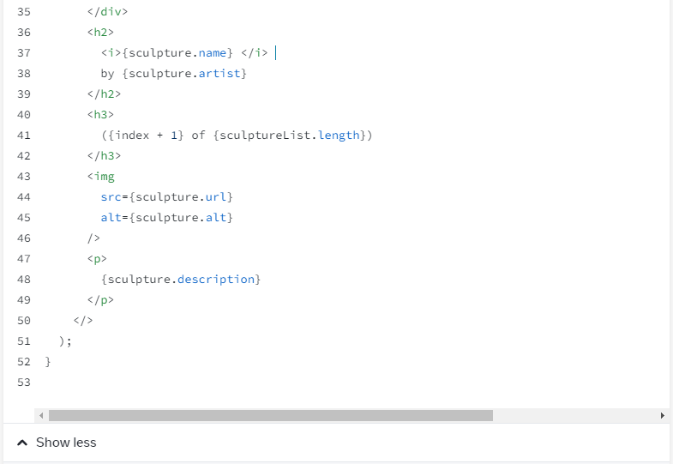

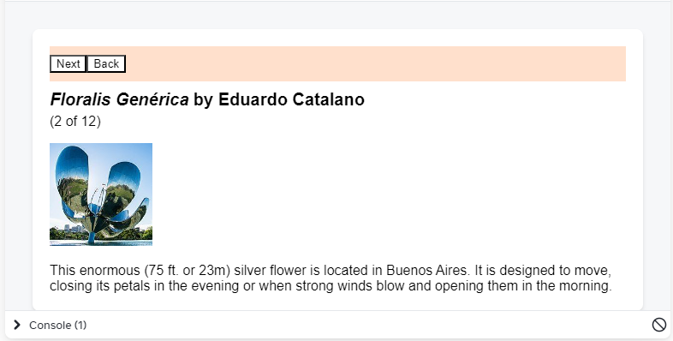

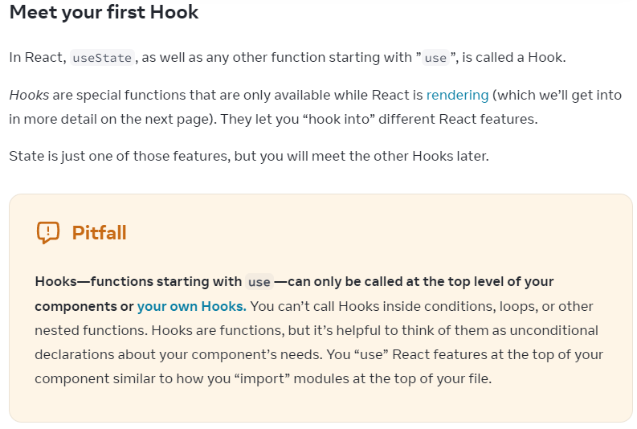

useState, useEffect, useXXX = Hooks

Let you "hook into" different React features

***Can only be called at Top level of components

*** similar to import XXX from './XXX.js';

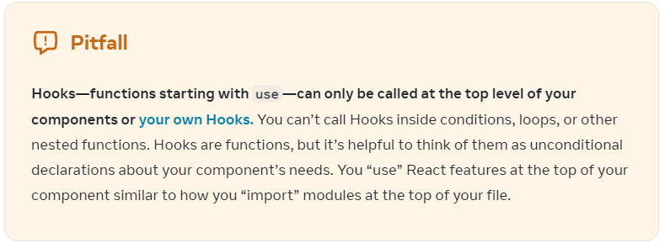

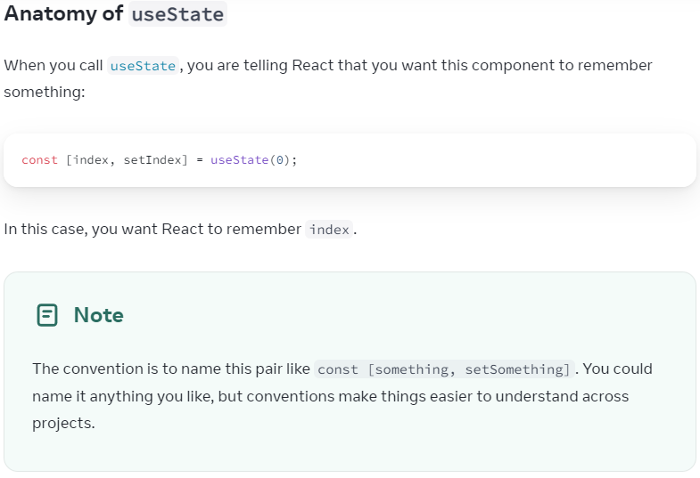

// Wanting to remember something:

const [something, setSomething] = useState(0);

1. **Your component renders the first time:**

useState(0) = 0 is passed to 'useState' for initial 'index';

return (

[0, setIndex]

)

React remembers 0 = latest state value;

2. **You update the state:**

handleNext() button -> setIndex(index + 1);

index = 0;

setIndex(1);

React is told to remeber index = 1 now

3. **Your component's second render:**

React still sees 'useState(0)', but

as React remembers you set index = 1, returns

[1, setIndex] instead

4. And so on

**Giving a component multiple state variables**

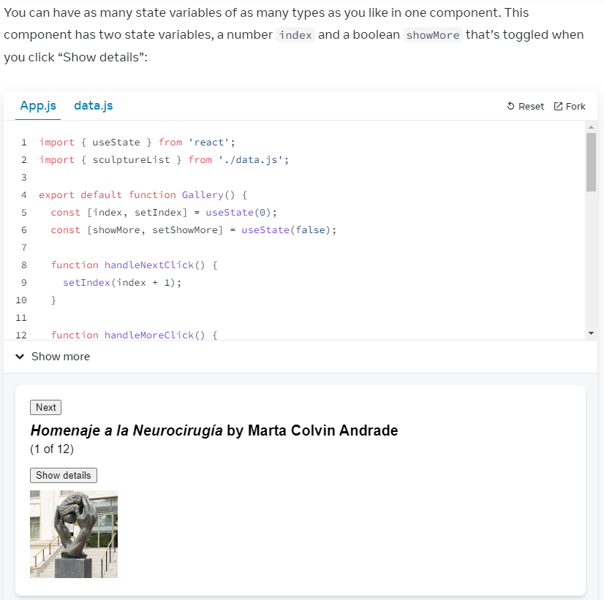

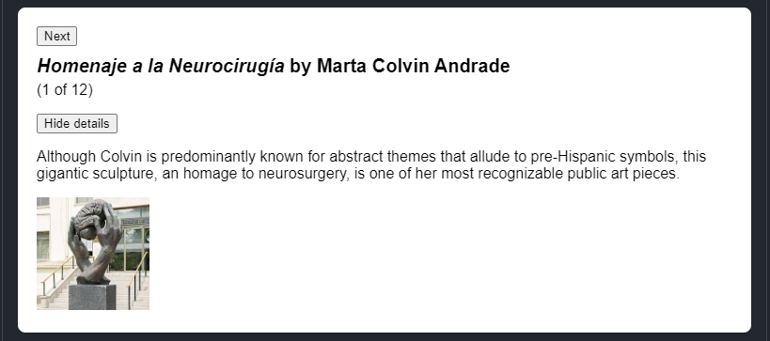

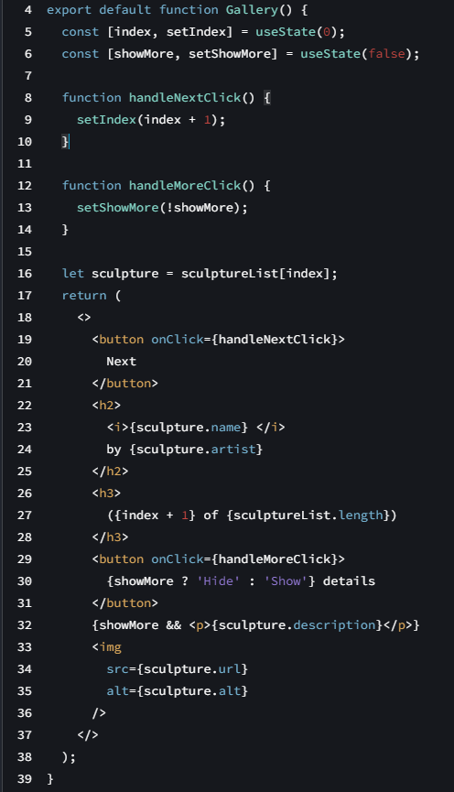

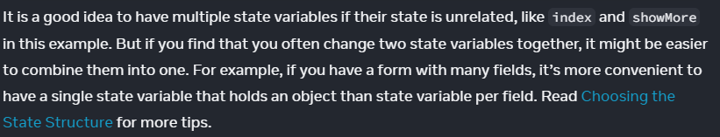

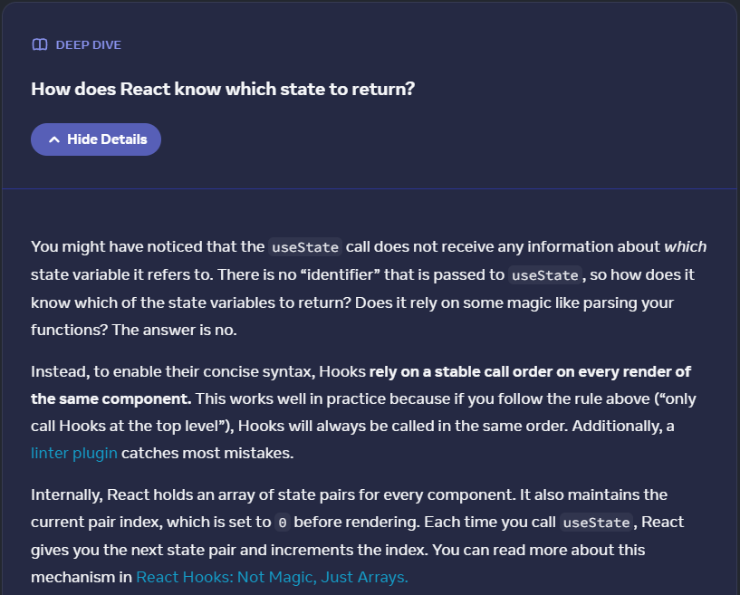

<https://medium.com/@ryardley/react-hooks-not-magic-just-arrays-cd4f1857236e>

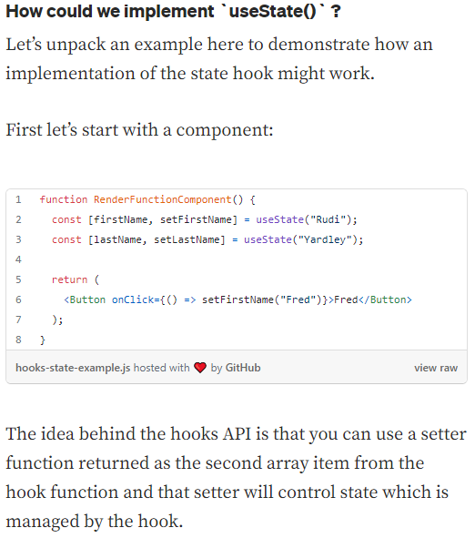

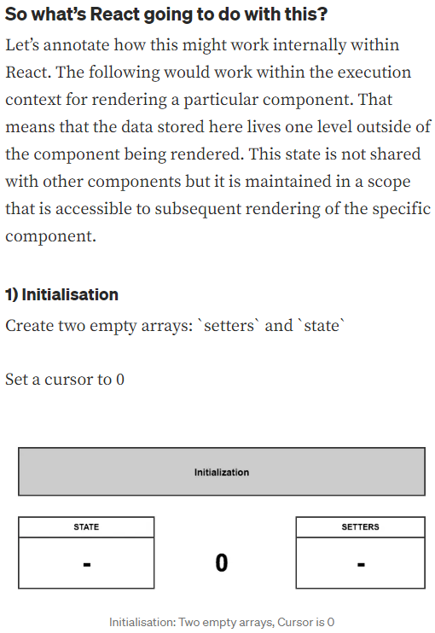

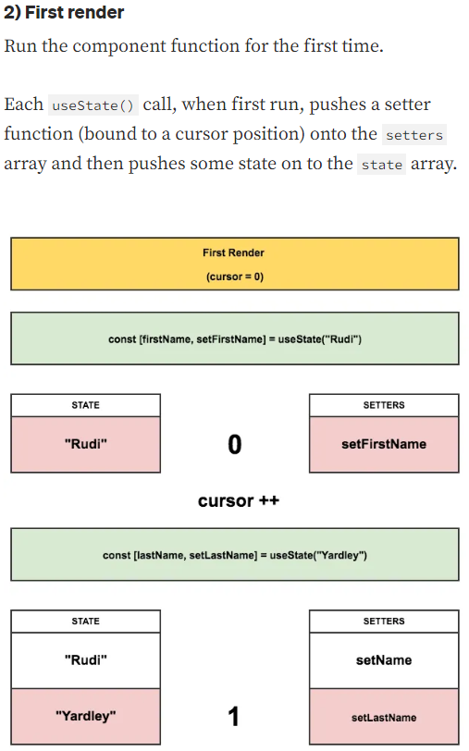

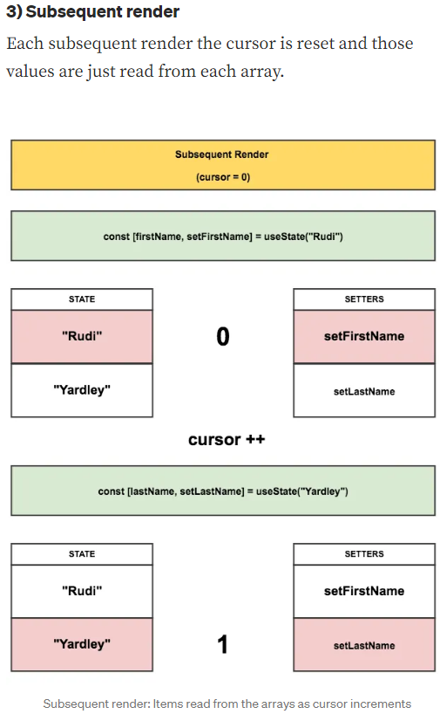

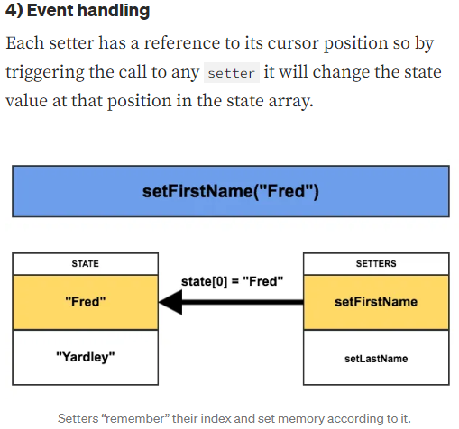

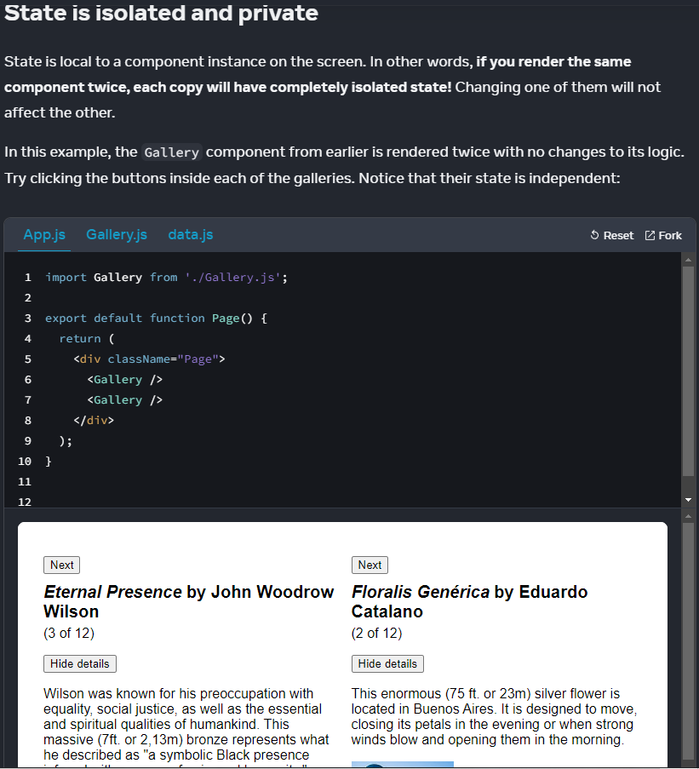

State is NOT tied to a specific function call OR

a place in code

State is local to the specific place on screen.

**State is fully private to component declaring it**

**Parent component CANNOT change State**

==========Challenge 1 of 4

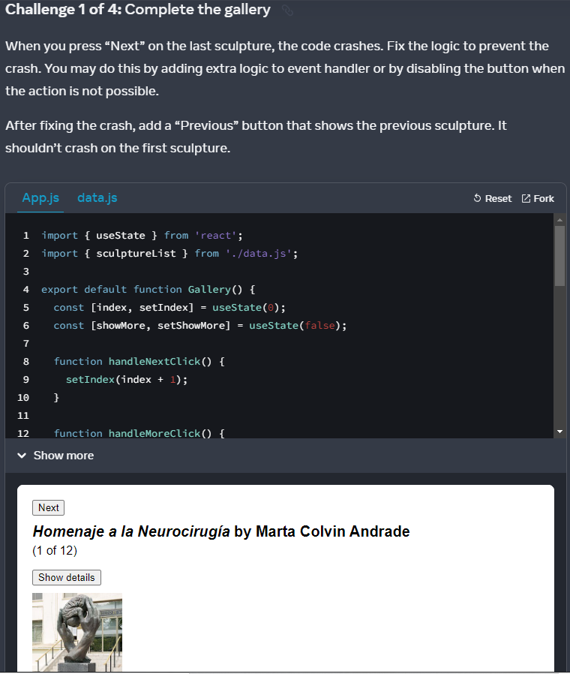

Question:

import { useState } from 'react';

import { sculptureList } from './data.js';

export default function Gallery() {

const [index, setIndex] = useState(0);

const [showMore, setShowMore] = useState(false);

function handleNextClick() {

setIndex(index + 1);

}

function handleMoreClick() {

setShowMore(!showMore);

}

let sculpture = sculptureList[index];

return (

<>

<button onClick={handleNextClick}>

Next

</button>

<h2>

<i>{sculpture.name} </i>

by {sculpture.artist}

</h2>

<h3>

({index + 1} of {sculptureList.length})

</h3>

<button onClick={handleMoreClick}>

{showMore ? 'Hide' : 'Show'} details

</button>

{showMore && <p>{sculpture.description}</p>}

<img

src={sculpture.url}

alt={sculpture.alt}

/>

</>

);

}

Solution:

import { useState } from 'react';

import { sculptureList } from './data.js';

export default function Gallery() {

const [index, setIndex] = useState(0);

const [showMore, setShowMore] = useState(false);

let hasNext = index < sculptureList.length - 1;

let hasPrev = index > 0;

function handleNextClick() {

if (hasNext) {

setIndex(index + 1);

}

}

function handlePre() {

if (hasPrev) {

setIndex(index - 1);

}

}

function handleMoreClick() {

setShowMore(!showMore);

}

let sculpture = sculptureList[index];

return (

<>

<button onClick={handleNextClick} disabled={!hasNext}>

Next

</button>

<button onClick={handlePre} disabled={!hasPrev}>

Previous

</button>

<h2>

<i>{sculpture.name} </i>

by {sculpture.artist}

</h2>

<h3>

({index + 1} of {sculptureList.length})

</h3>

<button onClick={handleMoreClick}>

{showMore ? 'Hide' : 'Show'} details

</button>

{showMore && <p>{sculpture.description}</p>}

<img

src={sculpture.url}

alt={sculpture.alt}

/>

</>

);

}

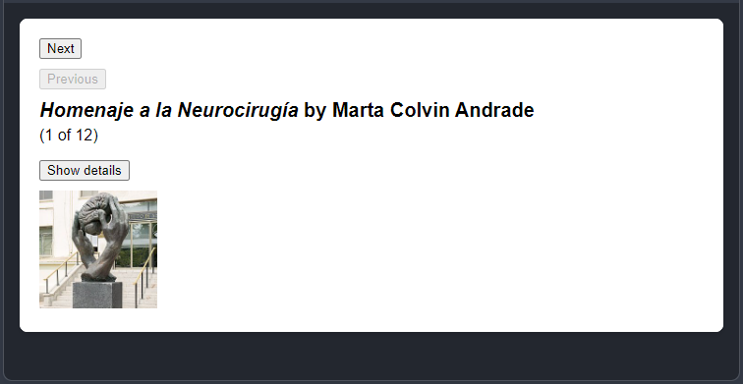

=====Challenge 2 of 4 Fix stuck form inputs

Conceptual findings:

import { useState } from 'react';

export default function Form() {

// useState

// firstName initial value = ""

const [firstName, setFirstName] = useState("");

const [lastName, setLastName] = useState("");

// eventListener "firstName"

function handleFirstNameChange(e) {

setFirstName(e.target.value);

}

// eventListener "lastName"

function handleLastNameChange(e) {

setLastName(e.target.value);

}

function handleReset() {

setFirstName("");

setLastName("");

}

return (

// form prevent default refresh on submit event

<form onSubmit={e => e.preventDefault()}>

<input

placeholder="First name"

value={firstName}

onChange={handleFirstNameChange}

/>

<input

placeholder="Last name"

value={LasttName}

onChange={handleLastNameChange}

/>

<h1>Hi, {firstName} {lastName}</h1>

<button onClick={handleReset}>Reset</button>

);

}

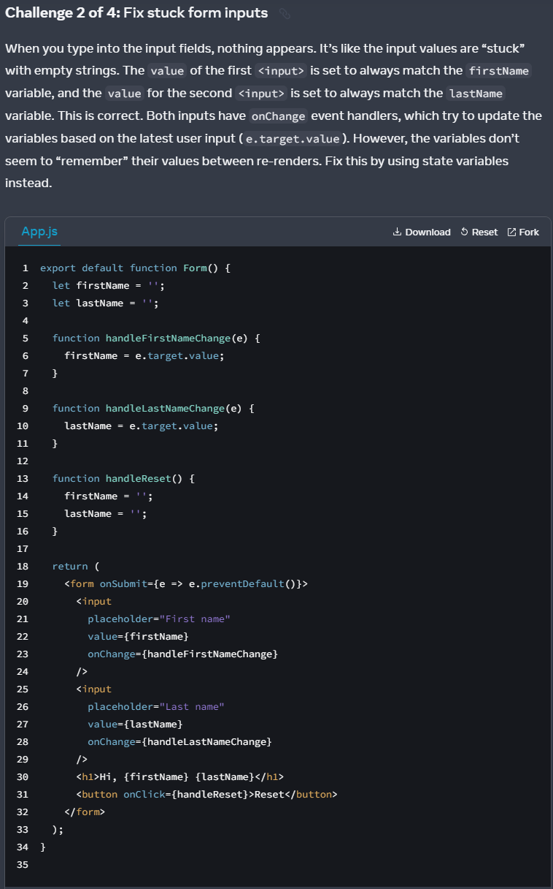

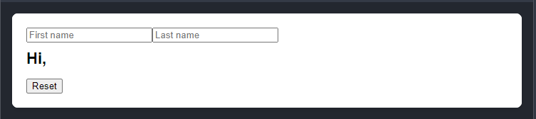

Question:

export default function Form() {

let firstName = '';

let lastName = '';

function handleFirstNameChange(e) {

firstName = e.target.value;

}

function handleLastNameChange(e) {

lastName = e.target.value;

}

function handleReset() {

firstName = '';

lastName = '';

}

return (

<form onSubmit={e => e.preventDefault()}>

<input

placeholder="First name"

value={firstName}

onChange={handleFirstNameChange}

/>

<input

placeholder="Last name"

value={lastName}

onChange={handleLastNameChange}

/>

<h1>Hi, {firstName} {lastName}</h1>

<button onClick={handleReset}>Reset</button>

</form>

);

}

My Solution:

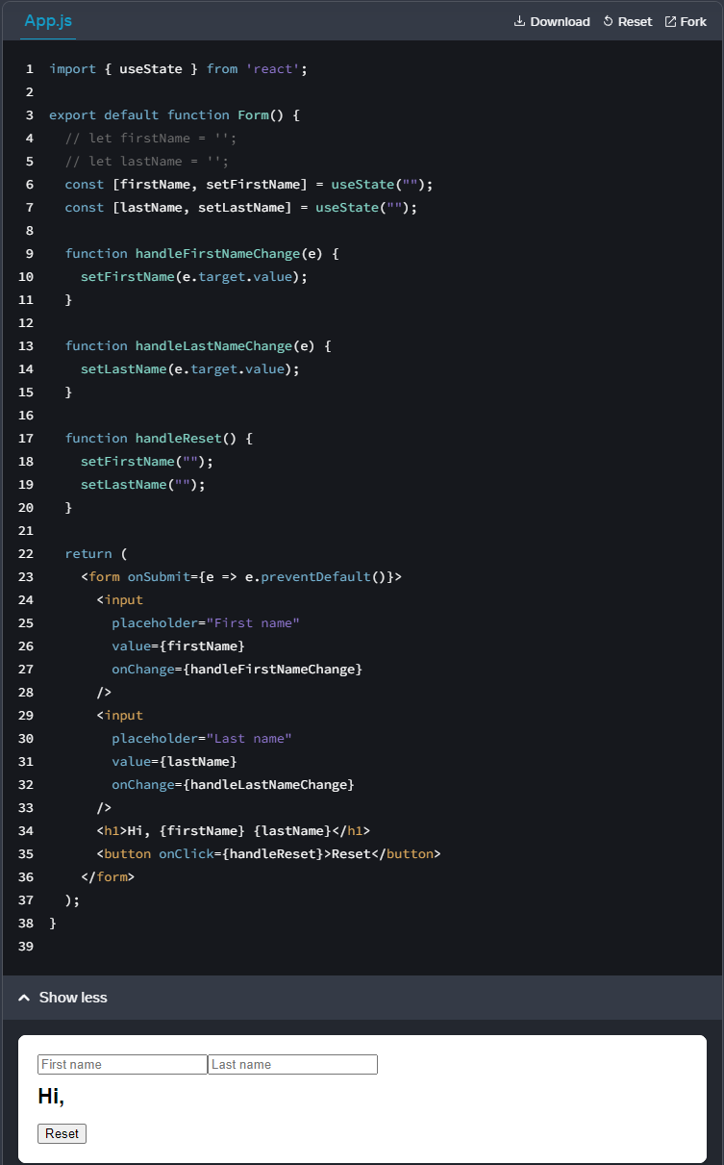

Code:

// Need useState from react

import { useState } from 'react';

export default function Form() {

// let firstName = '';

// let lastName = '';

// useState

const [firstName, setFirstName] = useState("");

const [lastName, setLastName] = useState("");

function handleFirstNameChange(e) {

setFirstName(e.target.value);

}

function handleLastNameChange(e) {

setLastName(e.target.value);

}

function handleReset() {

setFirstName("");

setLastName("");

}

return (

<form onSubmit={e => e.preventDefault()}>

<input

placeholder="First name"

value={firstName}

onChange={handleFirstNameChange}

/>

<input

placeholder="Last name"

value={lastName}

onChange={handleLastNameChange}

/>

<h1>Hi, {firstName} {lastName}</h1>

<button onClick={handleReset}>Reset</button>

</form>

);

}

Testing:

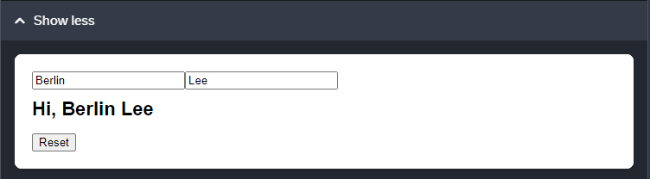

Reset:

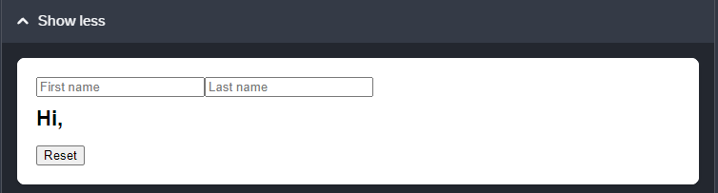

====Challenge 3 of 4

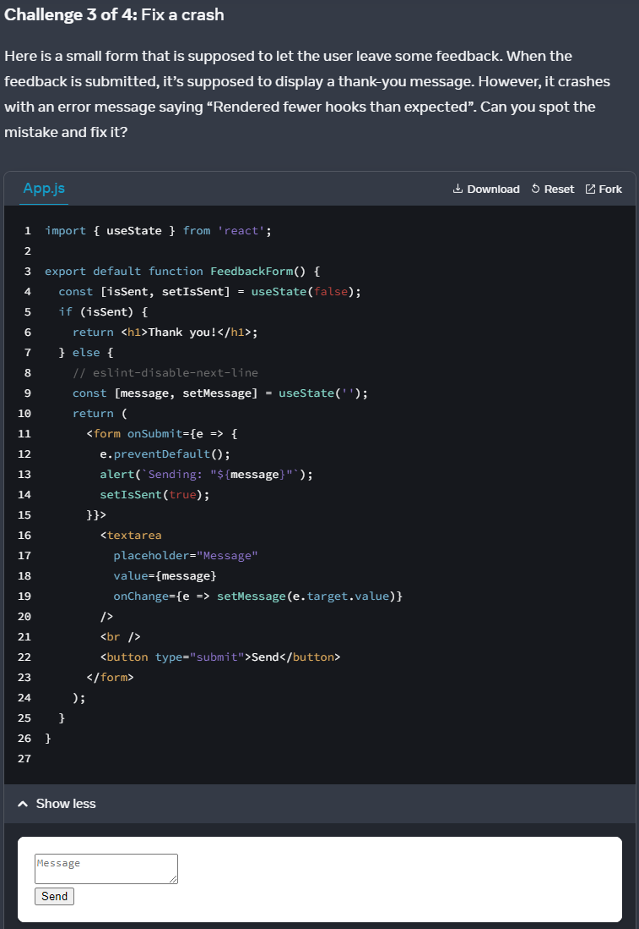

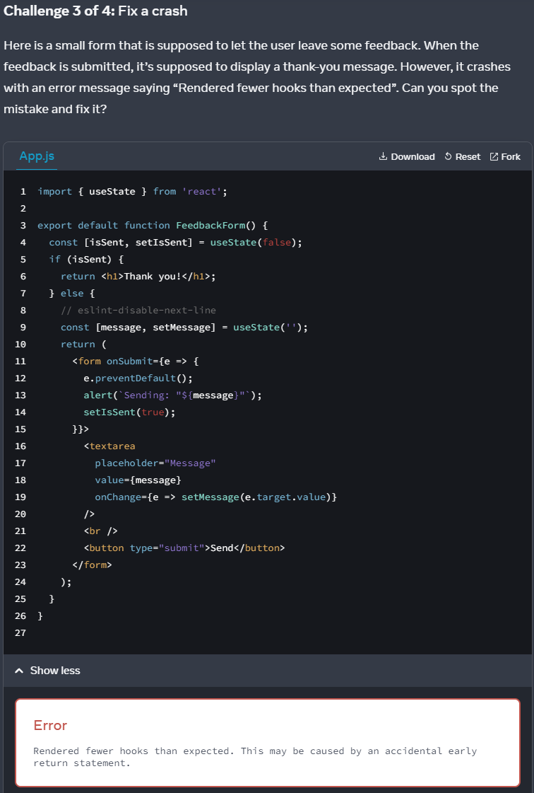

Code review:

import { useState } from 'react';

export default function FeedbackForm() {

const [isSent, setIsSent] = useState(false);

if (isSent) {

return <h1>Thank you!</h1>;

} else {

// setState cannot be used in conditional statement

const [message, setMessage] = useState('');

return (

// Can use arrow func, instead of inline event Listener

<form onSubmit={e => {

e.preventDefault();

alert(`Sending: "${message}"`);

setIsSent(true);

}}>

<textarea

placeholder="Message"

value={message}

// Can use arrow func, instead of inline event Listener

onChange={e => setMessage(e.target.value)}

/>

<br />

<button type="submit">Send</button>

</form>

);

}

}

My solution:

import { useState } from 'react';

export default function FeedbackForm() {

// useState should not be used in any conditional statements/ loops

const [isSent, setIsSent] = useState(false);

const [message, setMessage] = useState('');

if (isSent) {

return <h1>Thank you!</h1>;

} else {

// arrow func for onSubmit

const handleSubmit = (e) => {

e.preventDefault();

alert(`Sending: "${message}"`);

setIsSent(true);

}

// arrow func for onChange

const handleMessage = (e) => {

setMessage(e.target.value);

}

return (

// Lifting handleSubmit

<form onSubmit={handleSubmit}>

<textarea

placeholder="Message"

value={message}

// Lifting handleMessage

onChange={handleMessage}

/>

<br />

<button type="submit">Send</button>

</form>

);

}

}

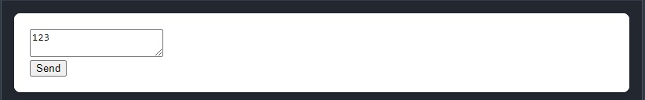

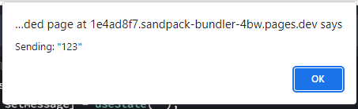

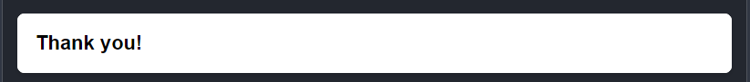

=====Challenge 4 of 4

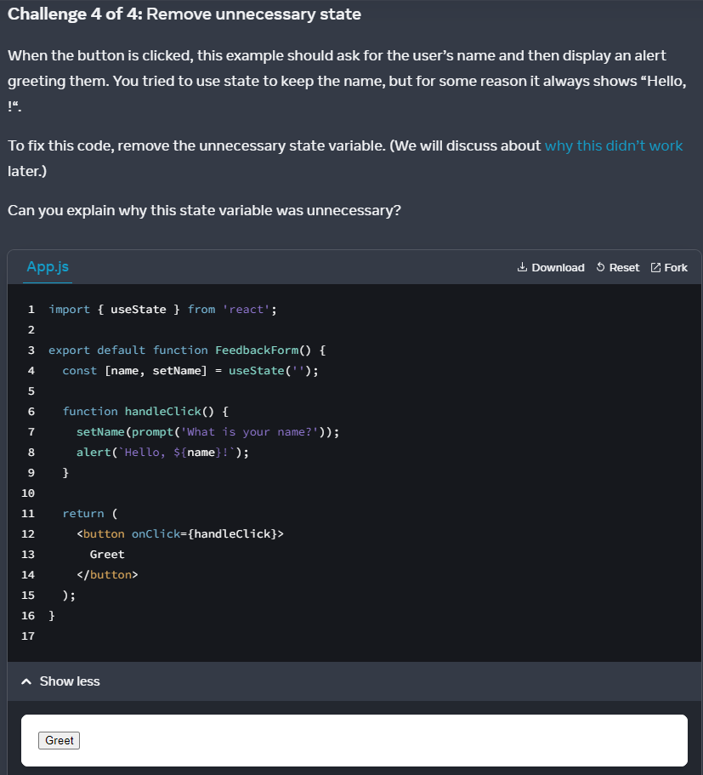

Code review:

import { useState } from 'react';

export default function FeedbackForm() {

const [name, setName] = useState('');

function handleClick() {

// no variable to store new inputs

setName(prompt('What is your name?'));

// returning old ${name}

alert(`Hello, ${name}!`);

}

return (

<button onClick={handleClick}>

Greet

</button>

);

}

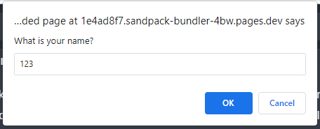

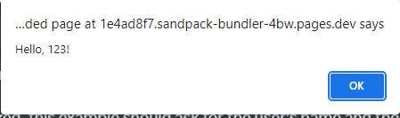

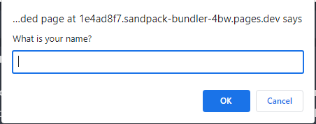





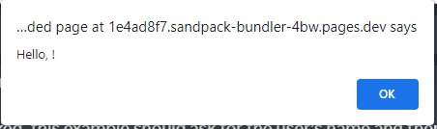

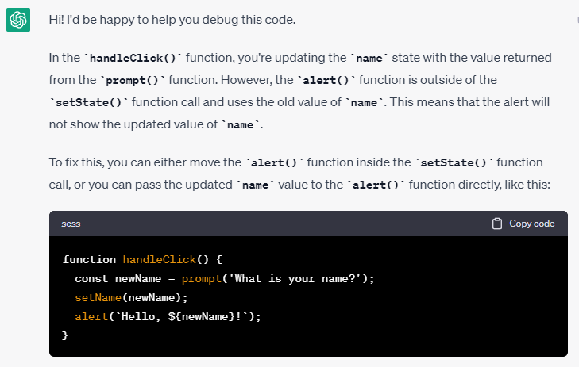

My solution:

import { useState } from 'react';

export default function FeedbackForm() {

const [name, setName] = useState('');

function handleClick() {

// store inputs into a variable: newName

const newName = prompt('What is your name?');

// useState to change name -> newName

setName(newName);

// return up-to-date name

alert(`Hello, ${newName}!`);

}

return (

<button onClick={handleClick}>

Greet

</button>

);

}









Render and Commit

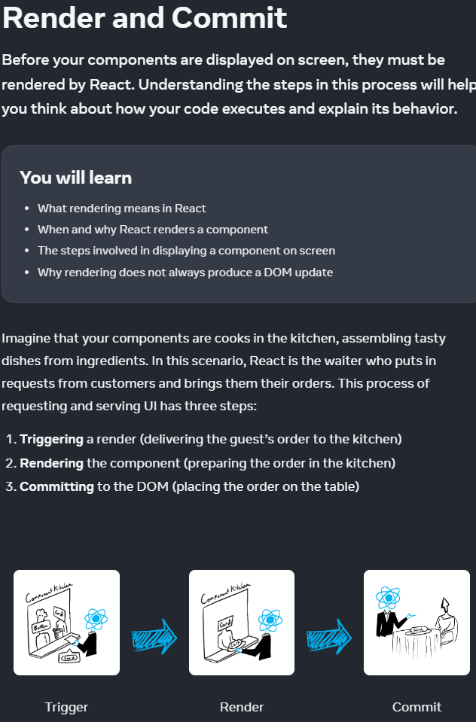

React -> receives Trigger from users ->

React -> pass Trigger to Kitchen ->

React receives Renders from Kitchen ->

React Commits renders to users

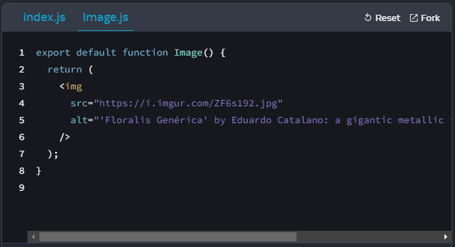

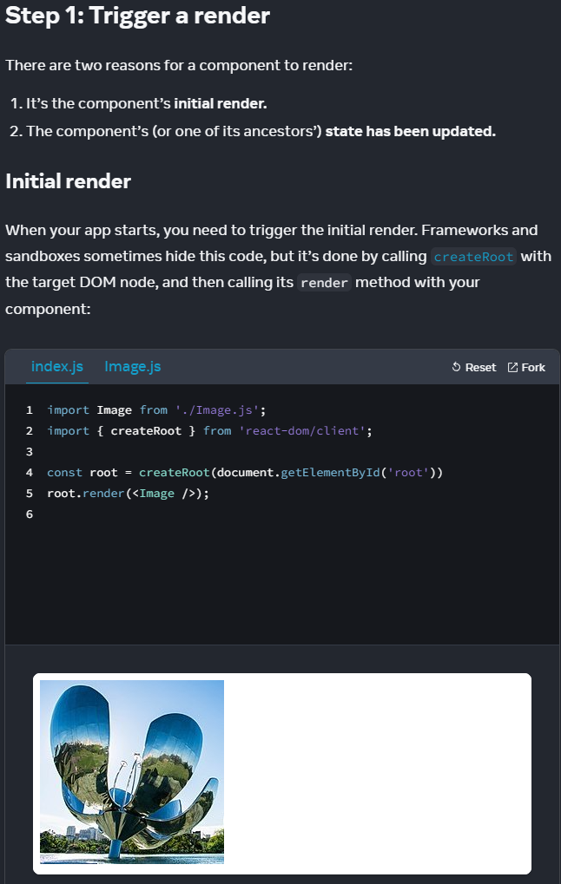

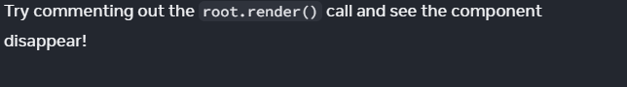

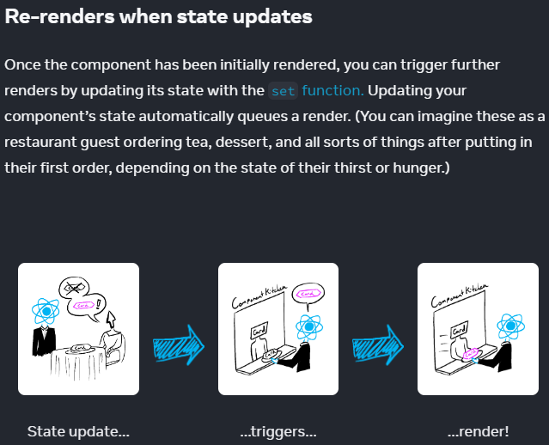

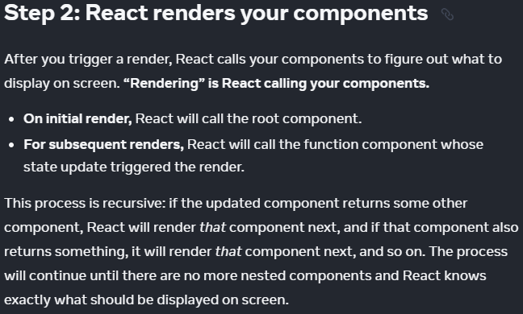

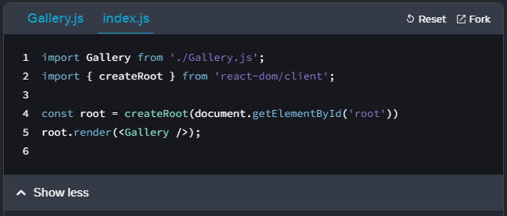

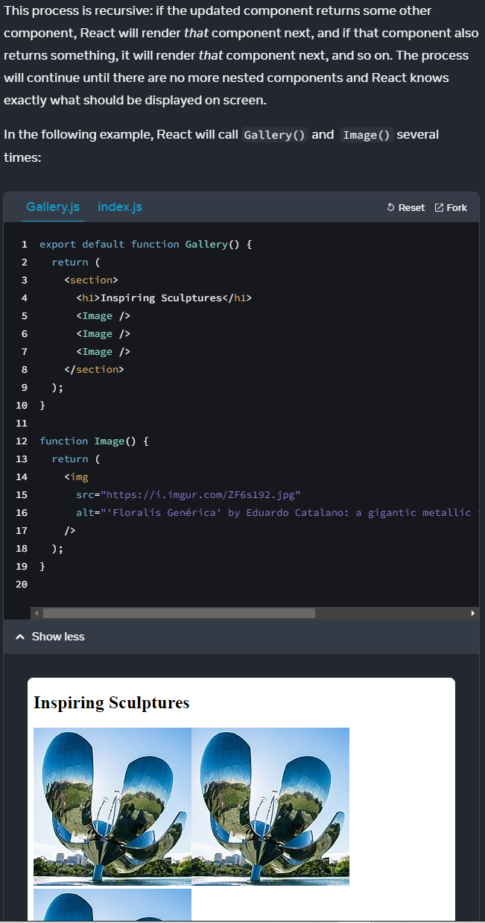

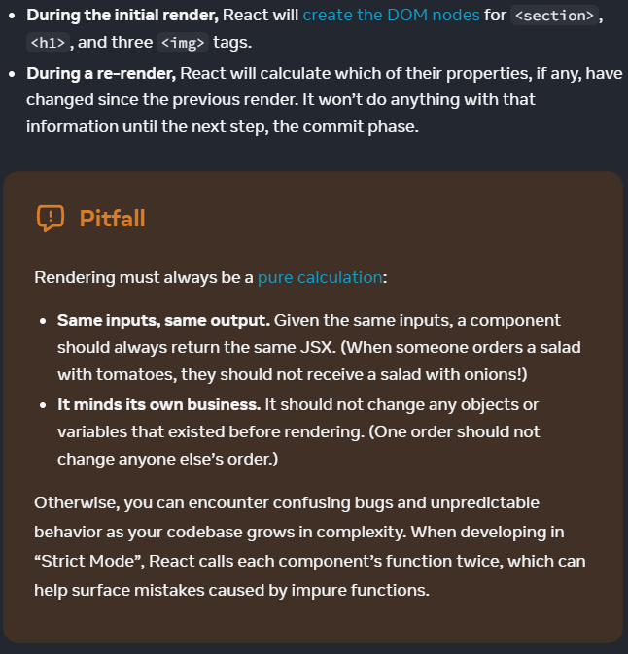

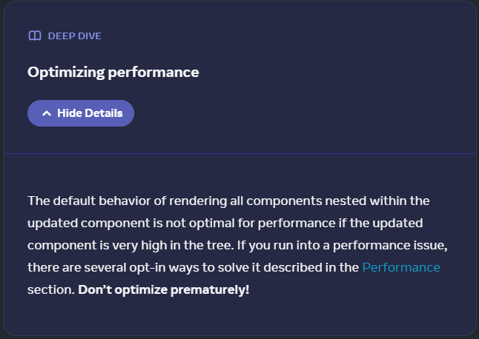

<https://legacy.reactjs.org/docs/optimizing-performance.html>

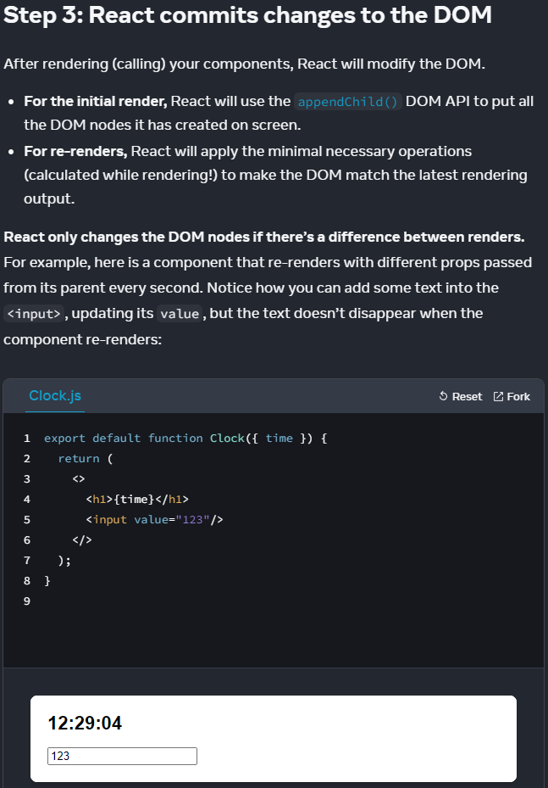

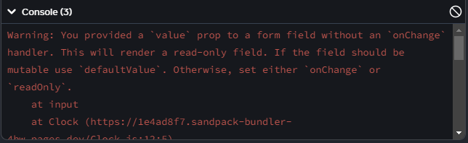

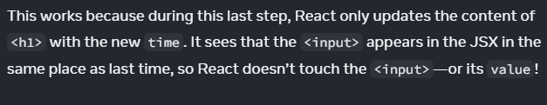

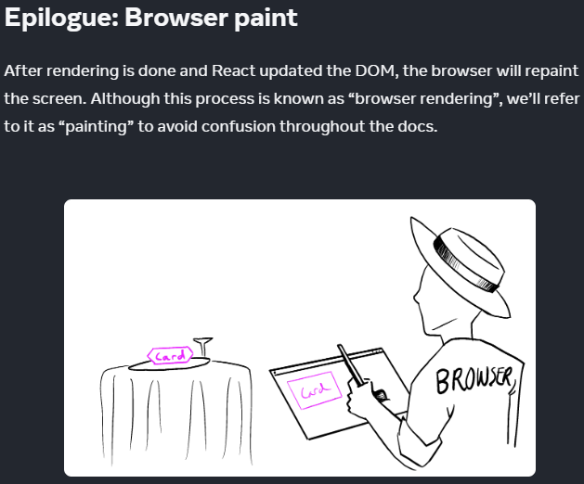

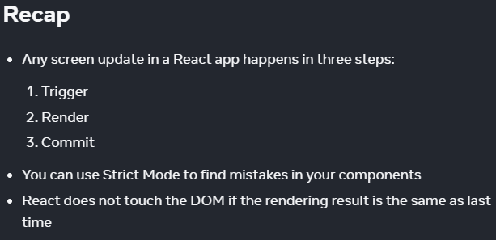

State as a Snapshot

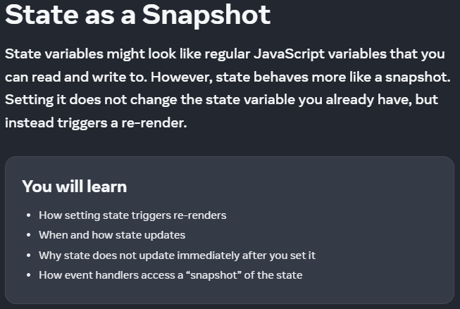

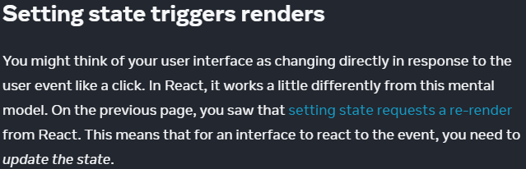

React renders initial DOM -> receives Triggers -> manipulate setState ->

calculations -> re-render Components -> update state -> Commit re-render

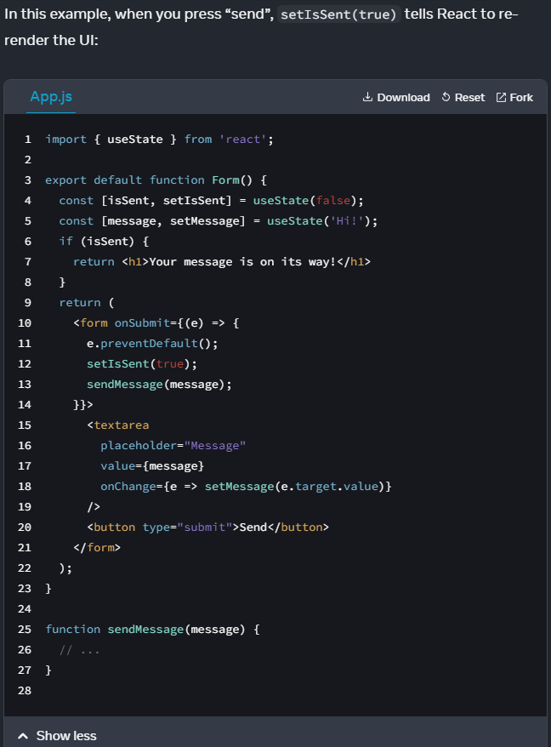

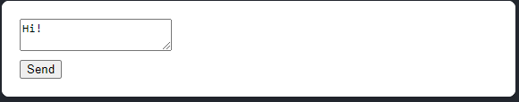

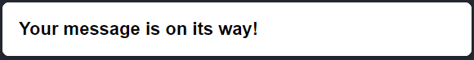

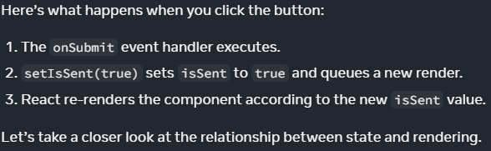

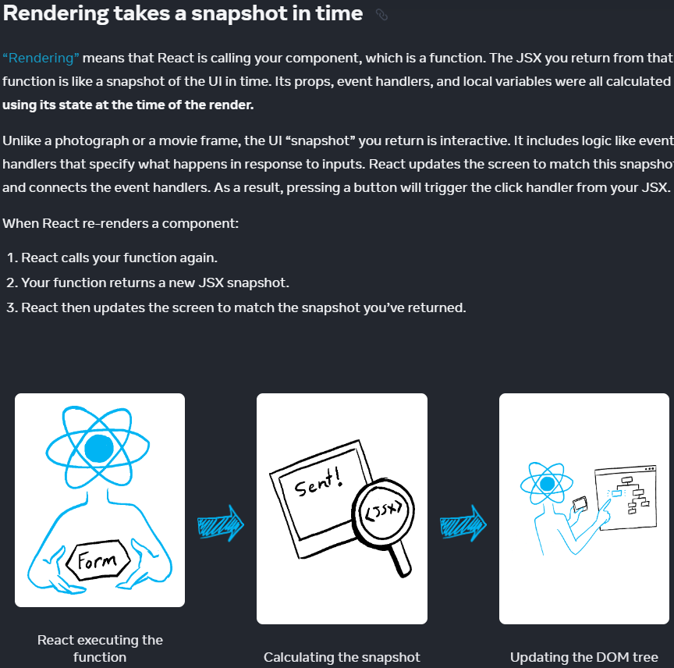

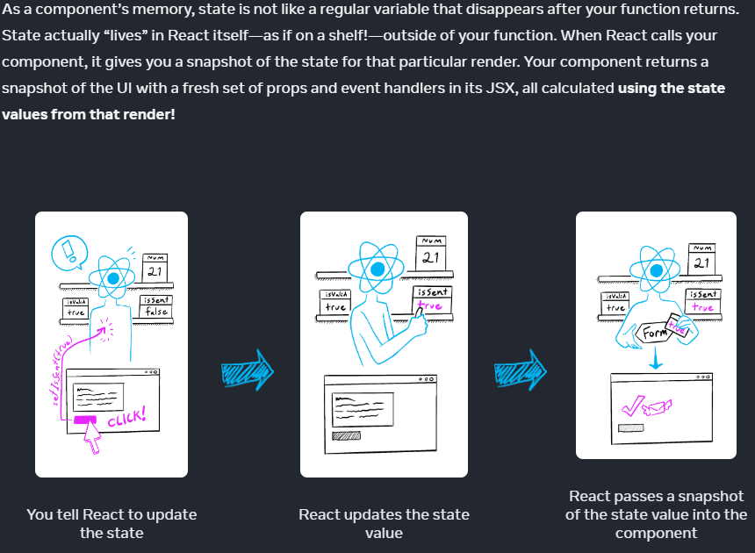

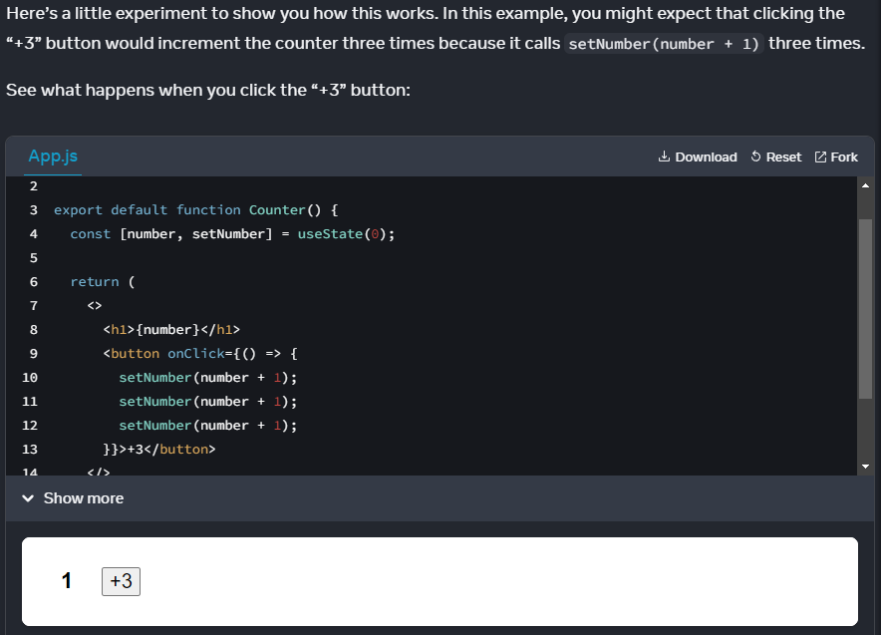

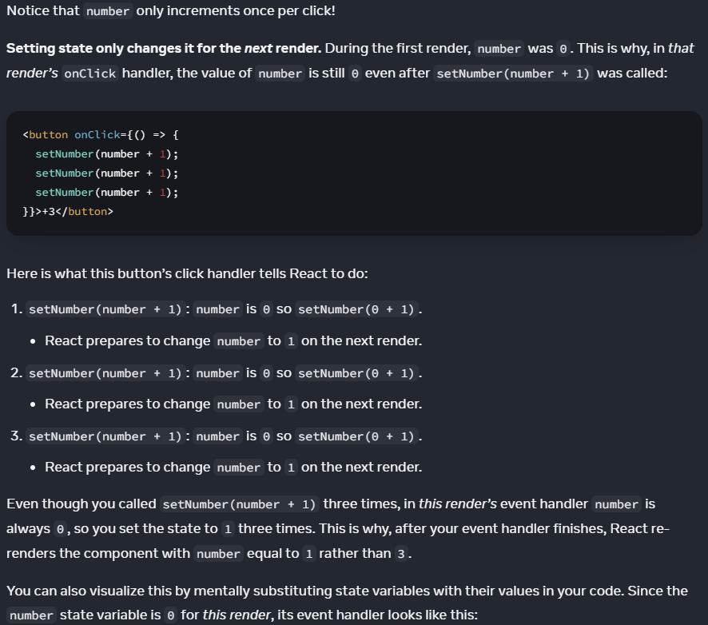

Experimenting:

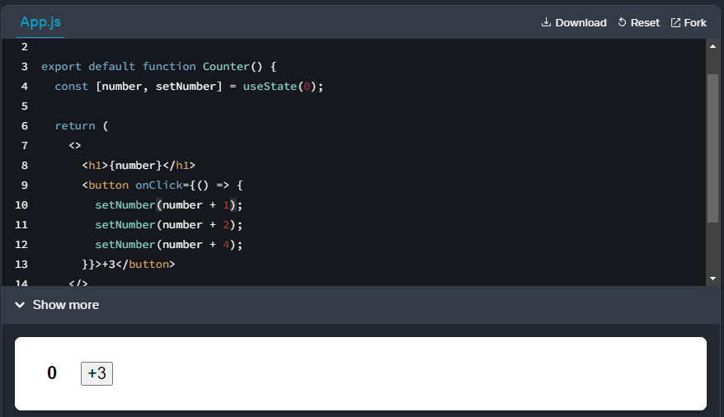

// Only the last line ran

Cuz we’d like to run multiple setState()

We’ll need to patch all setState() into one batch

setNumber(number + 4);

[number, setNumber] = useState(0);

0 click: [0, setNumber] = useState(0);

1st click:

setNumber(0 + 4) = 4;

[4, setNumber] = useState(4);

2nd click:

setNumber(4 + 4) = 8;

[8, setNumber] = useState(8);

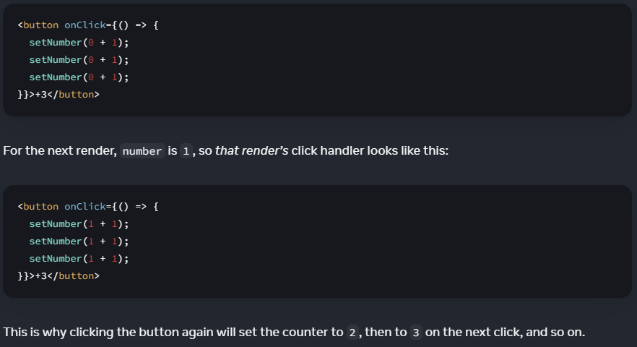

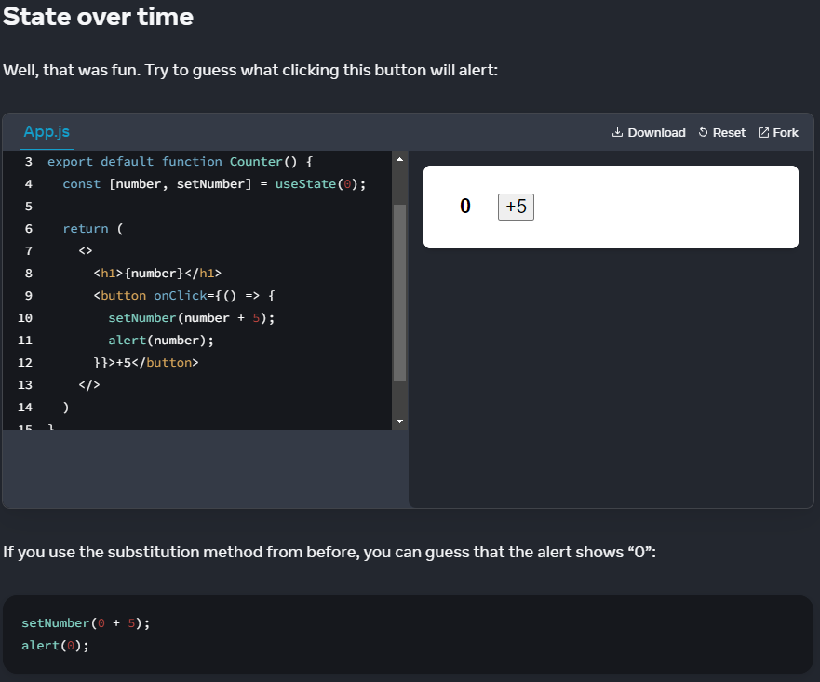

number = 0;

setNumber(0 + 5);

alert(number) -> alert('0')

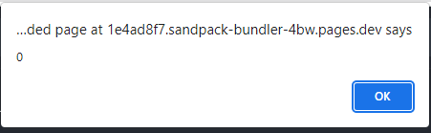

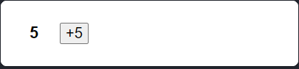

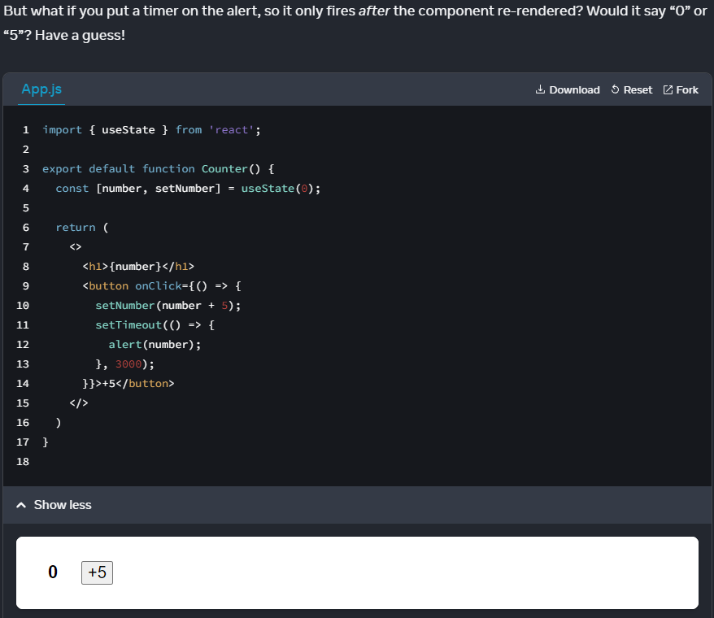

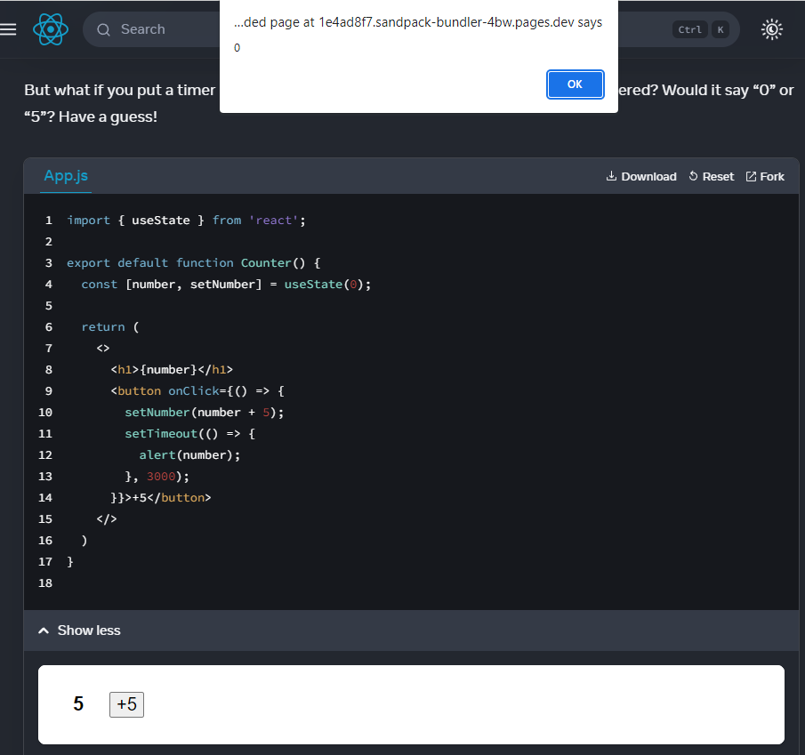

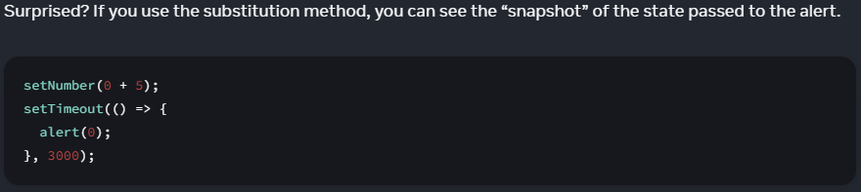

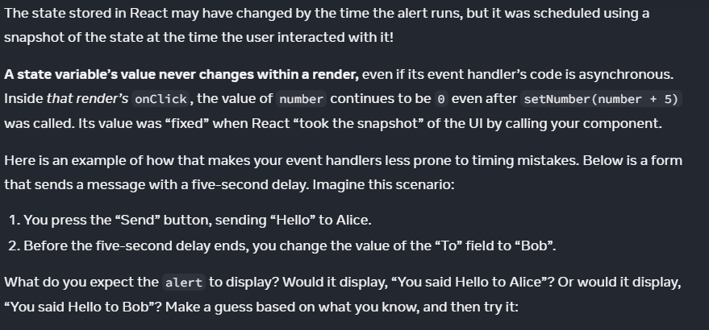

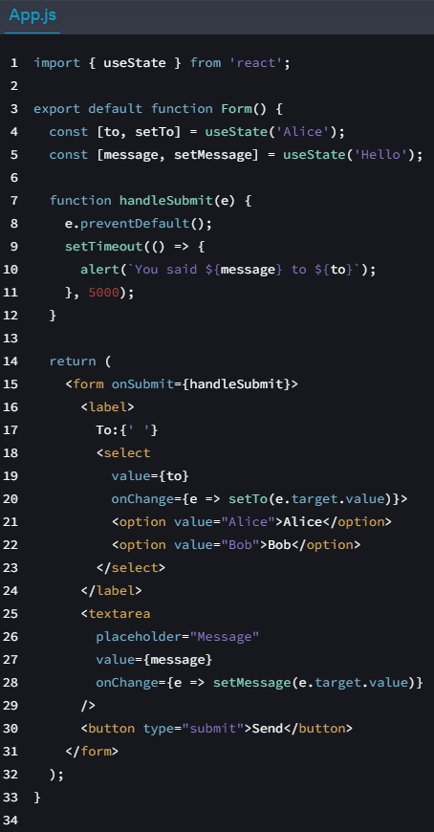

click 'Send' -> Changed To: Bob

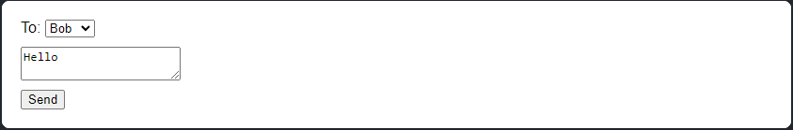

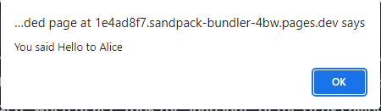

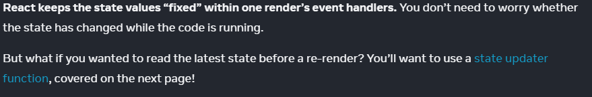

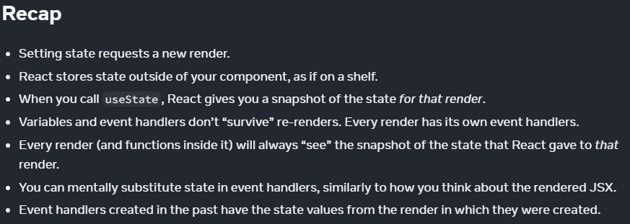

====Challenge 1 of 1

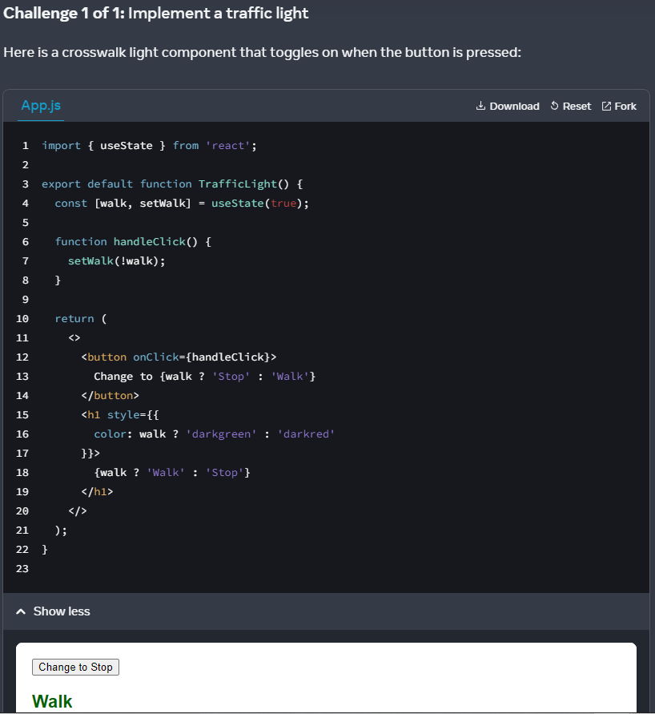

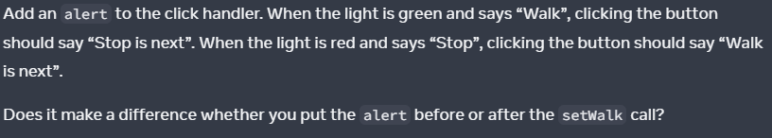

Solution:

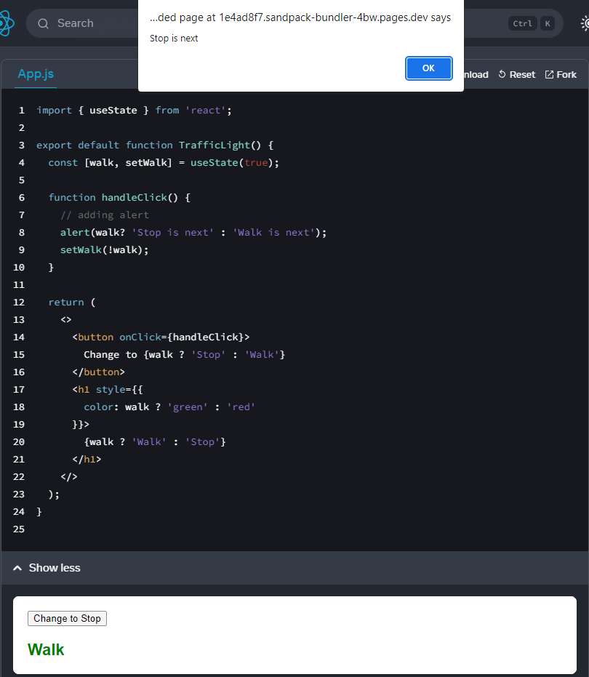

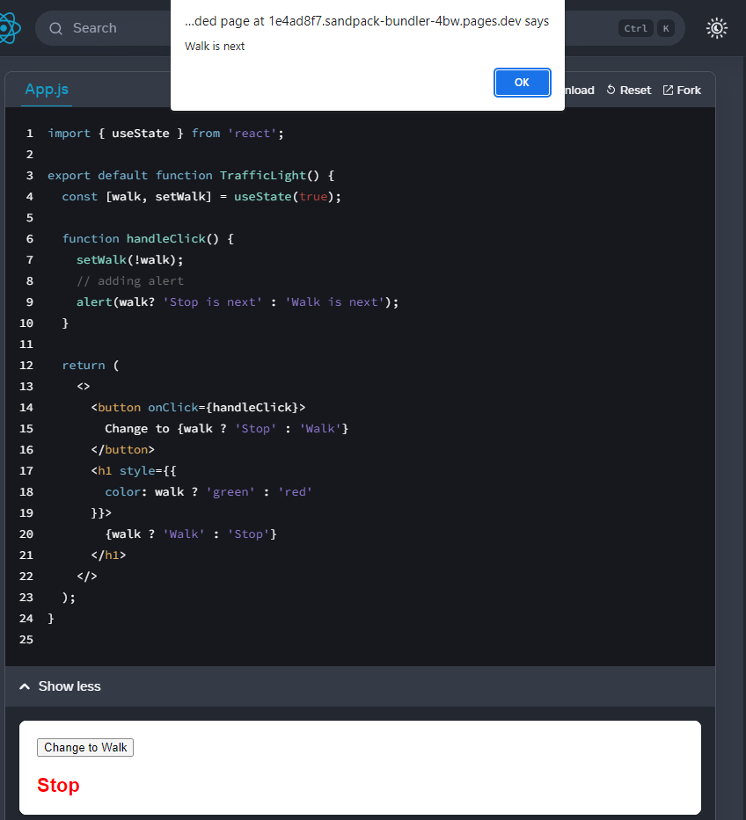

It makes NO difference whether you put 'alert' before/after setWalk call

(setting State does NOT change the state variable you already have)

because React remembers the current state(snapshot) of render.

State in constructor

==== **State in constructor()**

index.js:

import "bootstrap/dist/css/bootstrap.css";

ReactDOM.render( <Timer me="Props" />, document.getElementById("root) );

Timer.jsx:

import React, { Component } from 'react';

// Inheriting a React.Component attributes & methods

class Timer extends Component {

// Adding constructor()

constructor(props) {

// To instantiate class React.Component

properties or states

// before mounting components to UI

// otherwise, this.props will be undefined

super(props);

// Create state here

this.state = {

value: this.props.me,

counter: 0,

msg: "Click me",

}

}

onClick = () => {

this.setState({

counter: this.state.counter + 1,

msg: "Clicked"

});

}

render() {

return (

<div className="app">

<h5>{this.state.counter}</h5>

<button

className="btn btn-waring"

onClick={this.onClick}

>

{this.state.msg}:{this.state.counter} times

</button>

<p>{this.state.counter}</p>

</div>

);

}

}

export default Timer;

Queueing a Series of State Updates

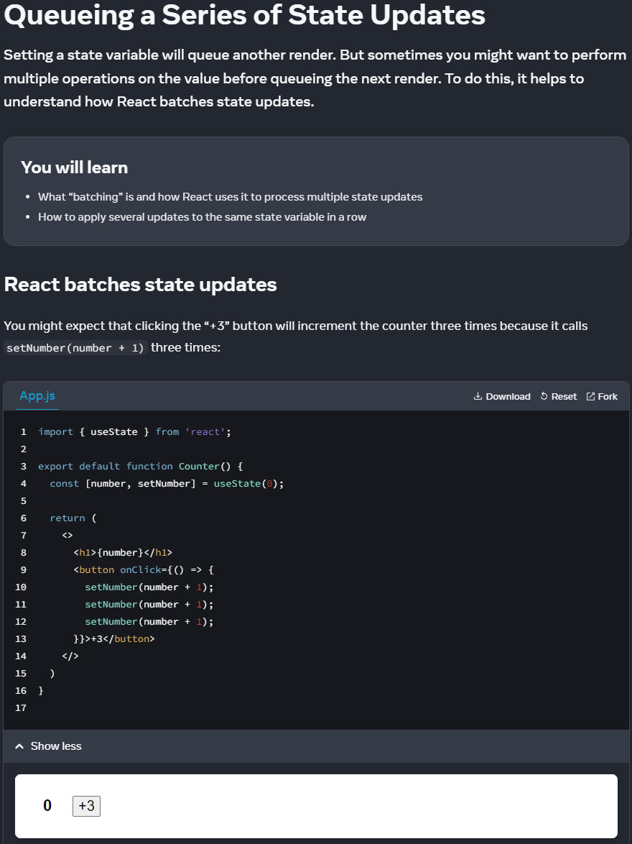

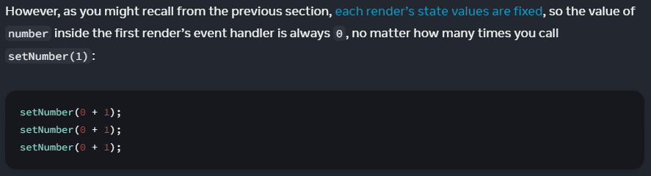

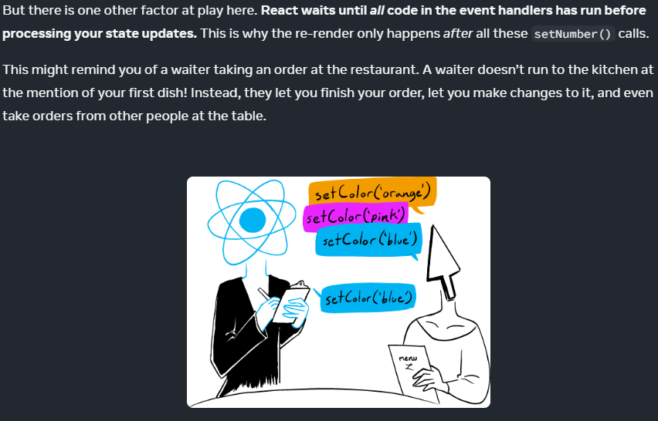

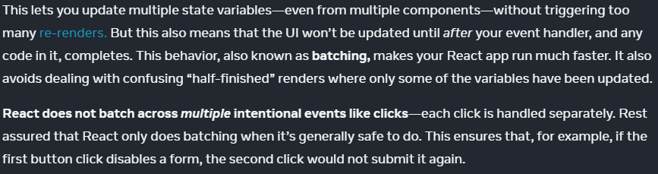

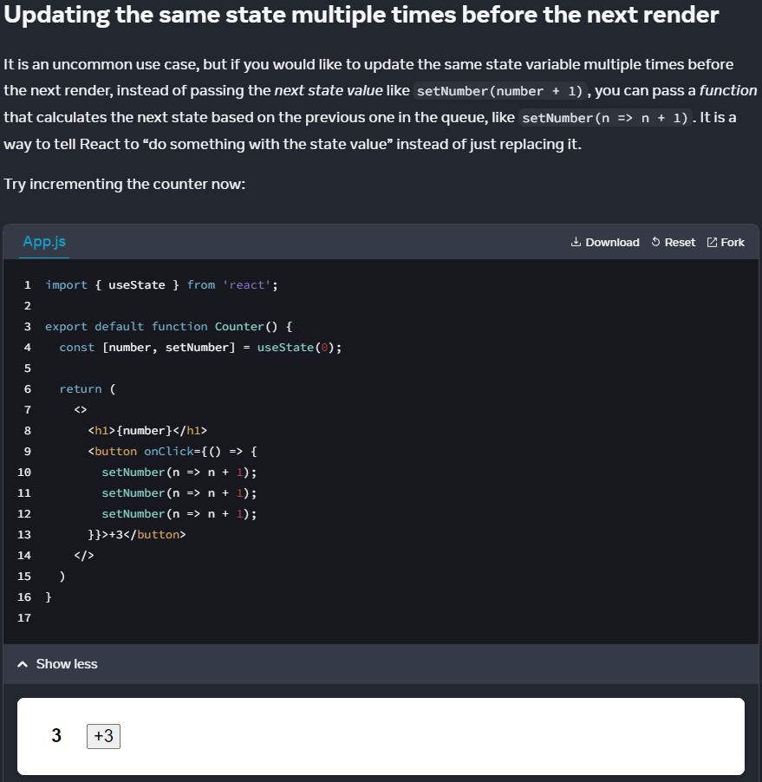

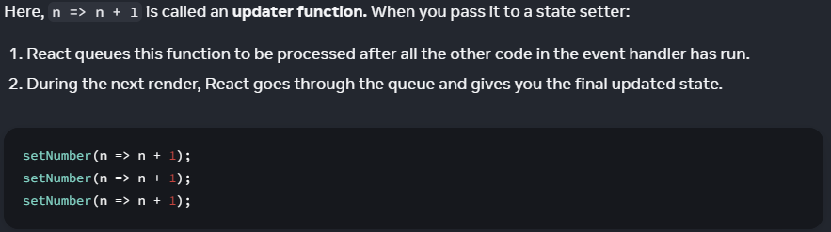

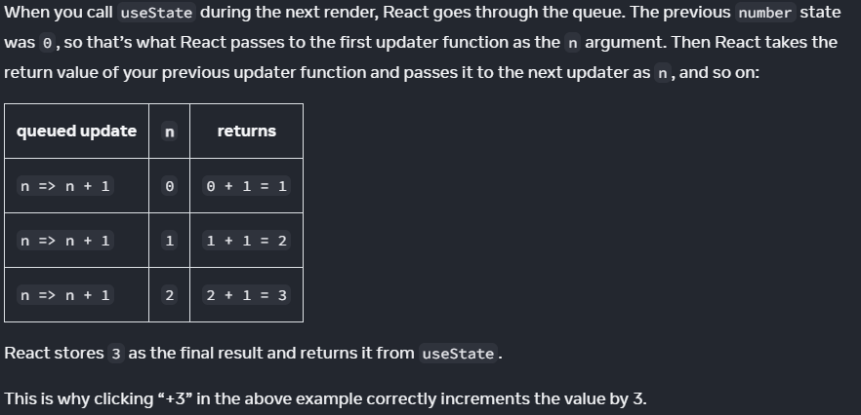

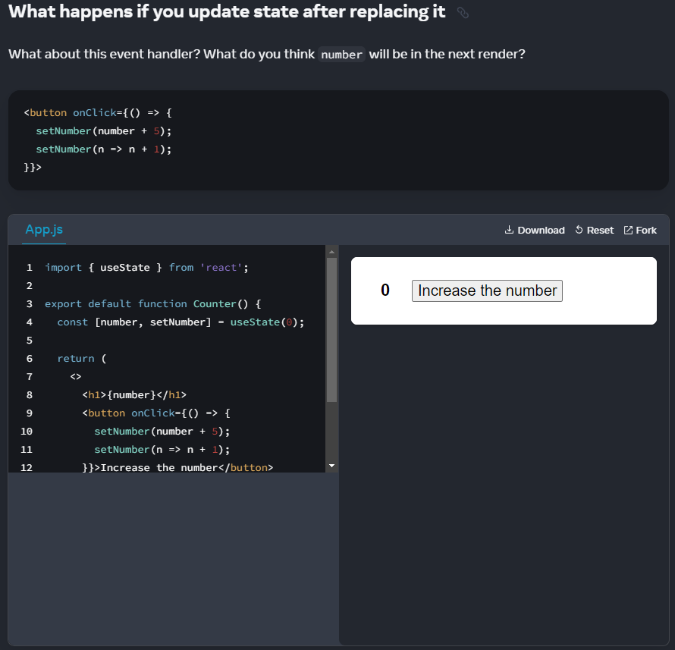

setNumber(0 + 5) -> number = 5 -> setNumber(5 => 5 + 1) -> number = 6;

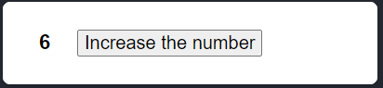

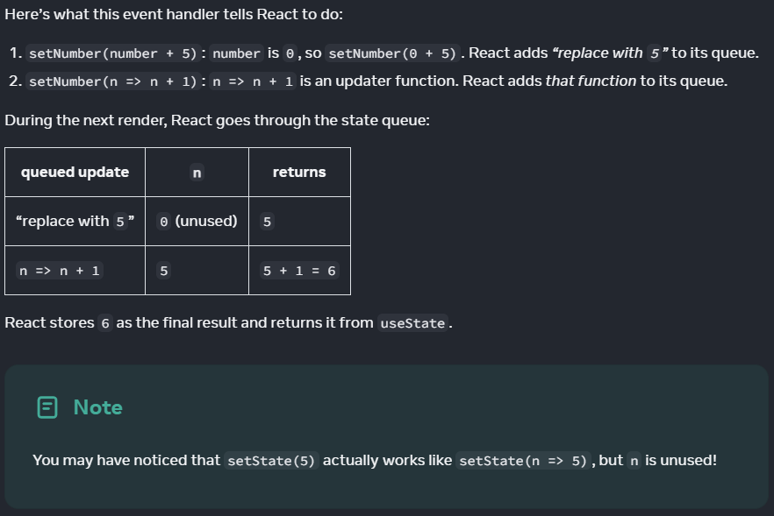

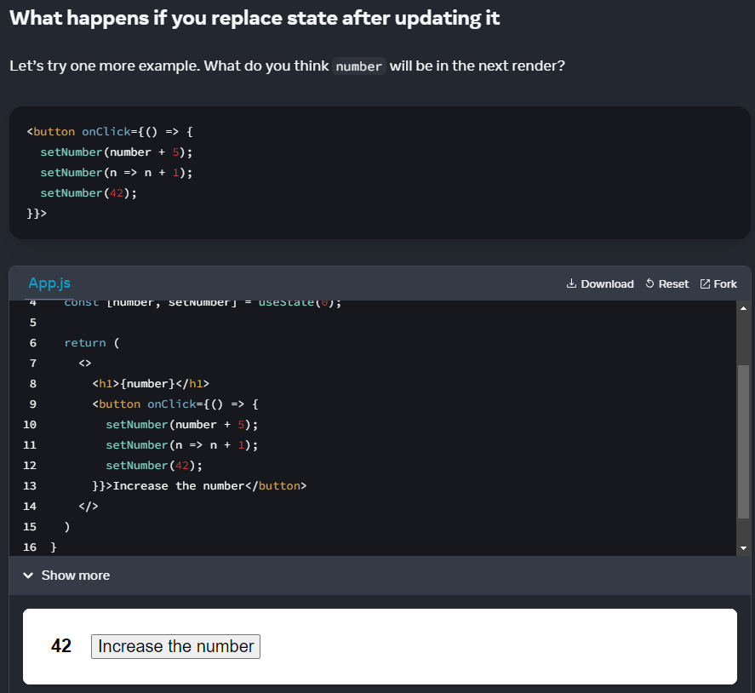

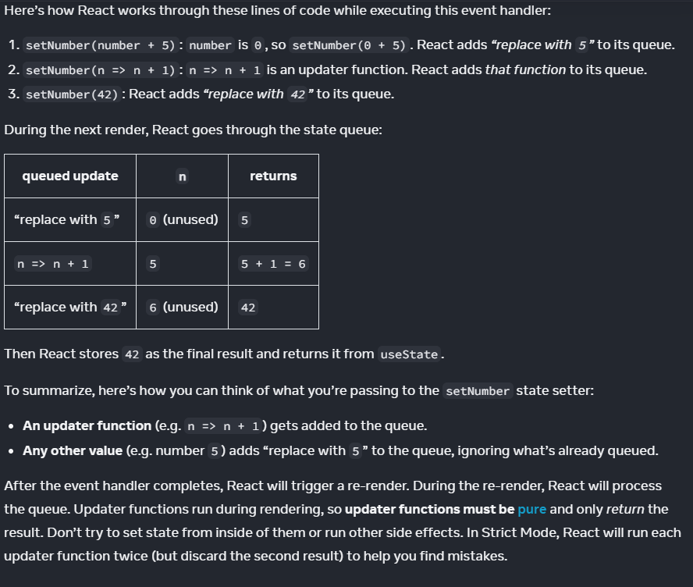

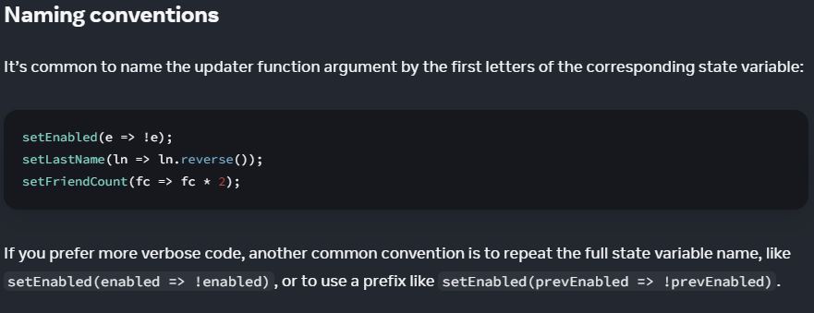

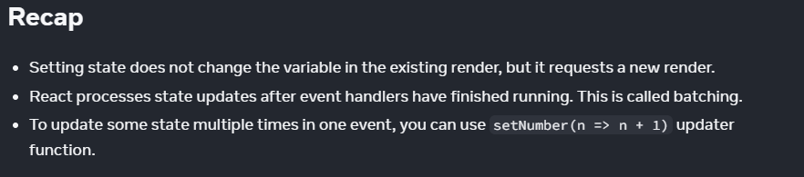

====Challenge 1 of 2

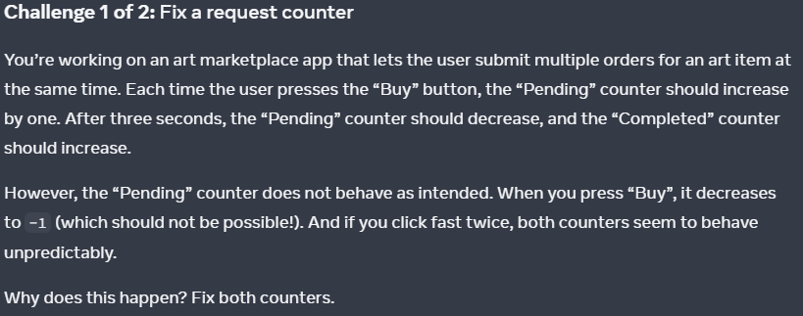

Question:

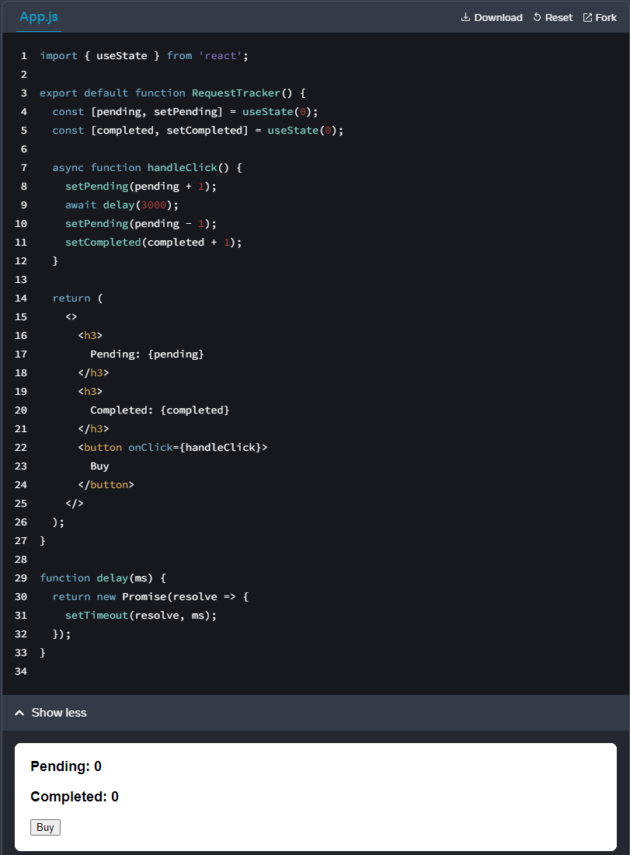

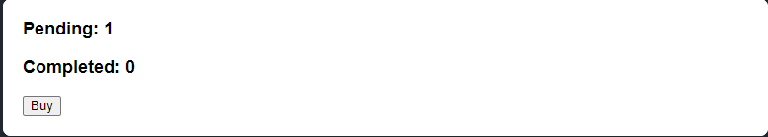

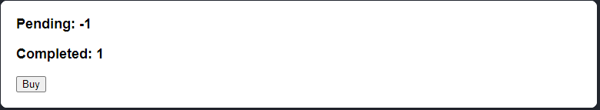

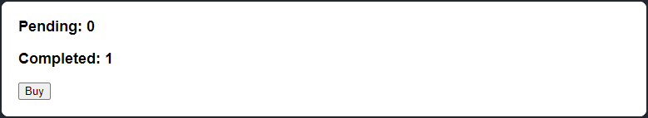

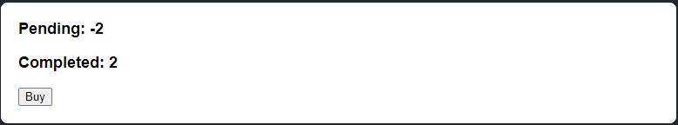

Code review:

import { useState } from 'react';

export default function RequestTracker() {

const [pending, setPending] = useState(0);

const [completed, setCompleted] = useState(0);

async function handleClick() {

// Missing queueing

setPending(pending + 1);

await delay(3000);

setPending(pending - 1);

setCompleted(completed + 1);

}

return (

<>

<h3>

Pending: {pending}

</h3>

<h3>

Completed: {completed}

</h3>

<button onClick={handleClick}>

Buy

</button>

</>

);

}

function delay(ms) {

return new Promise(resolve => {

setTimeout(resolve, ms);

});

}

My solution:

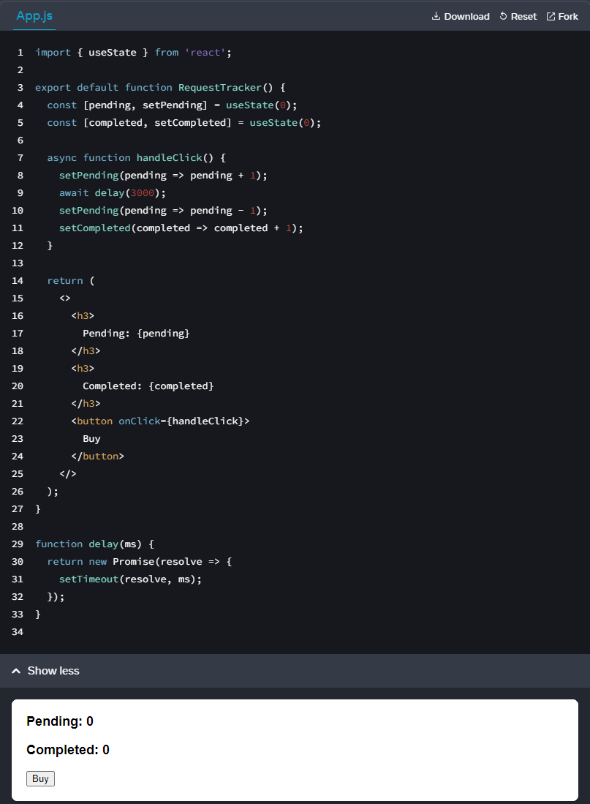

import { useState } from 'react';

export default function RequestTracker() {

const [pending, setPending] = useState(0);

const [completed, setCompleted] = useState(0);

async function handleClick() {

// Adding to queue

setPending(pending => pending + 1);

await delay(3000);

setPending(pending => pending - 1);

setCompleted(completed => completed + 1);

}

return (

<>

<h3>

Pending: {pending}

</h3>

<h3>

Completed: {completed}

</h3>

<button onClick={handleClick}>

Buy

</button>

</>

);

}

function delay(ms) {

return new Promise(resolve => {

setTimeout(resolve, ms);

});

}



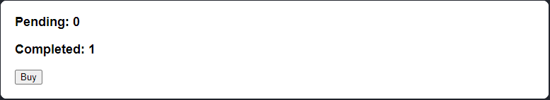

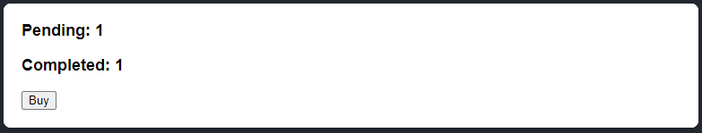

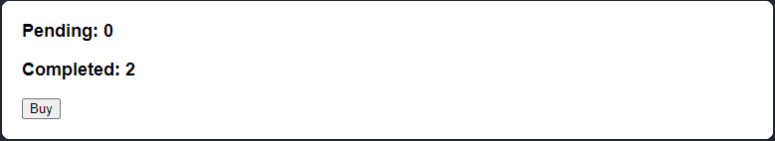

====Challenge 2 of 2

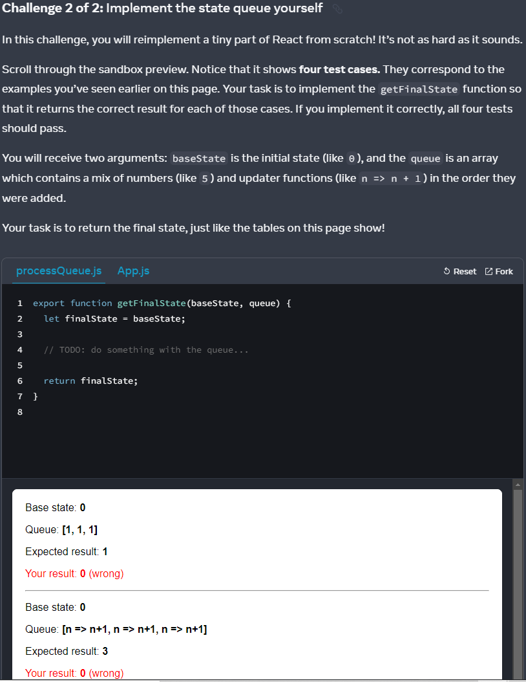

App.js

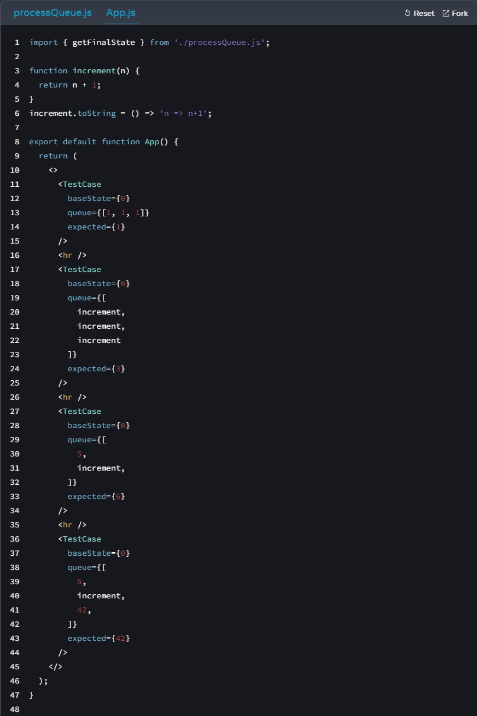

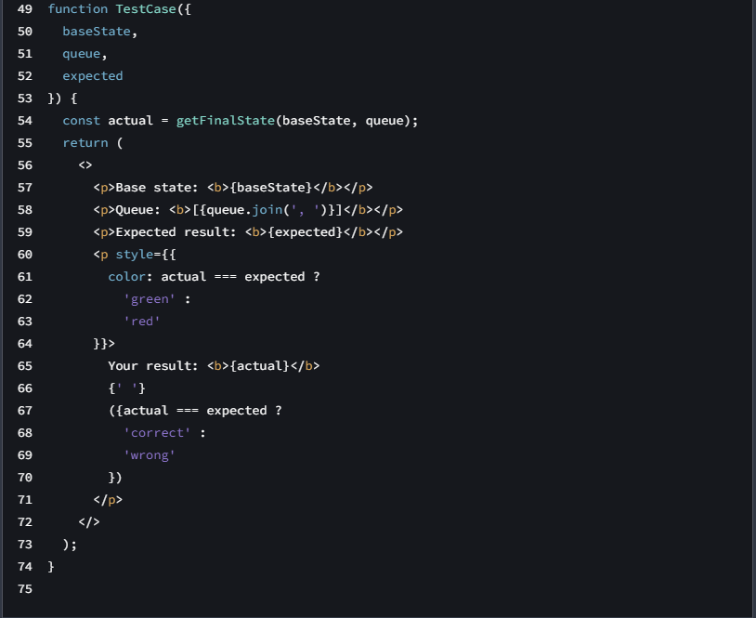

Question - App.js:

import { getFinalState } from './processQueue.js';

function increment(n) {

return n + 1;

}

increment.toString = () => 'n => n+1';

export default function App() {

return (

<>

<TestCase

baseState={0}

queue={[1, 1, 1]}

expected={1}

/>

<hr />

<TestCase

baseState={0}

queue={[

increment,

increment,

increment

]}

expected={3}

/>

<hr />

<TestCase

baseState={0}

queue={[

5,

increment,

]}

expected={6}

/>

<hr />

<TestCase

baseState={0}

queue={[

5,

increment,

42,

]}

expected={42}

/>

</>

);

}

function TestCase({

baseState,

queue,

expected

}) {

const actual = getFinalState(baseState, queue);

return (

<>

<p>Base state: <b>{baseState}</b></p>

<p>Queue: <b>[{queue.join(', ')}]</b></p>

<p>Expected result: <b>{expected}</b></p>

<p style={{

color: actual === expected ?

'green' :

'red'

}}>

Your result: <b>{actual}</b>

{' '}

({actual === expected ?

'correct' :

'wrong'

})

</p>

</>

);

}

====

Question - processQueue.js:

export function getFinalState(baseState, queue) {

let finalState = baseState;

for (let update of queue) {

if (typeof update === 'function') {

// TODO: apply the updater function

} else {

// TODO: replace the state

}

}

return finalState;

}

====

solution - processQueue.js:

export function getFinalState(baseState, queue) {

let finalState = baseState;

for (let update of queue) {

if (typeof update === 'function') {

// Apply the updater function.

finalState = update(finalState);

} else {

// Replace the next state.

finalState = update;

}

}

return finalState;

}

Updating Objects in State

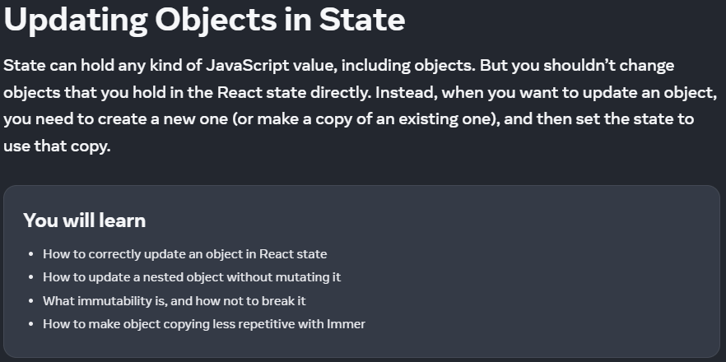

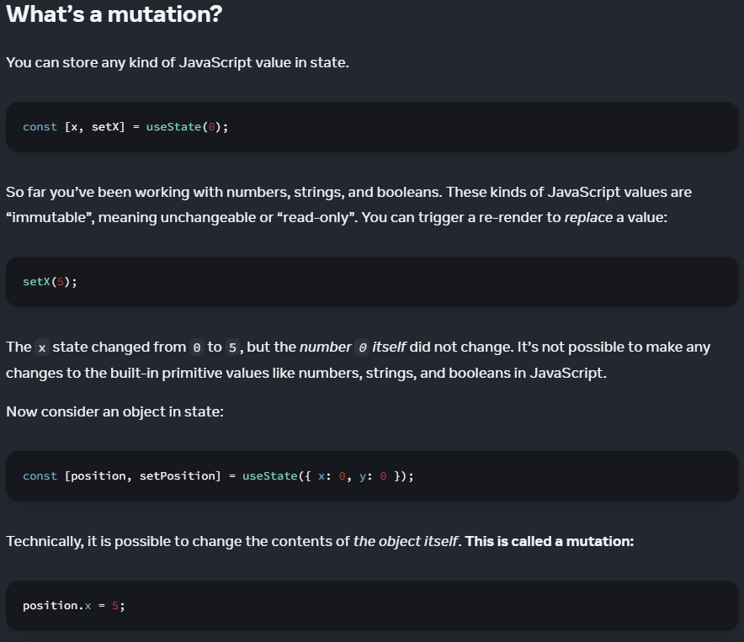

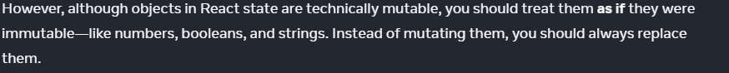

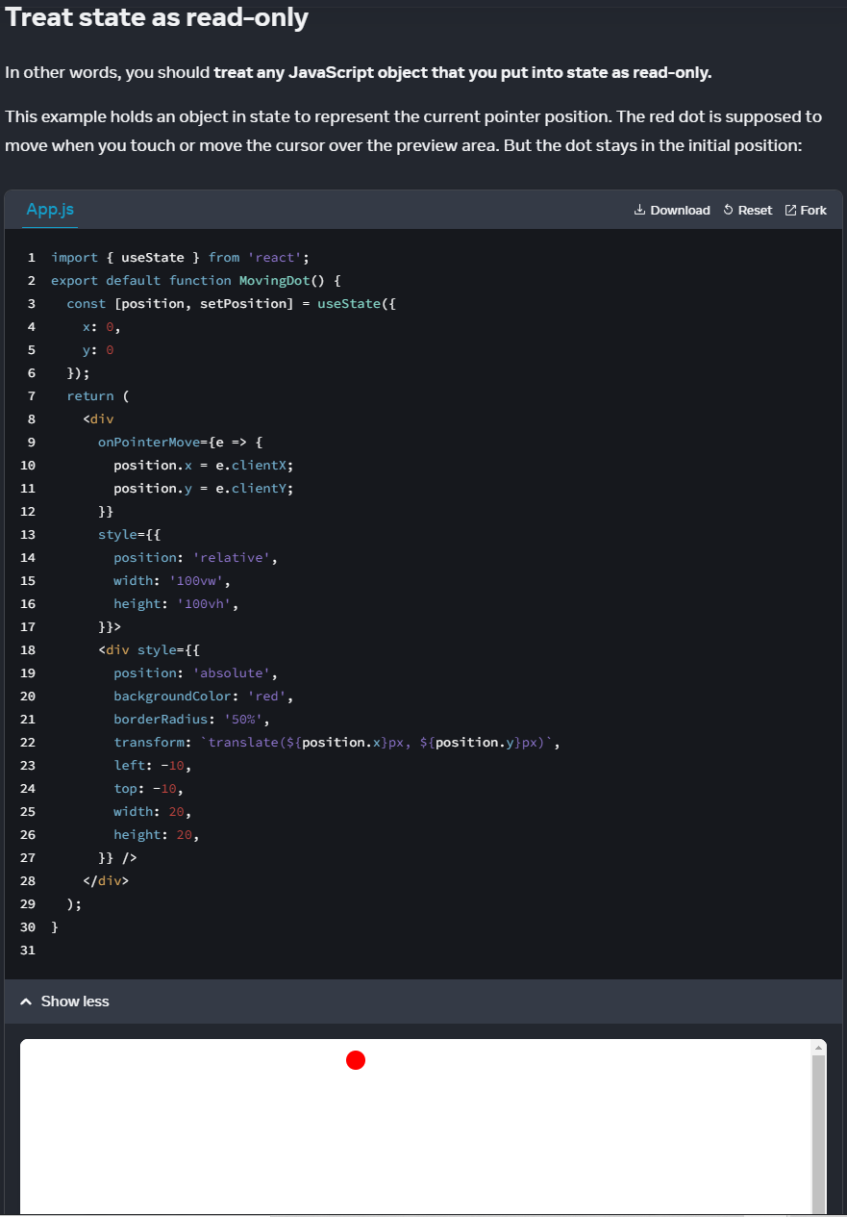

My solution:

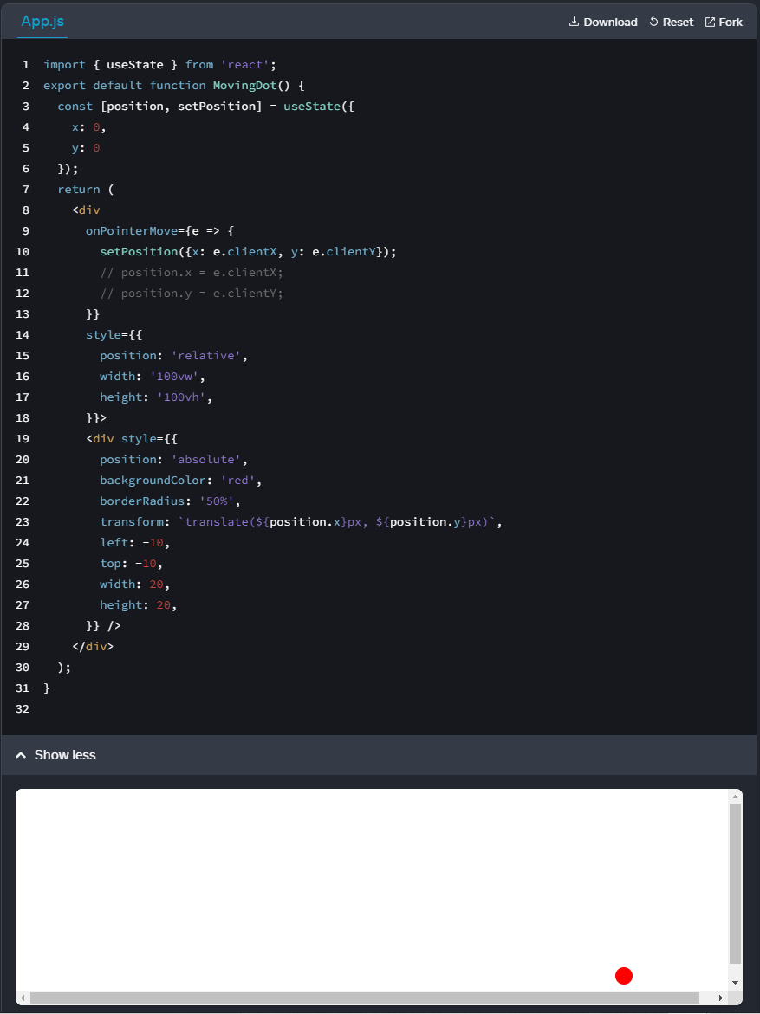

import { useState } from 'react';

export default function MovingDot() {

const [position, setPosition] = useState({

x: 0,

y: 0

});

return (

<div

onPointerMove={e => {

// useState listens to onPointerMove event

setPosition({x: e.clientX, y: e.clientY});

// position.x = e.clientX;

// position.y = e.clientY;

}}

style={{

position: 'relative',

width: '100vw',

height: '100vh',

}}>

<div style={{

position: 'absolute',

backgroundColor: 'red',

borderRadius: '50%',

transform: `translate(${position.x}px, ${position.y}px)`,

left: -10,

top: -10,

width: 20,

height: 20,

}} />

</div>

);

}

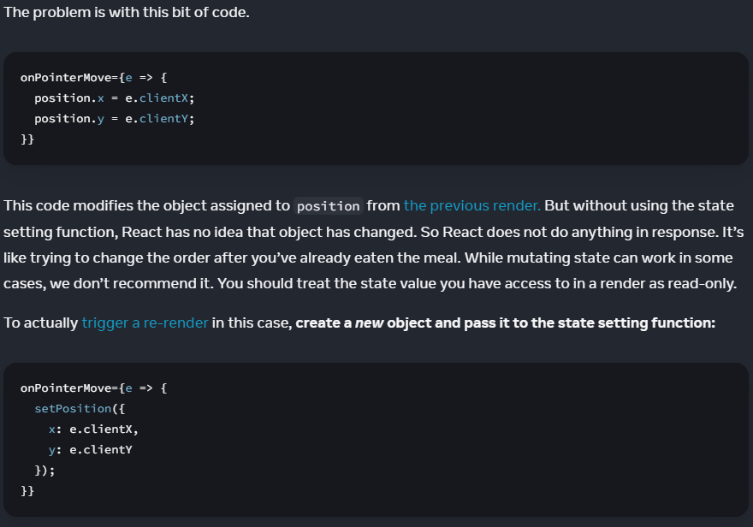

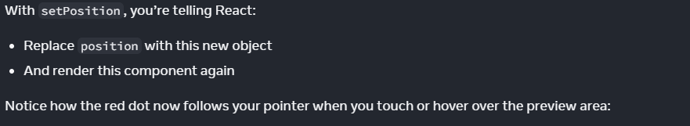

**Local Mutation is OKAY**

const [position, setPosition] = useState({

x: 0,

y: 0

});

This mutation is NOT acceptable:

// Mutating current state variables

position.x = e.clientX;

position.y = e.clientY;

// Mutating fresh objects is OKAY, as the current state is not using them for initial // render

setPosition({

x: e.clientX,

y: e.clientY

});

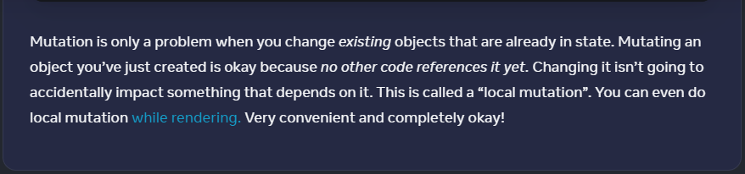

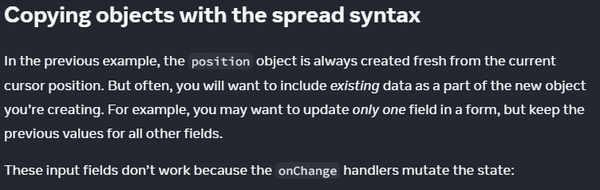

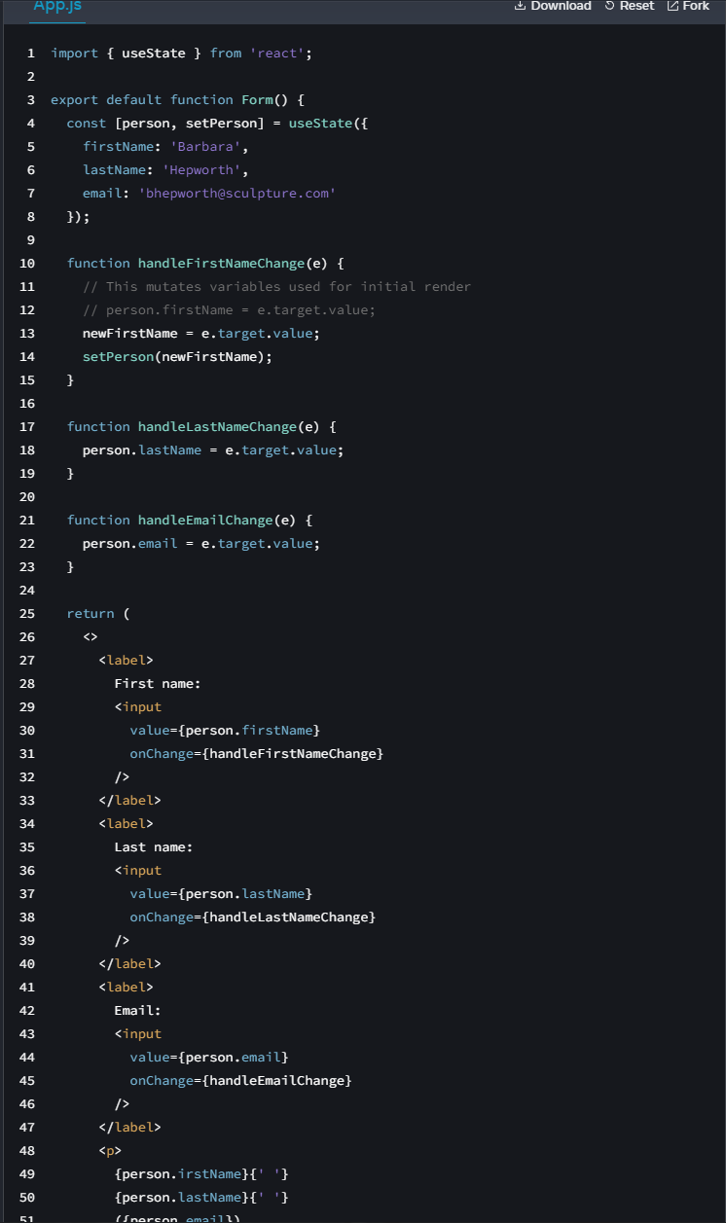

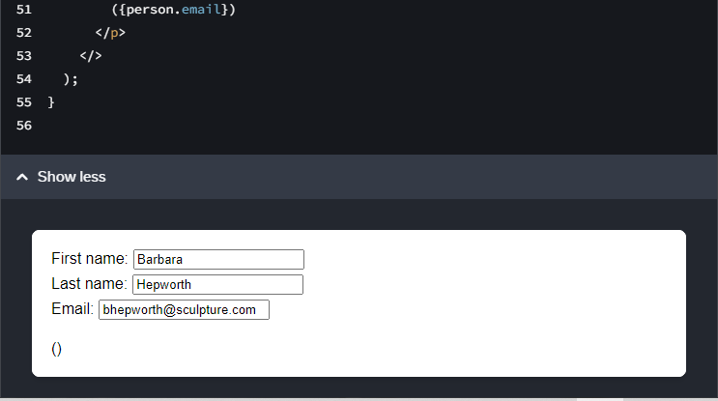

react copying objects {...obj}

Solution:

import { useState } from 'react';

export default function Form() {

const [person, setPerson] = useState({

firstName: 'Barbara',

lastName: 'Hepworth',

email: 'bhepworth@sculpture.com'

});

function handleFirstNameChange(e) {

// This mutates variables used for initial render

// person.firstName = e.target.value;

setPerson(

{...person,

firstName: e.target.value

});

}

function handleLastNameChange(e) {

// person.lastName = e.target.value;

setPerson({...person,

lastName: e.target.value

});

}

function handleEmailChange(e) {

// person.email = e.target.value;

// setPerson({...person -> shallow copy

setPerson({...person,

email: e.target.value

});

}

return (

<>

<label>

First name:

<input

value={person.firstName}

onChange={handleFirstNameChange}

/>

</label>

<label>

Last name:

<input

value={person.lastName}

onChange={handleLastNameChange}

/>

</label>

<label>

Email:

<input

value={person.email}

onChange={handleEmailChange}

/>

</label>

<p>

{person.firstName}{' '}

{person.lastName}{' '}

({person.email})

</p>

</>

);

}

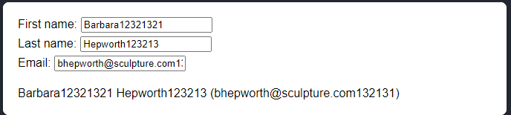

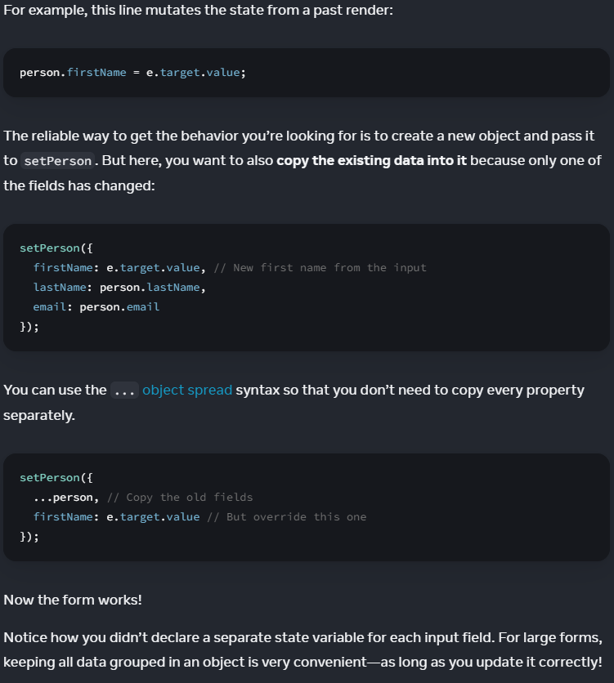

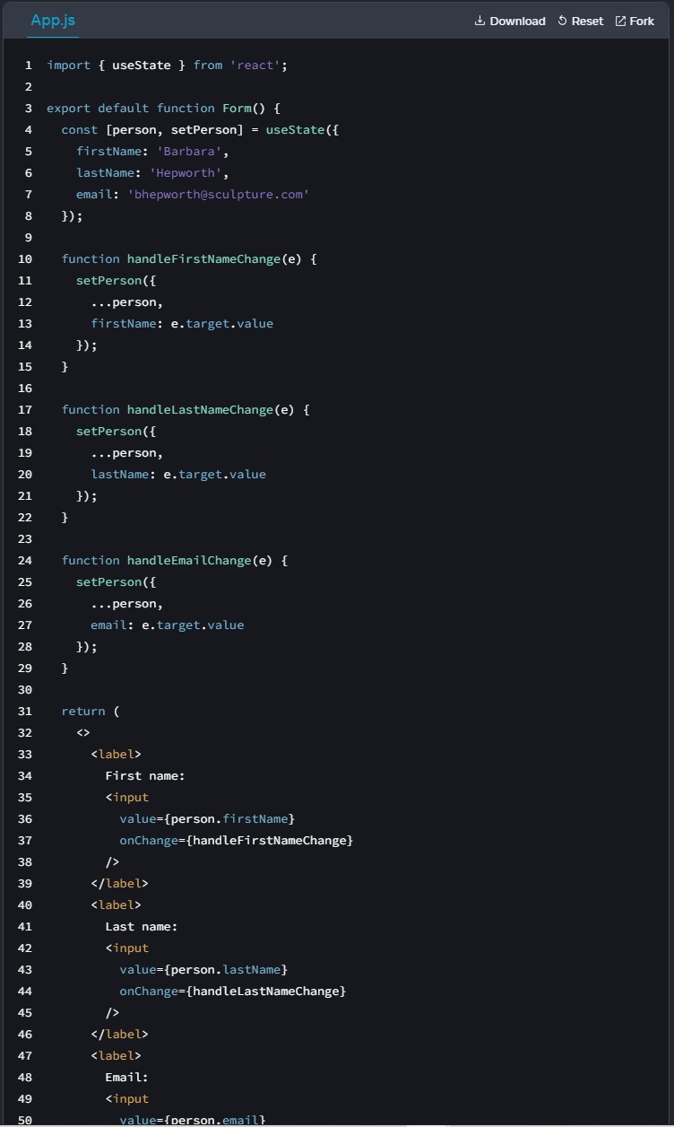

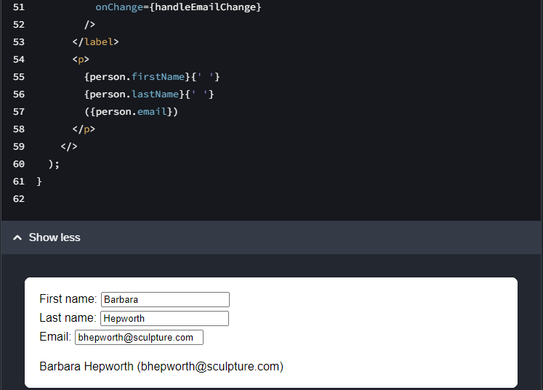

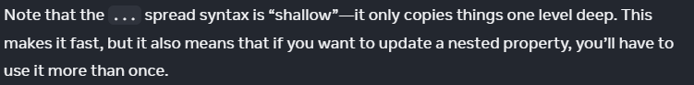

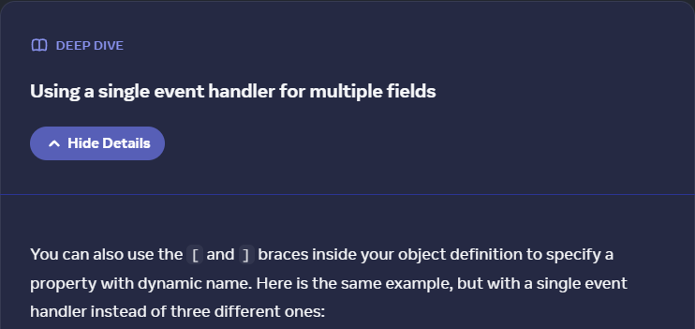

react array object - array list - handle changes

Using setPerson({

...person,

[e.target.name]: e.target.value

});

Code review:

import { useState } from 'react';

export default function Form() {

const [person, setPerson] = useState({

firstName: 'Barbara',

lastName: 'Hepworth',

email: 'bhepworth@sculpture.com'

});

function handleChange(e) {

setPerson({

...person,

[e.target.name]: e.target.value

});

}

return (

<>

<label>

First name:

<input

name="firstName"

value={person.firstName}

onChange={handleChange}

/>

</label>

<label>

Last name:

<input

name="lastName"

value={person.lastName}

onChange={handleChange}

/>

</label>

<label>

Email:

<input

name="email"

value={person.email}

onChange={handleChange}

/>

</label>

<p>

{person.firstName}{' '}

{person.lastName}{' '}

({person.email})

</p>

</>

);

}

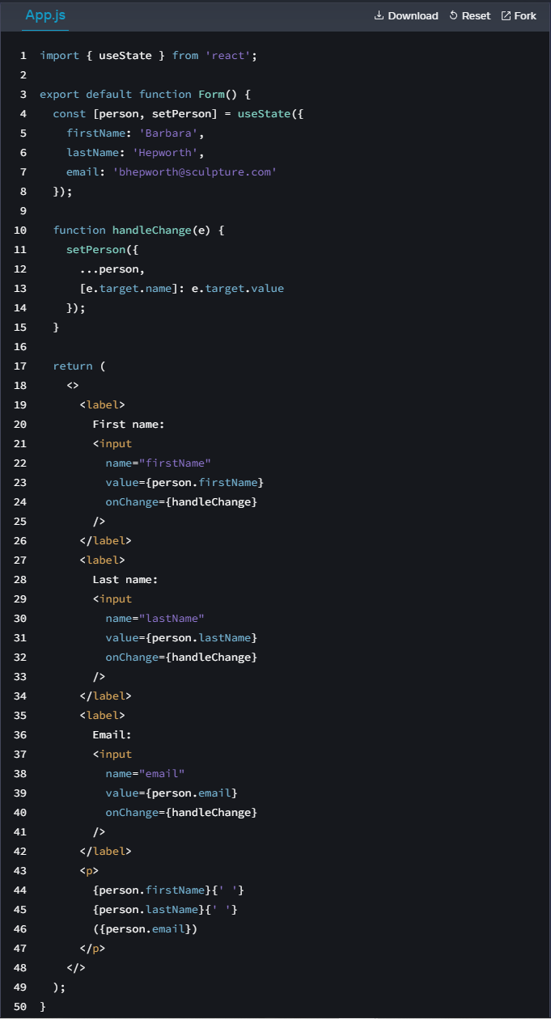

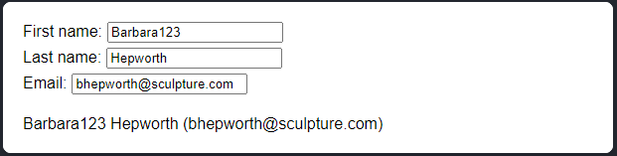

=========

react updating a nested object

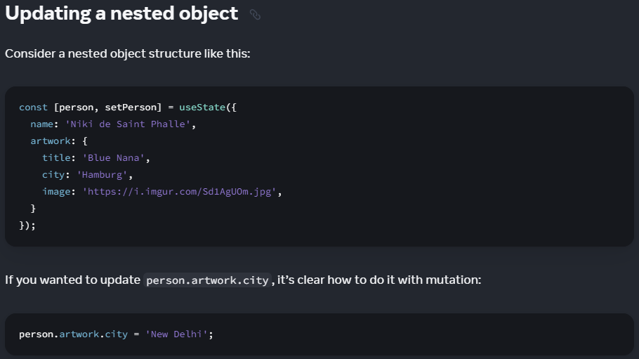

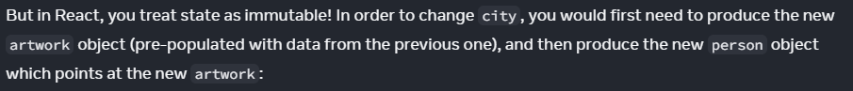

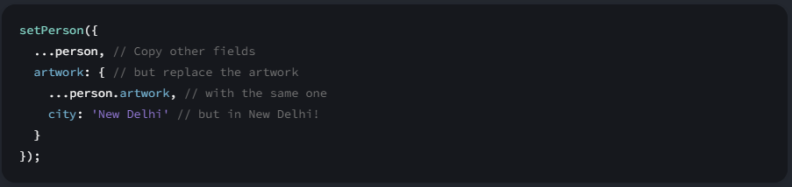

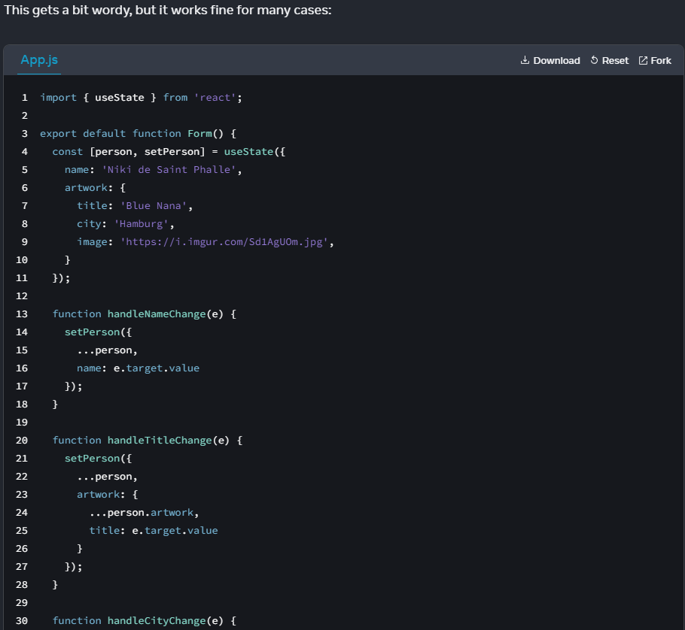

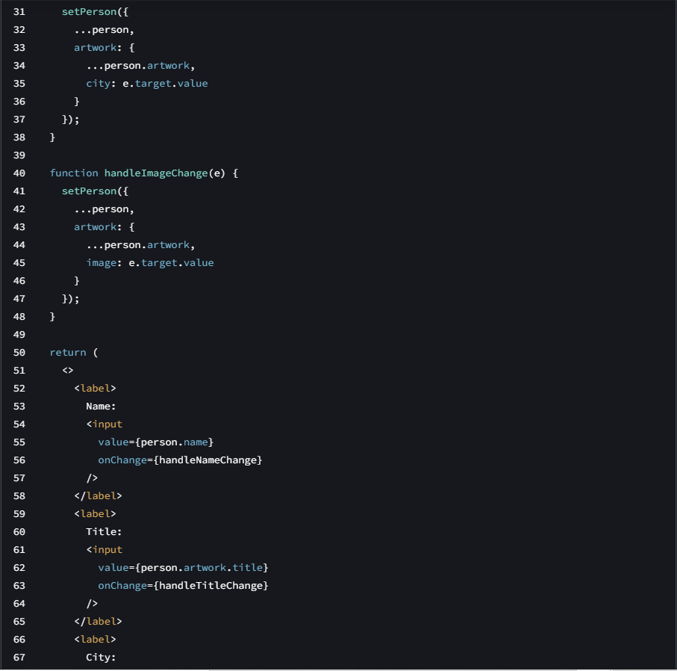

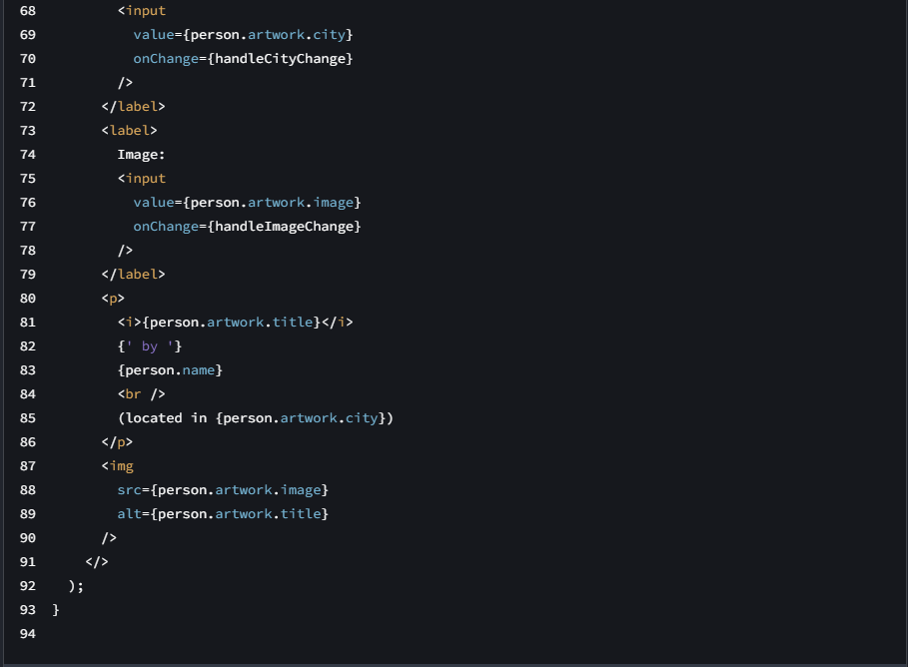

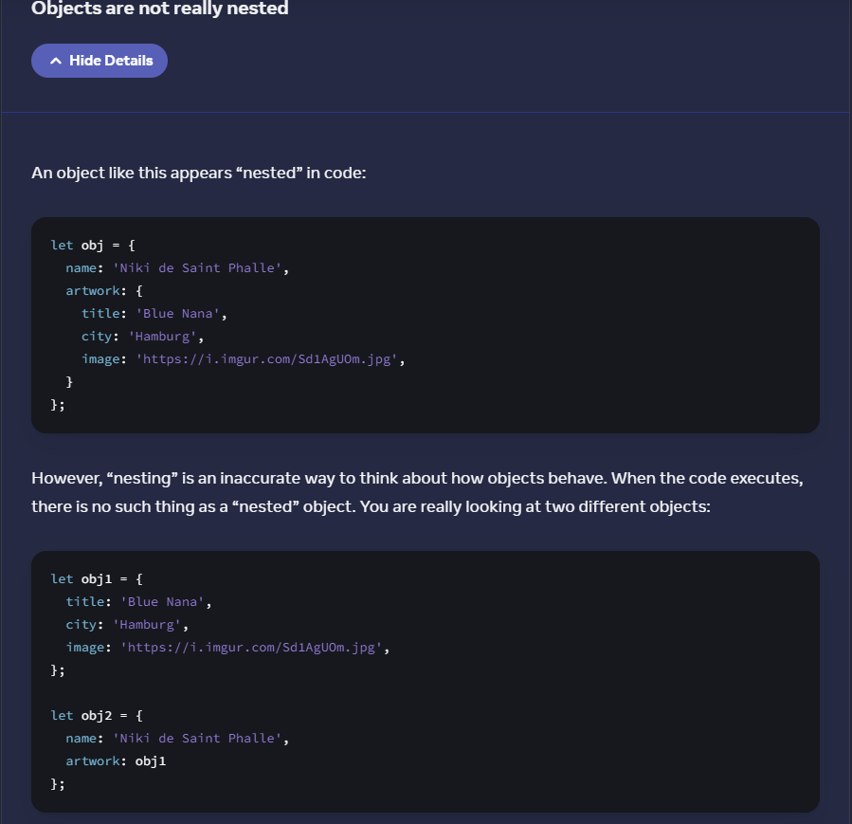

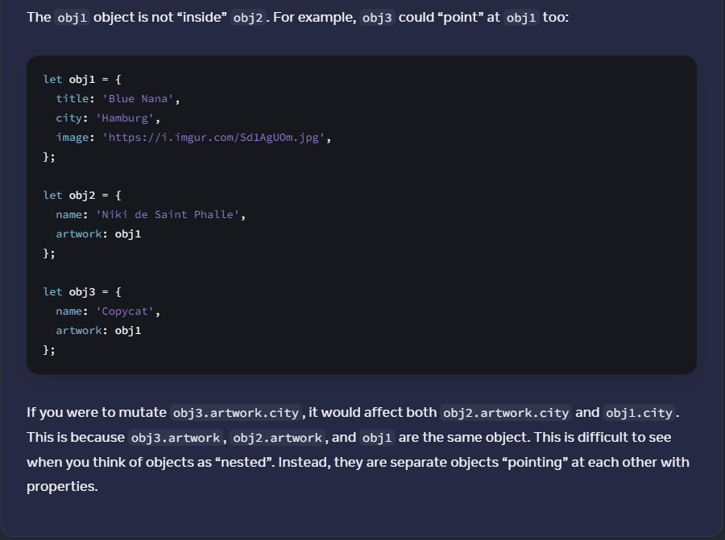

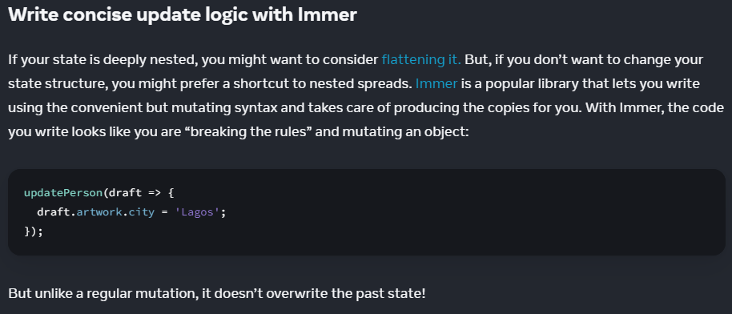

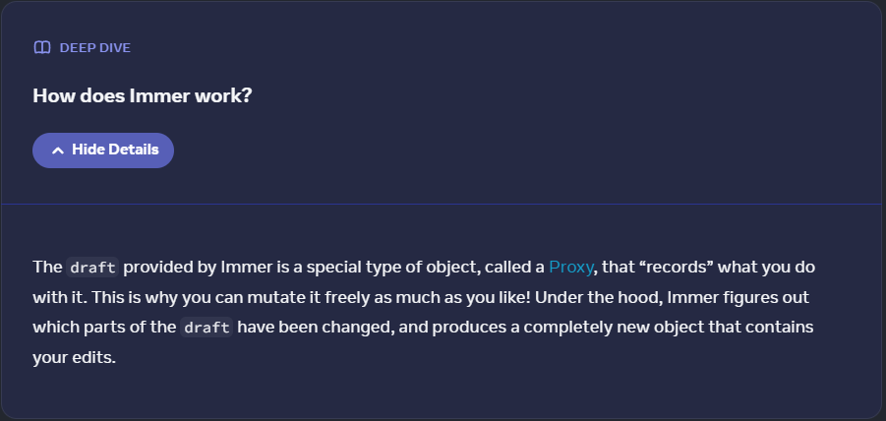

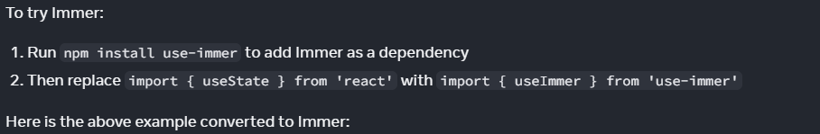

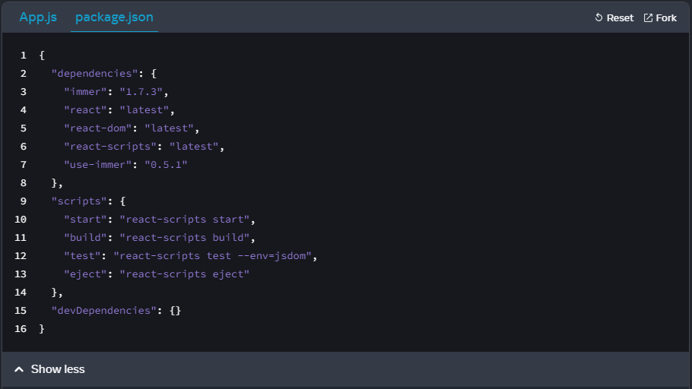

npm install use-immer

App.js:

import { useImmer } from 'use-immer';

const [person, updatePerson] = useImmer({

name: '',

artwork: {

title: '',

city: '',

image: '',

}

});

const handleNameChange = (e) => {

updatePerson({

draft => draft.name = e.target.value

});

}

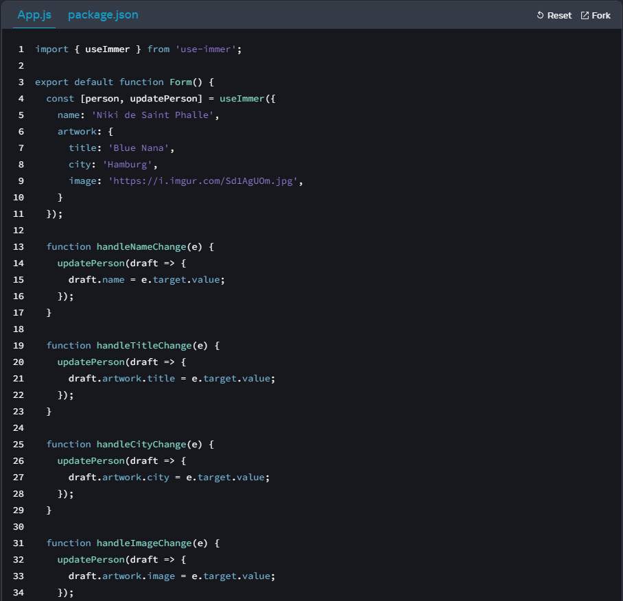

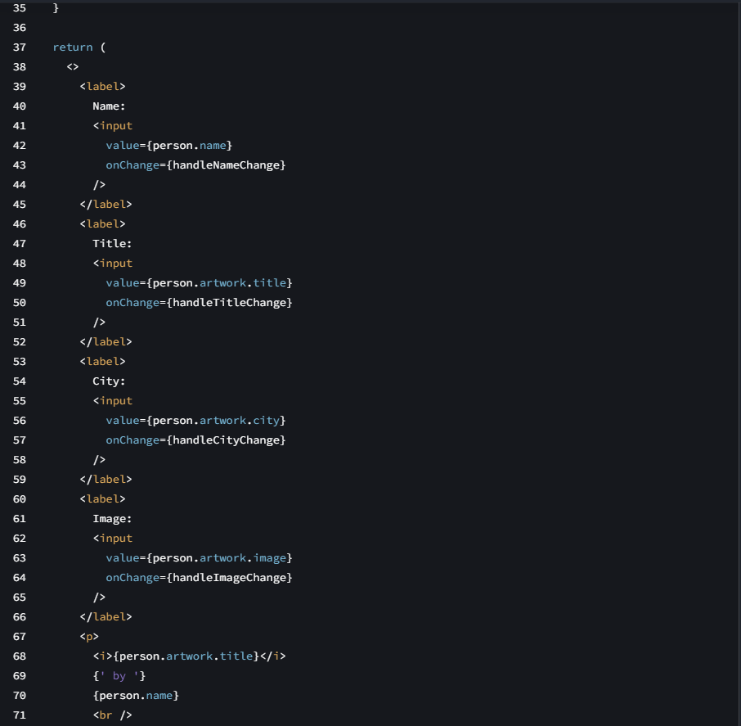

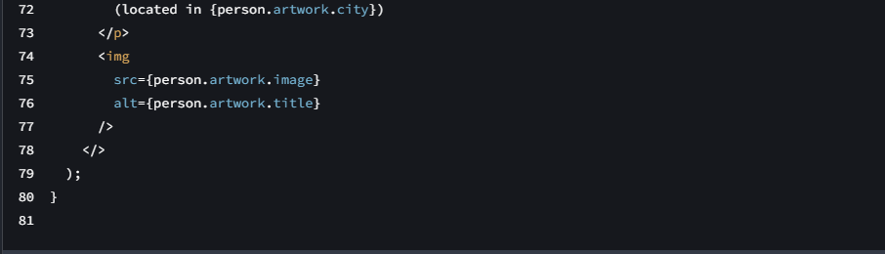

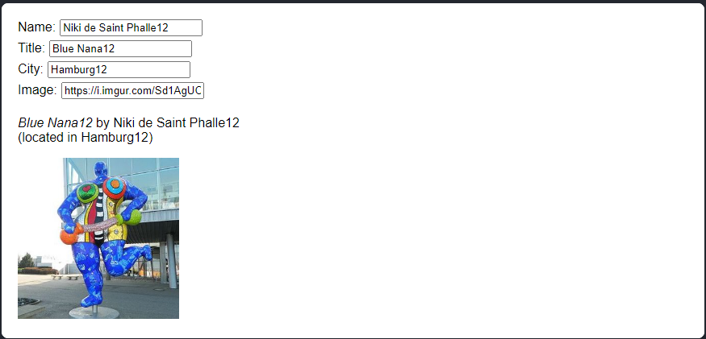

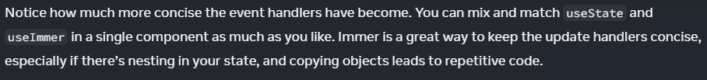

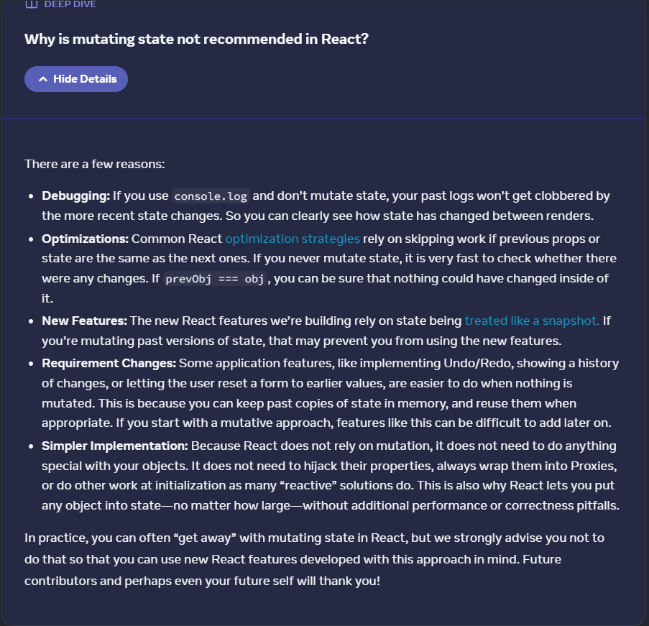

**Debugging:**

console.log(state);

console.log(setState);

**Optimization:**

If prevObj === obj -> React skips checking

**New features:**

State = Snapshots

**Requirements:**

App features e.g. Undo/Redo, showing history of changes OR

letting users reset a form

All depend on past copies of state in memory

Copies of state can be reused

**Simpler Implementation:**

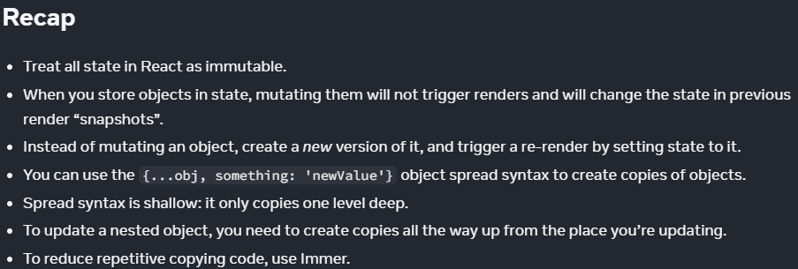

====Challenge 1 of 3

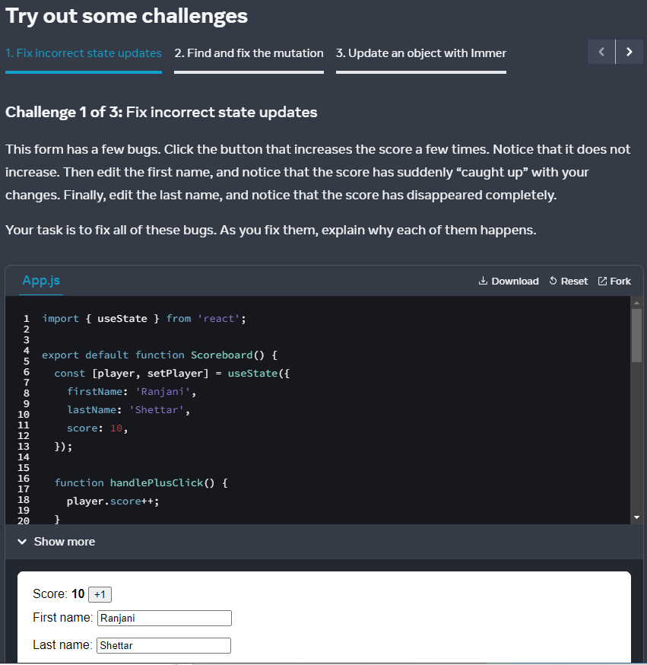

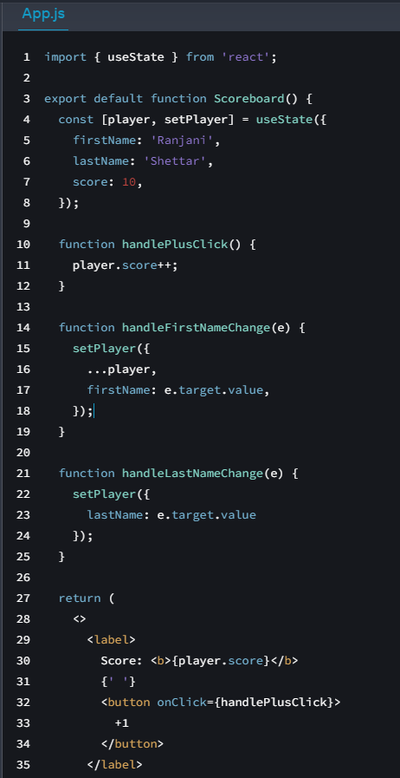

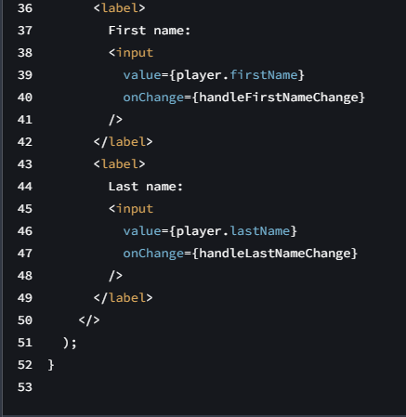

Code review:

import { useState } from 'react';

export default function Scoreboard() {

const [player, setPlayer] = useState({

firstName: 'Ranjani',

lastName: 'Shettar',

score: 10,

});

function handlePlusClick() {

// Missing ...person,

// score: player.score + 1

player.score++;

}

function handleFirstNameChange(e) {

setPlayer({

...player,

firstName: e.target.value,

});

}

function handleLastNameChange(e) {

setPlayer({

// Missing ...person,

lastName: e.target.value

});

}

return (

<>

<label>

Score: <b>{player.score}</b>

{' '}

<button onClick={handlePlusClick}>

+1

</button>

</label>

<label>

First name:

<input

value={player.firstName}

onChange={handleFirstNameChange}

/>

</label>

<label>

Last name:

<input

value={player.lastName}

onChange={handleLastNameChange}

/>

</label>

</>

);

}

My solution:

import { useState } from 'react';

export default function Scoreboard() {

const [player, setPlayer] = useState({

firstName: 'Ranjani',

lastName: 'Shettar',

score: 10,

});

function handlePlusClick() {

setPlayer({

...player,

score: player.score + 1,

});

}

function handleFirstNameChange(e) {

setPlayer({

...player,

firstName: e.target.value,

});

}

function handleLastNameChange(e) {

setPlayer({

...player,

lastName: e.target.value

});

}

return (

<>

<label>

Score: <b>{player.score}</b>

{' '}

<button onClick={handlePlusClick}>

+1

</button>

</label>

<label>

First name:

<input

value={player.firstName}

onChange={handleFirstNameChange}

/>

</label>

<label>

Last name:

<input

value={player.lastName}

onChange={handleLastNameChange}

/>

</label>

</>

);

}

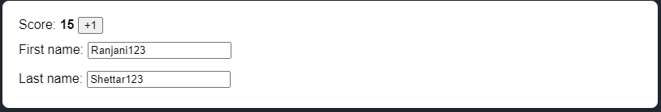

====Challenge 2 of 3 react find + fix mutation

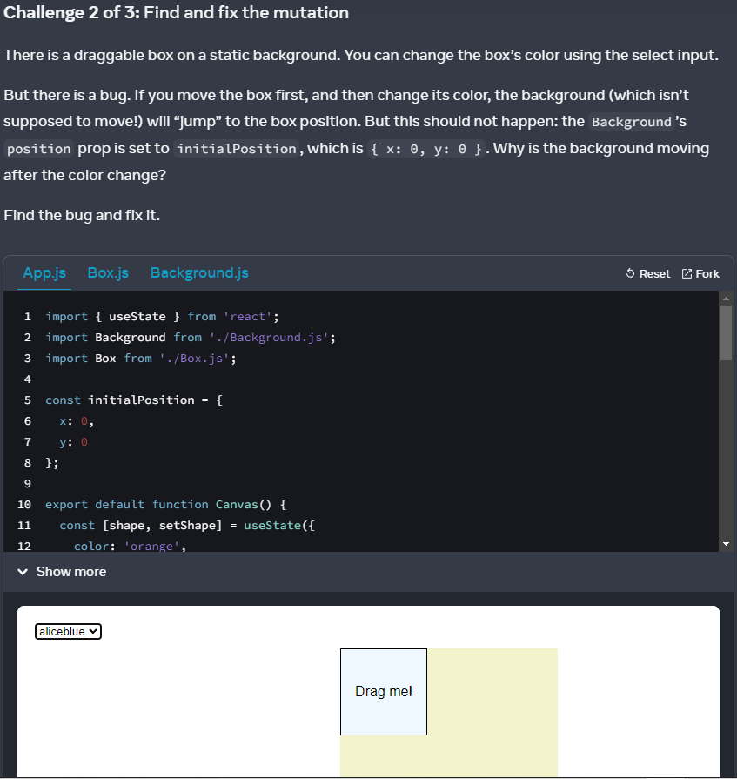

Code review:

App.js:

import { useState } from 'react';

import Background from './Background.js';

import Box from './Box.js';

const initialPosition = {

x: 0,

y: 0

};

export default function Canvas() {

const [shape, setShape] = useState({

color: 'orange',

position: initialPosition

});

function handleMove(dx, dy) {

// Cannot mutate local variable

shape.position.x += dx;

shape.position.y += dy;

}

function handleColorChange(e) {

setShape({

...shape,

color: e.target.value

});

}

return (

<>

<select

value={shape.color}

onChange={handleColorChange}

>

<option value="orange">orange</option>

<option value="lightpink">lightpink</option>

<option value="aliceblue">aliceblue</option>

</select>

<Background

position={initialPosition}

/>

<Box

color={shape.color}

position={shape.position}

onMove={handleMove}

>

Drag me!

</Box>

</>

);

}

----

Box.js:

import { useState } from 'react';

export default function Box({

children,

color,

position,

onMove

}) {

const [

lastCoordinates,

setLastCoordinates

] = useState(null);

function handlePointerDown(e) {

e.target.setPointerCapture(e.pointerId);

setLastCoordinates({

x: e.clientX,

y: e.clientY,

});

}

function handlePointerMove(e) {

if (lastCoordinates) {

setLastCoordinates({

x: e.clientX,

y: e.clientY,

});

const dx = e.clientX - lastCoordinates.x;

const dy = e.clientY - lastCoordinates.y;

onMove(dx, dy);

}

}

function handlePointerUp(e) {

setLastCoordinates(null);

}

return (

<div

onPointerDown={handlePointerDown}

onPointerMove={handlePointerMove}

onPointerUp={handlePointerUp}

style={{

width: 100,

height: 100,

cursor: 'grab',

backgroundColor: color,

position: 'absolute',

border: '1px solid black',

display: 'flex',

justifyContent: 'center',

alignItems: 'center',

transform: `translate(

${position.x}px,

${position.y}px

)`,

}}

>{children}</div>

);

}

----

Background.js:

export default function Background({

position

}) {

return (

<div style={{

position: 'absolute',

transform: `translate(

${position.x}px,

${position.y}px

)`,

width: 250,

height: 250,

backgroundColor: 'rgba(200, 200, 0, 0.2)',

}} />

);

};

My solution:

import { useState } from 'react';

import Background from './Background.js';

import Box from './Box.js';

const initialPosition = {

x: 0,

y: 0

};

export default function Canvas() {

const [shape, setShape] = useState({

color: 'orange',

position: initialPosition

});

function handleMove(dx, dy) {

setShape({

...shape,

x: shape.position.x += dx,

y: shape.position.y += dy,

});

}

function handleColorChange(e) {

setShape({

...shape,

color: e.target.value

});

}

return (

<>

<select

value={shape.color}

onChange={handleColorChange}

>

<option value="orange">orange</option>

<option value="lightpink">lightpink</option>

<option value="aliceblue">aliceblue</option>

</select>

<Background

position={initialPosition}

/>

<Box

color={shape.color}

position={shape.position}

onMove={handleMove}

>

Drag me!

</Box>

</>

);

}

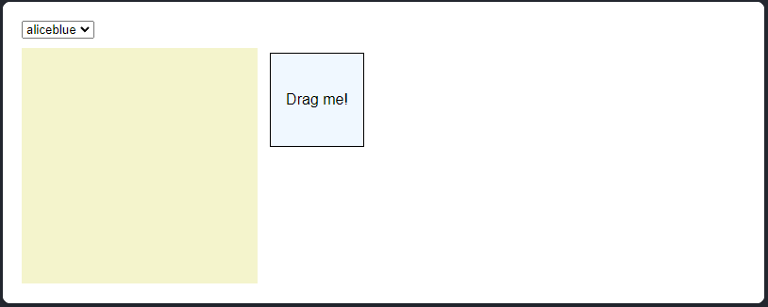

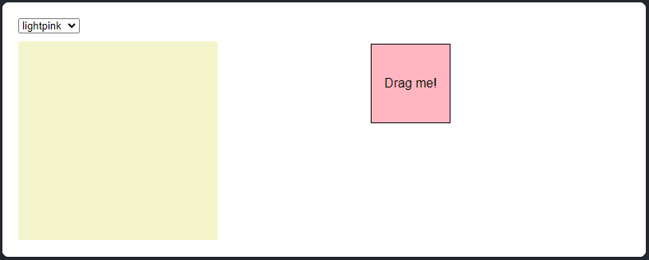

====Challenge 3 of 3

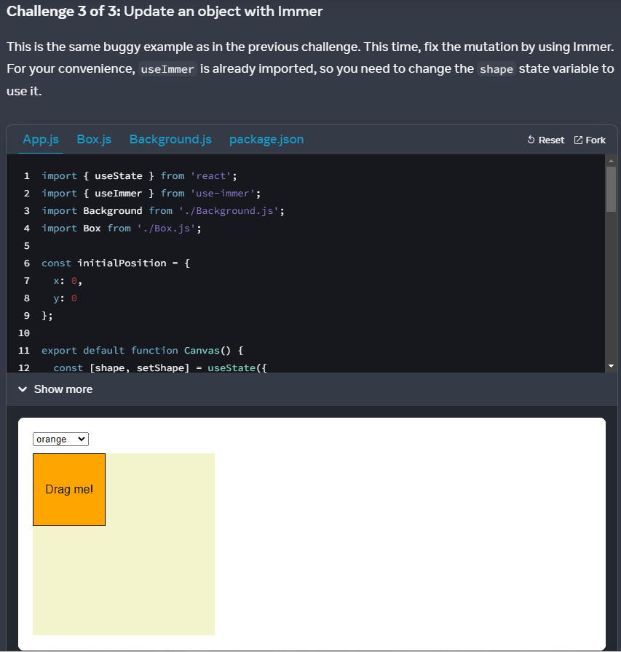

----

Use Immer

My solution:

App.js:

import { useState } from 'react';

import { useImmer } from 'use-immer';

import Background from './Background.js';

import Box from './Box.js';

const initialPosition = {

x: 0,

y: 0

};

export default function Canvas() {

const [shape, updateShape] = useImmer({

color: 'orange',

position: initialPosition

});

function handleMove(dx, dy) {

updateShape(draft => {

draft.position.x += dx;

draft.position.y += dy;

});

}

function handleColorChange(e) {

updateShape(draft => {

draft.color = e.target.value

});

}

return (

<>

<select

value={shape.color}

onChange={handleColorChange}

>

<option value="orange">orange</option>

<option value="lightpink">lightpink</option>

<option value="aliceblue">aliceblue</option>

</select>

<Background

position={initialPosition}

/>

<Box

color={shape.color}

position={shape.position}

onMove={handleMove}

>

Drag me!

</Box>

</>

);

}

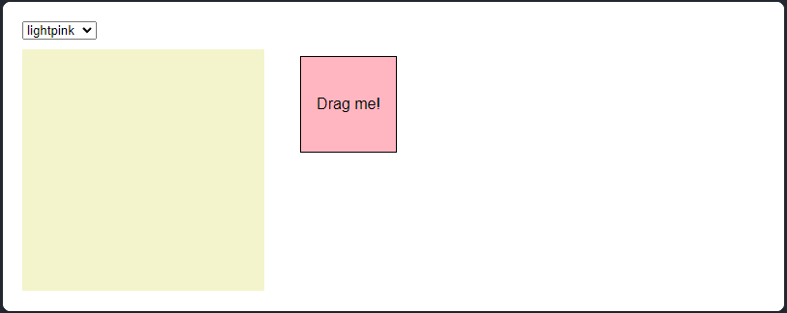

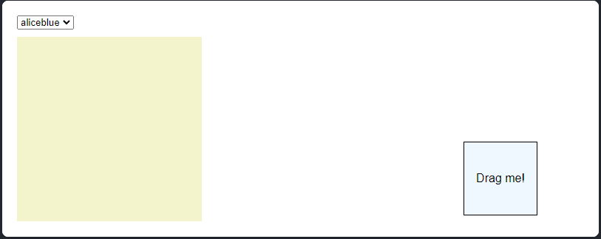

Updating Arrays in State [...arr]

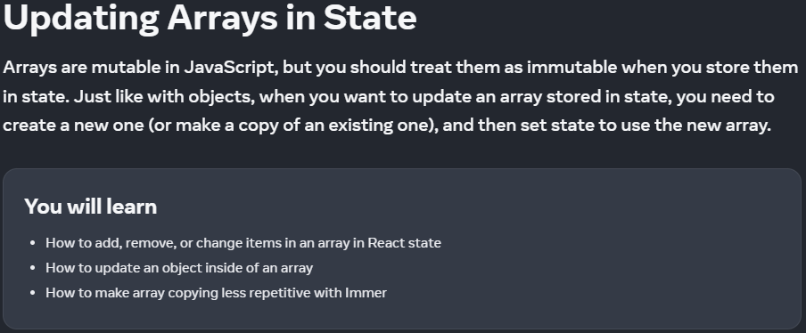

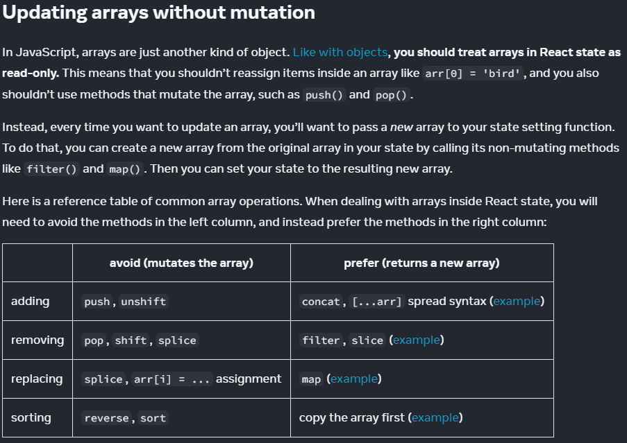

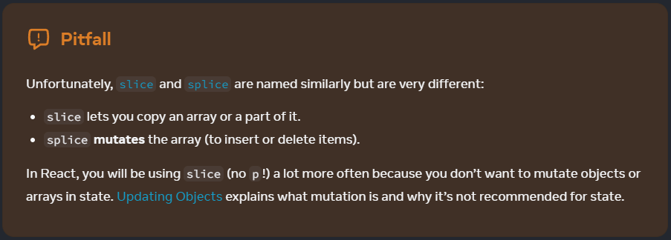

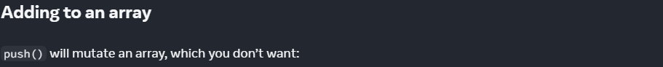

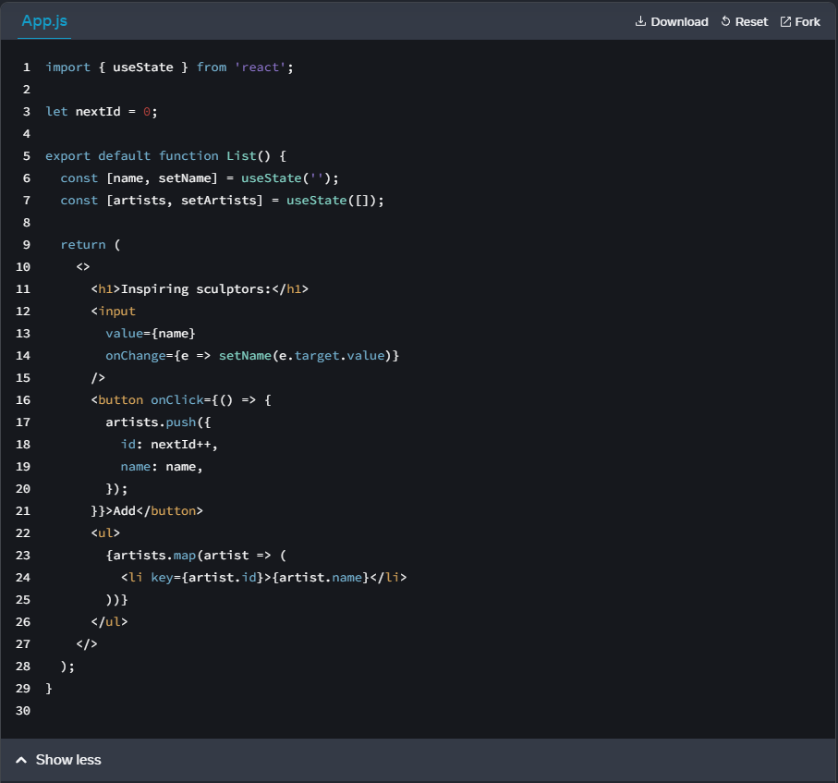

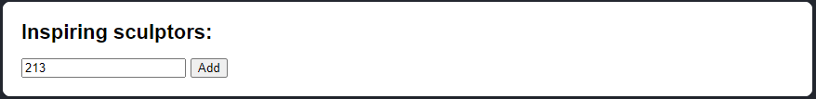

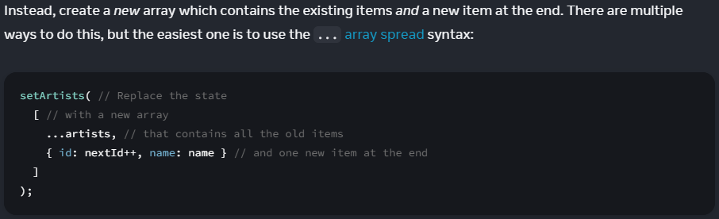

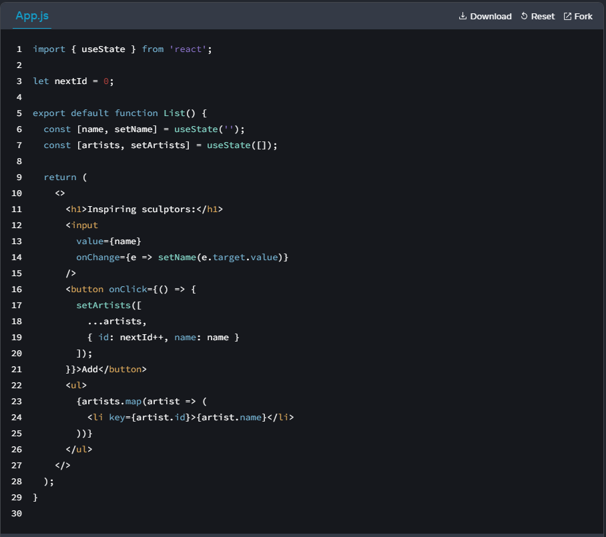

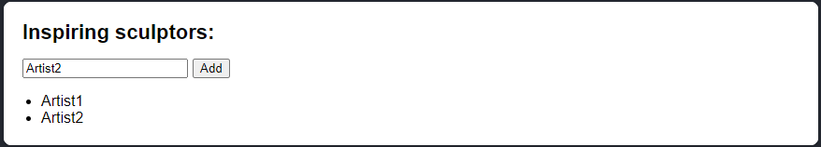

====

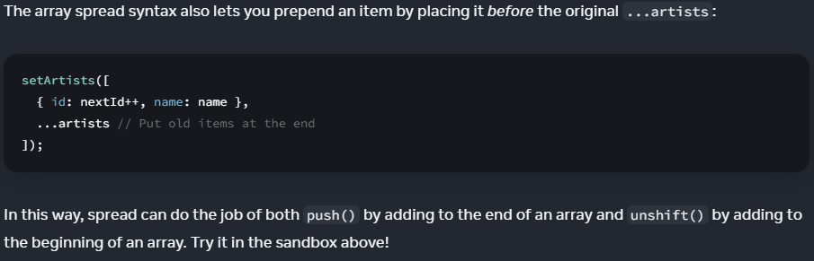

react - array objects - array list - adding to array

import { useState } from 'react';

let nextId = 0;

export default function List() {

const [name, setName] = useState('');

const [artists, setArtists] = useState([]);

return (

<>

<h1>Inspiring sculptors:</h1>

<input

value={name}

onChange={e => setName(e.target.value)}

/>

<button onClick={() => {

// setState for array objects

setArtists([

{ id: nextId++, name: name },

...artists //Put old items to last location of list

]);

}}>Add</button>

<ul>

{artists.map(artist => (

<li key={artist.id}>{artist.name}</li>

))}

</ul>

</>

);

}

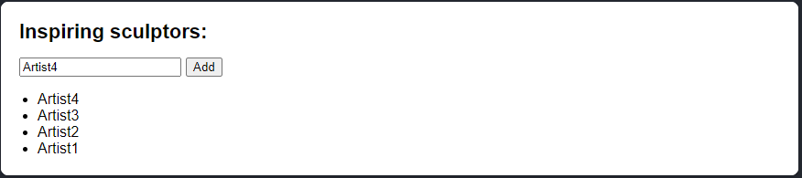

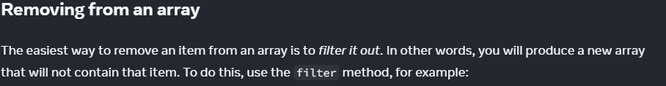

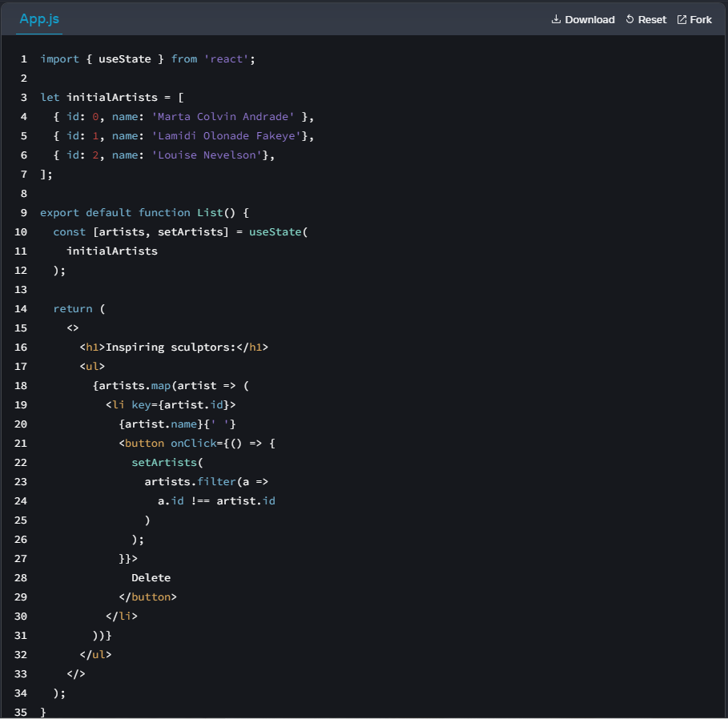

react - array objects - array list - remove item

const [artists, setArtists] = useState(

initialArtists

);

<ul>

{artists.map(artist => (

<li key={artist.id}>

{artist.name}{' '}

<button onClick={() => {

setArtists(

artists.filter(a =>

a.id !== artist.id

)

);

}}>

Text

</button>

</li>

))}

</ul>

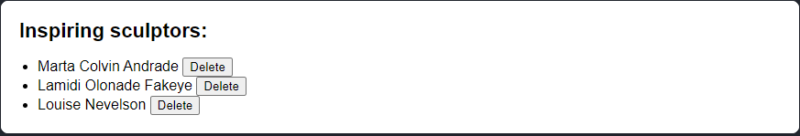

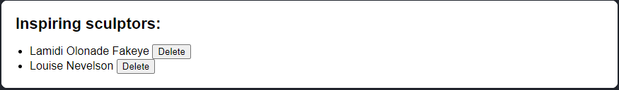

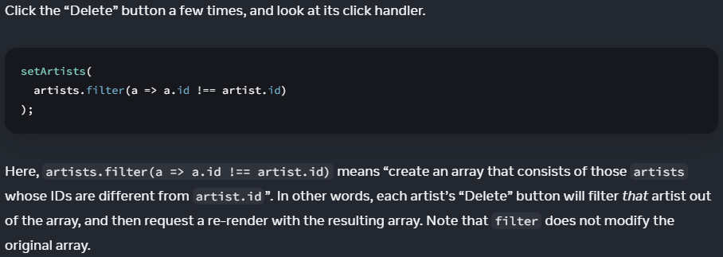

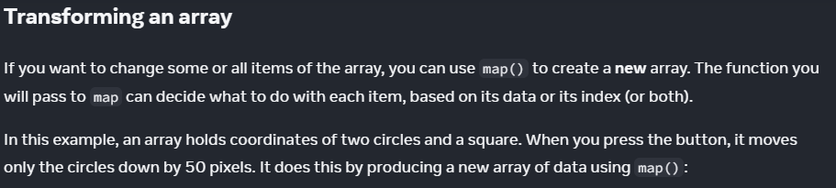

react - array - transform array

App.js:

import { useState } from 'react';

let initialShapes = [

{ id: 0, type: 'circle', x: 50, y: 100 },

{ id: 1, type: 'square', x: 150, y: 100 },

{ id: 2, type: 'circle', x: 250, y: 100 },

];

export default function ShapeEditor() {

const [shapes, setShapes] = useState(

initialShapes

);

function handleClick() {

const nextShapes = shapes.map(shape => {

if (shape.type === 'square') {

// No change

return shape;

} else {

// Return a new circle 50px below

return {

...shape,

y: shape.y + 50,

};

}

});

// Re-render with the new array

setShapes(nextShapes);

}

return (

<>

<button onClick={handleClick}>

Move circles down!

</button>

{shapes.map(shape => (

<div

key={shape.id}

style={{

background: 'purple',

position: 'absolute',

left: shape.x,

top: shape.y,

borderRadius:

shape.type === 'circle'

? '50%' : '',

width: 20,

height: 20,

}} />

))}

</>

);

}

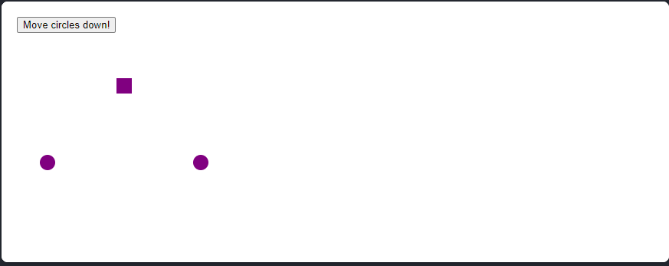

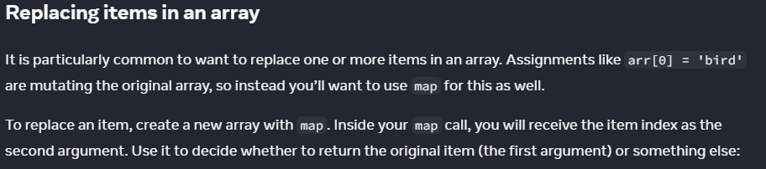

react array - replacing items

App.js:

import { useState } from 'react';

let initialCounters = [

0, 0, 0

];

export default function CounterList() {

const [counters, setCounters] = useState(

initialCounters

);

function handleIncrementClick(index) {

const nextCounters = counters.map((c, i) => {

if (i === index) {

// Increment the clicked counter

return c + 1;

} else {

// The rest haven't changed

return c;

}

});

setCounters(nextCounters);

}

return (

<ul>

{counters.map((counter, i) => (

<li key={i}>

{counter}

<button onClick={() => {

handleIncrementClick(i);

}}>+1</button>

</li>

))}

</ul>

);

}

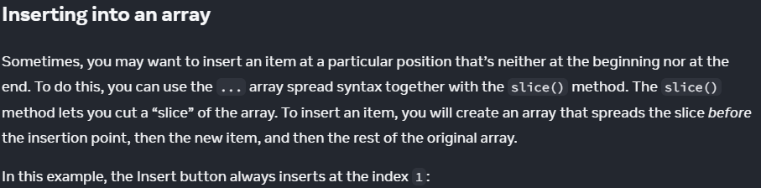

react array objects - array list - insert items

App.js:

import { useState } from 'react';

const initialArtists = [

{ id: 0, name: 'Marta Colvin Andrade' },

{ id: 1, name: 'Lamidi Olonade Fakeye'},

{ id: 2, name: 'Louise Nevelson'},

];

let nextId = initialArtists.map(artist.id).length + 1;

export default function List() {

const [name, setName] = useState('');

const [artists, setArtists] = useState(

initialArtists

);

function handleClick() {

const insertAt = 0; // insert point can be any index

const nextArtists = [

// Inset item as 1st item in list:

...artists.slice(0, insertAt),

// New item:

{ id: nextId++, name: name },

// Items after the insertion point:

...artists.slice(insertAt)

];

setArtists(nextArtists);

setName('');

}

return (

<>

<h1>Inspiring sculptors:</h1>

<input

value={name}

onChange={e => setName(e.target.value)}

/>

<button onClick={handleClick}>

Insert

</button>

<ul>

{artists.map(artist => (

<li key={artist.id}>{artist.name}</li>

))}

</ul>

</>

);

}

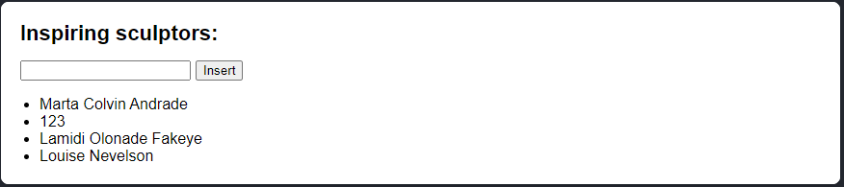

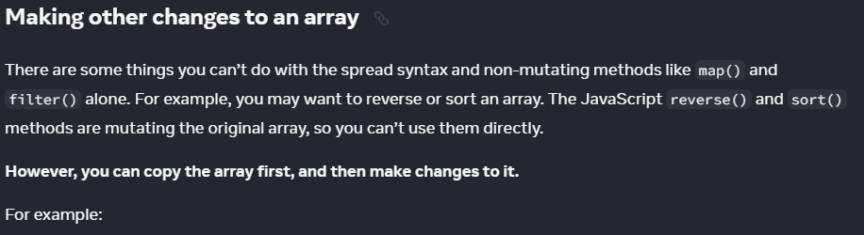

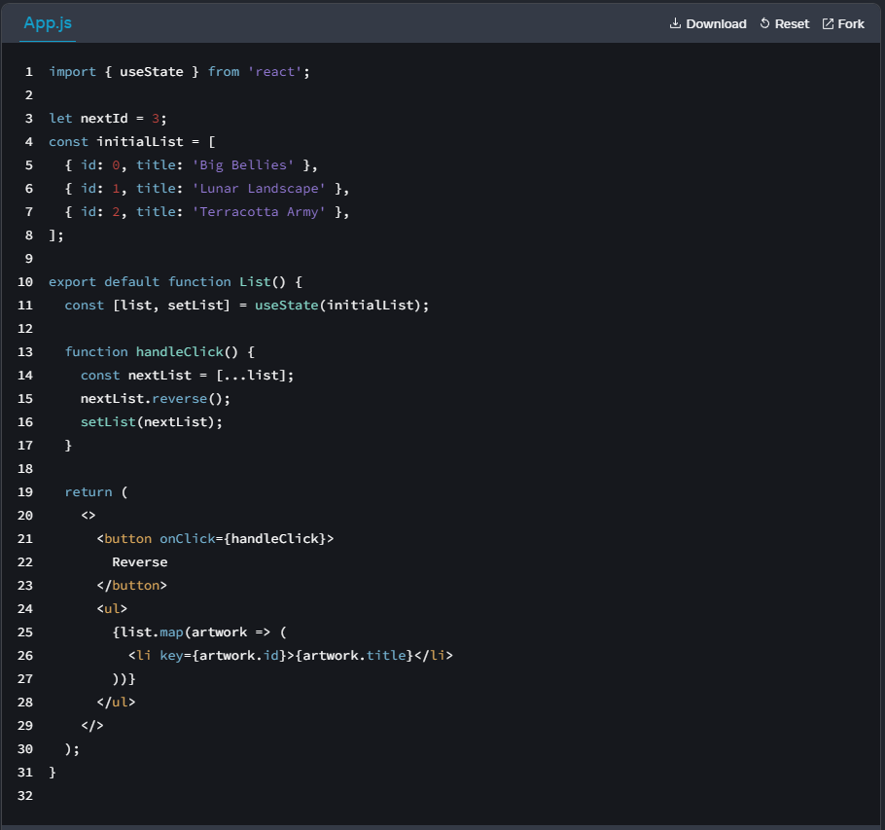

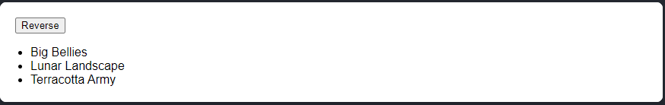

react array objects - array list - reverse list

import { useState } from 'react';

const initialList = [

{ id: 0, title: 'Big Bellies' },

{ id: 1, title: 'Lunar Landscape' },

{ id: 2, title: 'Terracotta Army' },

];

let nextId = initialList.map(list => list.title).length;

export default function List() {

const [list, setList] = useState(initialList);

function handleClick() {

// making a new copy of initialList using hooks

const nextList = [...list];

nextList.reverse();

setList(nextList);

}

return (

<>

<button onClick={handleClick}>

Reverse

</button>

<ul>

{list.map(artwork => (

<li key={artwork.id}>{artwork.title}</li>

))}

</ul>

</>

);

}

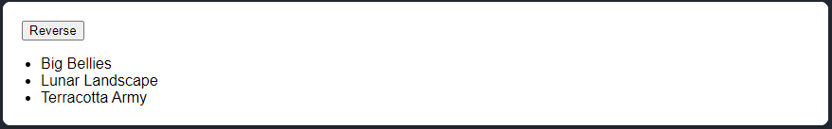

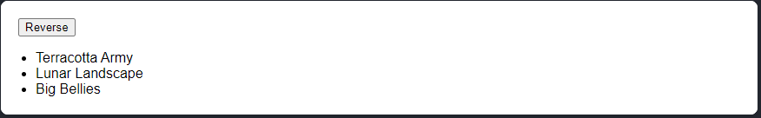

react array objects - array list - remove item

import { useState } from 'react';

const initialList = [

{ id: 0, title: 'Big Bellies' },

{ id: 1, title: 'Lunar Landscape' },

{ id: 2, title: 'Terracotta Army' },

];

let nextId = initialList.map(list => list.title).length;

export default function List() {

const [list, setList] = useState(initialList);

function handleClick() {

const nextList = [...list];

nextList.reverse();

setList(nextList);

}

function removeFirst() {

const firstToRemove = [...list];

firstToRemove.shift();

setList(firstToRemove);

}

function removeLast() {

const lastToRemove = [...list];

lastToRemove.pop();

setList(lastToRemove);

}

return (

<>

<button onClick={handleClick}>

Reverse

</button>

<ul>

{list.map(artwork => (

<li key={artwork.id}>{artwork.title}</li>

))}

</ul>

<button onClick={removeFirst}>

Remove first item

</button>

<button onClick={removeLast}>

Remove last item

</button>

</>

);

}



Pressed twice 'Remove first'

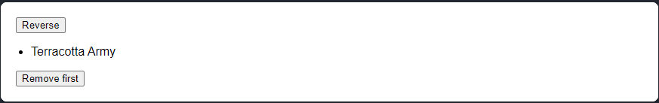

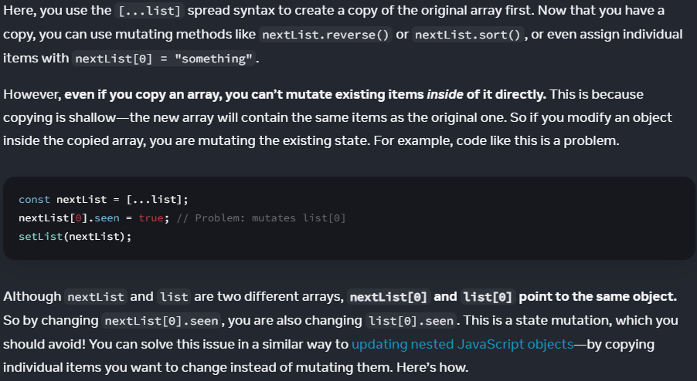

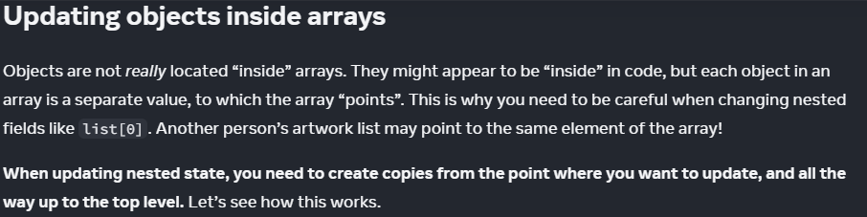





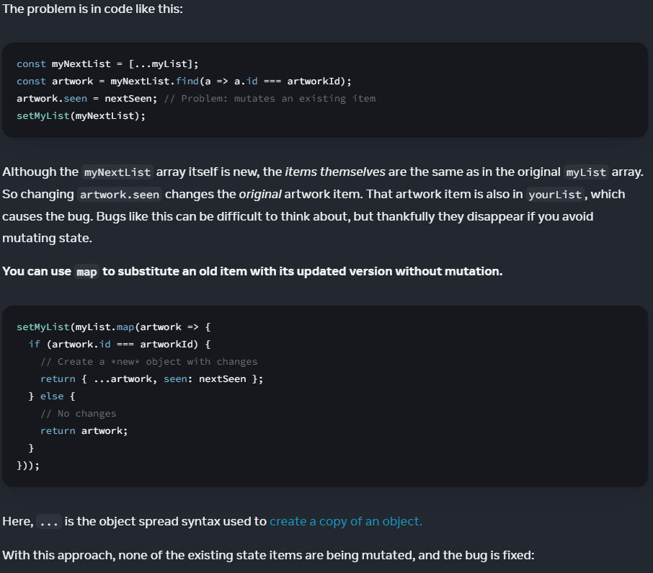

react array objects - array list - Toggle seen -

App.js:

import { useState } from 'react';

let nextId = 3;

const initialList = [

{ id: 0, title: 'Big Bellies', seen: false },

{ id: 1, title: 'Lunar Landscape', seen: false },

{ id: 2, title: 'Terracotta Army', seen: true },

];

export default function BucketList() {

const [myList, setMyList] = useState(initialList);

const [yourList, setYourList] = useState(

initialList

);

function handleToggleMyList(artworkId, nextSeen) {

const myNextList = [...myList];

const artwork = myNextList.find(

a => a.id === artworkId

);

// Mutation

artwork.seen = nextSeen;

setMyList(myNextList);

}

function handleToggleYourList(artworkId, nextSeen) {

const yourNextList = [...yourList];

const artwork = yourNextList.find(

a => a.id === artworkId

);

// Mutation

artwork.seen = nextSeen;

setYourList(yourNextList);

}

return (

<>

<h1>Art Bucket List</h1>

<h2>My list of art to see:</h2>

<ItemList

artworks={myList}

onToggle={handleToggleMyList} />

<h2>Your list of art to see:</h2>

<ItemList

artworks={yourList}

onToggle={handleToggleYourList} />

</>

);

}

function ItemList({ artworks, onToggle }) {

return (

<ul>

{artworks.map(artwork => (

<li key={artwork.id}>

<label>

<input

type="checkbox"

checked={artwork.seen}

onChange={e => {

onToggle(

artwork.id,

e.target.checked

);

}}

/>

{artwork.title}

</label>

</li>

))}

</ul>

);

}

----

Solution:

import { useState } from 'react';

let nextId = 3;

const initialList = [

{ id: 0, title: 'Big Bellies', seen: false },

{ id: 1, title: 'Lunar Landscape', seen: false },

{ id: 2, title: 'Terracotta Army', seen: true },

];

export default function BucketList() {

const [myList, setMyList] = useState(initialList);

const [yourList, setYourList] = useState(

initialList

);

function handleToggleMyList(artworkId, nextSeen) {

// const myNextList = [...myList];

// const artwork = myNextList.find(

// a => a.id === artworkId

// );

// artwork.seen = nextSeen;

// setMyList(myNextList);

// }))

// Avoid Mutation using setMyList(myList.map(a => {

...

}

setMyList(myList.map(a => {

if (a.id === artworkId) {

return {

...a,

seen: nextSeen,

};

} else {

return a;

}

}))

}

function handleToggleYourList(artworkId, nextSeen) {

// const yourNextList = [...yourList];

// const artwork = yourNextList.find(

// a => a.id === artworkId

// );

// artwork.seen = nextSeen;

// Avoid Mutation using setYourList(yourList.map(a => {

...

}

setYourList(yourList.map(a => {

if (a.id === artworkId) {

return {...a, seen: nextSeen}

} else {

return a;

}

}));

}

return (

<>

<h1>Art Bucket List</h1>

<h2>My list of art to see:</h2>

<ItemList

artworks={myList}

onToggle={handleToggleMyList} />

<h2>Your list of art to see:</h2>

<ItemList

artworks={yourList}

onToggle={handleToggleYourList} />

</>

);

}

function ItemList({ artworks, onToggle }) {

return (

<ul>

{artworks.map(artwork => (

<li key={artwork.id}>

<label>

<input

type="checkbox"

checked={artwork.seen}

onChange={e => {

onToggle(

artwork.id,

e.target.checked

);

}}

/>

{artwork.title}

</label>

</li>

))}

</ul>

);

}





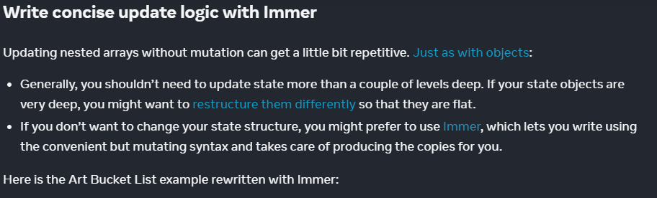

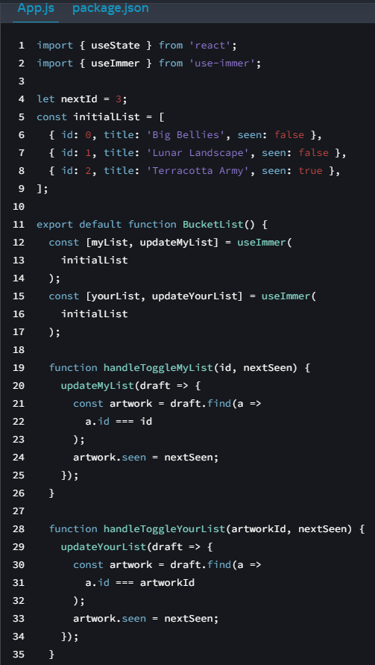

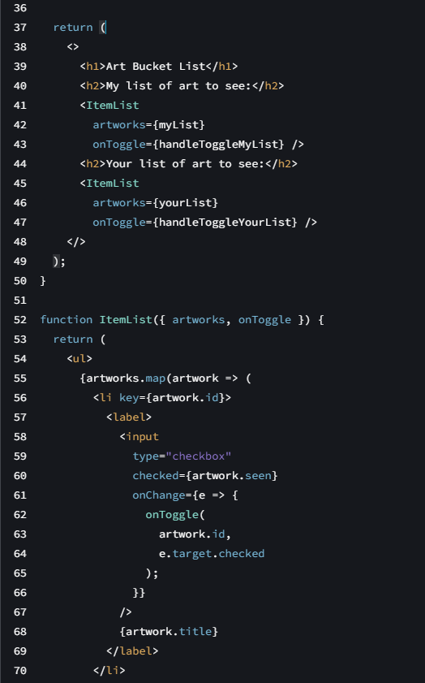

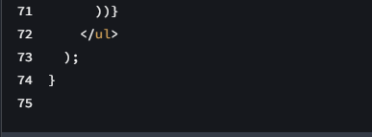

import { useState } from 'react';

import { useImmer } from 'use-immer';

let nextId = 3;

const initialList = [

{ id: 0, title: 'Big Bellies', seen: false },

{ id: 1, title: 'Lunar Landscape', seen: false },

{ id: 2, title: 'Terracotta Army', seen: true },

];

export default function BucketList() {

const [myList, updateMyList] = useImmer(

initialList

);

const [yourList, updateYourList] = useImmer(

initialList

);

function handleToggleMyList(id, nextSeen) {

updateMyList(draft => {

const artwork = draft.find(a =>

a.id === id

);

artwork.seen = nextSeen;

});

}

function handleToggleYourList(artworkId, nextSeen) {

updateYourList(draft => {

const artwork = draft.find(a =>

a.id === artworkId

);

artwork.seen = nextSeen;

});

}

return (

<>

<h1>Art Bucket List</h1>

<h2>My list of art to see:</h2>

<ItemList

artworks={myList}

onToggle={handleToggleMyList} />

<h2>Your list of art to see:</h2>

<ItemList

artworks={yourList}

onToggle={handleToggleYourList} />

</>

);

}

function ItemList({ artworks, onToggle }) {

return (

<ul>

{artworks.map(artwork => (

<li key={artwork.id}>

<label>

<input

type="checkbox"

checked={artwork.seen}

onChange={e => {

onToggle(

artwork.id,

e.target.checked

);

}}

/>

{artwork.title}

</label>

</li>

))}

</ul>

);

}



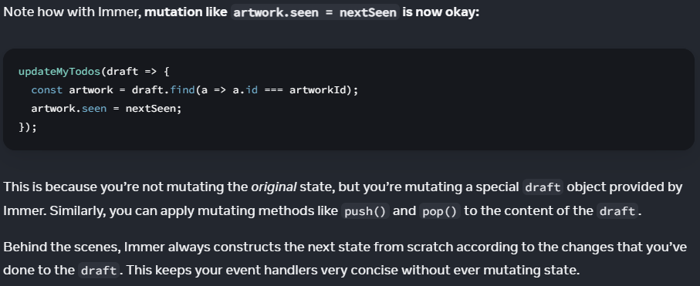

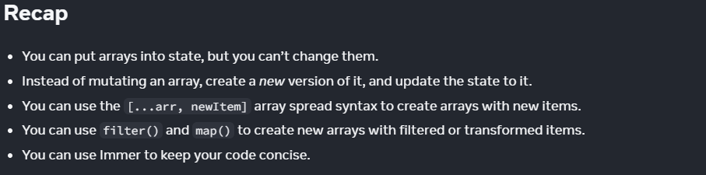

====Challenge 1 of 4 react shopping cart - add item

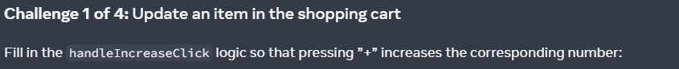

Question:

App.js:

import { useState } from 'react';

const initialProducts = [{

id: 0,

name: 'Baklava',

count: 1,

}, {

id: 1,

name: 'Cheese',

count: 5,

}, {

id: 2,

name: 'Spaghetti',

count: 2,

}];

export default function ShoppingCart() {

const [

products,

setProducts

] = useState(initialProducts)

function handleIncreaseClick(productId) {

// TODO

}

return (

<ul>

{products.map(product => (

<li key={product.id}>

{product.name}

{' '}

(<b>{product.count}</b>)

<button onClick={() => {

handleIncreaseClick(product.id);

}}>

+

</button>

</li>

))}

</ul>

);

}

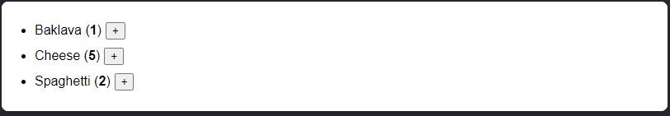

----

My solution:

import { useState } from 'react';

const initialProducts = [{

id: 0,

name: 'Baklava',

count: 1,

}, {

id: 1,

name: 'Cheese',

count: 5,

}, {

id: 2,

name: 'Spaghetti',

count: 2,

}];

export default function ShoppingCart() {

const [

products,

setProducts

] = useState(initialProducts)

function handleIncreaseClick(productId) {

setProducts(products.map(product => {

if (product.id === productId) {

return {...product, count: product.count + 1 };

} else {

return product

}

}));

}

return (

<ul>

{products.map(product => (

<li key={product.id}>

{product.name}

{' '}

(<b>{product.count}</b>)

<button onClick={() => {

handleIncreaseClick(product.id);

}}>

+

</button>

</li>

))}

</ul>

);

}

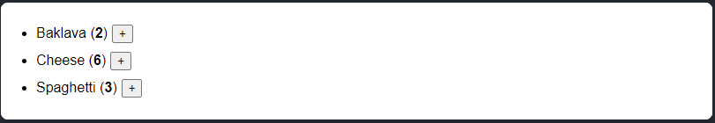

Adding '-' button:

import { useState } from 'react';

const initialProducts = [{

id: 0,

name: 'Baklava',

count: 1,

}, {

id: 1,

name: 'Cheese',

count: 5,

}, {

id: 2,

name: 'Spaghetti',

count: 2,

}];

export default function ShoppingCart() {

const [

products,

setProducts

] = useState(initialProducts)

function handleIncreaseClick(productId) {

setProducts(products.map(product => {

if (product.id === productId) {

return {...product, count: product.count + 1 }

} else {

return product;

}

}));

}

function handleDecreaseClick(productId) {

setProducts(products.map(product => {

if (product.id === productId && product.count > 0) {

return {...product, count: product.count - 1 }

} else {

return product;

}

}));

}

return (

<ul>

{products.map(product => (

<li key={product.id}>

{product.name}

{' '}

(<b>{product.count}</b>)

<button onClick={() => {

handleIncreaseClick(product.id);

}}>

+

</button>

<button onClick={() => {

handleDecreaseClick(product.id);

}}>

-

</button>

</li>

))}

</ul>

);

}

====Challenge 2 of 4 react shopping cart - remove item

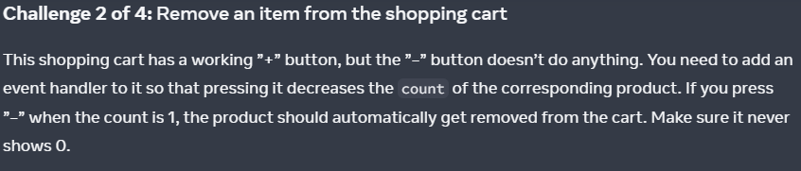

Question:

App.js:

import { useState } from 'react';

const initialProducts = [{

id: 0,

name: 'Baklava',

count: 1,

}, {

id: 1,

name: 'Cheese',

count: 5,

}, {

id: 2,

name: 'Spaghetti',

count: 2,

}];

export default function ShoppingCart() {

const [

products,

setProducts

] = useState(initialProducts)

function handleIncreaseClick(productId) {

setProducts(products.map(product => {

if (product.id === productId) {

return {

...product,

count: product.count + 1

};

} else {

return product;

}

}))

}

return (

<ul>

{products.map(product => (

<li key={product.id}>

{product.name}

{' '}

(<b>{product.count}</b>)

<button onClick={() => {

handleIncreaseClick(product.id);

}}>

+

</button>

<button>

–

</button>

</li>

))}

</ul>

);

}

My Solution:

import { useState } from 'react';

const initialProducts = [{

id: 0,

name: 'Baklava',

count: 1,

}, {

id: 1,

name: 'Cheese',

count: 5,

}, {

id: 2,

name: 'Spaghetti',

count: 2,

}];

export default function ShoppingCart() {

const [

products,

setProducts

] = useState(initialProducts)

function handleIncreaseClick(productId) {

setProducts(products.map(product => {

if (product.id === productId) {

return {

...product,

count: product.count + 1

};

} else {

return product;

}

}))

}

// Decrease product count && remove product if product.count = 0

function handleDecreaseClick(productId) {

setProducts(products

.map(product => {

if (product.id === productId && product.count > 0) {

return {

...product,

count: product.count - 1

};

} else {

return product;

}

})

**// Remove product if count = 0

.filter(p => p.count > 0)

);

}

return (

<ul>

{products.map(product => (

<li key={product.id}>

{product.name}

{' '}

(<b>{product.count}</b>)

<button onClick={() => {

handleIncreaseClick(product.id);

}}>

+

</button>

<button onClick={() => {

handleDecreaseClick(product.id);

}}>

–

</button>

</li>

))}

</ul>

);

}



====Challenge 3 of 4 react avoid mutations

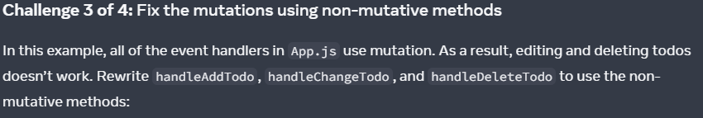

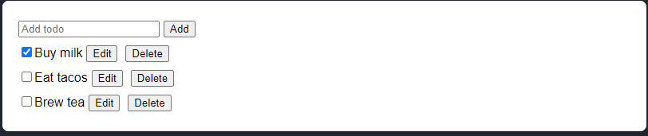

Question:

TaskList.js:

import { useState } from 'react';

export default function TaskList({

todos,

onChangeTodo,

onDeleteTodo

}) {

return (

<ul>

{todos.map(todo => (

<li key={todo.id}>

<Task

todo={todo}

onChange={onChangeTodo}

onDelete={onDeleteTodo}

/>

</li>

))}

</ul>

);

}

function Task({ todo, onChange, onDelete }) {

const [isEditing, setIsEditing] = useState(false);

let todoContent;

if (isEditing) {

todoContent = (

<>

<input

value={todo.title}

onChange={e => {

onChange({

...todo,

title: e.target.value

});

}} />

<button onClick={() => setIsEditing(false)}>

Save

</button>

</>

);

} else {

todoContent = (

<>

{todo.title}

<button onClick={() => setIsEditing(true)}>

Edit

</button>

</>

);

}

return (

<label>

<input

type="checkbox"

checked={todo.done}

onChange={e => {

onChange({

...todo,

done: e.target.checked

});

}}

/>

{todoContent}

<button onClick={() => onDelete(todo.id)}>

Delete

</button>

</label>

);

}

----

AddTodo.js:

import { useState } from 'react';

export default function AddTodo({ onAddTodo }) {

const [title, setTitle] = useState('');

return (

<>

<input

placeholder="Add todo"

value={title}

onChange={e => setTitle(e.target.value)}

/>

<button onClick={() => {

setTitle('');

onAddTodo(title);

}}>Add</button>

</>

)

}

----

App.js:

import { useState } from 'react';

import AddTodo from './AddTodo.js';

import TaskList from './TaskList.js';

let nextId = 3;

const initialTodos = [

{ id: 0, title: 'Buy milk', done: true },

{ id: 1, title: 'Eat tacos', done: false },

{ id: 2, title: 'Brew tea', done: false },

];

export default function TaskApp() {

const [todos, setTodos] = useState(

initialTodos

);

function handleAddTodo(title) {

todos.push({

id: nextId++,

title: title,

done: false

});

}

function handleChangeTodo(nextTodo) {

const todo = todos.find(t =>

t.id === nextTodo.id

);

todo.title = nextTodo.title;

todo.done = nextTodo.done;

}

function handleDeleteTodo(todoId) {

const index = todos.findIndex(t =>

t.id === todoId

);

todos.splice(index, 1);

}

return (

<>

<AddTodo

onAddTodo={handleAddTodo}

/>

<TaskList

todos={todos}

onChangeTodo={handleChangeTodo}

onDeleteTodo={handleDeleteTodo}

/>

</>

);

}

====

My solution:

App.js:

import { useState } from 'react';

import AddTodo from './AddTodo.js';

import TaskList from './TaskList.js';

// let nextId = 3;

const initialTodos = [

{ id: 0, title: 'Buy milk', done: true },

{ id: 1, title: 'Eat tacos', done: false },

{ id: 2, title: 'Brew tea', done: false },

];

let nextId = initialTodos.map(todo => todo.id).length + 1;

export default function TaskApp() {

const [todos, setTodos] = useState(

initialTodos

);

function handleAddTodo(title) {

// insert point

const insertAt = 0;

// Make a copy of todos to avoid mutations

const nextTodos = [

// Location of New item being inserted in array list

...todos.slice(0, insertAt),

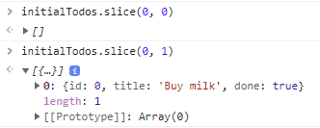

// Inserting new items

{ id: nextId++, title: title, done: false, },

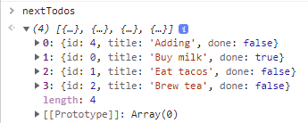

// New item to be inseted at top of array list

// right before all existing items in array list

...todos.slice(insertAt)

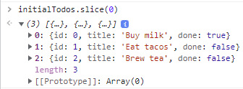

];

setTodos(nextTodos);

// Local mutation

// todos.push({

// id: nextId++,

// title: title,

// done: false

// });

}

function handleChangeTodo(nextTodo) {

// Make a copy of todos to avoid mutations

const nextTodos = todos.map(todo => {

if (todo.id === nextTodo.id) {

return {

...todo,

title: nextTodo.title,

done: nextTodo.done,

}

} else {

return todo;

}

})

setTodos(nextTodos);

// Local mutation

// const todo = todos.find(t =>

// t.id === nextTodo.id

// );

// todo.title = nextTodo.title;

// todo.done = nextTodo.done;

}

function handleDeleteTodo(todoId) {

// Removing item from todos using setState

setTodos(

todos.filter(todo => {

return todo.id !== todoId

}))

// const index = todos.findIndex(t =>

// t.id === todoId

// );

// todos.splice(index, 1);

}

return (

<>

<AddTodo

onAddTodo={handleAddTodo}

/>

<TaskList

todos={todos}

onChangeTodo={handleChangeTodo}

onDeleteTodo={handleDeleteTodo}

/>

</>

);

}

Add 'new item1'

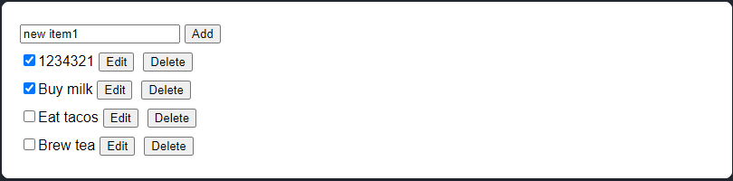

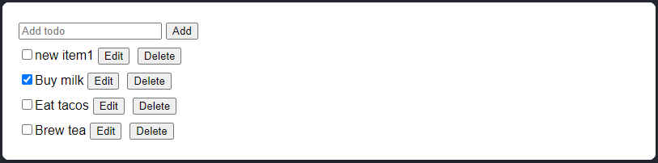

----

Edit 'new item1'

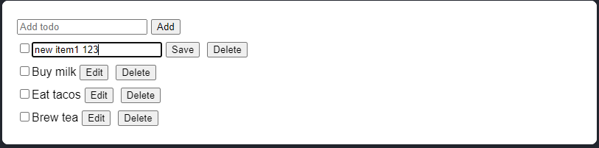

Save

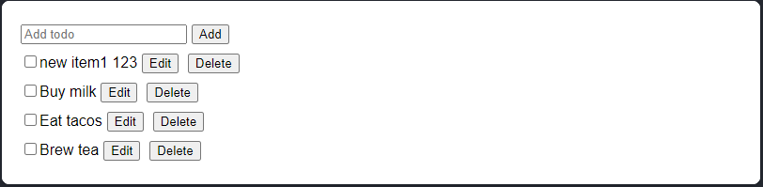

----

Delete 'new item1'

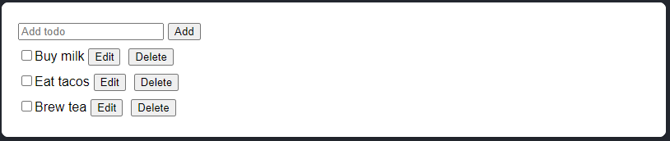

Managing State - youtube

[React State Management – Intermediate JavaScript Course](https://www.youtube.com/watch?v=-bEzt5ISACA)



React:

Turn State -> HTML

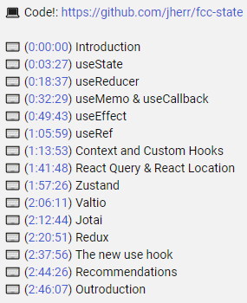

useState:

import { useState } from "react";

// useState intro

function NameList() {

  const [list, setList] = useState(["Jack", "Jill", "John"]);

  // Scalar String

  // const [name, setName] = useState('');

  const [name, setName] = useState(() => "Jack");

  // will return Jack by deafult in <input>

  const onAddName = () => {

      // Local mutation

      // list.push(name);

    // Adding new items to new array by Shallow copy [...list]

    setList([...list, name]);

    setName(''); // clearing cached name after adding an item

  };

  return (

    <div>

      <ul>

        {list.map( (name) => (

          <li key={name}>{name}</li>

        ))}

      </ul>

      <input

        type="text"

        value={name} // Jack

        onChange={(e) => setName(name => name = e.target.value)}

      />

      <button

        onClick={onAddName}

      >

        Add Name

      </button>

    </div>

  );

}

function Counter() {

  const [count, setCount] = useState(10);

  function addOne() {

    setCount(count => count + 1);

  }

  return (

    <div className="App">

      <button

        onClick={addOne}

      >Count = {count}

      </button>

    </div>

  );

}

function App() {

  return (

    <div>

      {/* Each Component maintains its own count */}

      <Counter />

      <NameList />

    </div>

  )

}

export default App

// useReducer

import { useReducer } from "react";

function App() {

  const [state, dispatch] = useReducer((state, action) => {

    switch(action.type) {

      case "SET_NAME":

        return { ...state, name: action.payload };

    }

  }, {

    names: [],

    name: '',

  })

  return (

    <div className="App">

      <input

        type="text"

        value={state.name}

        onChange={e => dispatch( { type: "SET_NAME", payload: e.target.value})}

      />

      <div>Name = {state.name}</div>

    </div>

  );

}

export default App;

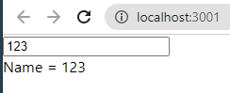

00:26:42 over 02:46:37

Managing State intro

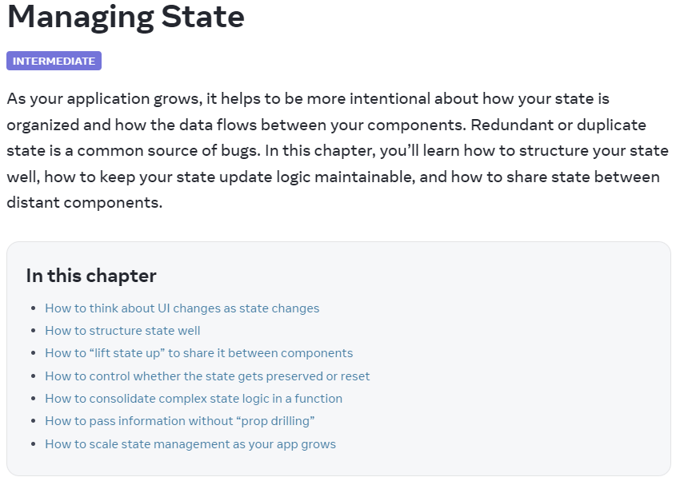

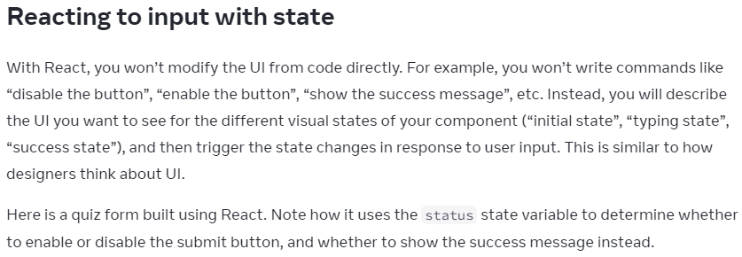

App.js:

import { useState } from 'react';

export default function Form() {

const [answer, setAnswer] = useState('');

const [error, setError] = useState(null);

const [status, setStatus] = useState('typing');

if (status === 'success') {

return <h1>That's right!</h1>

}

async function handleSubmit(e) {

e.preventDefault();

setStatus('submitting');

try {

await submitForm(answer);

setStatus('success');

} catch (err) {

setStatus('typing');

setError(err);

}

}

function handleTextareaChange(e) {

setAnswer(e.target.value);

}

return (

<>

<h2>City quiz</h2>

<p>

In which city is there a billboard that turns air into drinkable water?

</p>

<form onSubmit={handleSubmit}>

<textarea

value={answer}

onChange={handleTextareaChange}

disabled={status === 'submitting'}

/>

<br />

<button disabled={

answer.length === 0 ||

status === 'submitting'

}>

Submit

</button>

{error !== null &&

<p className="Error">

{error.message}

</p>

}

</form>

</>

);

}

function submitForm(answer) {

// Pretend it's hitting the network.

return new Promise((resolve, reject) => {

setTimeout(() => {

let shouldError = answer.toLowerCase() !== 'lima'

if (shouldError) {

reject(new Error('Good guess but a wrong answer. Try again!'));

} else {

resolve();

}

}, 1500);

});

}

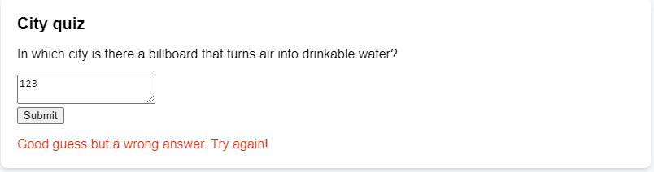



**Removing Redundant state variables**

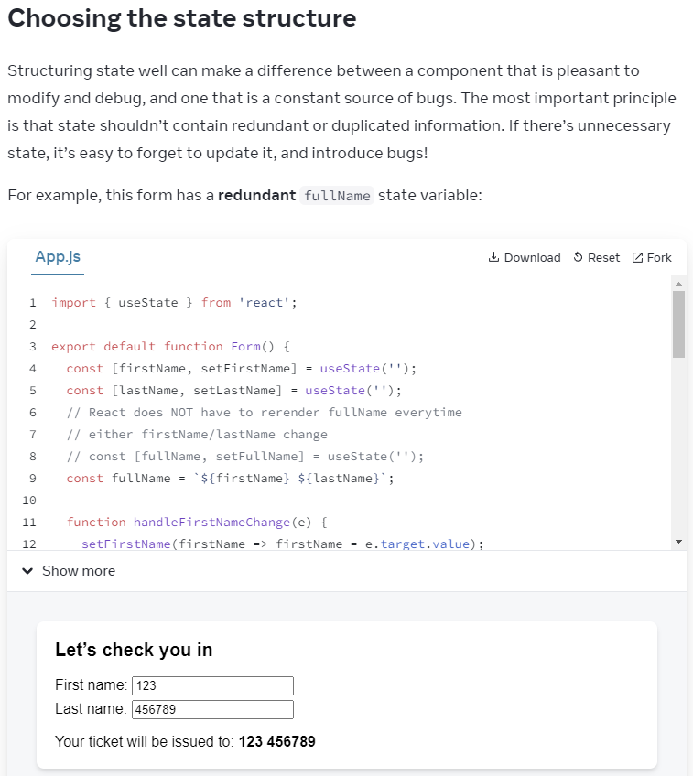

Code review:

import { useState } from 'react';

export default function Form() {

const [firstName, setFirstName] = useState('');

const [lastName, setLastName] = useState('');

// This fullName useState will rerender page twice...Redundant

// const [fullName, setFullName] = useState('');

// React does NOT have to rerender fullName when

// either firstName/lastName change

const fullName = `${firstName} ${lastName}`;

function handleFirstNameChange(e) {

setFirstName(firstName => firstName = e.target.value);

// setFullName(e.target.value + ' ' + lastName);

}

function handleLastNameChange(e) {

setLastName(lastName => lastName = e.target.value);

// setFullName(firstName + ' ' + e.target.value);

}

return (

<>

<h2>Let’s check you in</h2>

<label>

First name:{' '}

<input

value={firstName}

onChange={handleFirstNameChange}

/>

</label>

<label>

Last name:{' '}

<input

value={lastName}

onChange={handleLastNameChange}

/>

</label>

<p>

Your ticket will be issued to: <b>{fullName}</b>

</p>

</>

);

}

//

----



// **Parent func stores state variables**

// Pass it to children as **props**

export default function Accordion() {

const [activeIndex, setActiveIndex] = useState(0);

return (

...

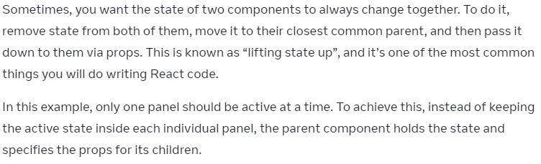

App.js:

import { useState } from 'react';

export default function Accordion() {

const [activeIndex, setActiveIndex] = useState(0);

return (

<>

<h2>Almaty, Kazakhstan</h2>

<Panel

title="About"

isActive={activeIndex === 0} // isActive(false) => <button> shows up

onShow={() => setActiveIndex(0)} //onShow = onClick passed as props

>

With a population of about 2 million, Almaty is Kazakhstan's largest city. From 1929 to 1997, it was its capital city.

</Panel>

<Panel

title="Etymology"

isActive={activeIndex === 1}

onShow={() => setActiveIndex(1)}

>

The name comes from <span lang="kk-KZ">алма</span>, the Kazakh word for "apple" and is often translated as "full of apples". In fact, the region surrounding Almaty is thought to be the ancestral home of the apple, and the wild <i lang="la">Malus sieversii</i> is considered a likely candidate for the ancestor of the modern domestic apple.

</Panel>

</>

);

}

// Figure out **props** to be **lifted**

function Panel({

title,

children,

isActive,

onShow

}) {

return ( // <Panel /> Redering

<section className="panel">

<h3>{title}</h3>

{isActive ? (

<p>{children}</p>

) : (

<button onClick={onShow}> // lifting props **onShow** to **parent**

Show

</button>

)}

</section>

);

}

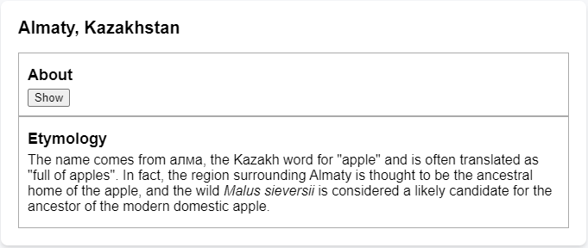

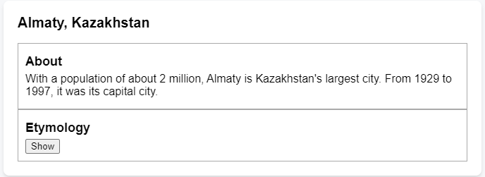

-----

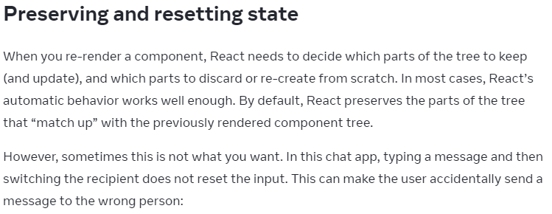

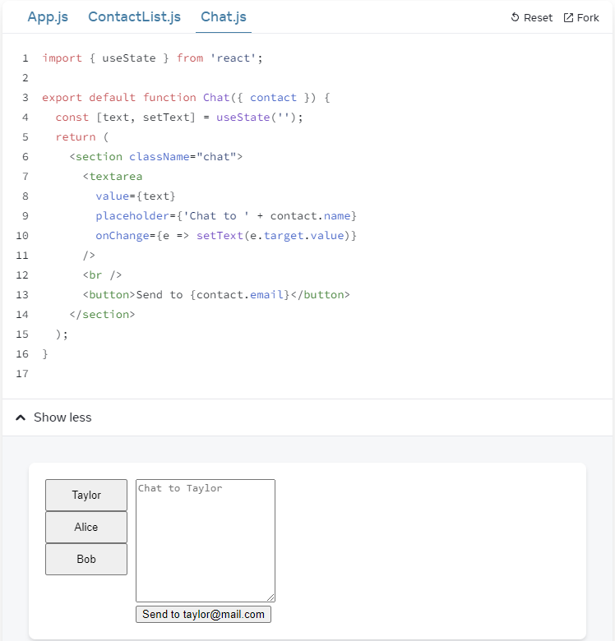

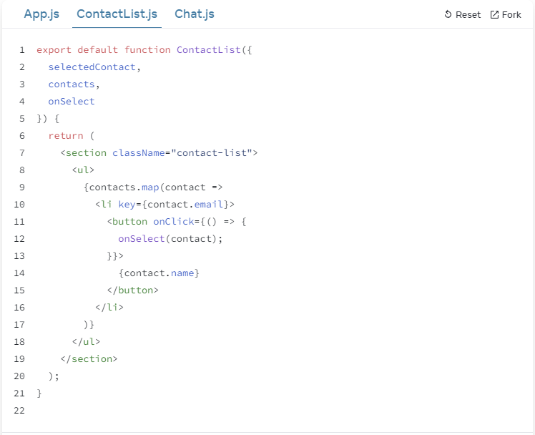

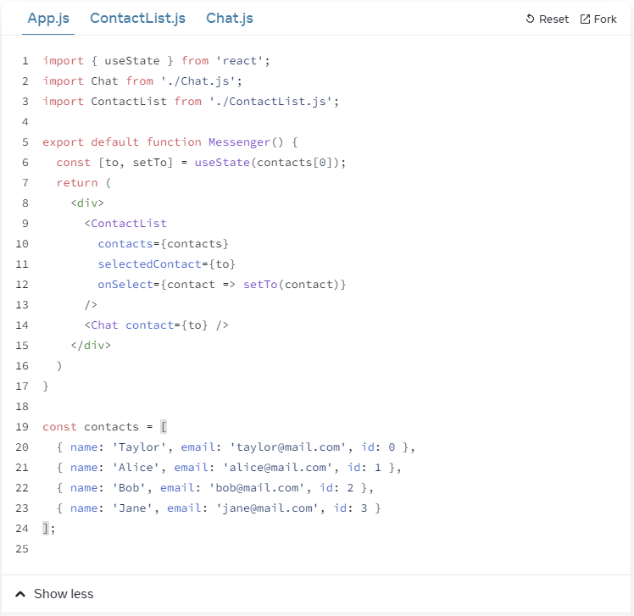

App.js:

import { useState } from 'react';

import Chat from './Chat.js';

import ContactList from './ContactList.js';

export default function Messenger() {

const [to, setTo] = useState(contacts[0]);

return (

<div>

<ContactList

contacts={contacts}

selectedContact={to}

onSelect={contact => setTo(contact)}

/>

<Chat key={to.email} contact={to} />

</div>

)

}

const contacts = [

{ name: 'Taylor', email: 'taylor@mail.com' },

{ name: 'Alice', email: 'alice@mail.com' },

{ name: 'Bob', email: 'bob@mail.com' }

];

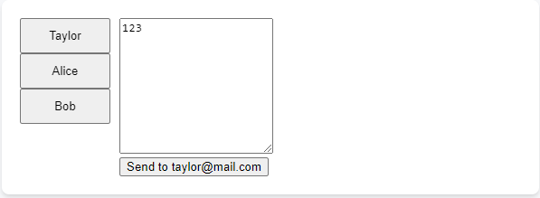

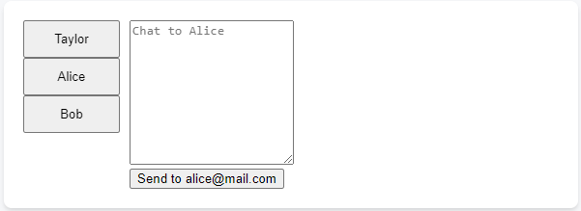

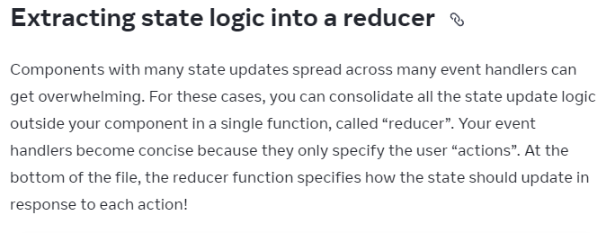

App.js:

import { useReducer } from 'react';

import AddTask from './AddTask.js';

import TaskList from './TaskList.js';

export default function TaskApp() {

const [tasks, dispatch] = useReducer(

tasksReducer,

initialTasks

);

function handleAddTask(text) {

dispatch({

type: 'added',

id: nextId++,

text: text,

});

}

function handleChangeTask(task) {

dispatch({

type: 'changed',

task: task

});

}

function handleDeleteTask(taskId) {

dispatch({

type: 'deleted',

id: taskId

});

}

return (

<>

<h1>Prague itinerary</h1>

<AddTask

onAddTask={handleAddTask}

/>

<TaskList

tasks={tasks}

onChangeTask={handleChangeTask}

onDeleteTask={handleDeleteTask}

/>

</>

);

}

function tasksReducer(tasks, action) {

switch (action.type) {

case 'added': {

return [...tasks, {

id: action.id,

text: action.text,

done: false

}];

}

case 'changed': {

return tasks.map(t => {

if (t.id === action.task.id) {

return action.task;

} else {

return t;

}

});

}

case 'deleted': {

return tasks.filter(t => t.id !== action.id);

}

default: {

throw Error('Unknown action: ' + action.type);

}

}

}

let nextId = 3;

const initialTasks = [

{ id: 0, text: 'Visit Kafka Museum', done: true },

{ id: 1, text: 'Watch a puppet show', done: false },

{ id: 2, text: 'Lennon Wall pic', done: false }

];

The useReducer part:

**useReducer to extract state logic**

function tasksReducer(tasks, action) {

switch (action.type) {

case 'added': {

return [...tasks, {

id: action.id,

text: action.text,

done: false

}];

}

case 'changed': {

return tasks.map(t => {

if (t.id === action.task.id) {

return action.task;

} else {

return t;

}

});

}

case 'deleted': {

return tasks.filter(t => t.id !== action.id);

}

default: {

throw Error('Unknown action: ' + action.type);

}

}

}

Reacting to Input with State

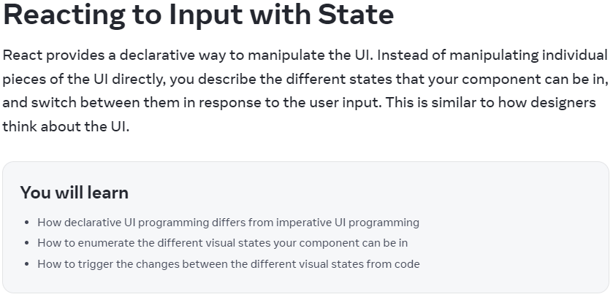

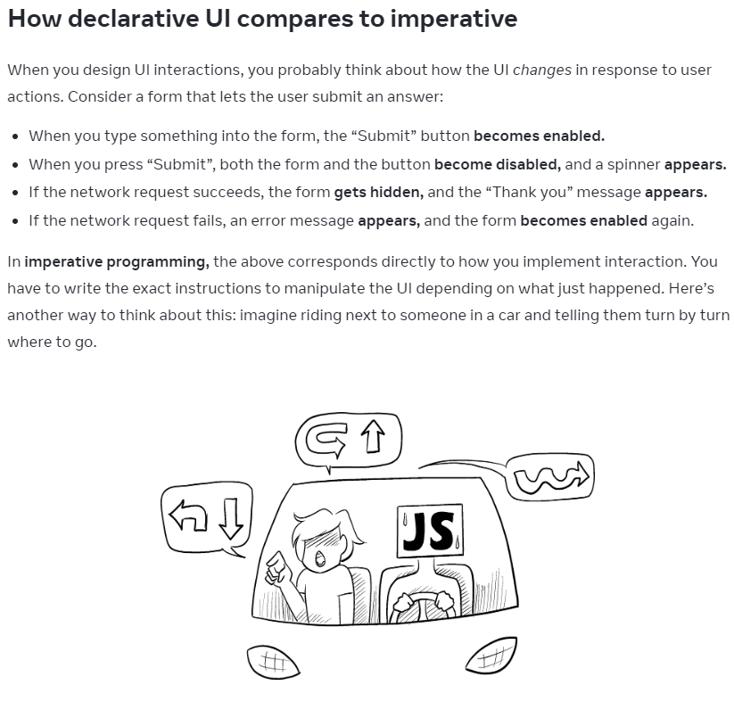

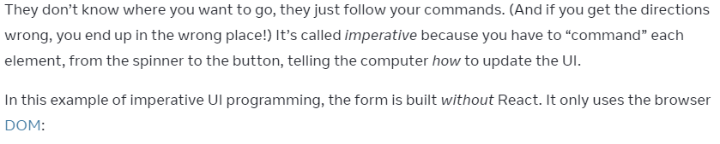

index.js:

async function handleFormSubmit(e) {

e.preventDefault();

disable(textarea);

disable(button);

show(loadingMessage);

hide(errorMessage);

try {

await submitForm(textarea.value);

show(successMessage);

hide(form);

} catch (err) {

show(errorMessage);

errorMessage.textContent = err.message;

} finally {

hide(loadingMessage);

enable(textarea);

enable(button);

}

}

function handleTextareaChange() {

if (textarea.value.length === 0) {

disable(button);

} else {

enable(button);

}

}

function hide(el) {

el.style.display = 'none';

}

function show(el) {

el.style.display = '';

}

function enable(el) {

el.disabled = false;

}

function disable(el) {

el.disabled = true;

}

function submitForm(answer) {

// Pretend it's hitting the network.

return new Promise((resolve, reject) => {

setTimeout(() => {

if (answer.toLowerCase() == 'istanbul') {

resolve();

} else {

reject(new Error('Good guess but a wrong answer. Try again!'));

}

}, 1500);

});

}

let form = document.getElementById('form');

let textarea = document.getElementById('textarea');

let button = document.getElementById('button');

let loadingMessage = document.getElementById('loading');

let errorMessage = document.getElementById('error');

let successMessage = document.getElementById('success');

form.onsubmit = handleFormSubmit;

textarea.oninput = handleTextareaChange;

====

index.html:

<form id="form">

<h2>City quiz</h2>

<p>

What city is located on two continents?

</p>

<textarea id="textarea"></textarea>

<br />

<button id="button" disabled>Submit</button>

<p id="loading" style="display: none">Loading...</p>

<p id="error" style="display: none; color: red;"></p>

</form>

<h1 id="success" style="display: none">That's right!</h1>

<style>

* { box-sizing: border-box; }

body { font-family: sans-serif; margin: 20px; padding: 0; }

</style>

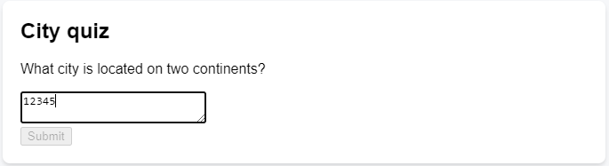

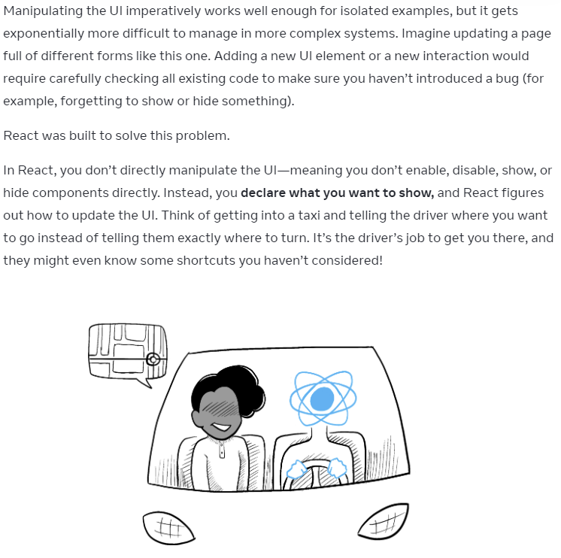

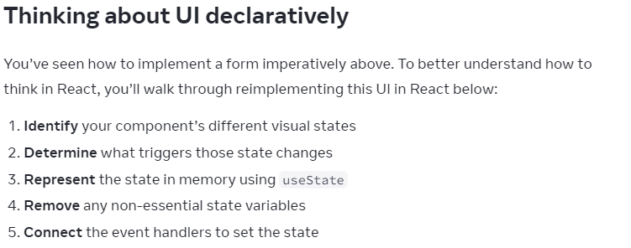

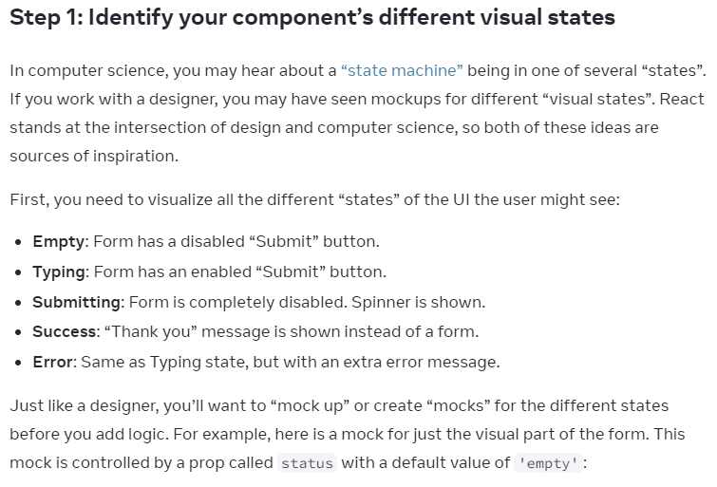

**Step1: Figure out Components' possible visual states**

Mocking before adding logic:

5 scenarios:

1. Empty form <button disabled={ status === 'arg1' || status === 'arg2' } >Submit</button>

2. Typing

3. Submitting

4. Success

5. Error

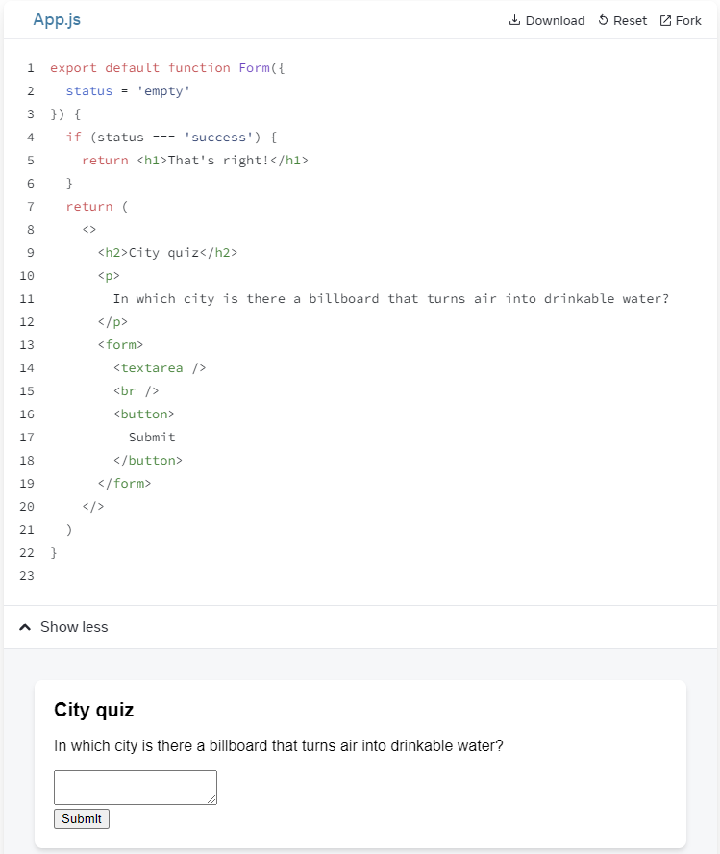

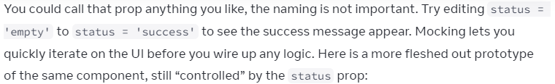

App.js:

export default function Form({

// Try 'submitting', 'error', 'success':

status = 'error'

}) {

if (status === 'success') {

return <h1>That's right!</h1>

}

return (

<>

<h2>City quiz</h2>

<p>

In which city is there a billboard that turns air into drinkable water?

</p>

<form>

<textarea disabled={

status === 'submitting'

} />

<br />

<button disabled={

status === 'empty' ||

status === 'submitting'

}>

Submit

</button>

{status === 'error' &&

<p className="Error">

Good guess but a wrong answer. Try again!

</p>

}

</form>

</>

);

}

=====

status = 'submitting'

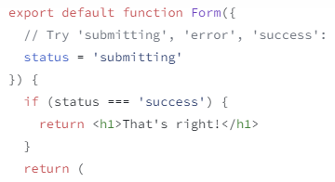

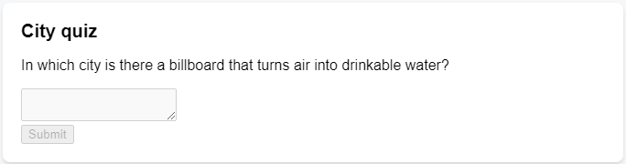

=====

status = 'error'

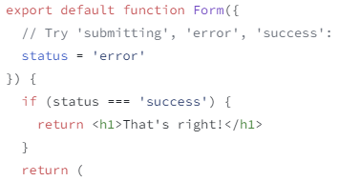

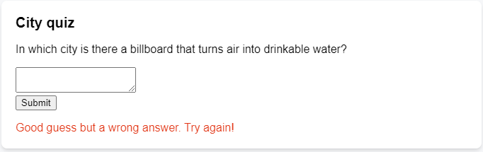

=====

status = 'success'

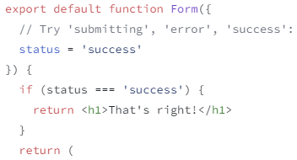

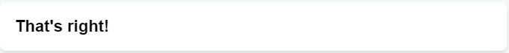

=====

**Step2: Figure out Triggers to State changes**

Triggers can be:

**1. Human inputs:**

-onClick

-onChange in <input>

-Navigating a link

**2. Computer inputs:**

-network response

-timeout completing

-image loading

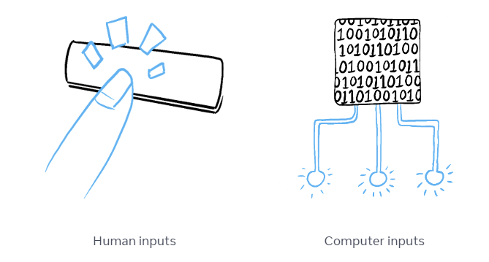

In Both cases,

you must **set state variables** to **update UI**

Form -> receives trigger -> change state

**-Changing text input** (human): (state) Empty <-> *Typing*

**-Clicking 'Submit' button** (human): (state) Typing -> *Submitting*

**-Successful network response** (comp 200): (state) Submitting -> *Success*

**-Failed network response** (comp 408): (state) Submitting -> *Error*

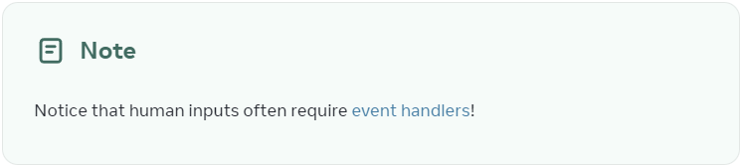

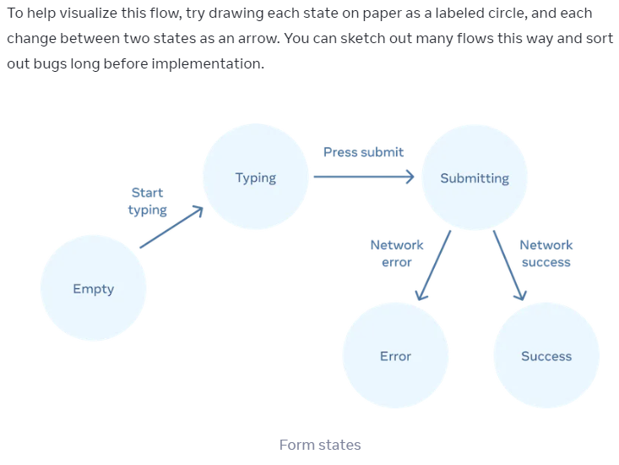

Step3: Represent State in memory with **useState**

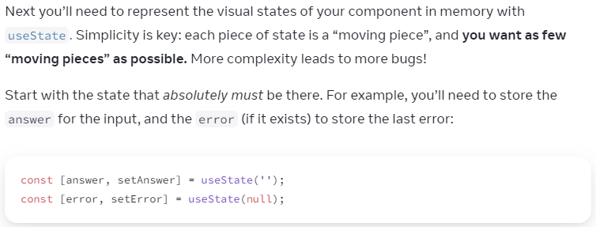

If struggle to figure out **States:**

-List them out

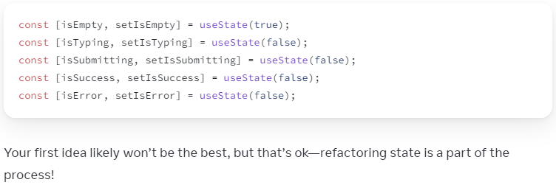

=====

**Step 4: Remove non-essential state variables**

Narrowing down from 7 alternatives:

In UI, users will only see:

answer <input>,

error,

status responses

(1. typing = submit btn activated;

2. submitting = submit btn disabled;

3. success = navigate to another link)

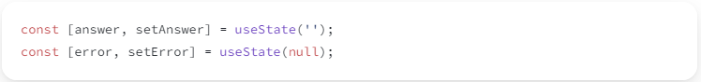



Goal = **Prevent cases where state in memory !== UI** (that a user sees)

**-Does this state cause a paradox?**

i.e. *isTyping* & *isSubmitting* cannot be *true* at the same time

[paradox = state not constrained enough (vague) ]

**-Is the same info available in another state variable already?**

i.e. *isEmpty* & *isTyping* cannot be *true* at the same time

check:

answer.length === 0

**-Can you get the same info from the inverse of another state variable?**

*isError* is not needed, as you can check:

error !== null

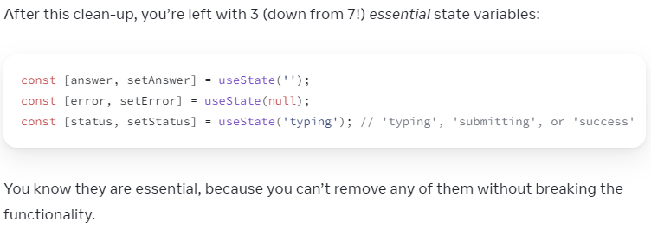

====

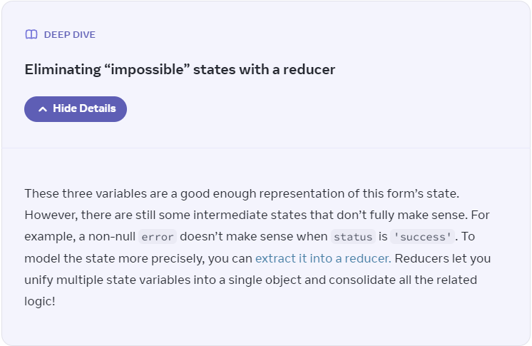

====

**Step 5: Connect event handlers to setState**



App.js:

import { useState } from 'react';

export default function Form() {

// Allow user to type text in <input>

const [answer, setAnswer] = useState('');

// Default error = null/err;

const [error, setError] = useState(null);

// setError(err) -> setStatus('typing')

// To allow users re-type

const [status, setStatus] = useState('typing');

// Upon submitForm resolve()

// setStatus('success')

if (status === 'success') {

// return () to re-render the page

return <h1>That's right!</h1>

}

async function handleSubmit(e) {

e.preventDefault();

setStatus('submitting');

try {

await submitForm(answer);

setStatus('success');

} catch (err) {

setStatus('typing');

setError(err);

}

}

// re-render upon submitting text in <input>

function handleTextareaChange(e) {

setAnswer(e.target.value);

}

// default UI

return (

<>

<h2>City quiz</h2>

<p>

In which city is there a billboard that turns air into drinkable water?

</p>

<form onSubmit={handleSubmit}>

<textarea

value={answer}

onChange={handleTextareaChange}

disabled={status === 'submitting'}

/>

<br />

<button disabled={

answer.length === 0 ||

status === 'submitting'

}>

Submit

</button>

{error !== null &&

<p className="Error">

{error.message}

</p>

}

</form>

</>

);

}

function submitForm(answer) {

// Pretend it's hitting the network.

return new Promise((resolve, reject) => {

setTimeout(() => {

// let shouldError = answer.toLowerCase() !== 'lima';

let validate = answer.toLowerCase() === 'lima';

// if (shouldError) {

// reject(new Error('Good guess but a wrong answer. Try again!'));

// } else {

// resolve();

// }

if (validate) {

resolve();

} else {

reject(new Error('Good guess but a wrong answer. Try again!'));

}

}, 1500);

});

}

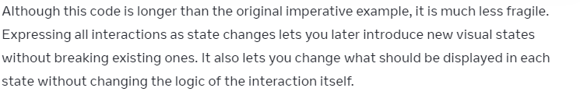

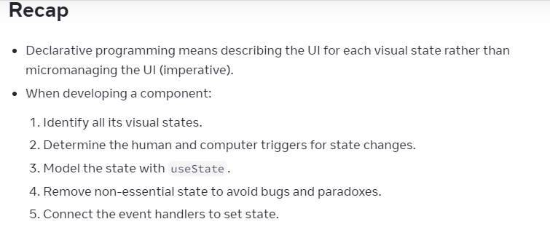

**Challenge 1 of 3: Add & remove a CSS class**

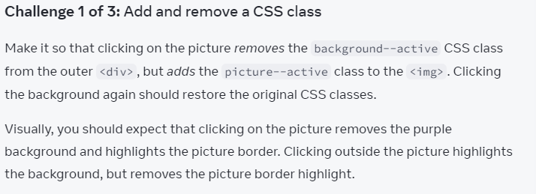

**Visual states:**

**-onClick <img> => remove purple background**

**-onClick <div> background => remove picture border highlight**

**Visual state1:**

<div className="background background--active">

<img className="picture" />

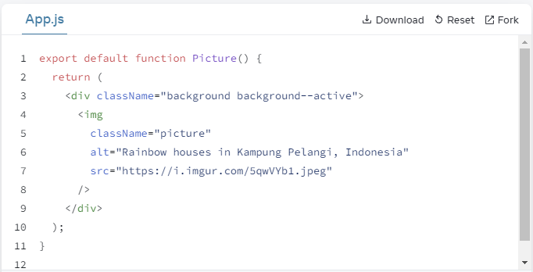

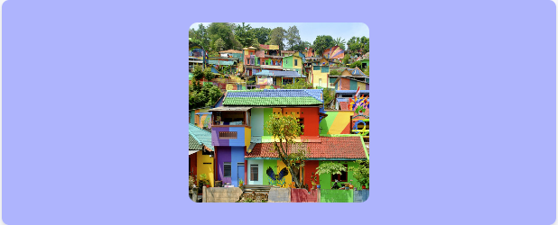

**Visual state2:**

<div className="background">

<img className="picture picture--active" />

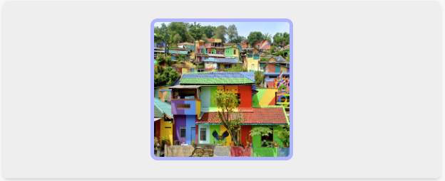

**====**

App.js:

export default function Picture() {

return (

<div className="background background--active">

<img

className="picture"

alt="Rainbow houses in Kampung Pelangi, Indonesia"

src="https://i.imgur.com/5qwVYb1.jpeg"

/>

</div>

);

}

====

My solution:

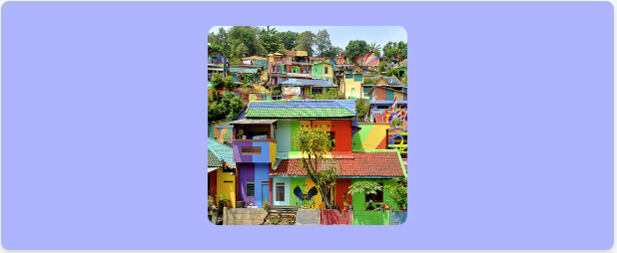

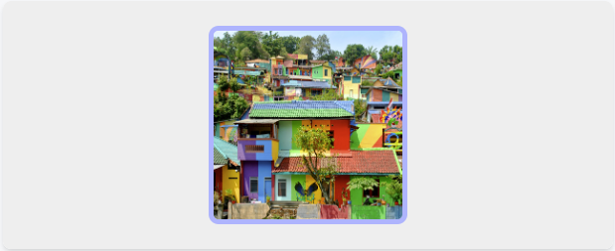

App.js:

import { useState } from 'react';

export default function Picture() {

const [toggle, setToggle] = useState(false)

// onClick setToggle => true/false

const handleClick = () => {

setToggle( (toggle) => !toggle )

}

return (

<>

<div

className={toggle ? "background" : "background background--active"}

onClick={handleClick}

>

<img

className={ toggle ? "picture picture--active" : "picture"}

alt="Rainbow houses in Kampung Pelangi, Indonesia"

src="https://i.imgur.com/5qwVYb1.jpeg"

/>

</div>

</>

);

}

----

**Solution:**

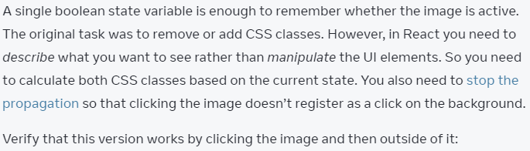

import { useState } from 'react';

export default function Picture() {

const [isActive, setIsActive] = useState(false)

let backgroundClassName = 'background';

let pictureClassName = 'picture';

if (isActive) {

pictureClassName += ' picture--active';

} else {

backgroundClassName += ' background--active';

}

return (

<>

<div

className={backgroundClassName}

onClick={() => setIsActive(false) }

>

<img

onClick={e => {

e.stopPropagation();

// *** <div><img/></div> thus need to stop Event Bubbling

setIsActive(true);

}}

className={pictureClassName}

alt="Rainbow houses in Kampung Pelangi, Indonesia"

src="https://i.imgur.com/5qwVYb1.jpeg"

/>

</div>

</>

);

}

Choosing the State Structure

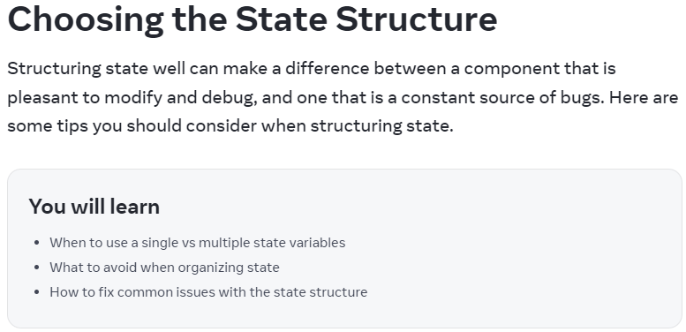

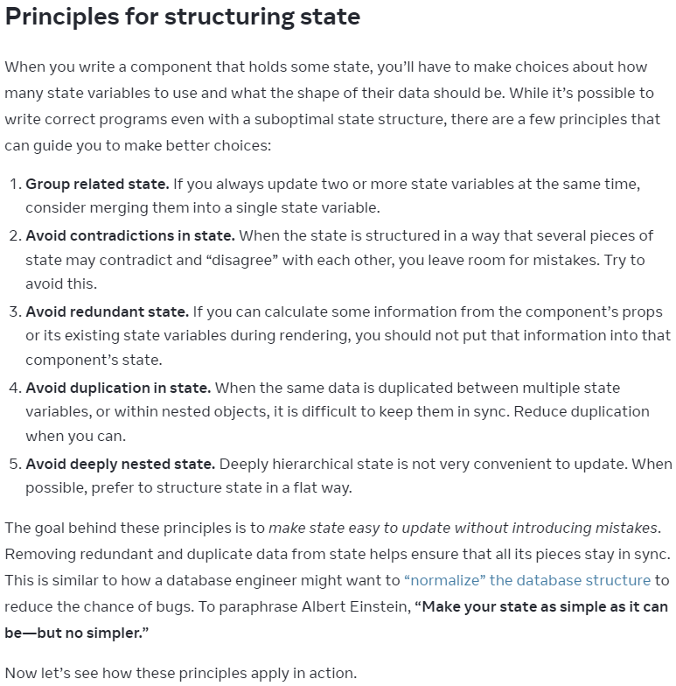

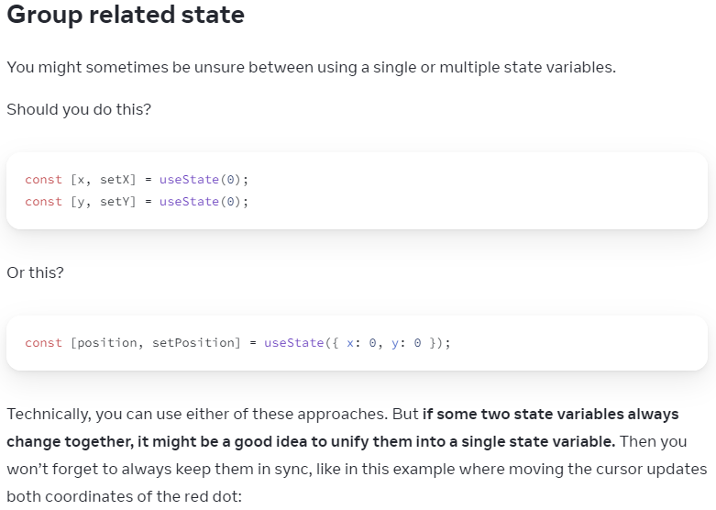

App.js:

import { useState } from 'react';

export default function MovingDot() {

const [position, setPosition] = useState({

x: 0,

y: 0

});

return (

<div

onPointerMove={e => {

setPosition({

x: e.clientX,

y: e.clientY

});

}}

style={{

position: 'relative',

width: '100vw',

height: '100vh',

}}>

<div style={{

position: 'absolute',

backgroundColor: 'red',

borderRadius: '50%',

transform: `translate(${position.x}px, ${position.y}px)`,

left: -10,

top: -10,

width: 20,

height: 20,

}} />

</div>

)

}

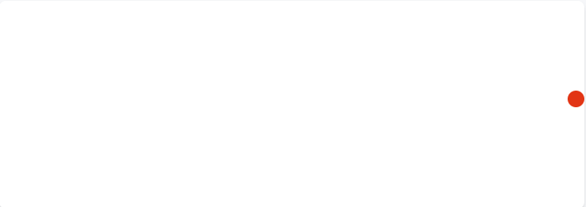

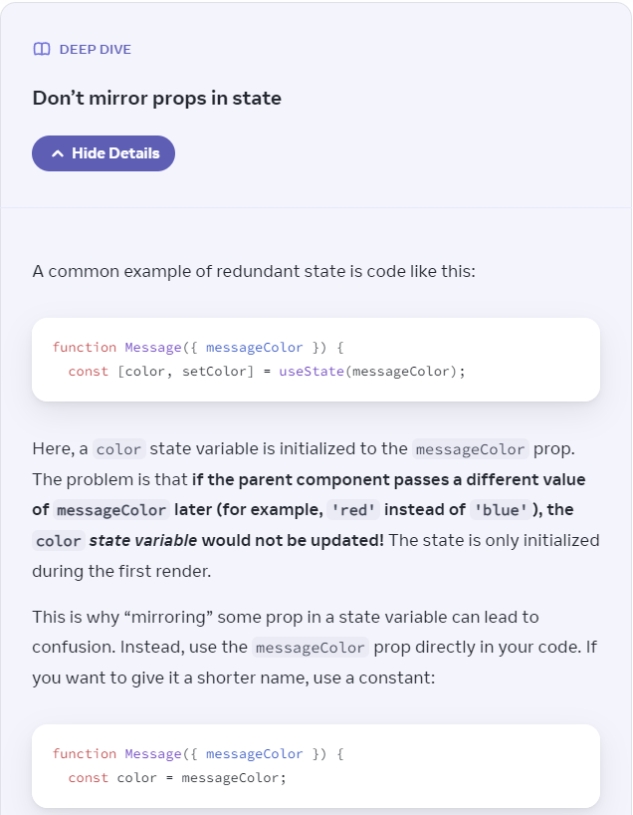

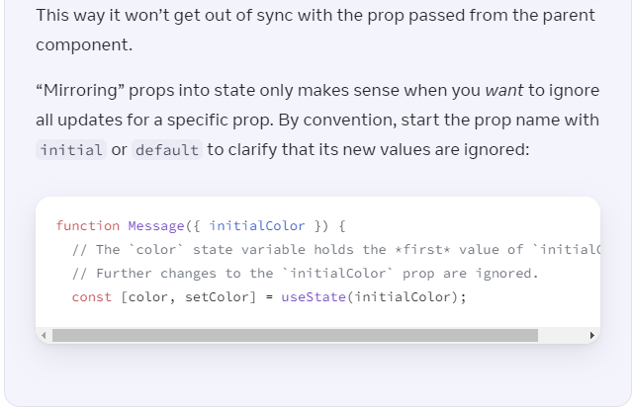

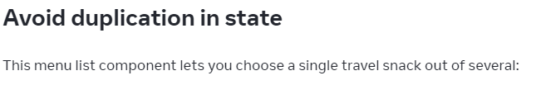

App.js:

import { useState } from 'react';

const initialItems = [

{ title: 'pretzels', id: 0 },

{ title: 'crispy seaweed', id: 1 },

{ title: 'granola bar', id: 2 },

];

export default function Menu() {

const [items, setItems] = useState(initialItems);

const [selectedItem, setSelectedItem] = useState(

items[0]

);

return (

<>

<h2>What's your travel snack?</h2>

<ul>

{items.map(item => (

<li key={item.id}>

{item.title}

{' '}

<button onClick={() => {

setSelectedItem(item);

}}>Choose</button>

</li>

))}

</ul>

<p>You picked {selectedItem.title}.</p>

</>

);

}

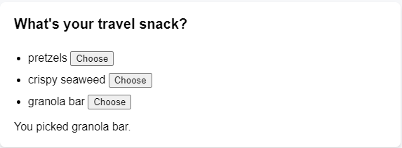

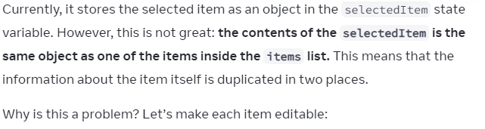

App.js:

import { useState } from 'react';

const initialItems = [

{ title: 'pretzels', id: 0 },

{ title: 'crispy seaweed', id: 1 },

{ title: 'granola bar', id: 2 },

];

export default function Menu() {

const [items, setItems] = useState(initialItems);

const [selectedItem, setSelectedItem] = useState(

items[0]

);

function handleItemChange(id, e) {

setItems(items.map(item => {

if (item.id === id) {

return {

...item,

title: e.target.value,

};

} else {

return item;

}

}));

}

return (

<>

<h2>What's your travel snack?</h2>

<ul>

{items.map((item, index) => (

<li key={item.id}>

<input

value={item.title}

onChange={e => {

handleItemChange(item.id, e)

}}

/>

{' '}

<button onClick={() => {

setSelectedItem(item);

}}>Choose</button>

</li>

))}

</ul>

<p>You picked {selectedItem.title}.</p>

</>

);

}

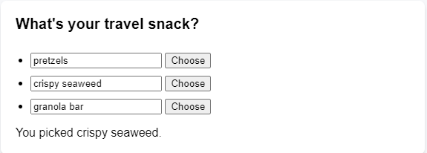

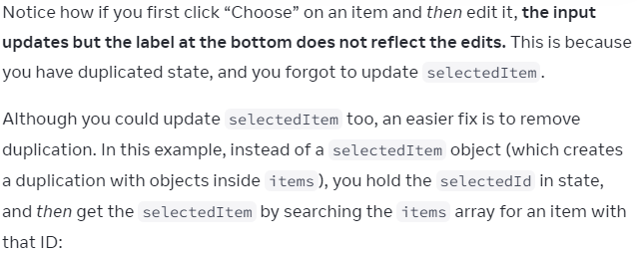

import { useState } from 'react';

const initialItems = [

  { title: 'pretzels', id: 0 },

  { title: 'crispy seaweed', id: 1 },

  { title: 'granola bar', id: 2 },

];

let nextId = initialItems.length;

export default function Menu() {

  const [items, setItems] = useState(initialItems);

  const [selectedId, setSelectedId] = useState(0);

  const [custom, setCustom] = useState('');

// If edit the selected item, the message will update immediately

// As setItems triggers a re-render, and items.find(...)

// would find the item with the updated title

  const selectedItem = items.find(item =>

    item.id === selectedId

  );

  const exist = selectedItem;

  function handleItemChange(id, e) {

    setItems(items.map(item => {

      if (item.id === id) {

        return {

          ...item,

          title: e.target.value,

        };

      } else {

        return item;

      }

    }));

  }

  return exist? (

    <>

      <h2>What's your travel snack?</h2>

      <h4>Add your own travel snack </h4>

      <input

        type="text"

        value={custom}

        onChange={e => setCustom(e.target.value)}

      />

      <button onClick={() => {

        setItems([

          {id: nextId++, title: custom},

          ...items

        ]);

      }}>Add</button>

      <ul>

        {items.map((item, index) => (

          <li key={item.id}>

            <input

              value={item.title}

              onChange={e => {

                handleItemChange(item.id, e)

              }}

            />

            {' '}

            <button onClick={() => {

              setSelectedId(item.id);

            }}>Choose</button>

            <button onClick={() => {

              setItems(items.filter(each => each.id !== item.id))

            }

            }>Delete</button>

          </li>

        ))}

      </ul>

      <p>You picked {selectedItem.title}.</p>

    </>

  ) :

  (

    <>

      <h2>What's your travel snack?</h2>

      <h4>Add your own travel snack </h4>

// Input text for adding custom snack

      <input

        type="text"

        value={custom}

        onChange={e => setCustom(e.target.value)}

      />

// Add a custom snack

      <button onClick={() => {

        setItems([

          {id: nextId++, title: custom},

          ...items

        ]);

      }}>Add</button>

      <ul>

        {items.map((item, index) => (

          <li key={item.id}>

            <input

              value={item.title}

              onChange={e => {

                handleItemChange(item.id, e)

              }}

            />

            {' '}

            <button onClick={() => {

              setSelectedId(item.id);

            }}>Choose</button>

// Remove a snack

            <button onClick={() => {

              setItems(items.filter(each => each.id !== item.id))

            }

            }>Delete</button>

          </li>

        ))}

      </ul>

      <p>Your selected item has been removed...</p>

    </>

  )

}

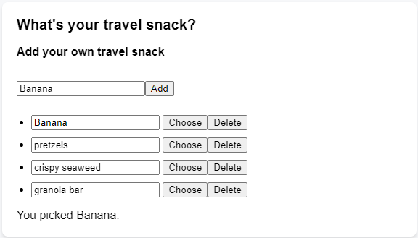

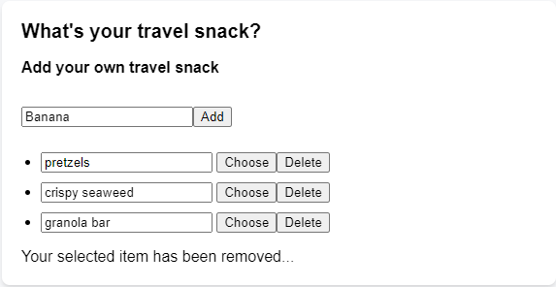

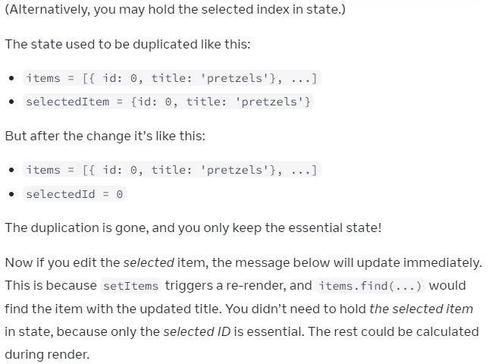

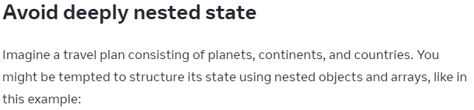

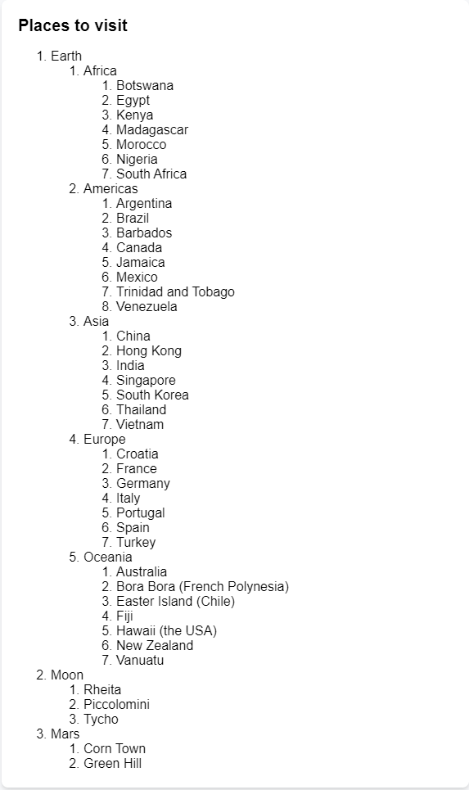

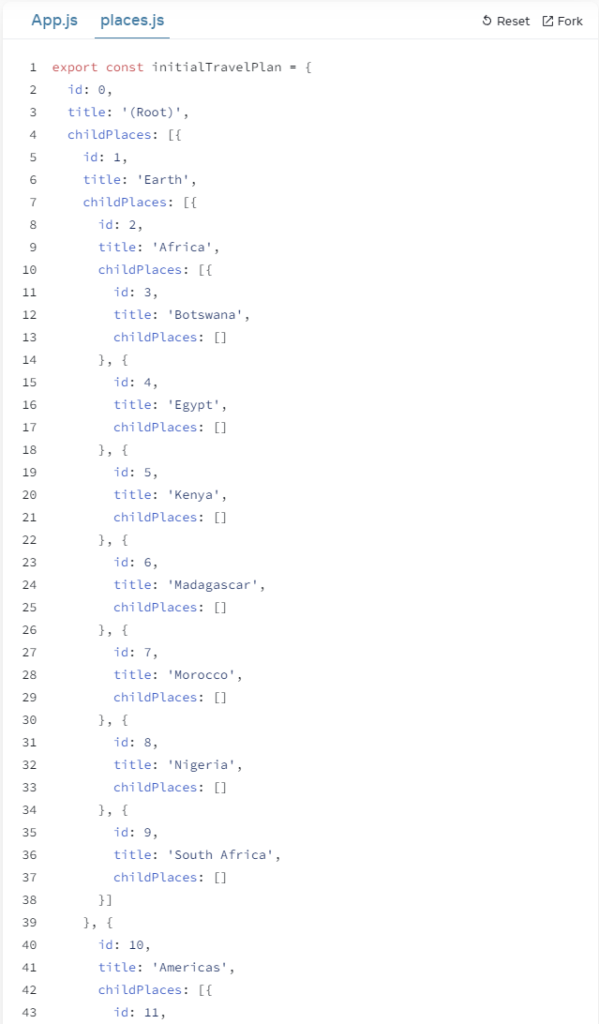

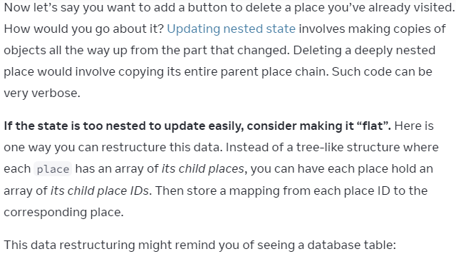

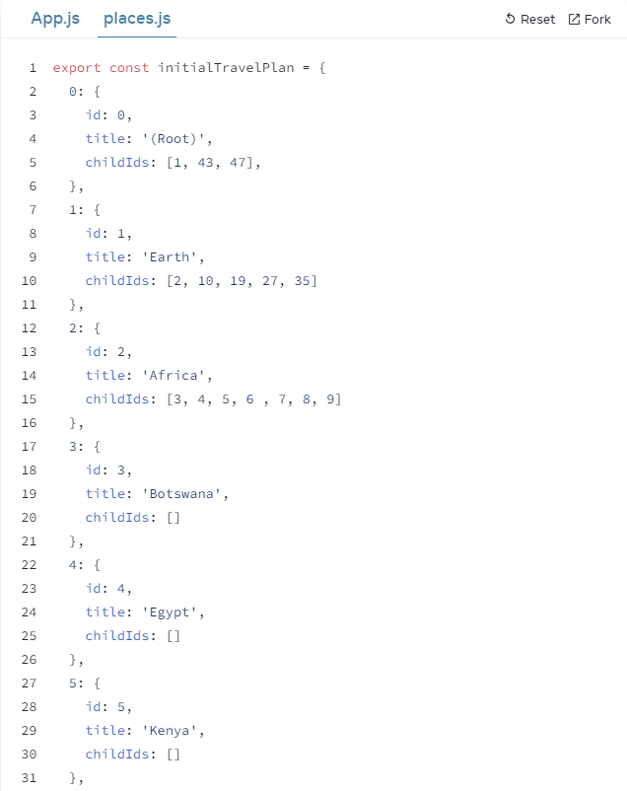

Hooks

Class component [OOP paradigm]

Mounting events: 4 methods

==== **componentDidMount()**

Introduced in v16.0

<https://react.dev/learn#using-hooks>

Learn how to learn new features upon lib updates

**It's hard to reuse stateful logic between components**

**Complex components become hard to understand**

componentDidMount

componentDidUpdate

componentWillUnmount

**Classes are confusing people & machines**

**this.**

Future potential:

Ahead-of-time compilation of components

=====

Hooks do not live in a class:

No class XX extends Component { }

No constructor { super() }

No this.state = { a: [],b: ''}

No componentDidMount()

Hooks use functional components :React.FC<Generics>

**Convert class App => function**

// function App

export default function App() {

// No constructor(), super()

    // constructor() {

    //     super() // Need to call constructor() of Component => super() to extend class

    //     // Declare state here

    //     this.state = {

    //         // STATE >> props

    //         // robots: robots,

    //         robots: [],

    //         searchfield: '',

    //         }

    //         // console.log('1 in constructor() ');

    //     }

    const [robots, setRobots] = useState([]);

    const [searchfield, setSearchfield] = useState('');

    const [searchDisplay, setSearchDisplay] = useState('search robots');

// useEffect is replacing componentDidMount(), componentWillUpdate()

// No componentDidMount

    // componentDidMount() {

    //     fetch('https://jsonplaceholder.typicode.com/users')

    //     .then((response) => {

    //         return response.json();

    //     })

    //     .then(users => {

    //         this.setState( {robots: users} );

    //         console.log(users);

    //     })

    // }

    useEffect(() => {

        fetch('https://jsonplaceholder.typicode.com/users')

        .then((response) => {

            return response.json();

        })

        .then(users => {

            setRobots(robots => robots = users);

            console.log(users);

        })

    }, [])

// Tell React to only re-render useEffect() when searcfield

// changes

// const Arrow functions

    const onSearchChange = (event) => {

        setSearchfield(searchfield => searchfield = event.target.value);

        // Logging SearchBox <input type='search'> text onChange event

        // console.log(event.target.value);

        // this.state.robots = array

    }

    // const Arrow functions

    const onClear = () => {

        setSearchfield(searchfield => searchfield = '');

        setSearchDisplay(searchDisplay => searchDisplay = 'search robots');

    }

// No render() { }

        // Using destructuring

        const filteredRobots = robots.filter(robot => {

            return robot.name.toLowerCase().includes(searchfield.toLowerCase())

        })

**useEffect Hook**

Adds the ability to perform side effects from a function component.

Serves the same purpose as:

componentDidMount

componentDidUpdate

componentWillUnmount

useEffect(() => {

        fetch('https://jsonplaceholder.typicode.com/users')

        .then((response) => {

            return response.json();

        })

        .then(users => {

            setRobots(robots => robots = users);

            console.log(users);

        })

    }, [])

**Crucially, Hooks work side-by-side with existing code, thus you can adopt them gradually.**

**Only call Hooks from React Functions**

**Only call Hooks at Top Level**

Stateless Functional Component (FP)

==== **Stateless functional component (Functional Programming)**

no class, no this.

presentational component => UI

class component => elec

imr

const Box = ( { me } ) => {

return (

<div className="d-flex flex-row">

<span>{Element(1)}</span>

<span>{Element(2)}</span>

<span>{Element(3)}</span>

</div>

);

};

let Element = ( { value} ) => {

return (

<div>

<span className="border p-3 m-3 bg-light">

Element {value}

</span>

</div>

);

export default Box;

componentDidMount & componentWillMount

Saturday, 14 September 2024

4:59 PM

====**componentWillMount(), componentDidMount()**

import React, { Component } from 'react';

import ReactDOM from 'react-dom';

class LifeCycle extends Component {

// Before initial render

// Only called 1 time

// Will not have access to DOM && children

componentWillMount() {

console.log("Executed before Component is mounted");

console.log(ReactDom.findDOMNode(this));

}

// When React has already rendered a component

// && has put it into DOM

// is mounted on native UI

// Can fetch data to server with AJAX

componentDidMount() {

console.log("Executed after Component is mounted");

console.log(ReactDom.findDOMNode(this));

}

render() {

return (

<div className="app">

<h5>React DOM</h5>

</div>

);

}

}

export default LifeCycle;

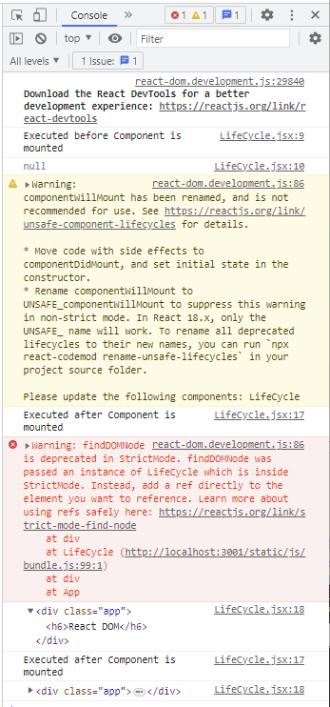

componentDidUpdate & componentWillUpdate

====**componentWillUpdate(), componentDidUpdate()**

import React, { Component } from 'react';

class Timer extends Component {

    // Adding constructor()

    constructor(props) {

        // super() will call constructor() {} of extended Component class

        // To initialize properties or states

        // before mounting components to UI

        // otherwise, this.props will be undefined

        super(props);

        // Create state here

        this.state = {

            counter: 0,

            msg: "Click me",

            };

            console.log("Timer constructor called");

        }

        // Used when calculations & preparations of items are needed

        componentWillUpdate(newProps, newState) {

            console.log("Called before the render()");

        }

        onClick = () => {

        this.setState({

            counter: this.state.counter + 1,

            msg: "Clicked"

             });

        }

            render() {

                return (

                    <div className="app">

                        <h5>{this.state.counter}</h5>

                        <button

                         className="btn btn-waring"

                         onClick={this.onClick}

                        >

                        {this.state.msg}

                        </button>

                        <p>{this.state.msg}:{this.state.counter} times</p>

                    </div>

                    );

                }

    }

export default Timer;

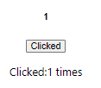

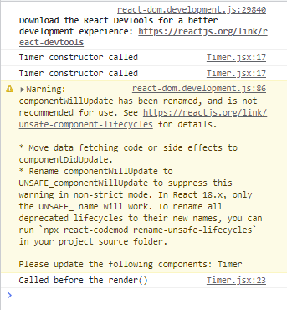

import React, { Component } from 'react';

class Timer extends Component {

    // Adding constructor()

    constructor(props) {

        // super() will call constructor() {} of extended Component class

        // To initialize properties or states

        // before mounting components to UI

        // otherwise, this.props will be undefined

        super(props);

        // Create state here

        this.state = {

            counter: 0,

            msg: "Click me",

            };

            console.log("Timer constructor called");

        }

        // Used when calculations & preparations of items are needed

        componentWillUpdate(newProps, newState) {

            console.log("Called before the render()");

            console.log("newProps", newProps);

            console.log("newState", newState);

        }

        onClick = () => {

        this.setState({

            counter: this.state.counter + 1,

            msg: "Clicked"

             });

        }

            render() {

                return (

                    <div className="app">

                        <h5>{this.state.counter}</h5>

                        <button

                         className="btn btn-waring"

                         onClick={this.onClick}

                        >

                        {this.state.msg}

                        </button>

                        <p>{this.state.msg}:{this.state.counter} times</p>

                    </div>

                    );

                }

    }

export default Timer;



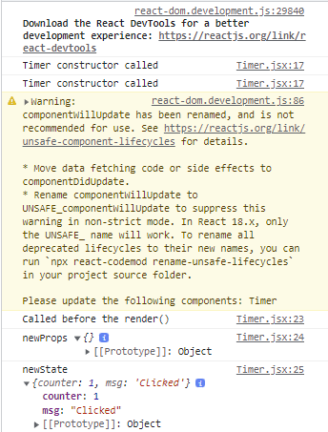



import React, { Component } from 'react';

class Timer extends Component {

    // Adding constructor()

    constructor(props) {

        // super() will call constructor() {} of extended Component class

        // To initialize properties or states

        // before mounting components to UI

        // otherwise, this.props will be undefined

        super(props);

        // Create state here

        this.state = {

            counter: 0,

            msg: "Click me",

            };

            console.log("Timer constructor called");

        }

        // BEFORE render()

        // When a component is being updated

        // SHOW new Props && new State

        componentWillUpdate(newProps, newState) {

            console.log("Called before the render()");

            console.log("newProps", newProps);

            console.log("newState", newState);

        }

        // AFTER render()

        // When a component is being updated

        // SHOW previous Props && previous State

        componentDidUpdate(prevProps, prevState) {

            console.log("Called after the render()");

            console.log("prevProps", prevProps);

            console.log("prevState", prevState);

        }

        // Called when a component is being unmounted from DOM

        // i.e. unregistering from 3rd party Lib, Event elements

        //

        componentWillUnmount() {

            console.log("Component will unmount");

        }

        onClick = () => {

        this.setState({

            counter: this.state.counter + 1,

            msg: "Clicked"

             });

        }

            render() {

                return (

                    <div className="app">

                        <h5>{this.state.counter}</h5>

                        <button

                         className="btn btn-waring"

                         onClick={this.onClick}

                        >

                        {this.state.msg}

                        </button>

                        <p>{this.state.msg}:{this.state.counter} times</p>

                    </div>

                    );

                }

    }

export default Timer;

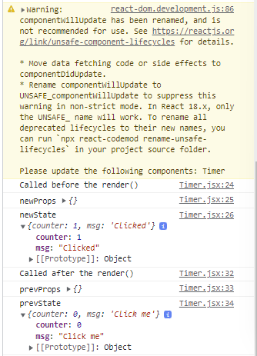

Statement Management - Redux

Why Redux?

For State Management

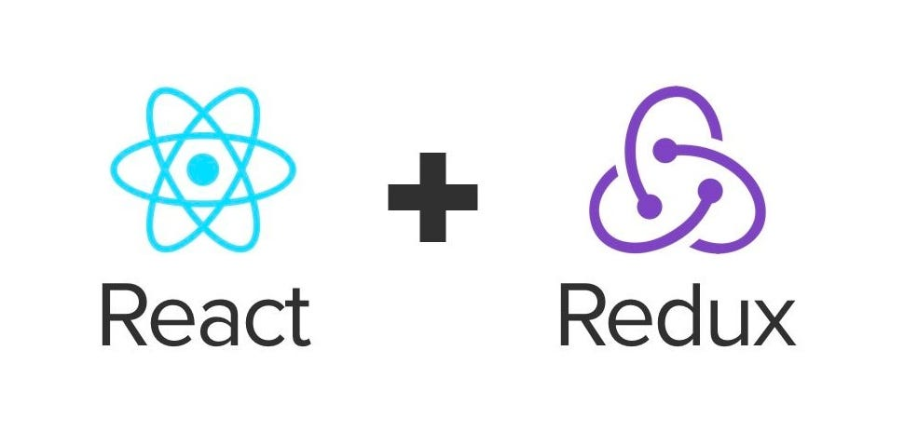

React = a group of components

For example:

state = {

signedInAs: "user1"

}

state = {

admin: ""

}

state = {

user: "Hello"

}

Redux = Tree-like Structure

